Moderator’s Guide for Consumer Focus Group Sessions

Food Choices and Nutrition

[LOCATION] – [DATE]

Need in the room: Pencils and highlighters for all participants; an easel for the moderator.

Introduction [10 minutes]
Welcome and thank you for joining us. My name is [moderator’s name] and I will be your moderator for this focus group session, which is about food choices and nutrition. I’d like to hear how you feel about issues related to this topic, and I’m also interested in your perceptions of some messages written about this topic. I want to let you know that I am not an expert in nutrition; rather, I am an independent moderator trained to facilitate our discussion. Our client for this research is the U.S. Department of Agriculture (USDA), located in Washington, D.C. The USDA provides nutrition information and food assistance services to the American public. Our discussion should take about two hours.

Disclosure
- Observation: There is a one-way mirror with observers in the next room who are interested in hearing your views, but don’t want to interrupt the conversation.
- Audio taping and video recording: This session will be recorded by audio and video tape to enable us to capture everything that is being said today. We will use the tape to write our report to our client.
- Confidentiality assured: All of your answers will be confidential, so feel free to say exactly what is on your mind. Nothing will be attributed to any particular person in our report.

Ground rules
- Need to hear from everyone, one at a time please
- No right or wrong answers, want personal opinions
- Moderator is impartial, please be candid
- It’s okay to be critical. If you dislike something you hear, it’s fine to disagree but please be willing to offer your own views and opinions.
- If anyone needs to use the rest room, they are located [specify]. There is no need to stop the discussion.

Do you have any questions before we get started?

Participant introductions
- Brief introductions around the table – name
  - Ask each participant to briefly describe one thing they have seen or heard that changed or influenced their eating habits.

Warm Up on Healthy Eating [10 minutes]

Let’s get started by talking about how you decide which foods to eat each day.

Is the idea of “healthy eating” a factor in your decisions about food choices for you and your family? Do you try to “eat healthy” each day?
- [If yes] What does “eating healthy” mean to you?
  - What are the top two or three things you do to try to “eat healthy” each day?
- [If no] Is there something about “eating healthy” that doesn’t appeal to you or isn’t a priority for you?
  - Can you describe these?

Are there any things you’d like to change or improve in your daily food choices? What are some of these?
- What are some of the things that keep you from making these changes?
- What changes do you think you could reasonably make in your daily food choices?

When you make your food choices each day, do you specifically think about managing your weight?
- [If yes] What are some of the things you do to manage your weight?
  - Have you experienced any challenges in trying to manage your weight?
    - What are some of the main challenges?
- [If no] Is there something about managing your weight that doesn’t appeal to you or isn’t a priority for you?
  - Can you describe these?

Exploring Nutrition Messages [60 minutes]
Let’s look at some recommendations that have been developed to help people make healthier food choices.
I’d like to get your reactions to these recommendations.
Hand out one pager with all 7 messages on it. Ask participants to circle any words, phrases, or concepts they like, X any they do not like, and then rank them from 1-7 (with “1” being the message they like least and “7” most).
Reveal each message, as it’s discussed, from a flip chart.

Message #1: Enjoy what you eat, just eat less of it.
- Fill up a smaller plate and glass.
- Slow down and savor each bite.
- Stop before you’re stuffed.

- How would you sum up your first impression of this message?
  - Do you like it? Not like it? What makes you say that?
- What is the main idea this message is trying to get across, in your own words? Probe for thinking before you eat. Do participants do this? If so, describe.
  - How well do you think the main idea comes across in this message?
- Does this message make sense to you?
  - Is there anything confusing, unclear or hard to understand?
- Do you feel like you would get a benefit if you followed this advice?
  - [If yes] What type of benefit would you expect?
  - [If no] what makes you say that?
- Do you feel like you have enough information to follow this advice?
  - Is there anything you want to know that this message does not tell you?
- How easy or difficult would it be for you to follow this advice?
  - What challenges would you have?
- How likely are you to try to follow this advice tomorrow?
  - What about longer term – over the next six months?

Let’s look at the second message for this concept. Please read along as I read this message aloud.

Message #2: Know your personal calorie limit. Depending on your health needs, this may range between 350 – 700 calories per meal.
- Get your personal daily calorie budget at XXX.gov.
- Eat no more than 650 calories per meal.
- Know your personal calorie limit, it may be as little as 350 calories per meal.
- Cutting just 100 Calories per day adds up to 10 pounds of weight loss per year!
- Calories add up, know your personal limit and use them wisely.

- How would you sum up your first impression of this message?
  - Do you like it? Not like it? What makes you say that?
- What is the main idea this message is trying to get across, in your own words?
  - How well do you think the main idea comes across in this message?
- Does this message make sense to you?
  - Is there anything confusing, unclear or hard to understand?
- Do you feel like you would get a benefit if you followed this advice?
  - [If yes] What type of benefit would you expect?
  - [If no] what makes you say that?
- Do you feel like you have enough information to follow this advice?
  - Is there anything you want to know that this message does not tell you?
- What does the number of calories per meal mean to you? Do you think this information would help you manage and decide what and how much to eat? When eating at home? Away from home?
- How easy or difficult would it be for you to follow this advice?
  - What challenges would you have?
- How likely are you to try to follow this advice tomorrow?
  - What about longer term – over the next six months?

Let’s look at the third message for this concept. Please read along as I read this message aloud.

Message #3: . Snack wisely.
- If you’re hungry, reach for fruit, vegetables or nuts – nature’s original fast food – not salty or sugary snacks.
- If you’re bored, fill your time with activity, not food.

- How would you sum up your first impression of this message?
  - Do you like it? Not like it? What makes you say that?
- What is the main idea this message is trying to get across, in your own words?
  - How well do you think the main idea comes across in this message?
- Does this message make sense to you?
  - Is there anything confusing, unclear or hard to understand?
- Do you feel like you would get a benefit if you followed this advice?
  - [If yes] What type of benefit would you expect?
  - [If no] what makes you say that?
- Do you feel like you have enough information to follow this advice?
  - Is there anything you want to know that this message does not tell you?
- How easy or difficult would it be for you to follow this advice?
  - What challenges would you have?
- How likely are you to try to follow this advice tomorrow?
  - What about longer term – over the next six months?

Before we leave this concept, please take a moment and circle the phrases you think are effective and put an X next to the phrases that you think are not effective. Please include the underlined top messages in addition to the messages in bullets that fall under the top messages.

[Distribute one page with one concept message plus two messages below it.] Please read along as I read this message aloud.

Message #4: Save half your plate for fruits and vegetables.
- Eat fruits & vegetables vibrant with nutrition-packed colors, especially orange and dark green.
- Fill the other side of your plate mostly with naturally fiber-rich 100% whole grain rice, bread, pasta and cereals.
- Eat seafood and beans more often.
- Keep meat portions small and lean.

- How would you sum up your first impression of this message?
  - Do you like it? Not like it? What makes you say that?
- What is the main idea this message is trying to get across, in your own words?
  - How well do you think the main idea comes across in this message?
- Does this message make sense to you?
  - Is there anything confusing, unclear or hard to understand?
- Do you feel like you would get a benefit if you followed this advice?
  - [If yes] What type of benefit would you expect?
  - [If no] what makes you say that?
- Do you feel like you have enough information to follow this advice?
  - Is there anything you want to know that this message does not tell you?
- How easy or difficult would it be for you to follow this advice?
  - What challenges would you have?
- How likely are you to try to follow this advice tomorrow?
  - What about longer term – over the next six months?

Let’s look at the second message for this concept. Please read along as I read this message aloud.

Message #5: Switch to 1% or fat-free milk.
- A cup of whole milk has the same amount of saturated fat as a fast-food burger or 5 strips of bacon.
- Keep your milk simple – no added sugars.
- Yogurt should also be low-fat or non-fat, and keep added sugars to a minimum (no more than X grams per cup).

- How would you sum up your first impression of this message?
  - Do you like it? Not like it? What makes you say that?
- What is the main idea this message is trying to get across, in your own words?
  - How well do you think the main idea comes across in this message?
- Does this message make sense to you?
  - Is there anything confusing, unclear or hard to understand?
- Do you feel like you would get a benefit if you followed this advice?
  - [If yes] What type of benefit would you expect?
  - [If no] what makes you say that?
- Do you feel like you have enough information to follow this advice?
  - Is there anything you want to know that this message does not tell you?
- How easy or difficult would it be for you to follow this advice?
  - What challenges would you have?
- How likely are you to try to follow this advice tomorrow?
  - What about longer term – over the next six months?
Before we leave this concept, please take a moment and circle the phrases you think are effective and put an X next to the phrases that you think are not effective. Please include the underlined top messages in addition to the messages in bullets that fall under the top messages.

[Distribute one page with one concept message plus three messages below it.] Please read along as I read this message aloud.

- Message #6: Cut back on foods with added sugars, salt, and fat.
- One glazed donut isn’t just filled with sugar and fat; it has almost the same number of calories and even more salt than a medium side of fast-food fries.
- If it’s in a package of any kind, that’s a red flag to check for added sugars or salt.
- Any food with sugar or salt listed in the first three ingredients should be just an occasional treat.
- Buy food with as little added sugars and salt as possible so that you can control the amount in what you eat/drink.

- How would you sum up your first impression of this message?
  - Do you like it? Not like it? What makes you say that?
- What is the main idea this message is trying to get across, in your own words?
  - How well do you think the main idea comes across in this message?
- Does this message make sense to you?
  - Is there anything confusing, unclear or hard to understand?
- Do you feel like you would get a benefit if you followed this advice?
  - [If yes] What type of benefit would you expect?
  - [If no] what makes you say that?
- Do you feel like you have enough information to follow this advice?
  - Is there anything you want to know that this message does not tell you?
- How easy or difficult would it be for you to follow this advice?
  - What challenges would you have?
- How likely are you to try to follow this advice tomorrow?
  - What about longer term – over the next six months?

Let’s look at the second message for this concept. Please read along as I read this message aloud.

Message #7: Break the sugary drink habit.
- A 12 oz can of soda has the same amount of sugar as 10 packets of sugar. A 16 oz. can of an energy drink has the same amount of sugar as 5 or 6 glazed donuts.
- Sodas, energy drinks, fruit drinks and other beverages heavy in added sugar can make you heavy.

- How would you sum up your first impression of this message?
  - Do you like it? Not like it? What makes you say that?
- What is the main idea this message is trying to get across, in your own words?
  - How well do you think the main idea comes across in this message?
- Does this message make sense to you? In your own words, what is a “sugar drink”?
  - Is there anything confusing, unclear or hard to understand?
- Do you feel like you would get a benefit if you followed this advice?
  - [If yes] What type of benefit would you expect?
  - [If no] what makes you say that?
- Do you feel like you have enough information to follow this advice?
  - Is there anything you want to know that this message does not tell you?
- How easy or difficult would it be for you to follow this advice?
  - What challenges would you have?
- How likely are you to try to follow this advice tomorrow?
  - What about longer term – over the next six months?

Before we leave this concept, please take a moment and circle the phrases you think are effective and put an X next to the phrases that you think are not effective. Please include the underlined top messages in addition to the messages in bullets that fall under the top messages.

Applying the Messages (20 minutes)
The recommendations we just explored contained several important nutrition terms. I’d like to talk about some of these terms to understand your perceptions of them and how you would apply them as you make your food choices each day.

Let’s start with calories….
- What are calories?
- How many calories should you have each day? Do you think about calories per day? Per meal? Per week?
- Does this amount vary from person to person? Probe for amount of calories different family members should have, including children.
- If you knew how many calories you should have each day, would you try to stay within that number?
  - How easy or difficult do you think it would be to do this?
  - What information or resources would be helpful to you?

One of the recommendations talked about cutting back on fat, sugar, and salt. Let’s talk about fat for a moment.
- If I asked you to reduce fat in your diet, what types of foods or beverages would you cut back on?
- What information or resources would be most helpful to you in selecting foods that are lower in fat?
- Are there different types of fat?
  - What are the different types of fat?
  - Are some types of fat better than others?
  - How do you know which foods contain better fats?
    - What information or resources would be helpful to you?
Now let’s talk about sugar and salt.
- If I asked you to reduce sugar in your diet, what types of foods or beverages would you cut back on?
- How easy or difficult would it be to cut back on sugar?
- What information or resources would be most helpful to you?
- If I asked you to reduce salt in your diet, what types of foods or beverages would you cut back on?
- How easy or difficult would it be to cut back on salt?
- What information or resources would be most helpful to you?

Let’s shift gears a bit and talk about a few food groups. Starting with dairy…
- What types of foods are included in this group?
- Are there foods you should eat more of and foods you should eat less of within this group?
  - What are some examples of each?

Moving on to vegetables…
- What types of foods are included in this group?
- Are there foods you should eat more of and foods you should eat less of within this group?
  - What are some examples of each?

Let’s talk about proteins…
- What types of foods tend to be rich in protein? [Foods rich in protein include meat, poultry, fish, eggs, nuts, seeds, dried beans and soy products]
- What terms or phrases do you typically use to describe foods that are rich in protein?
- We included “dried beans” in this group – what type of beans do you think of when you hear the term “dried beans?”
  - Are green beans included in this group?
  - What about peas – are they included?

One of the recommendations we talked about previously suggested switching to 100% whole grain breads, cereals and pastas.
- What are “whole grains”?
- What types of foods contain whole grains?
- Do you think it is easy or difficult to find whole grain foods at the grocery store?
- What information or resources would be most helpful to you in selecting foods that contain 100% whole grains?

MyPyramid – Current Images (5 minutes)

How many of you are familiar with the Food Pyramid, produced by the U.S. Department of Agriculture (USDA)? [Ask for show of hands] The Food Pyramid was created in 1992 as a nutrition education tool, and it was updated in 2005. Let’s look at the most recent version.

[Show image below on a board]
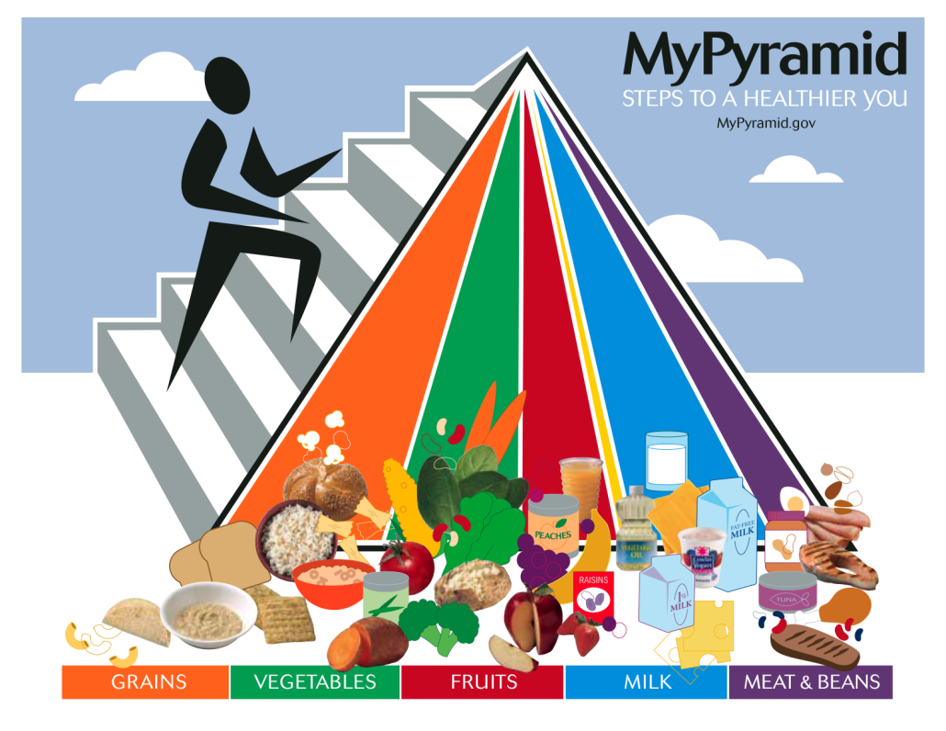

How would you explain MyPyramid to someone? What is this image telling you to do?

Probe:
- What do the colors communicate? [Probe if necessary: do the colors represent food groups?]
  - What types of food would you expect to see in each colored section?
- What do the different sizes of the color bands mean? Listen for responses and then explain what the size of the bands mean. Ask for reaction.
- What does the figure on the side of the Pyramid represent? Listen for responses and then explain what the figure represents. Ask for reaction.
- Do you get a sense that there are certain types of food you should eat more of and certain types of food you should eat less of?

New Graphic Images (12 minutes)
For our final section, let’s look at three different graphic images that have been designed to remind people to eat healthy.

[Show one graphic at a time, each on a separate board]

[For each graphic ask:]

- How would you sum up your first impression of this graphic?
  - Do you like it? Not like it? What makes you say that?
- What is the main idea this graphic is trying to get across?
  - How well do you think the main idea comes across in this graphic?
  - Do you think it fits in with the recommendations we have talked about for healthy eating?
- Do you think this image is an effective visual reminder to eat healthy?
  - Does it give you any information about what you should do to eat healthy?
    - What information does it give you?
- Is there anything you would change about this graphic image to make it more effective?
  - What would you change?

Graphic Concept #1:
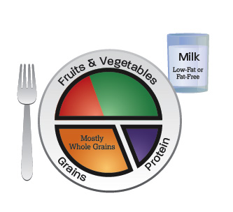

Graphic Concept #2:
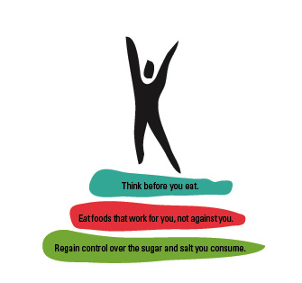

Graphic Concept #3:
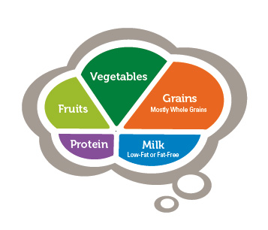

Between these three graphic images, is one more likely than the other to get your attention? Which one? Do any of these help you think differently about making better food choices for your children?
Which one is more motivating or inspiring?

Wrap Up
On behalf of the USDA, I want to thank all of you for your input today.
- Collect all materials.

