Form ED-209 OMB Control No. 0610-0095
(replaced ED-209S and ED-209A) Expiration Date: XX-XX-XXXX

RLF APPLICATION REQUIREMENTS

Revolving Loan Fund Management System (RLFMS) Grantee Data Entry Screens

Login screen:

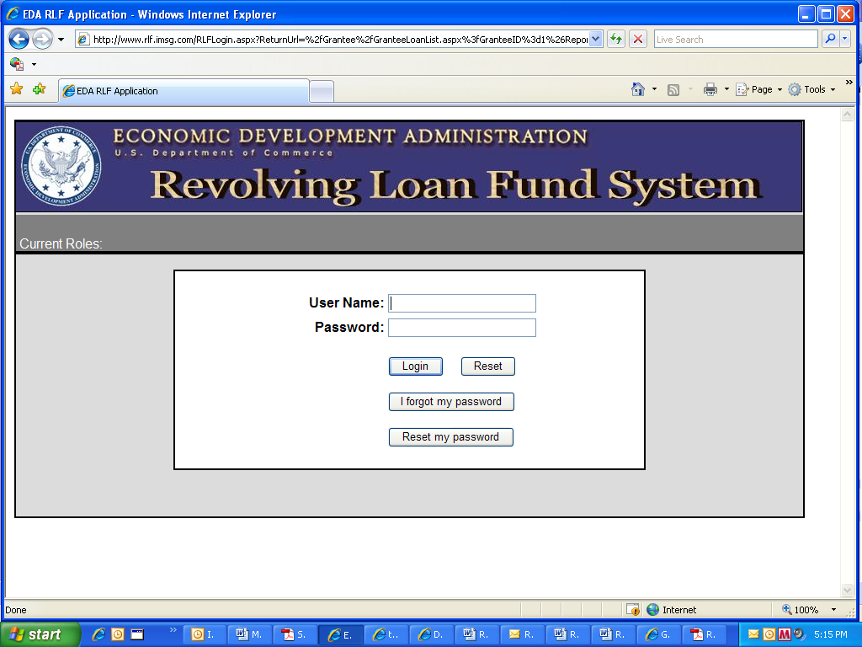

Portfolio Loan List screen (top):

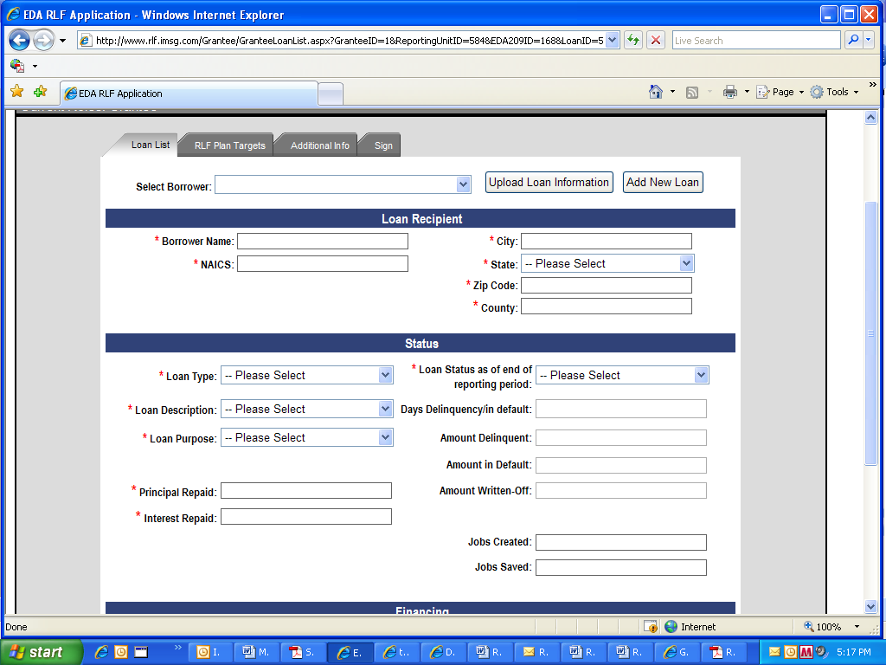

Portfolio Loan List screen (continued—whole screen cannot be displayed at once)

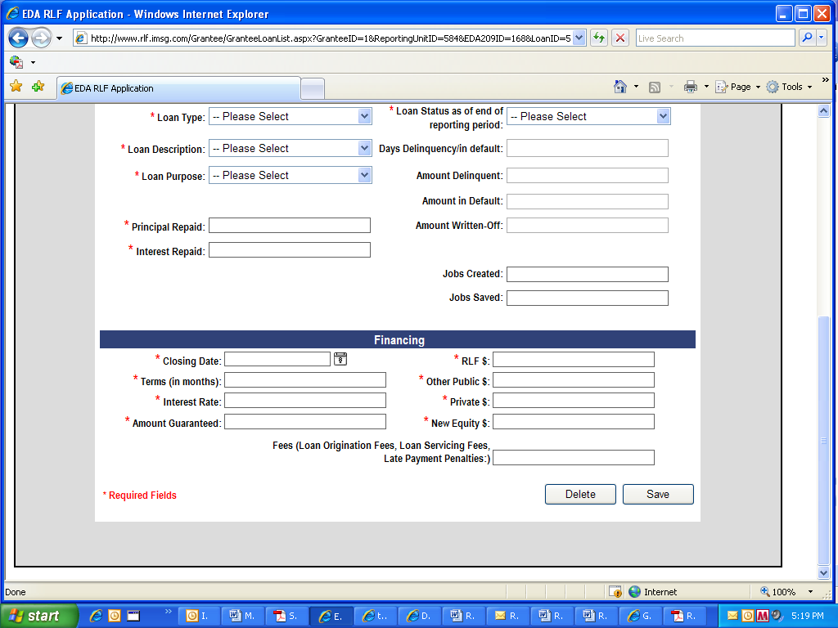

Additional Information Screen (top):

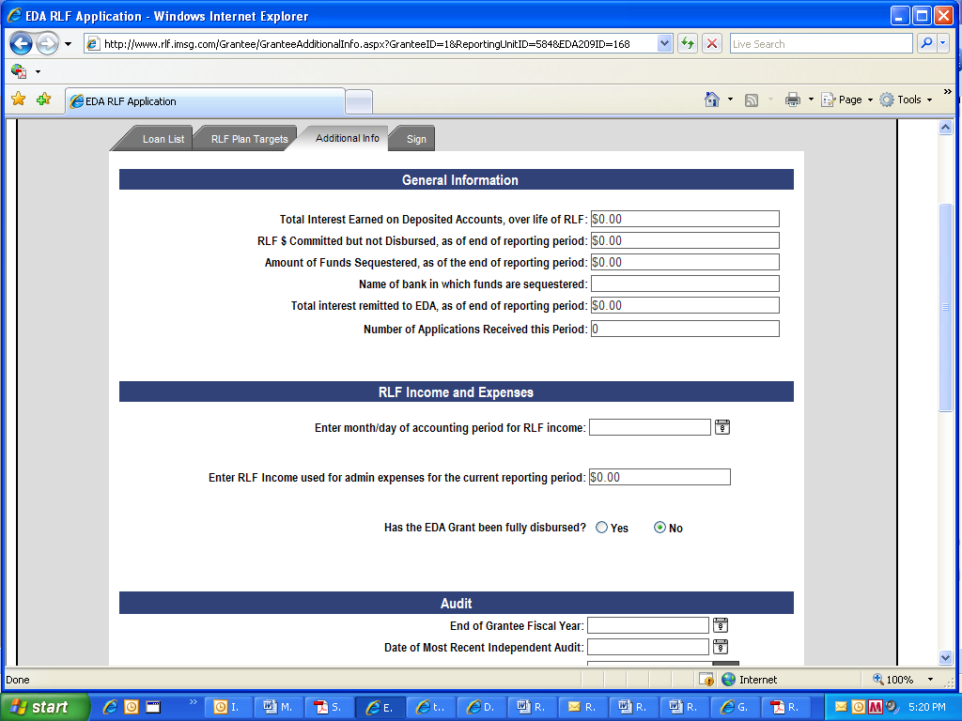
Additional Information screen (bottom—whole screen cannot be displayed at once)

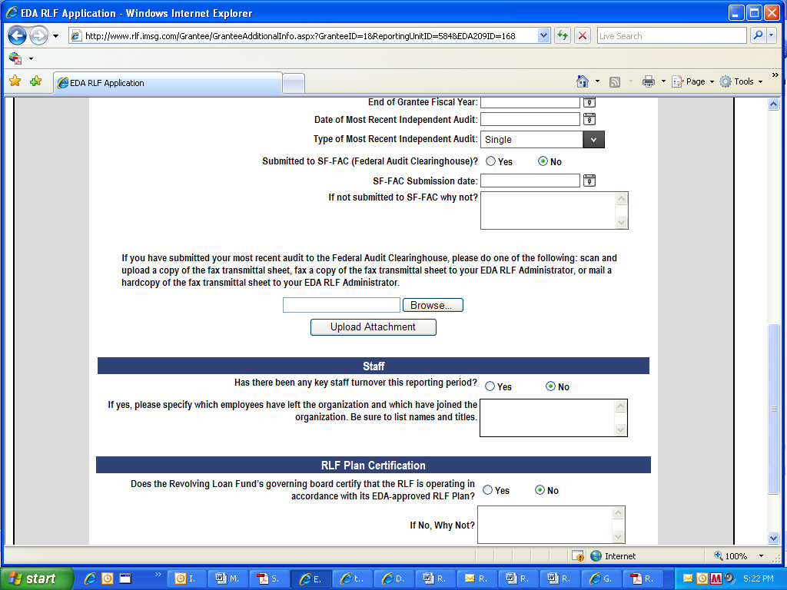

Signature page:

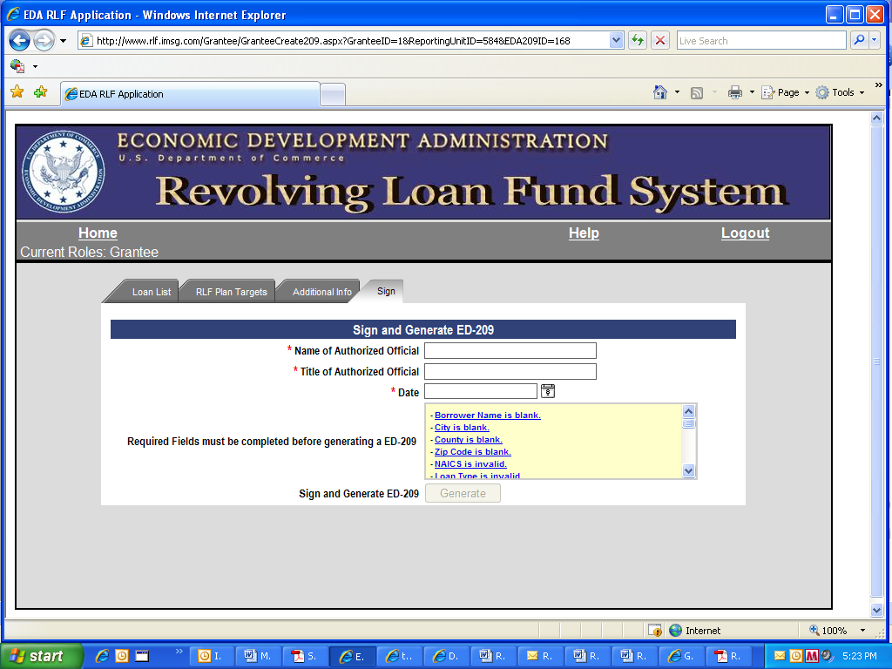

Appendix B—ED-209 Generated from RLFMS Data Entry Fields
(Note: Data shown in form is not real data. No personally identifiable information is shown.)

