

Are you over the age of 18?

Do you have 10 – 15 minutes to spare?

You may be eligible to take a Quick and Easy survey!

Participate in a health study survey investigating HIV reporting practices!

Participants will receive some compensation.

This survey is Private!

Time and Location :

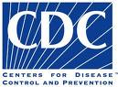 Sponsored by the Centers for Disease Control 
and Houston Department of Health and Human Services

