Form Approved
OMB No. 0920-0840
Expiration Date: 00/00/0000

Evaluation of Rapid HIV Self-Testing: Qualitative and User Proficiency Assessments
Generic Information Collection Request under 0920-0840

Attachment 1e
Proficiency Assessment--Testing Panel Images
Public reporting burden of this collection of information is estimated to average 10 minutes per response, including the time for reviewing instructions, searching existing data sources, gathering and maintaining the data needed, and completing and reviewing the collection of information. An agency may not conduct or sponsor, and a person is not required to respond to a collection of information unless it displays a currently valid OMB control number. Send comments regarding this burden estimate or any other aspect of this collection of information, including suggestions for reducing this burden to CDC/ATSDR Reports Clearance Officer; 1600 Clifton Road NE, MS D-74, Atlanta, Georgia 30333; Attn: OMB-PRA (0920-0840)

Example Images-- Evaluation of the ability of untrained potential users to read and interpret examples of test results
Study participants whose HIV status was not known prior to testing will be evaluated for their ability to correctly interpret a set of test results obtained with the investigational test (i.e., a random mix of devices with non-reactive, weakly reactive, strongly reactive, and invalid test results). Each study participant will be asked to interpret approximately 10 test results of each type (OraQuick and Sure Check). Results will be evaluated using appropriate statistical methods, including calculations of percent agreement for each type of result, each with 95% two-sided confidence interval lower bounds of at least 98% for non-reactive, strong reactive and invalid results and at least 95% for weak reactive results.
Examples of the types of images that will be used are provided below.

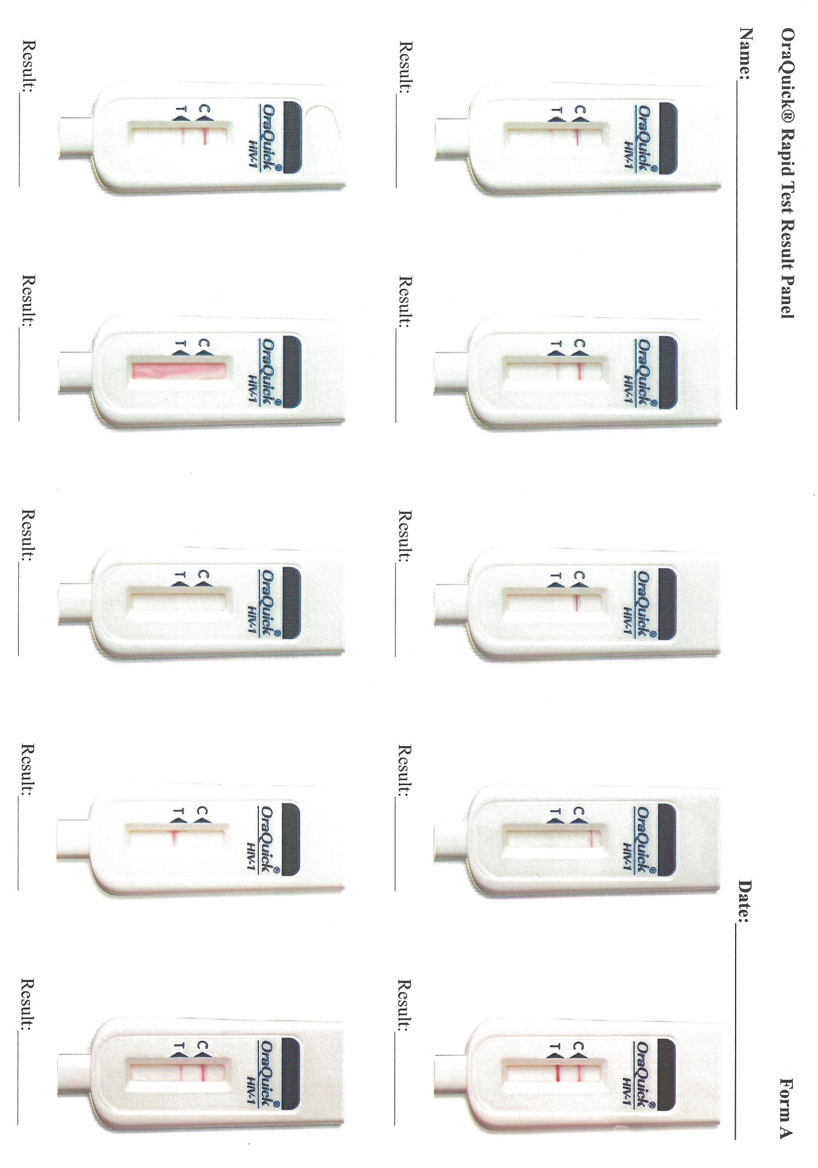
Sure Check Rapid Result Panel

