Request for Sub-collection Under the
Approved Generic ICR: Formative Research and Tool Development

OMB No. 0920-0840,
Expiration 31 January 2013

Minority HIV/AIDS Research Initiative (MARI) Project:

Sexual risk-taking among young black men who have sex with men: exploring the social and situational contexts of HIV risk, prevention, and treatment (BROTHERS CONNECT STUDY)

Attachment 4. Recruitment Materials and Website Screenshots

ARE YOU…
A BLACK MAN WHO HAS SEX WITH MEN?
SEXUALLY ACTIVE?
BETWEEN THE AGES OF 18-30?

If you answered yes we want to talk to you!

We would like to invite you to take part in a research study for young Black men living in the NYC area who have sex with other men.

If eligible, you will be asked to tell us about your health, sexual activity, and experiences in childhood and adulthood.

Take an online survey on a secure website.

Receive $30 for your time and find out of you qualify for other paid research opportunities!

Join BCS
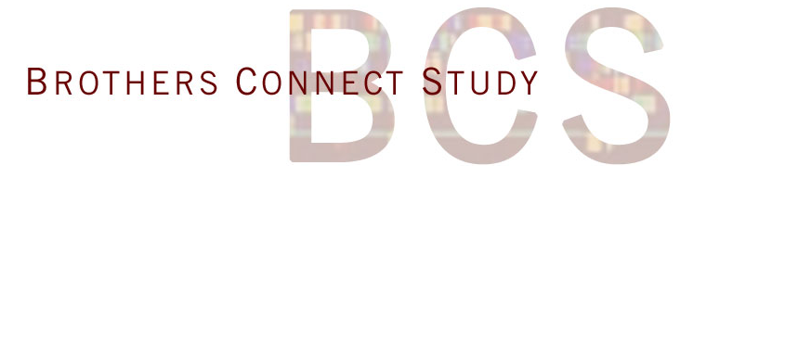
Researchers from Columbia University will carefully protect your CONFIDENTIALITY!

Email us at:
brothersconnect@columbia.edu
Or call at:
(212) 305 – 8110
ARE YOU A BLACK MAN WHO HAS SEX WITH MEN? SEXUALLY ACTIVE? BETWEEN THE AGES OF 18-30?

If you answered yes, we want to talk to you!

We would like to invite you to take part in a research study for young Black men who have sex with men, living in the NYC area. Complete a survey about your health, sexual activity and experiences in childhood and adulthood and receive $30 for your time! Also, you will be given information about other paid research opportunities. Must be able to come to conveniently located study office. Email the Brothers Connect Study at brothersconnect@columbia.edu or call us at (212) 305-8110.

- BCS website homepage
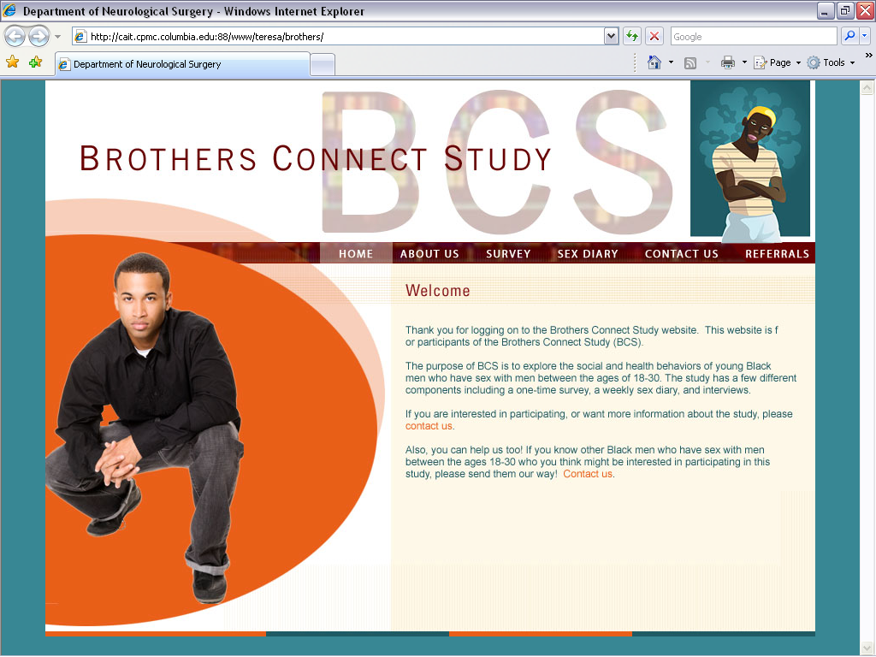

- Cross-sectional survey webpage
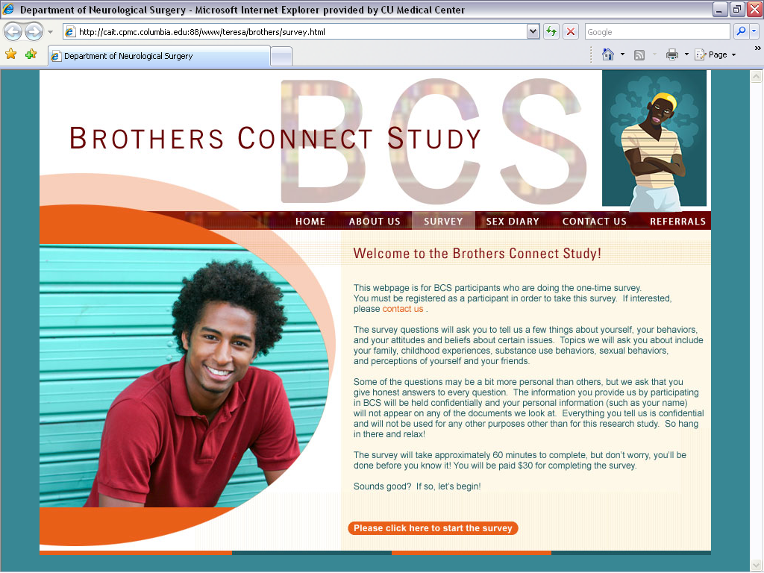

- Longitudinal structured sex diary webpage
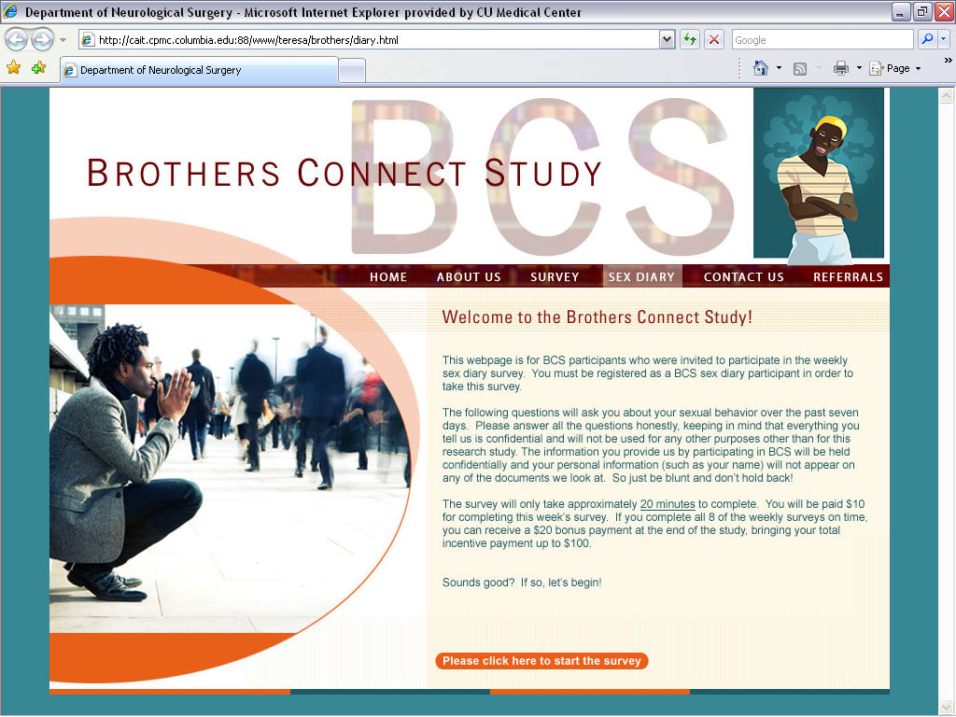

- “About Us” webpage
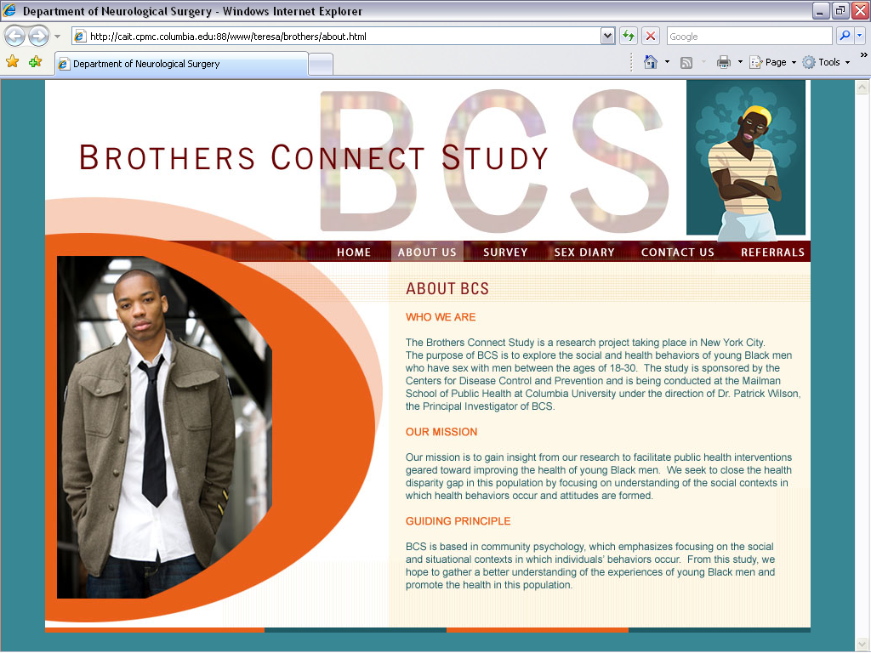
E. “Contact Us” webpage

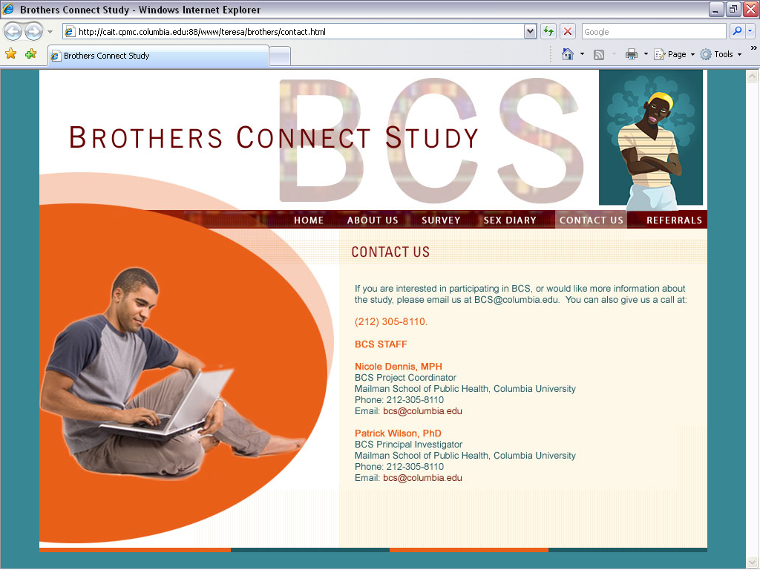

- Survey/sex diary log off webpage (the last webpage participants see after completing the survey/sex diary)

