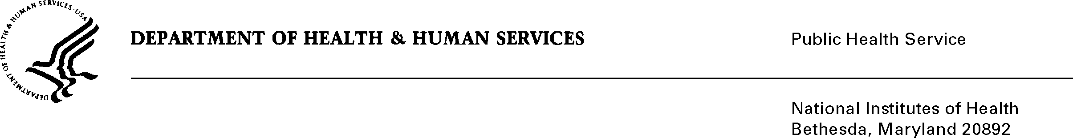
DEPARTMENT OF HEALTH & HUMAN SERVICES National Institutes of Health

Ronald J. Iannotti, PhD
Prevention Research Branch
Eunice Kennedy Shriver National
Institute of Child Health and
Human Development
6100 Building Room 7B05 MSC 7510
Bethesda, MD 20892-7510
Phone: 301 435-6951
Fax: 301 402-2084
E-mail: iannottr@mail.nih.gov

July 31, 2026

TO: Office of Management and Budget (OMB)
Through: Reports Clearance Officer, DHHS
Project Clearance Chief, NIH
Project Clearance Liaison, NICHD

FROM: Ronald J. Iannotti, PhD
NICHD/DESPR/PRB

SUBJECT: NEXT Generation Health Study

This is a request for OMB to approve the NEXT Generation Health Study. Approval is being sought for collection of reliable and valid data on changes in health and health behavior in a cohort of 2,700 U.S. adolescents. The study will collect information on adolescent health behaviors and social and environmental contexts for these behaviors annually for four years beginning in the 2009-2010 school year. Hispanic and African-American youth will be oversampled to provide better population estimates of these groups and to provide an adequate sample to examine racial/ethnic differences in longitudinal predictors of health, health behaviors, and health behavior change. Self-report of health status, health behaviors, and health attitudes will be collected by in-school and online surveys. Anthropometric data, genetic information, and neighborhood characteristics will be gathered on all participants as well. The study will also incorporate an Administrator Survey and other data sources to obtain related information on school-level health programs and community-level contextual data. In addition, a representative subsample of 750 overweight and normal weight adolescents will be identified: additional data on behavioral risk factors and biological markers and risk factors will be gathered on these adolescents. The projects supports the missions of the National Institute of Child Health and Human Development(NICHD), the National Heart, Lung, and Blood Institute (NHLBI), the National Institute of Alcohol Abuse and Addiction (NIAAA), and the Maternal and Child Health Branch of the Health Resources and Services Administration (HRSA/MCHB) in program requirements that address supportive health environments for adolescents.

This study has been approved by the NICHD IRB.

