Public reporting burden for this collection of information is estimated to average 2 minutes per response, including the time for reviewing instructions, searching existing data sources, gathering and maintaining the data needed, and completing and reviewing the collection of information. An agency may not conduct or sponsor, and a person is not required to respond to, a collection of information unless it displays a currently valid OMB control number. Send comments regarding this burden estimate or any other aspect of this collection of information, including suggestions for reducing this burden, to: NIH, Project Clearance Branch, 6705 Rockledge Drive, MSC 7974, Bethesda, MD 20892-7974, ATTN: PRA (####-####). Do not return the completed form to this address.

Waist Circumference PrOTOCOL (in School)

  - Equipment

- Tables
- Chairs for waiting students
- Privacy screens
- Waist measuring tapes (G-tape) with tension device
- Colored small adhesive dots or water-based color marker
- Alcohol wipes (to clean the skin if using water-based color marker)
- Large binder clips or elastic bands for holding students’ shirts above the waist

  - Personnel

- Health researchers trained and certified in measuring waist circumference according to study protocol (NOTE: Perhaps more than at other stations, it helps to have 2 people perform this measurement—one to hold the tape in place and one to record)

  - Procedures

- Introduce yourself and explain what you are going to do. NOTE that females are permitted to measure girls and either males or females are permitted to measure boys unless the student objects. It is preferable to have more than one staff person working behind the screen so that the student is not left alone with an adult.
- Ask permission to touch the student. If the student refuses, do not take the measurement. If the student either refuses or the measurement can’t be taken for some reason, note the reason on the data collection form.
- Have student stand in normal posture, breathing regularly. The measurement is made at a normal minimal respiration.
- Ask the student to push down elastic waist or unzip jeans/pants if needed so the crests of the ilium (hip bone) are exposed. Ask the student to tuck shirttail under the armpits and then drop arms to sides. If the student refuses to alter clothing, do not complete the measurement.
- To define the level at which waist circumference is measured, a bony landmark is first located and marked. (NOTE: Be careful not to poke or scrape the student with your fingernails.) Position at the right side of the subject and palpate the upper crest of the hipbone to locate the right iliac crest (see figure below from NHLBI Clinical Guidelines on the Identification, Evaluation, and Treatment of Overweight and Obesity in Adults: the Evidence Reported, page 59). Place a small adhesive dot (or mark with a colored water-based marker) at the point where the uppermost lateral border of the right iliac crest meets the mid-axillary line which is an imaginary vertical line from armpit. The iliac crest can be marked on both sides of the body in order to line up the measuring tape.

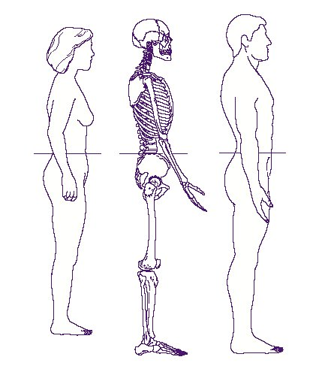

- Standing in front of the student’s right side, wrap the measuring tape in a horizontal plane around the abdomen at the level of the colored dot/mark on the right side of the trunk. This horizontal plane is parallel to the floor.
- The bottom of measuring tape should be at level of dot/mark for measurement purposes. Ensure that the tape is wrapped parallel to the ground and front and back are at same level. The tape should be snug but not compressing the skin.
- While holding the tape with one hand and the body of the tensioning device with the other, pull the tensioning device until red mark can be seen emerging from the end of the tensioning device. Do not pull on the end of the tape that does not have the tensioning device.
- Read the scale adjacent to the end of the measuring tape and measure to nearest 0.1 centimeter.
- Record first waist circumference on the data collection form.
- Remove tape and repeat procedures in steps 5-9.
- Record second waist circumference on the data collection form. If the first two measurements are ≤ + 1 cm of each other, stop and circle both measurements on the form.
- If the first two measurements are not ≤ + 1 cm of each other, repeat the procedures in steps 5-9, removing the tape between each measurement until two values are ≤ + 1 cm of each other. Record each measurement on the data collection form—space is left for up to 5 measurements, although it is not expected to take that many. Circle the two measurements which are within 1 cm of each other and which are to be data entered.
- Remove the adhesive dot or wipe marker spot with an alcohol wipe from the student’s skin and ask the student to return clothing to normal.
- Either send the student with the clipboard to the next station, or take student to next station and give clipboard with forms to study staff there.

The Next Generation Health Study

Waist Circumference Script

Note: Female health researchers are permitted to measure girls. Either male or female health researchers are permitted to measure boys unless the student objects. It is preferable to have more than one staff person working behind the screen so that the student is not left alone with an adult.

Note: If you (the health researcher) are wearing a watch and/or bracelets please remove prior to measuring the student

Hello. My name is __________ and I am going to measure your waist today. Now I am going to measure your waist at least two times.

Before we get started, can you think of any reason why your waist measurement might not be accurate today?

[Document any reason student may provide].

In order to take your waist circumference, I will need to touch your waist on each side of your body. Is that okay?

Student refusal: If the student refuses to be touched, do not complete the measurement. Indicate that a valid measurement is not available and make note of the reason why a valid measurement is not available.

To measure your waist I will need to find the top of your hip bone on both sides of your body. On me, the top of my hip bone is here [demonstrate on yourself]. Can you help me find the top of your hip bone? Thank you, that is very helpful.

Now, I need to be able to feel your hip bone. Can you please pull the waist band of your pants down a little, just below your hips? OR Can you please loosen your pants a little so that they are placed below your hip bone?

Student refusal: If the student refuses to alter clothing to expose the crests of the ilium (hip bone), do not complete the measurement. Indicate that a valid measurement is not available and make note of the reason why a valid measurement is not available.

Also, I need to be able to see your waist so that I can measure it. Can you please hold your shirt so that I can see your waist?

[Locate the top of the hip bone on both sides of the student’s body following instructions given in the protocol]

Please leave the adhesive dots on your hip until I have completed the measurement at least twice.

Now I am going to ask for your help to make sure I am getting an accurate measurement. Can you please gently hold the measuring tape on your right side with your thumb and index finger? We want the tape to rest against your skin lightly.

[Position the tape following instructions given in the protocol}

Thank you. Now I will take the first measurement. Please stand still and breathe normally.

[Perform waist circumference measurement]

Thank you. Now I am going to repeat the measurement.

[Perform repeat waist circumference measurement]

Thank you for your help! We are all done. Please remove these stickers and then you can readjust your clothing.

Adapted from the HEALTHY study (The HEALTHY Study Group, in press)

