Home Page
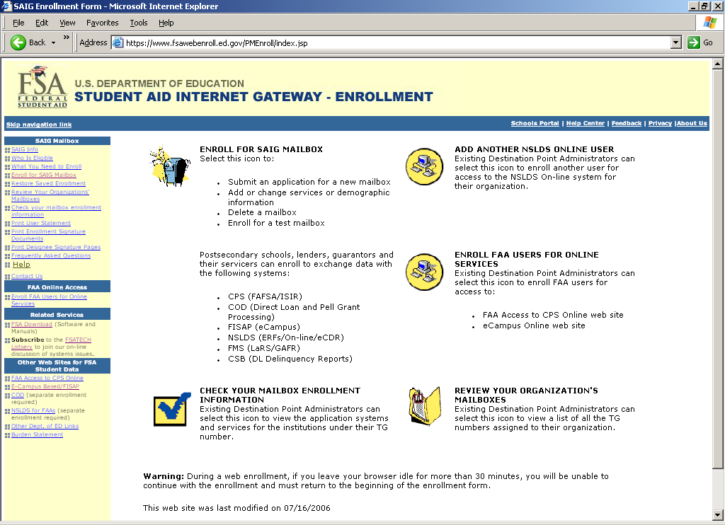
Initial Application Main Menu
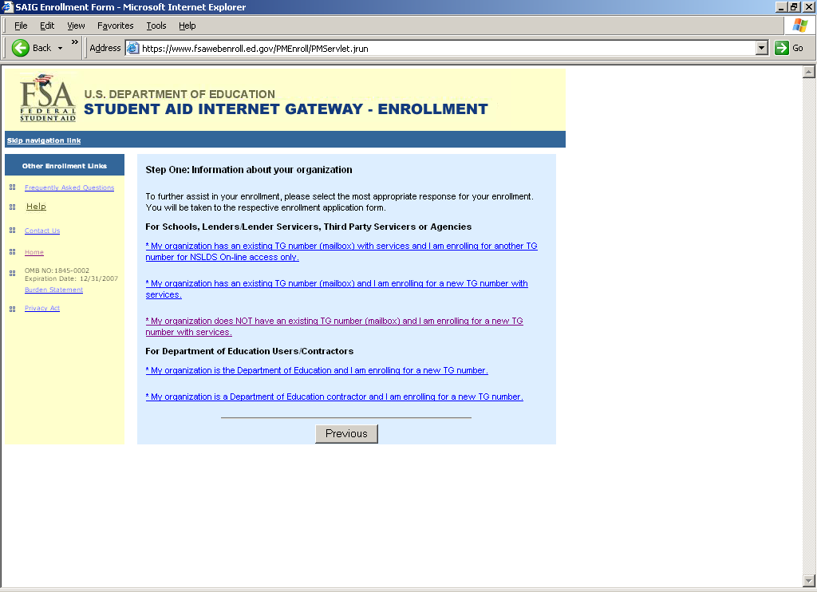

Demographic Information Screen
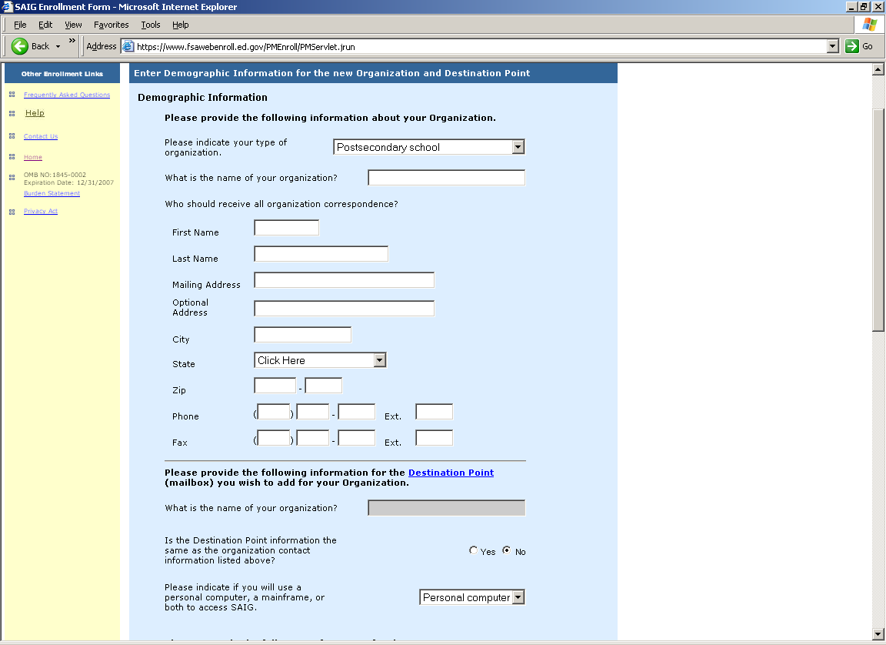

Demographic Information Screen Part 2
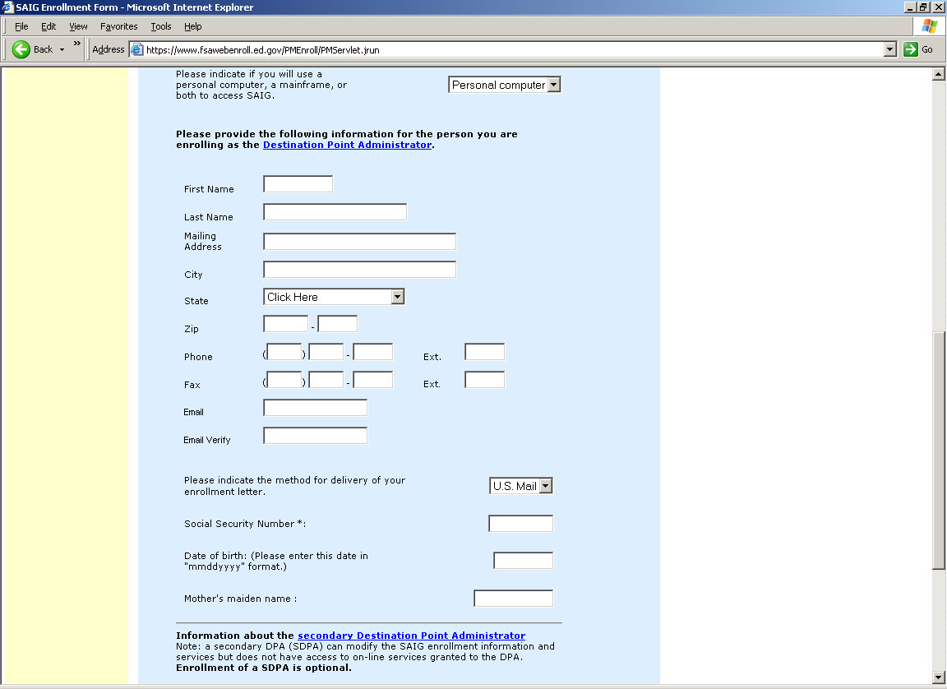

Demographic Information Screen Part 3
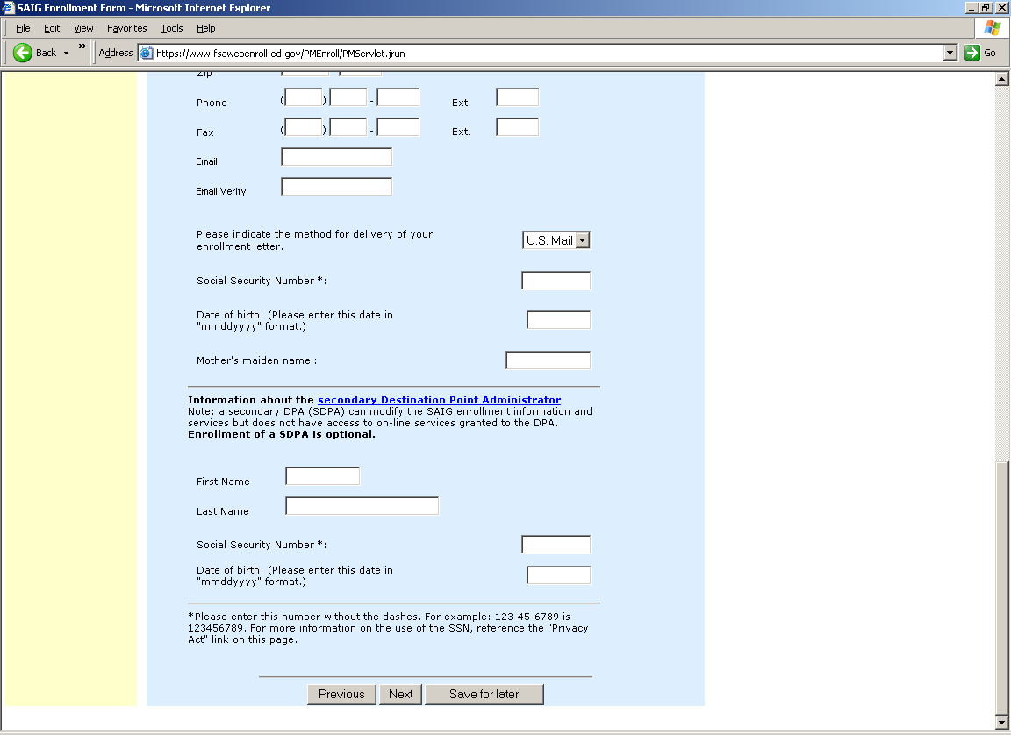

Services Screen
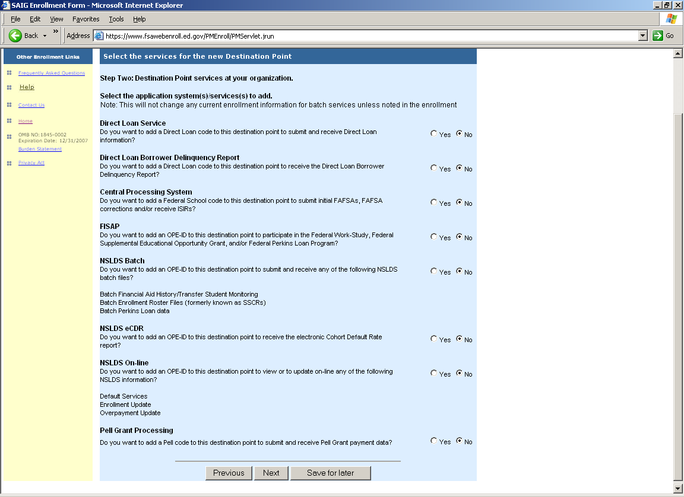

Direct Loan Services Screen
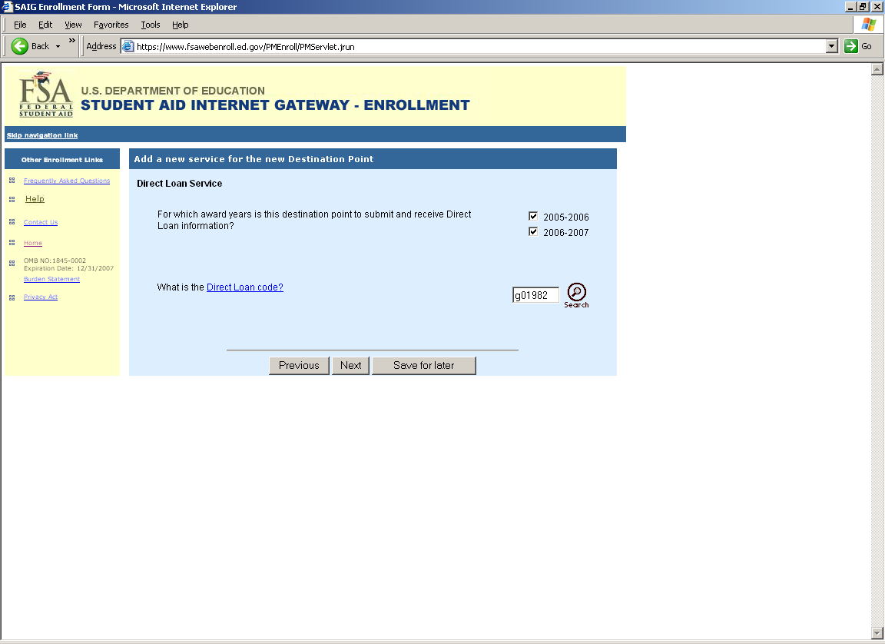
Direct Loan Borrower Delinquency Reports Screen
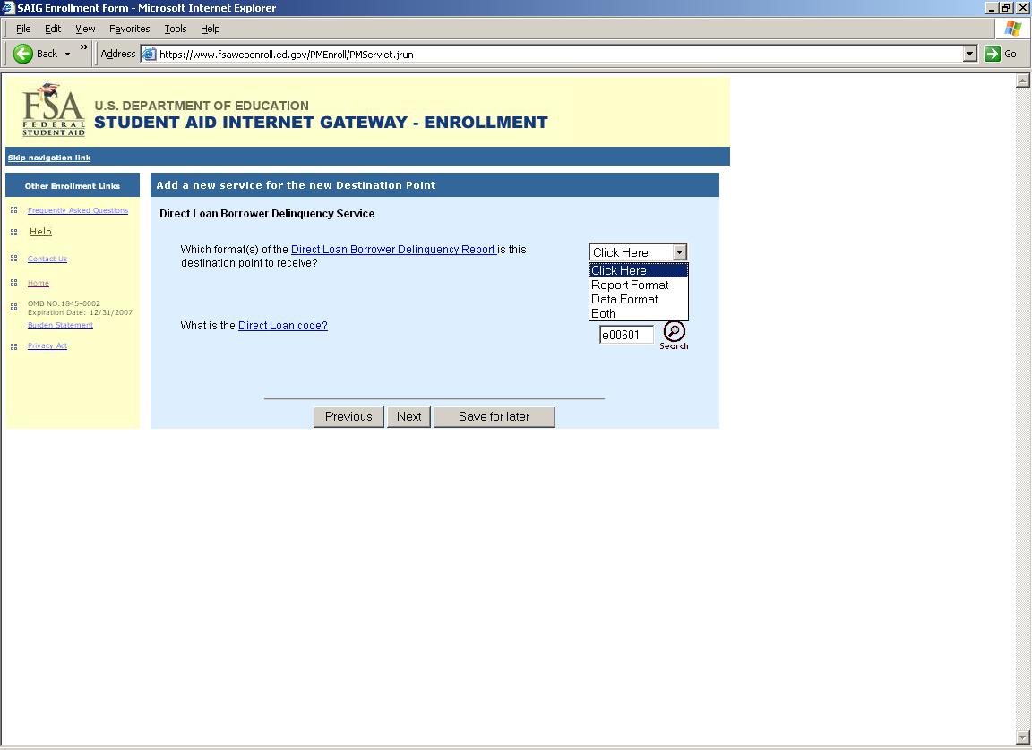

Central Processing System Screen
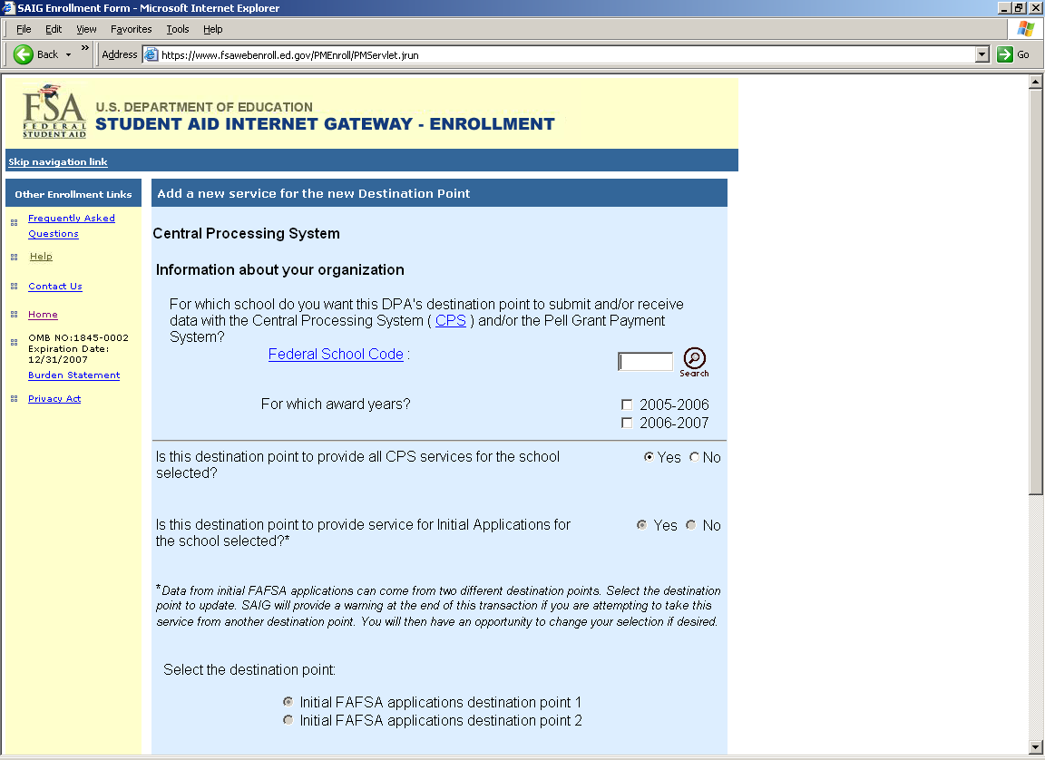
Central Processing Screen Part 2
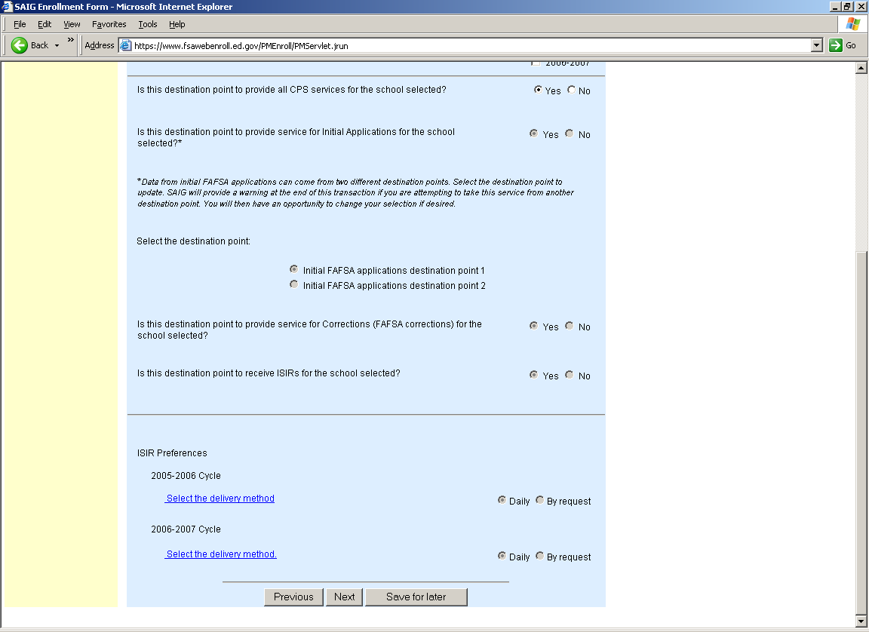

FISAP Services Screen
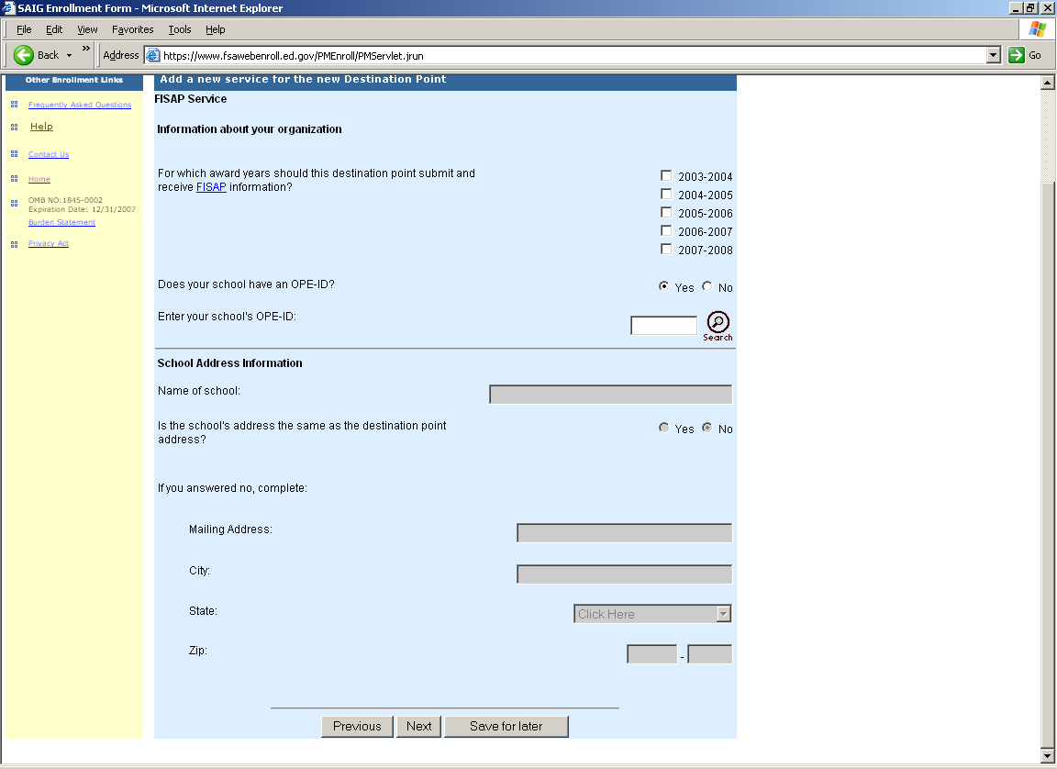
NSLDS Batch Services Screen
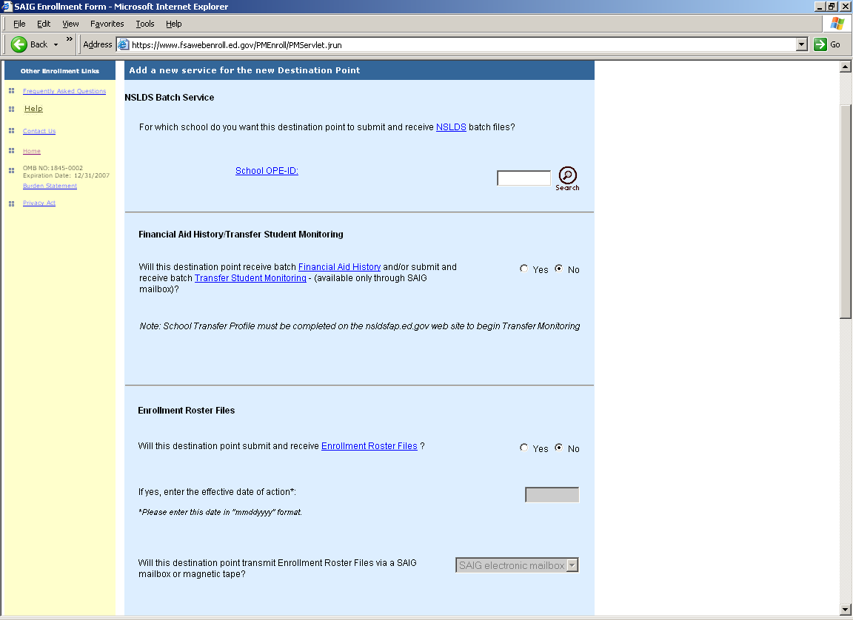

NSLDS Batch Services Screen Part 2
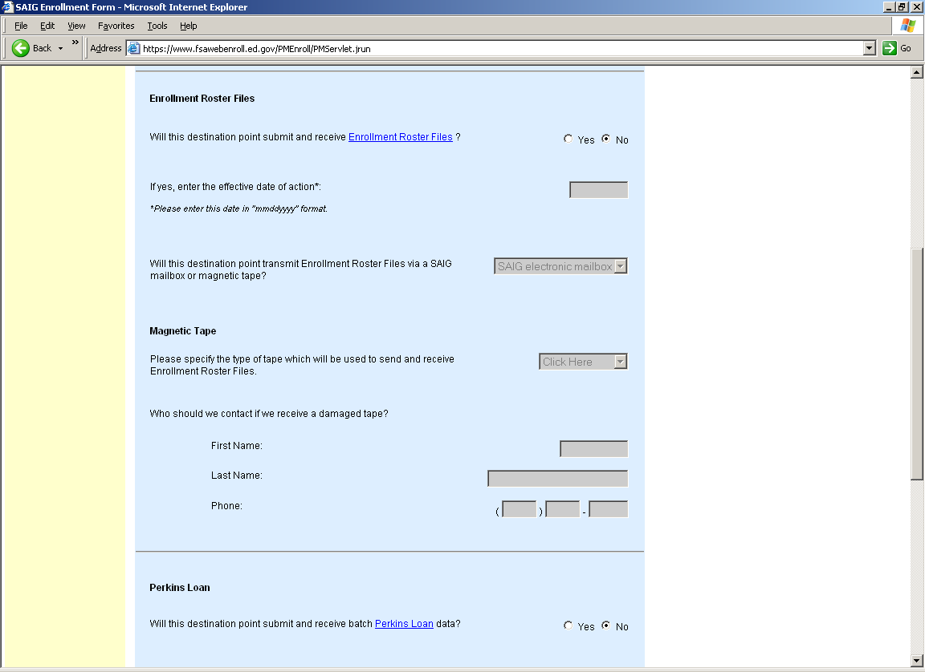
NSLDS Batch Services Screen Part 3
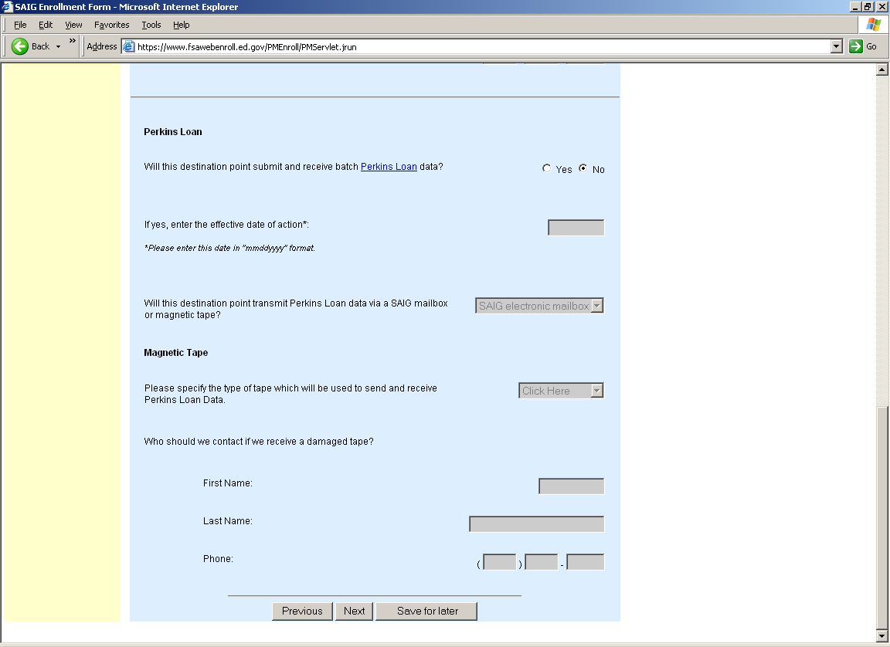
NSLDS eCDR Screen

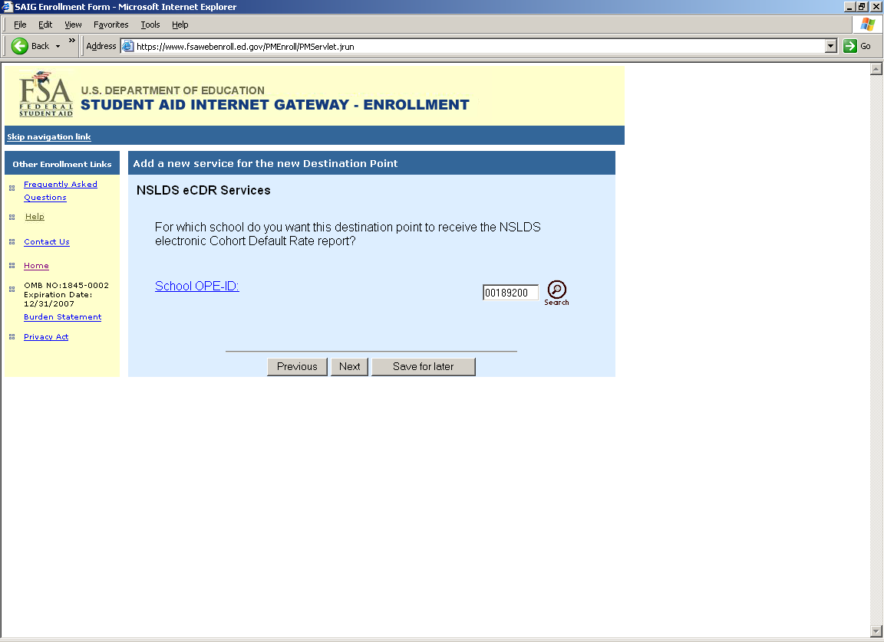
NSLDS Online Services Screen
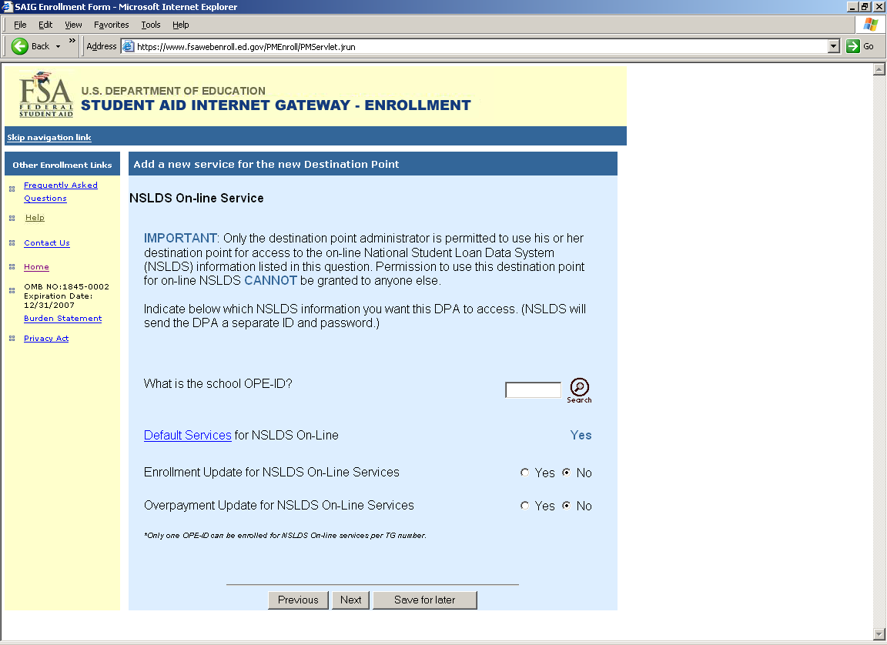
Pell Grant Processing Screen
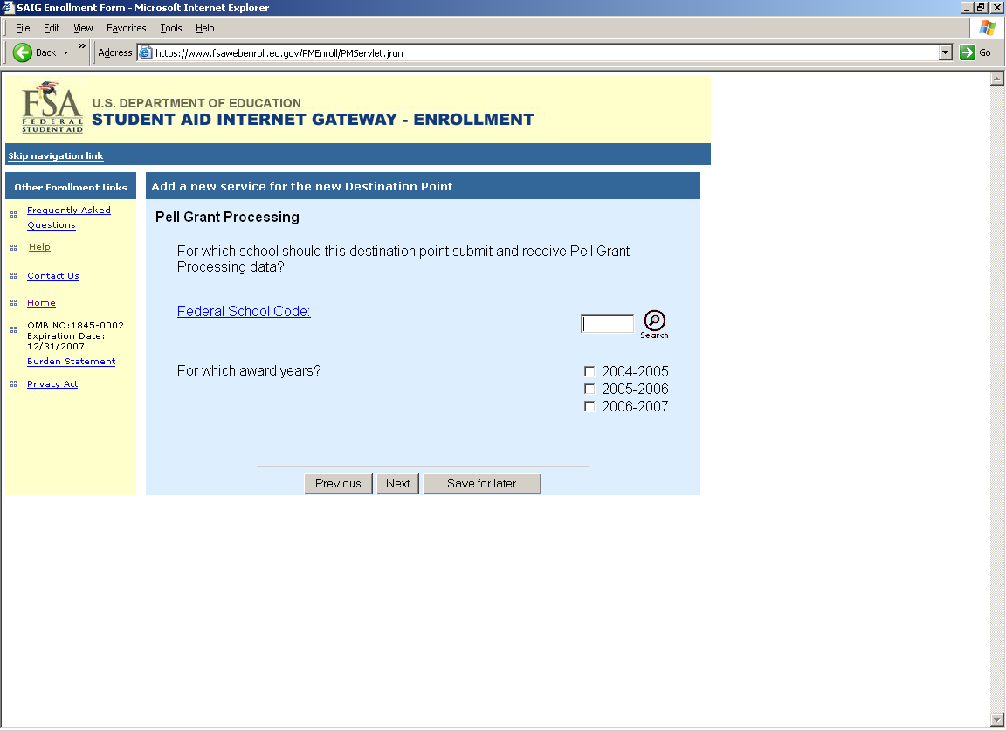
End of the Enrollment Form Screen
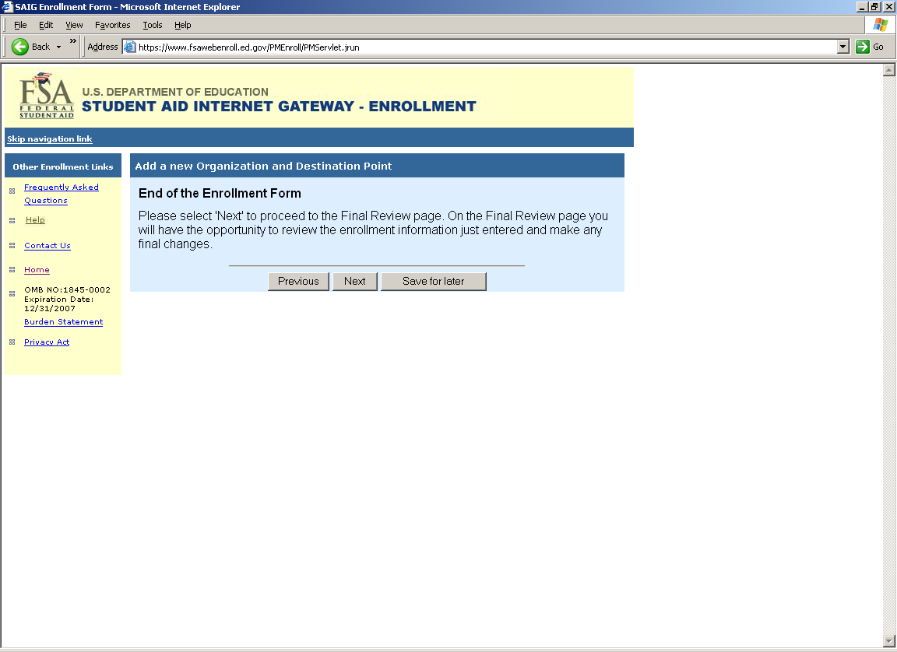
Final Review Screen
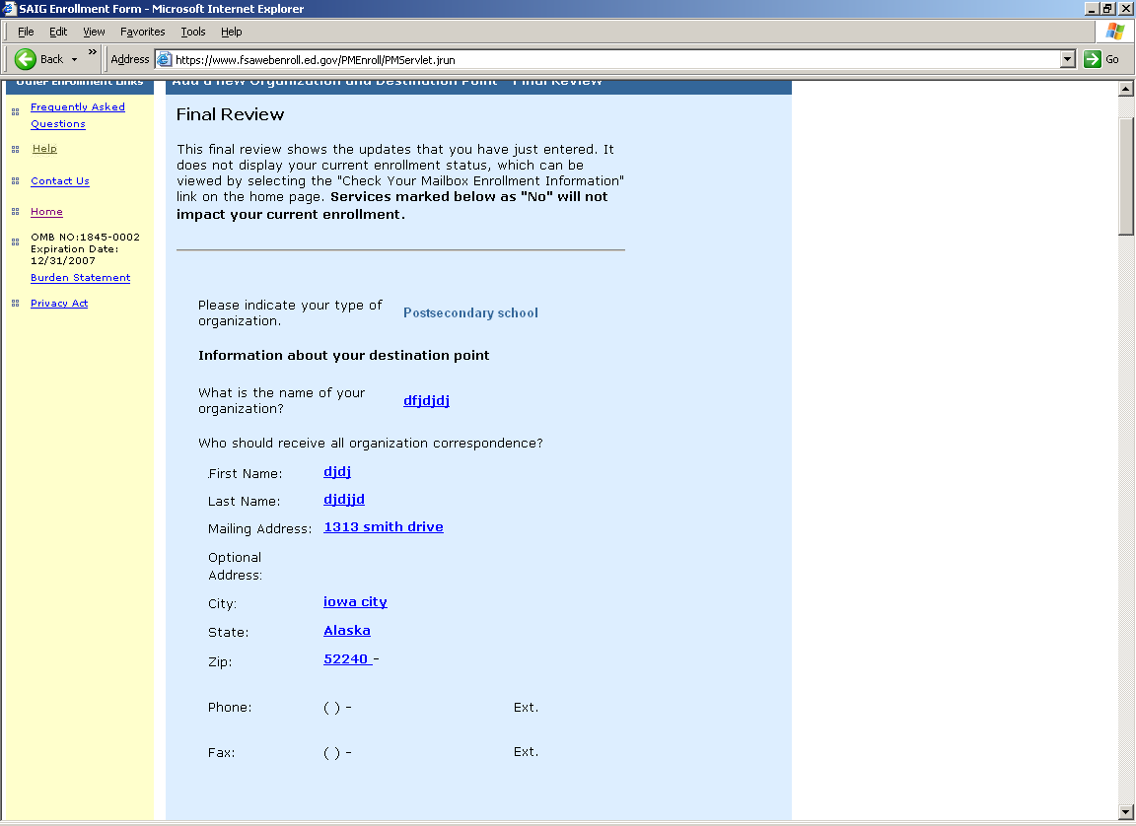
Final Review Screen Part 2

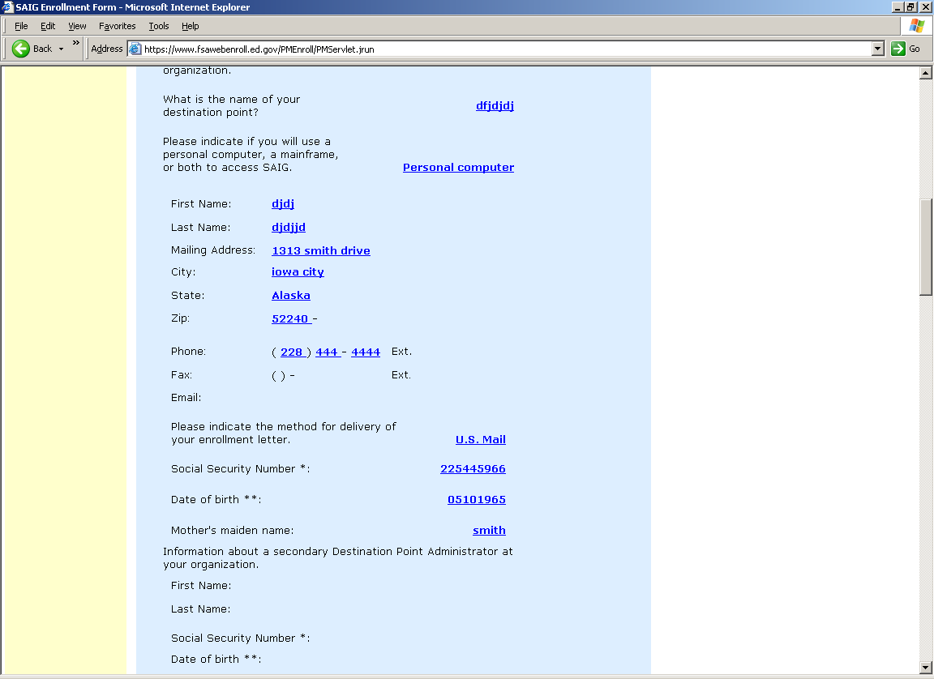
Final Review Screen Part 3
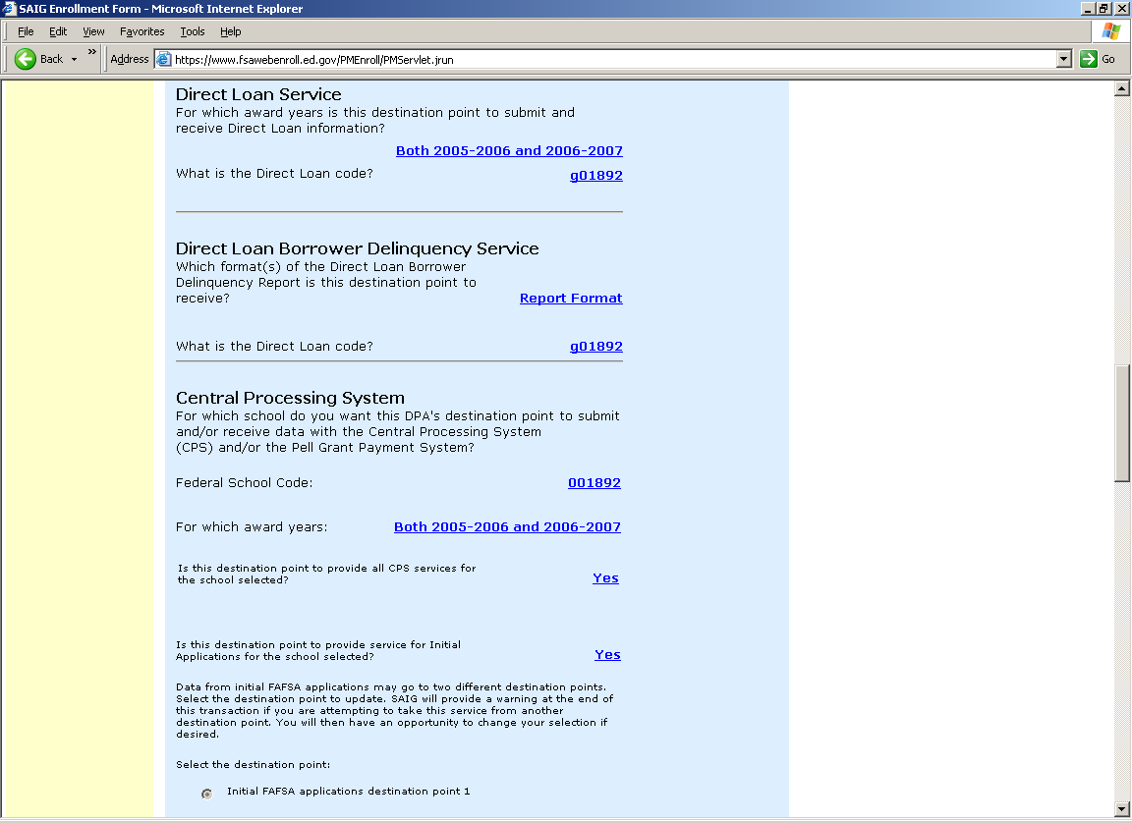
Final Review Screen Part 4
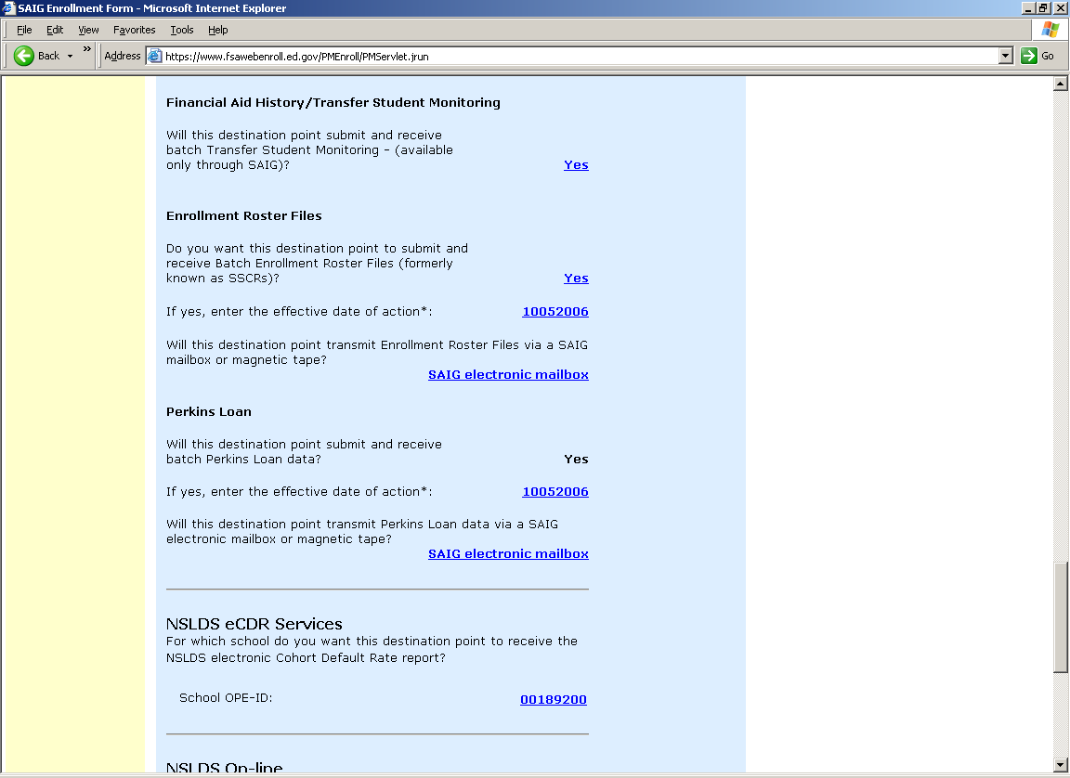

Final Review Screen Part 5
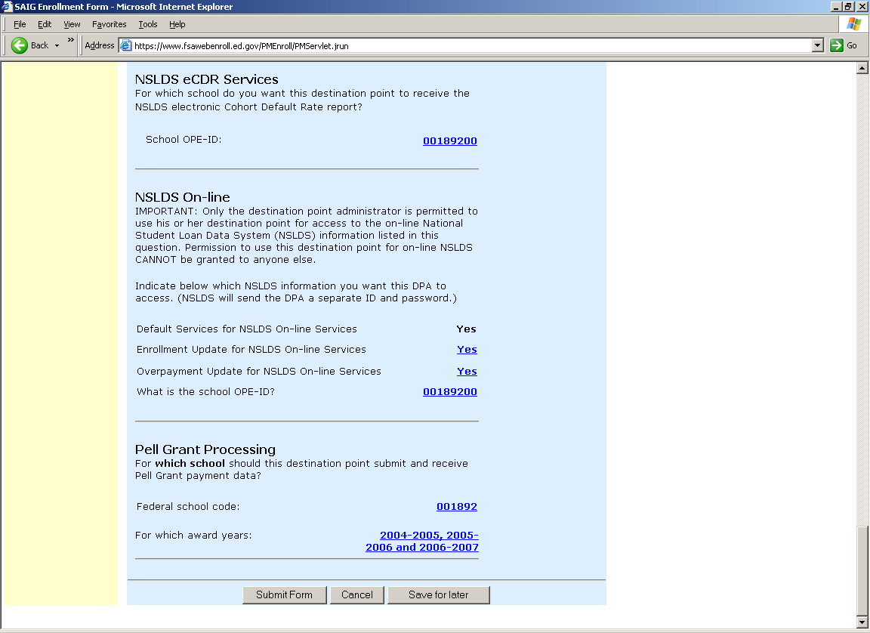
TG Number Login Page
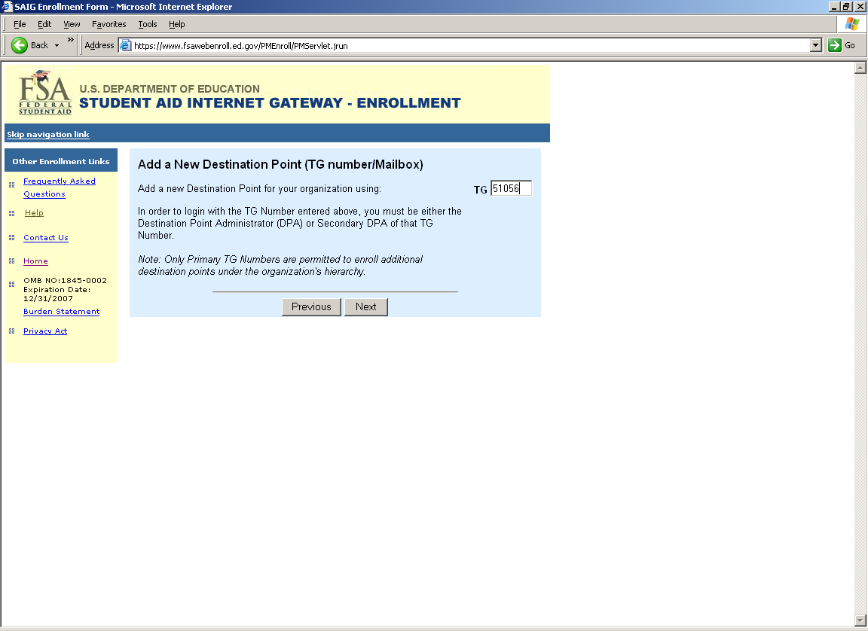
DPA Security Information Login Page

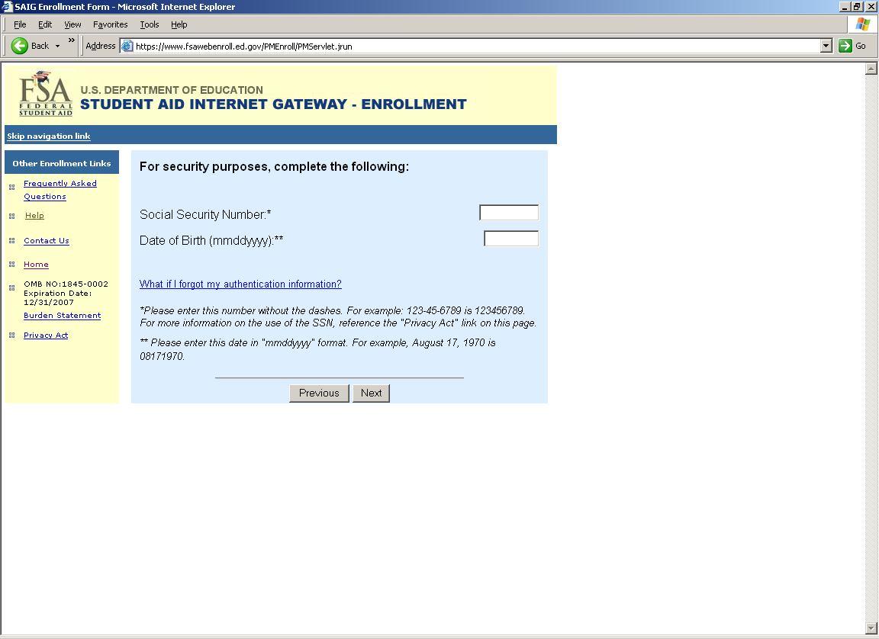

TG Number Login Page for FAA Services
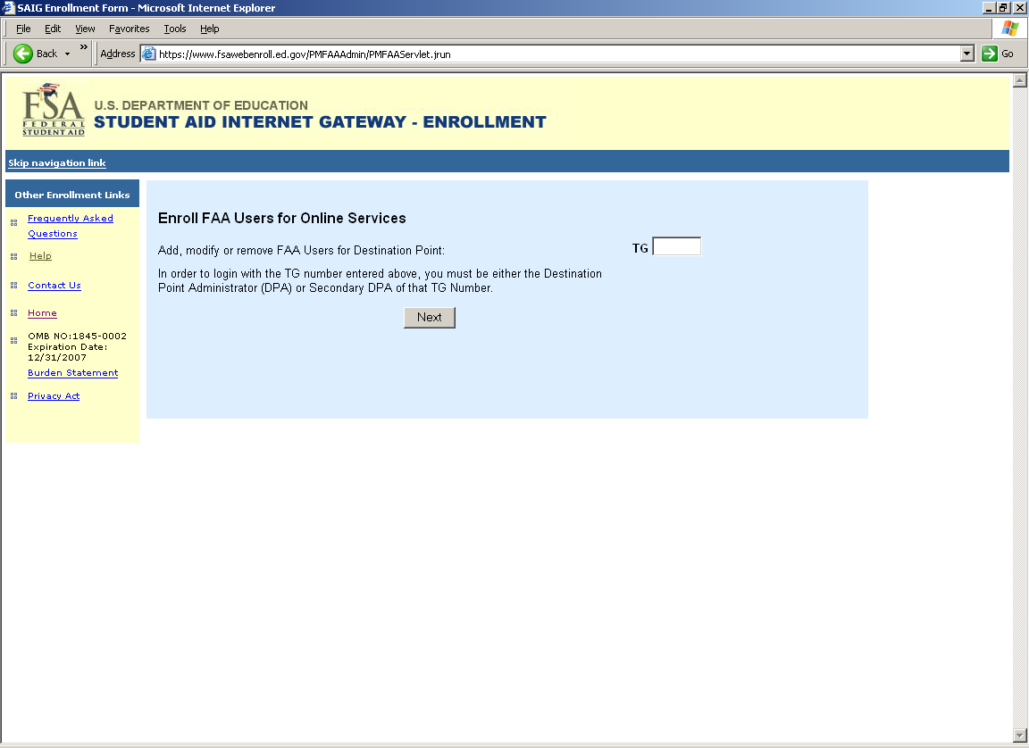
DPA Security Information Login Page for FAA Services 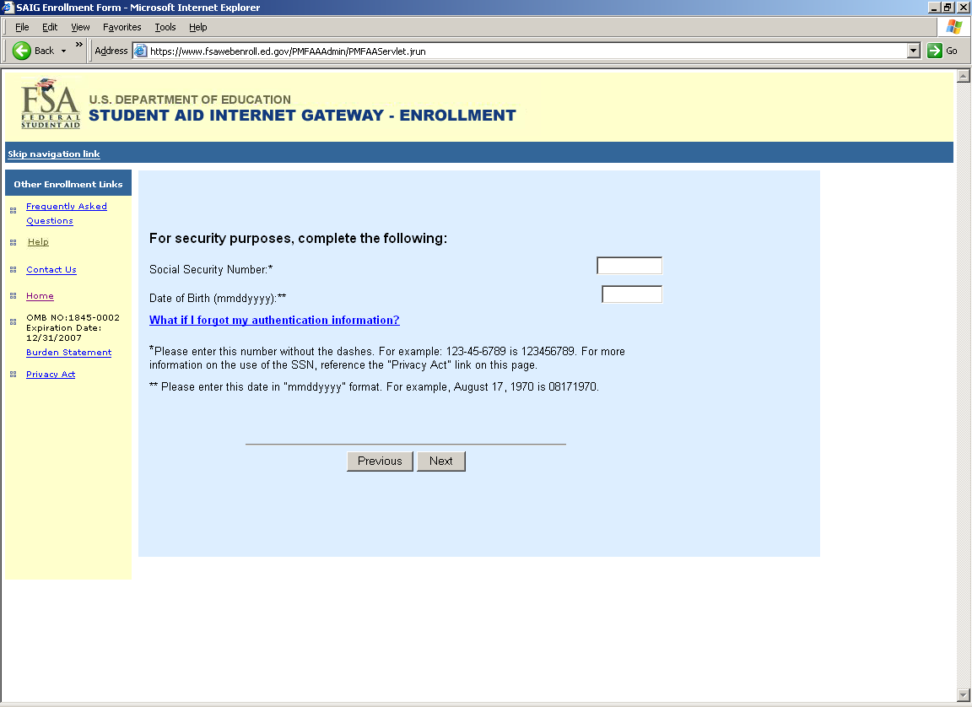
FAA Services Main Menu Screen
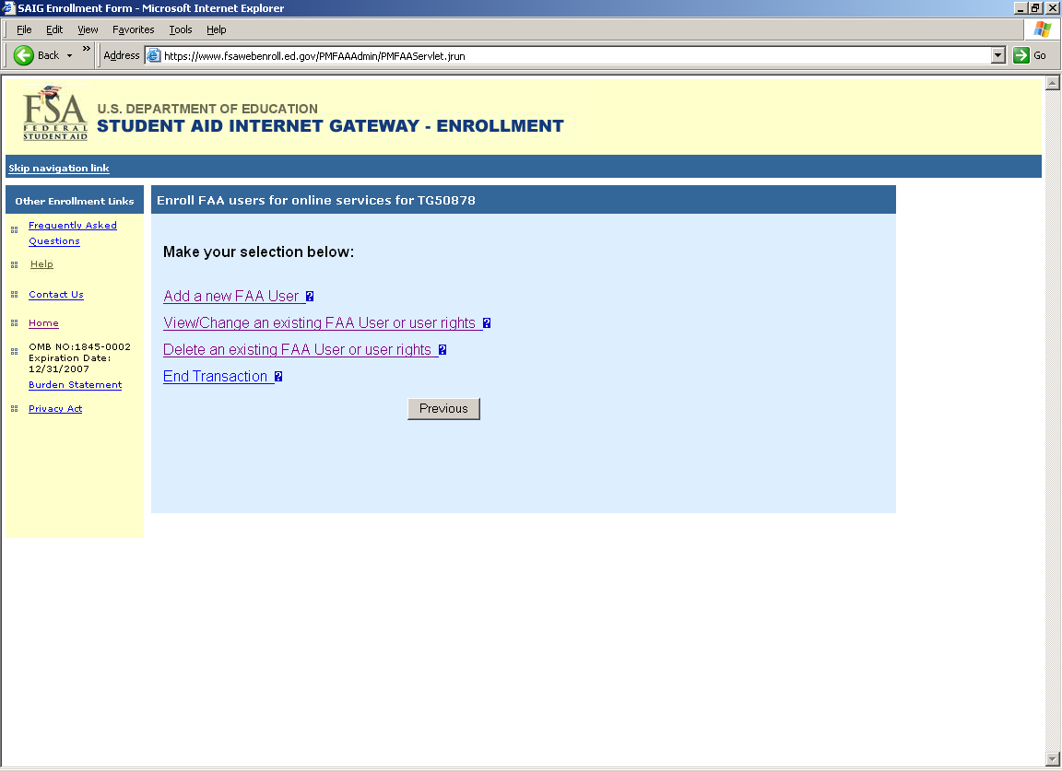
FAA User Demographic Page
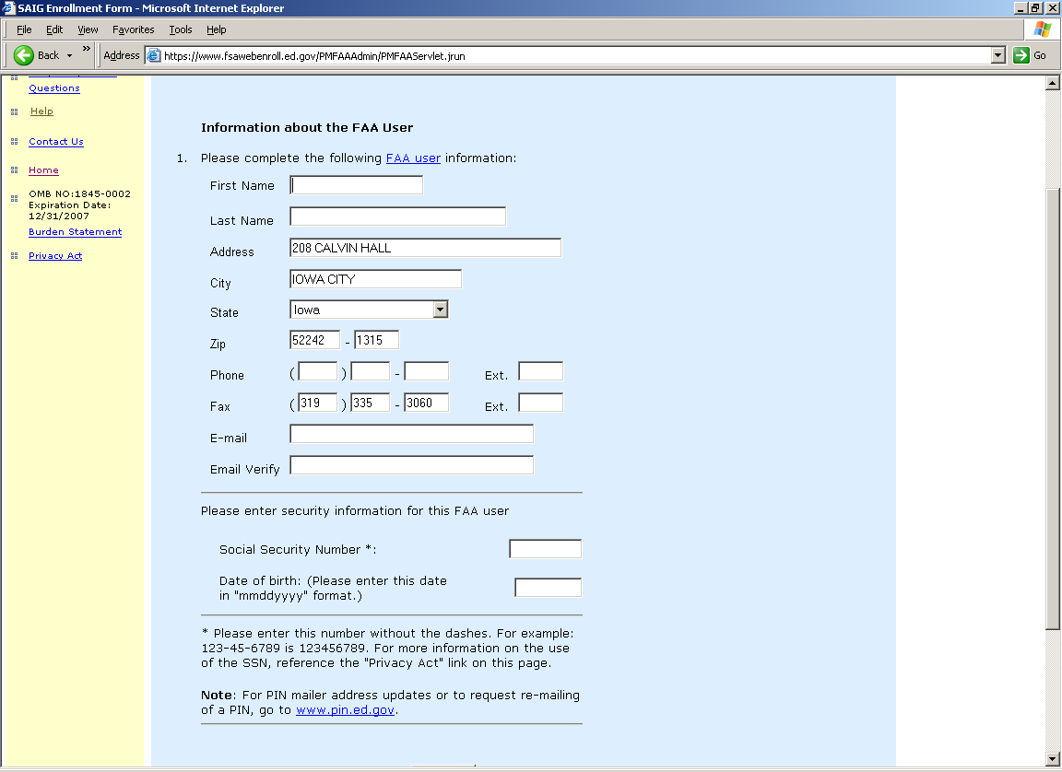
FAA User and Cycle Selection Screen
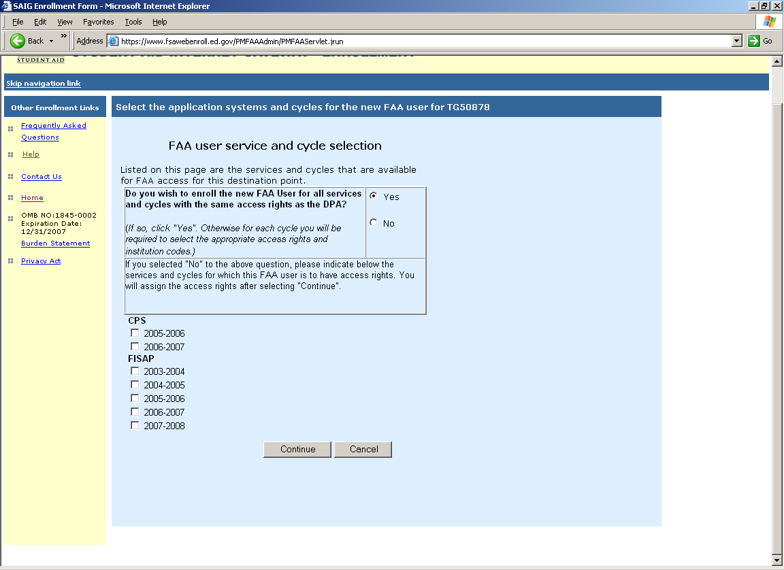
2005-2006 FAA CPS Online Services Screen
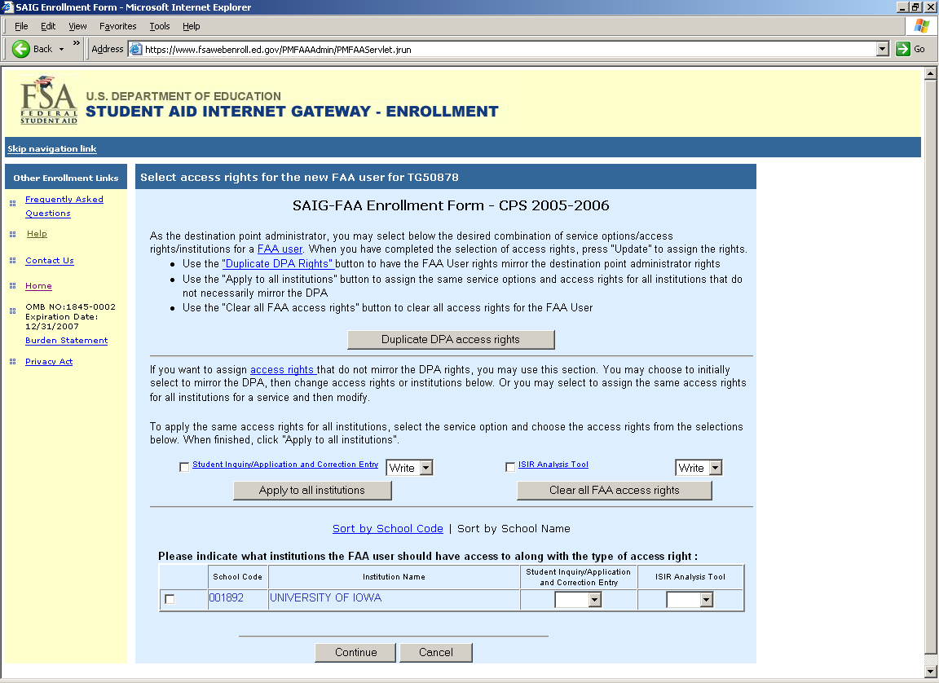
2006-2007 FAA CPS Online Services Screen
2003-2004 FAA FISAP Online Services Screen 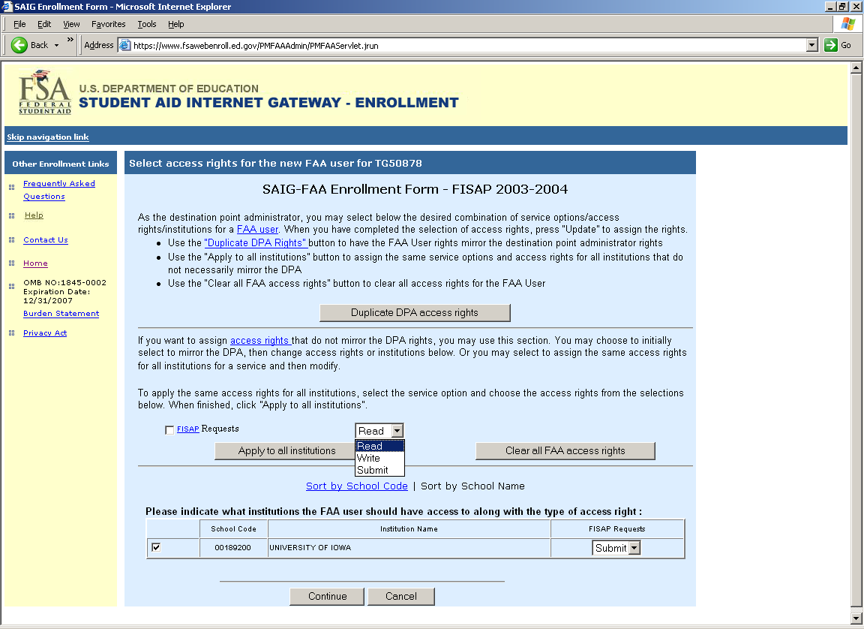
2004-2005 FAA FISAP Online Services Screen
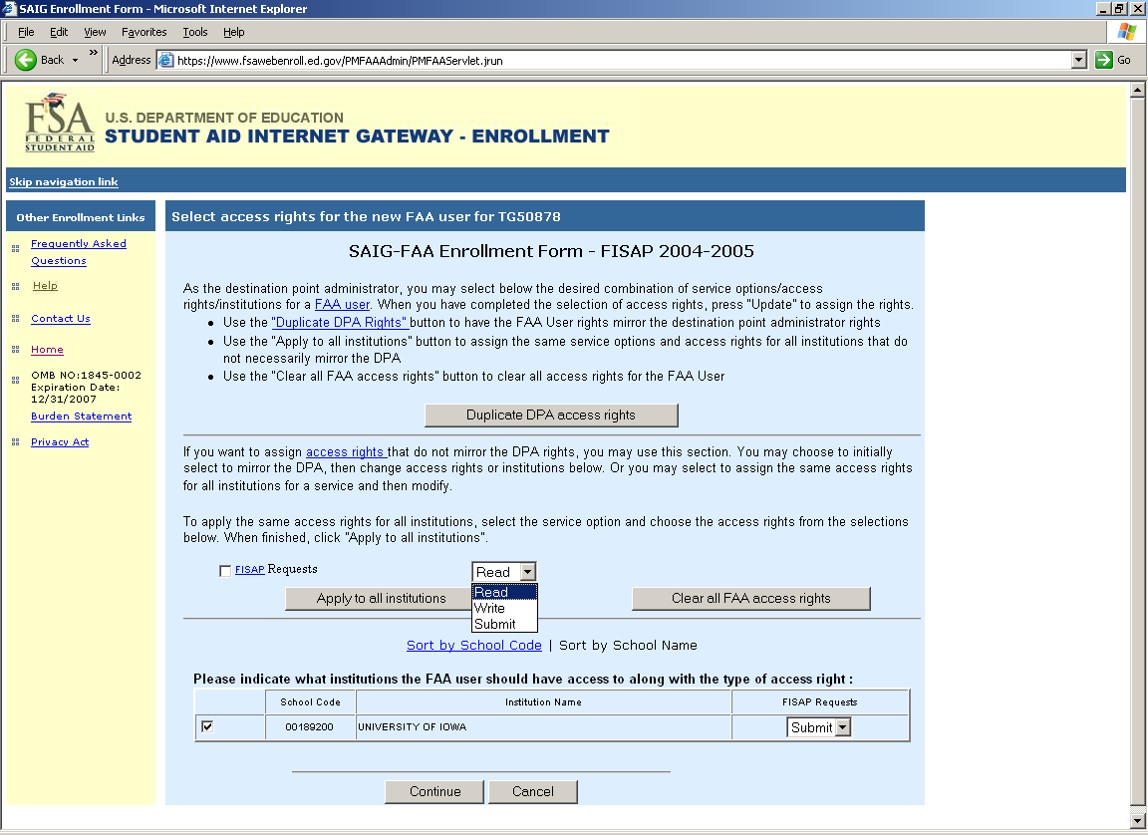
2005-2006 FAA FISAP Online Services Screen
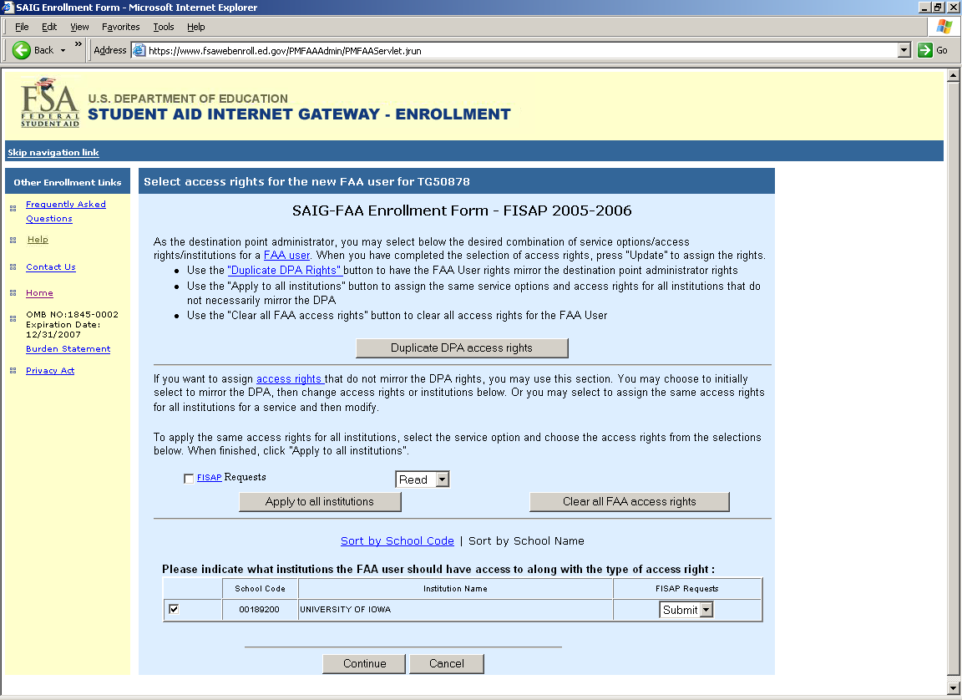
2006-2007 FAA FISAP Online Services Screen
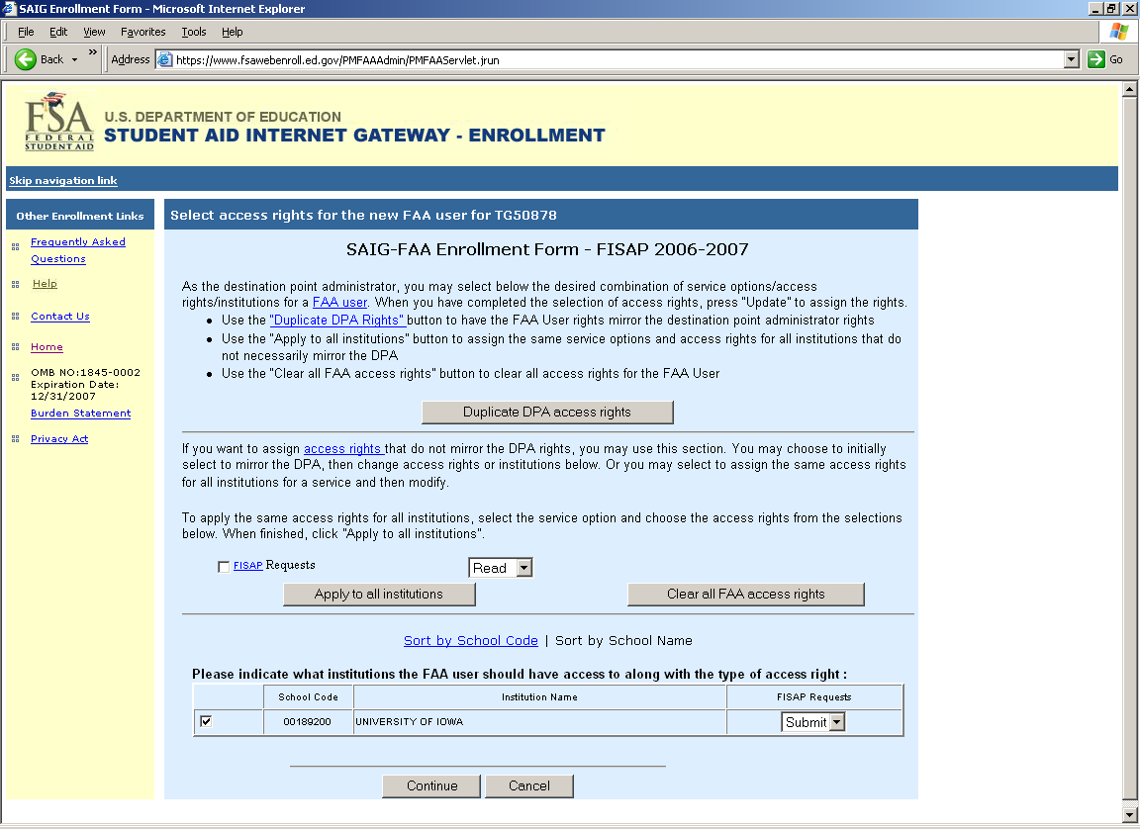
2007-2008 FAA FISAP Online Services Screen
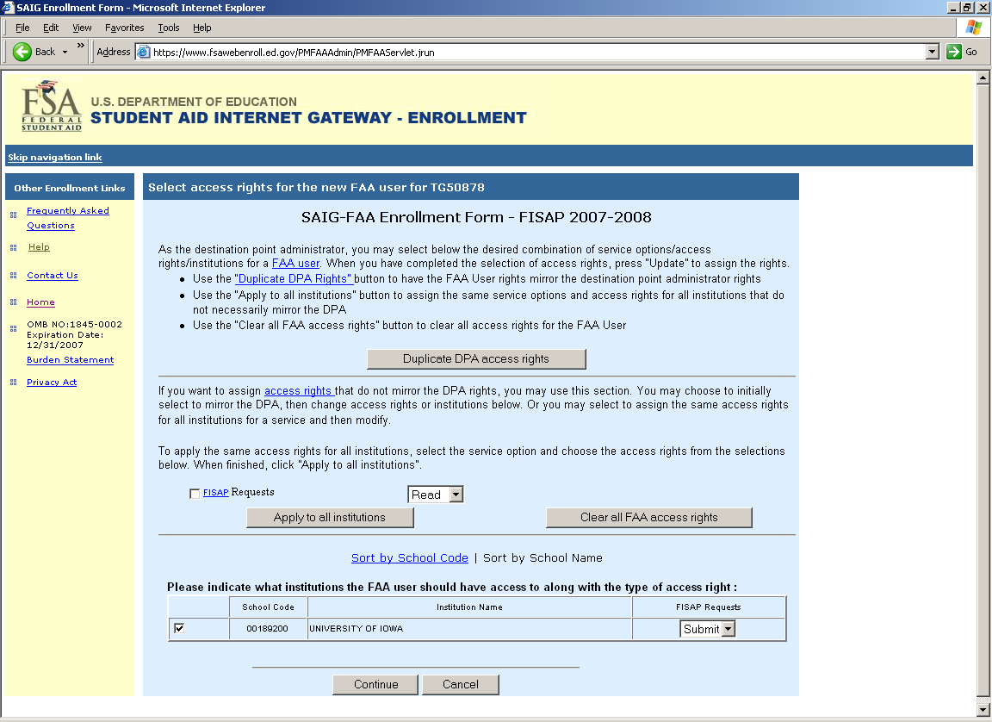
List of FAA Users Screen
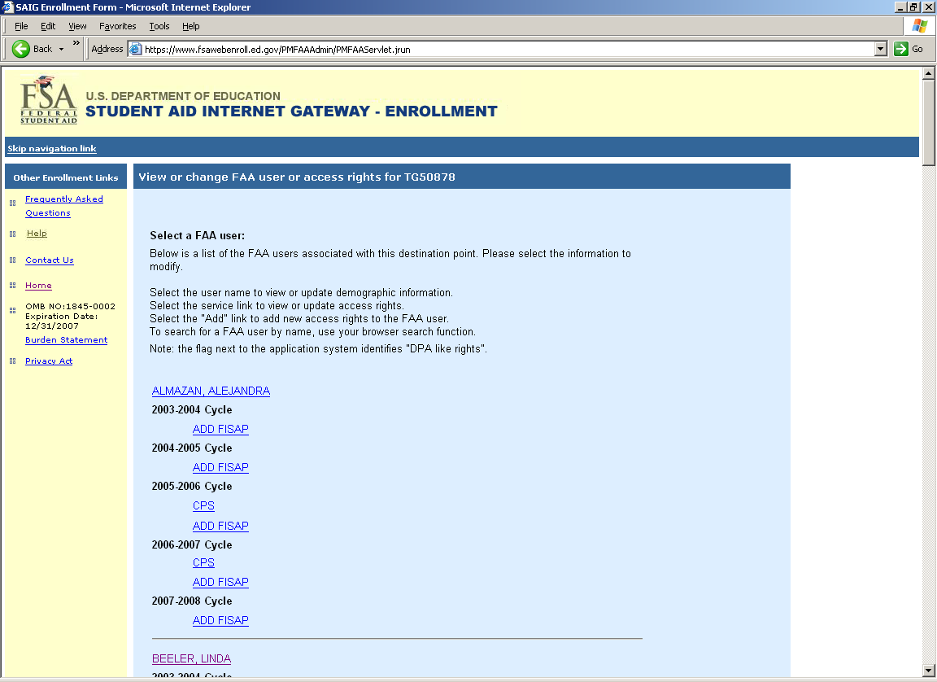
Delete a FAA User Screen

Check Your Mailbox Enrollment Screen 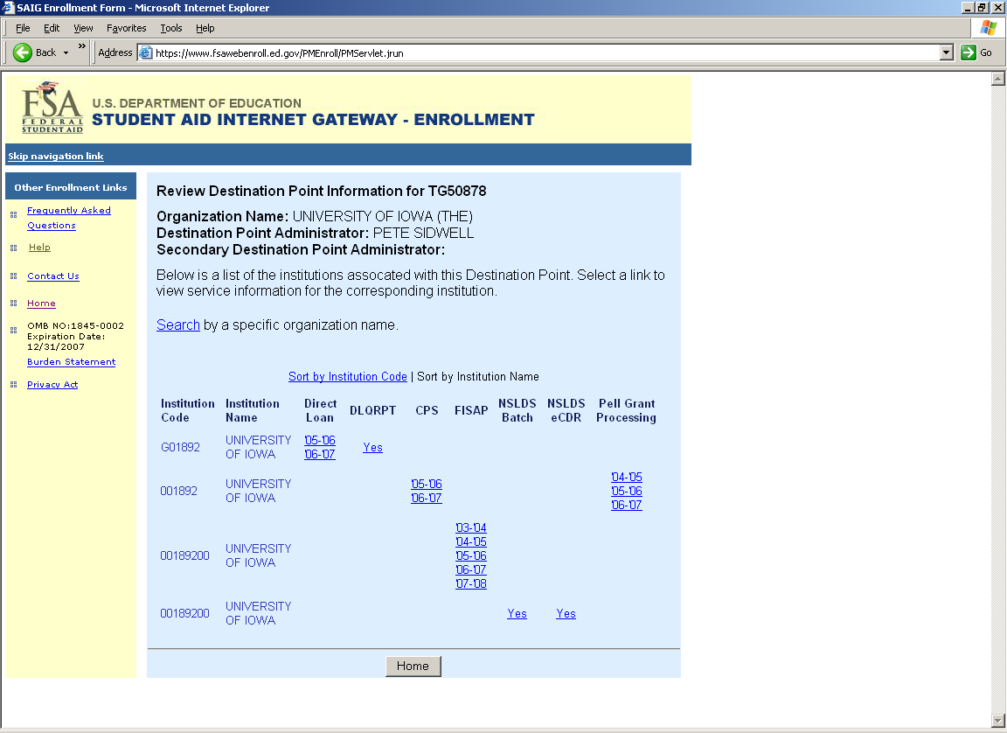
Review Your Organization’s Mailboxes Screen
