DRAFT social media venue to enable conversation with the public throughout the evolution of Data.gov; e.g., posting draft documents for the public’s review, obtaining feedback to posted questions, obtaining suggestions in general.

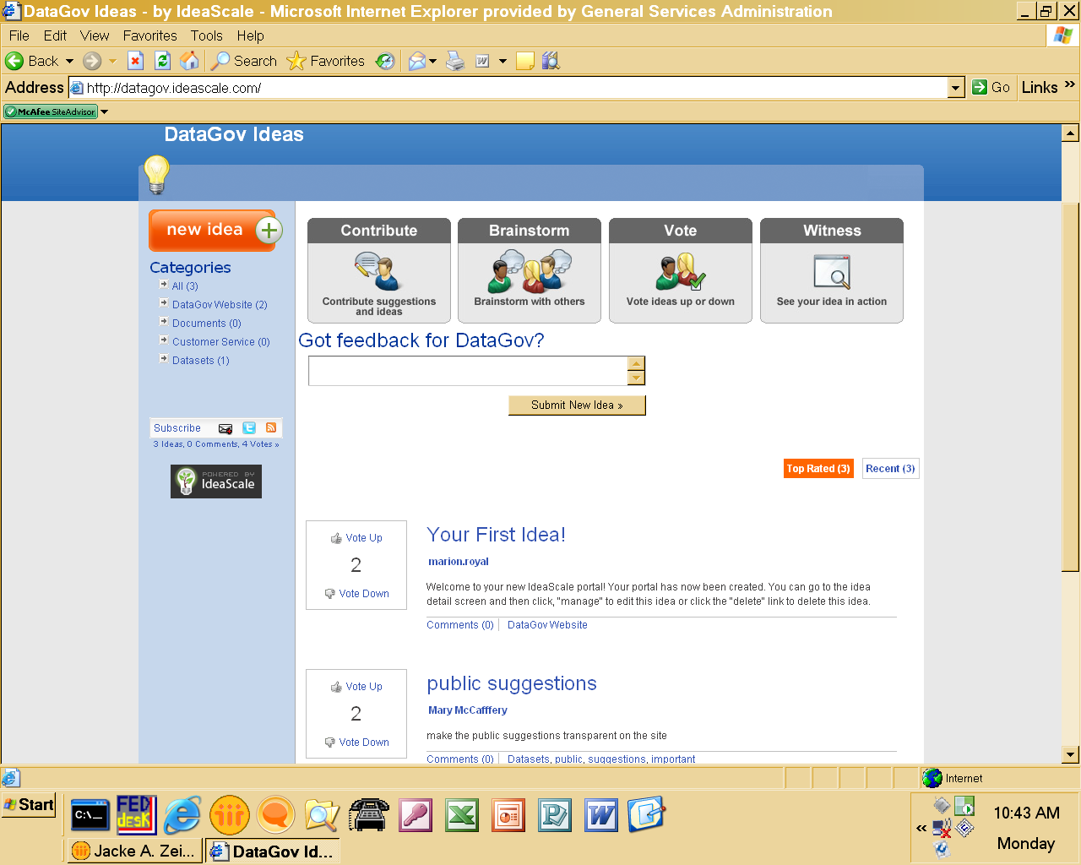

A url will be posted at the Data.gov site to guide visitors to a social media site. Initially, documents will be posted for review only; then for comment, and ranking of comments. Eventually, this site may be used to receive the public’s recommended datasets and other suggestions for Data.gov instead of the current menus at Data.gov or in addition to those menus. It is estimated that 1,000 respondents may participate each year in the social media functionality of providing a document for review and comment. It is estimated that participating may take 2 minutes; therefore, it is estimated that 2,000 minutes (34 burden hours) per year may be expended on a Data.gov social media site. For visitors to view and rank the comments of other visitors through voting up or down it is estimated that approximately 1,000 ratings (responses) may be submitted. Each rating may take approximately a minute; therefore, 1,000 minutes (16 burden hours) may be expended per year. Therefore, this IC represents 1,000 responses at 3 minutes each for a total estimated burden of 50 hours.

