System: Web-Based Supply Chain Management (WBSCM)
Form: Shipment Receipt Form
Screenshot as of: 7/13/09

Screenshot #1: Shipment Receipt Form
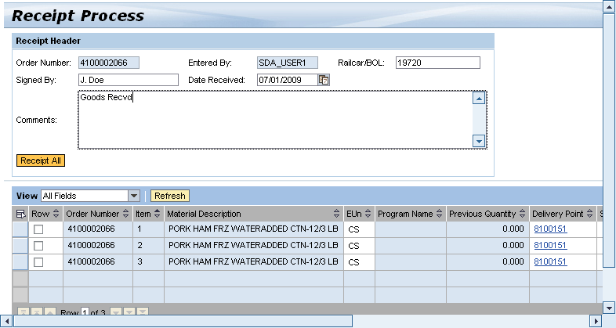

Screenshot #2: Shipment Receipt Form (Damage Quantity Details button)
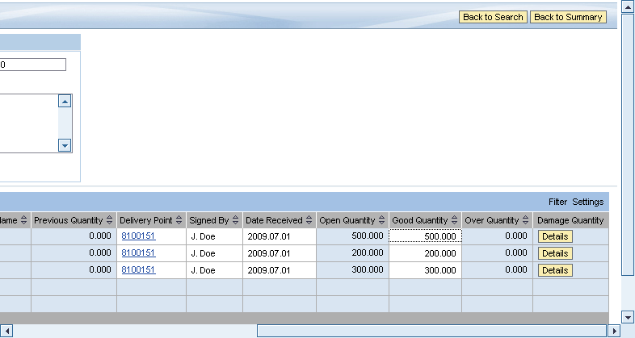

Screenshot #3: Shipment Receipt Form - Damage Quantity Details
