DEMOGRAPHICS

- Did you use your assigned kneepad for the entire time since our last visit (please circle; if “yes”, skip to question 3)?

  - Yes
  - No (please specify how long you did wear the kneepad: ______________)

- What reasons did you have for not wearing your assigned kneepad (please circle all that apply; if the miner wore the assigned kneepad for less than 1 week, skip to question 37)?

  - Not applicable
  - Straps were uncomfortable
  - Would not stay in place
  - Was a tripping hazard
  - Caused discomfort at the leg
  - Caused discomfort at the knee
  - Caused discomfort at the thigh
  - Other (please specify) ________________________________________

- What is your current job type (please enter)? _____________________________

- How many years of experience do you have in your current job (please enter)?________________

- How many days of leave have you had since our last visit (please enter)?_______________

- How many hours a week do you work most weeks (please enter)?_____________

- How many hours a week have you typically worked since our last visit (please enter)?__________________

BODY PART DISCOMFORT

- Point to the part of your body where you most often felt discomfort while performing your job over the past week (place an “x” over each region of the body identified by the miner)?

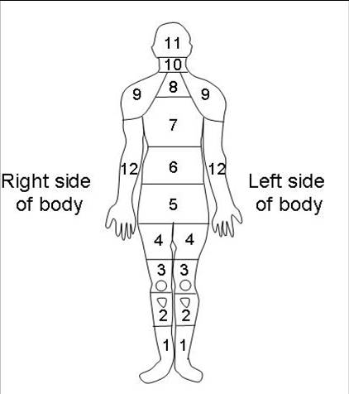

- While wearing your current kneepad, how often have you felt any numbness, tingling, or lost feeling to your leg (please circle)?

  - Never
  - Occasionally
  - Frequently
  - Always

- Have you experienced a knee injury or any knee pain at any time while wearing your current kneepad (please circle; describe if the answer is “Yes”)?

  - Yes (please describe: __________________________________________
_______________________________________________________________________________________________________________________)
  - No

- Were there any postures that were uncomfortable or difficult because of the kneepad (show diagram to miner and let them identify posture(s); please circle all that apply)?

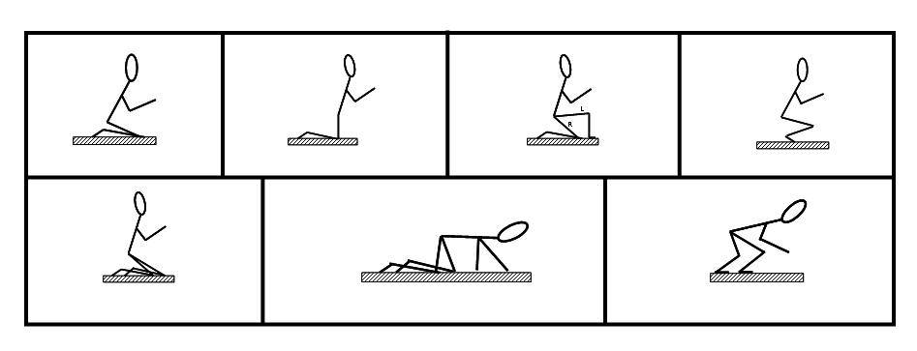
- Were there any mine conditions that made working uncomfortable or difficult due to the kneepad (please circle all that apply)?

  - None
  - Uneven ground
  - Wetness
  - Mud
  - Rocky
  - Other (please specify) ___________________________

- How comfortable are the straps (please circle)?

  - Very uncomfortable
  - Somewhat uncomfortable
  - Somewhat comfortable
  - Very comfortable

- Does coal ever get trapped in the kneepad (please circle)?

  - Yes
  - No (skip to question 17)

- How often does coal get trapped in the kneepad during your shift (please circle)?

  - Not applicable
  - 1-3 times
  - 4-6 times
  - 7-9 times
  - Other (please specify) ___________________________

- Where in the kneepad does coal get trapped (please circle all that apply)?

  - Not applicable
  - Between the inner padding and outer shell
  - Between the knee and inner padding
  - Under the straps
  - Other (please specify) ___________________________
USABILITY

- How difficult were the straps to put on (please circle)?

  - Difficult
  - Somewhat difficult
  - Somewhat easy
  - Easy

- How difficult were the straps to take off (please circle)?

  - Difficult
  - Somewhat difficult
  - Somewhat easy
  - Easy

- How difficult were the straps to adjust (please circle)?

  - Difficult
  - Somewhat difficult
  - Somewhat easy
  - Easy

- How many times per shift did you make adjustments to the straps (please circle)?

        - 0-1 times
        - 2-3 times
        - 4-5 times
        - ≥ 6 times

- When working in wet conditions, how water logged does your kneepad get by the end of your shift (please circle)?

  - Not water logged at all
  - Somewhat water logged
  - Extremely water logged

- At the end of your shift, how sweaty are your pants where your kneepad rests? (please circle)?

  - Not sweaty
  - Somewhat sweaty
  - Extremely sweaty
  - Conditions too wet to determine

- What kind of accidents, if any, has your current kneepad contributed to in the past (please circle all that apply)?

  - None
  - Accidently hit control lever
  - Tripped and fell while moving about the mine
  - Caught the kneepad on another object causing a trip or fall
  - Caught the kneepad on another object causing an uncomfortable twisting motion at the knee
  - Other (please specify) _________________________________________

EASE OF MOVEMENT

- Does your current kneepad affect any of your movements?

  - Yes
  - No

- What type of movements are affected by your current kneepad (please circle all that apply)?

  - Not applicable
  - Duck/stoop walking
  - Crawling
  - Switching between body positions
  - Other (please specify) ________________________

- During your last shift, how well did your kneepad stay in place while moving about the mine (please circle)?

  - Not well at all
  - Somewhat well
  - Very well

DURABILITY

- What features of the kneepad failed since your last interview (please circle all that apply)?

  - None
  - Straps
  - Connection of straps to kneepad
  - Inner padding
  - Outer shell
  - Connection of inner padding to kneepad
  - Hinge (if applicable)
  - Other (please specify) ________________________

- How durable were the following features of the kneepad (place an “x” under the appropriate category for each feature)?

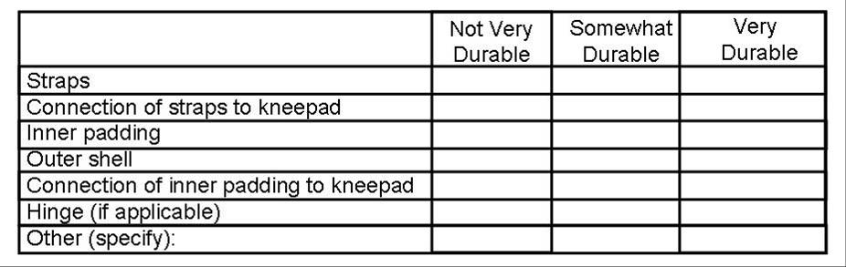

- Do you rotate between multiple pairs of your current kneepad type (please circle)?

  - Yes
  - No

- How often do you rotate between multiple pairs of your current kneepads (please circle)?

  - Not applicable
  - Every day
  - Every week
  - Every month
  - Other (please specify) _______________
CLEANING

- How often do you clean your kneepads (please circle)?

  - Never
  - Every day
  - Every week
  - Every month
  - Other (please specify) ________________

- How do you clean your kneepads (please circle all that apply)?

  - Not applicable
  - Hose off with water
  - Spray with disinfectant
  - Spray with Bleach/Clorox and water solution (specify water to Bleach/Clorox ratio) ________________________
  - Briefly dip in Bleach/Clorox and water solution (specify water to Bleach/Clorox ratio) ________________________
  - Submerge for an extended period of time in Bleach/Clorox and water solution (specify water to Bleach/Clorox ratio) _____________________
  - Other (please specify) _________________________________________

CHANGES TO KNEEPAD

- What features of your current kneepad do you like (please circle all that apply)?

  - None
  - Straps
  - Connection of straps to kneepad
  - Inner padding
  - Outer shell
  - Connection of inner padding to kneepad
  - Hinge (if applicable)
  - Other (please specify) ________________________

- What features of your current kneepad do you dislike (please circle all that apply)?

  - None
  - Straps
  - Connection of straps to kneepad
  - Inner padding
  - Outer shell
  - Connection of inner padding to kneepad
  - Hinge (if applicable)
  - Other (please specify) ________________________

- Did you modify any features of your current kneepad (please circle all that apply)?

  - None
  - Straps
  - Connection of straps to kneepad
  - Inner padding
  - Outer shell
  - Connection of inner padding to kneepad
  - Hinge (if applicable)
  - Other (please specify) ________________________

- If you modified your current kneepad, briefly explain any changes you made. (please write any information provided by the miner)._______________________
____________________________________________________________________________________________________________________________________________________________________________________________________________________________________________________________________________________________________________________________________________________________________________________________________________
BODY WEIGHT SUPPORT WORN AT THE ANKLE

- How often did you wear the body weight support (please circle)?

  - Never
  - Occasionally
  - Often
  - Always

- Why did you not wear the body weight support (please circle all that apply and continue with the form as long as the body weight support was worn at least occasionally; if the mine worker never wore the body weight support, this form is now complete as all other questions may be skipped)?

  - Not applicable
  - Straps were uncomfortable
  - Would not stay in place
  - Was a tripping hazard
  - Caused discomfort at the leg
  - Caused discomfort at the ankle/foot
  - Other (please specify) ________________________________________

- Why did you wear the body weight support (please circle all that apply)?

  - Felt relief at the knee
  - Felt relief at the back
  - Enabled you to put more weight on your ankles/feet
  - Other (please specify) _________________________________________

- Was the body weight support comfortable to wear (please circle)?

  - Not comfortable
  - Somewhat comfortable
  - Very comfortable

- Was the body weight support useful (please circle)?

  - Not at all useful
  - Somewhat useful
  - Very useful

- Did the body weight support increase your comfort compared to not using it (please circle)?

  - Not at all
  - Somewhat
  - A lot

- Did you experience any discomfort due to the body weight support?

  - Yes
  - No

- Where did you experience discomfort due to using the body weight support (please circle all that apply)?

  - Not applicable
  - Ankle
  - Knee
  - Toes
  - Buttocks

- Was the body weight support water logged at the end of each shift (please circle)?

  - Not at all
  - Somewhat
  - Very

- Did the body weight support move while you were working (please circle)?

  - Never
  - Occasionally
  - Frequently
  - Always

- Did the body weight support make any movements difficult (please circle all that apply)?

  - None
  - Walking in a straight line
  - Switching directions while walking
  - Crawling in a straight line
  - Switching directions while crawling
  - Moving between different body positions
  - Other (please specify) _________________________________________

- What features of the body weight support did you like (please circle all that apply)?

  - None
  - Straps
  - Connection of straps to body weight support
  - Padding
  - Shape
  - Other (please specify) _________________________________________

- What features of the body weight support did you dislike (please circle all that apply)?

  - None
  - Straps
  - Connection of straps to body weight support
  - Padding
  - Shape
  - Other (please specify) _________________________________________

- What features of the body weight support did you change or modify in any way (please circle all that apply)?

  - None
  - Straps
  - Connection of straps to body weight support
  - Padding
  - Shape
  - Other (please specify) _________________________________________

- If you modified the body weight support, briefly explain any changes you made. (please write any information provided by the miner)?______________________
____________________________________________________________________________________________________________________________________________________________________________________________________________________________________________________________________________________________________________________________________________________________________________________________________________

- What changes would you make to the kneepad to make it better suited for you, if any (please write any information provided by the miner)?___________________
______________________________________________________________________________________________________________________________________________________________________________________________________
ADDITIONAL NOTES
______________________________________________________________________________________________________________________________________________________________________________________________________________________________________________________________________________________________________________________________________________________________________________________________________________________________
_______________________________________________________________________________________________________________________________________________________________________________________________________________
_______________________________________________________________________________________________________________________________________________________________________________________________________________
_______________________________________________________________________________________________________________________________________________________________________________________________________________
_______________________________________________________________________________________________________________________________________________________________________________________________________________
_______________________________________________________________________________________________________________________________________________________________________________________________________________
_______________________________________________________________________________________________________________________________________________________________________________________________________________
_______________________________________________________________________________________________________________________________________________________________________________________________________________
_______________________________________________________________________________________________________________________________________________________________________________________________________________
_______________________________________________________________________________________________________________________________________________________________________________________________________________
_______________________________________________________________________________________________________________________________________________________________________________________________________________
_______________________________________________________________________________________________________________________________________________________________________________________________________________
_______________________________________________________________________________________________________________________________________________________________________________________________________________

