Attachment 2

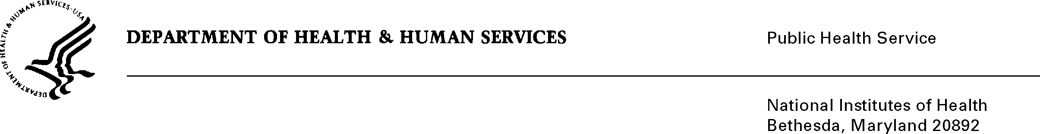

DATE: June 23, 2009

TO: Amy Pianalto
Division for the Application of Research Discoveries, NHLBI

FROM: NIH Privacy Act Officer

SUBJECT: Applicability of the Privacy Act: NHLBI “Parental Knowledge, Attitudes, and Behaviors Related to Pediatric Cardiovascular Health”

I have reviewed the NHLBI submission to OMB requesting approval for the use of the NHLBI Children’s Heart Health Promotion Tracker” survey, and determined that the Privacy Act will apply to this data collection which involves the collection of the personal characteristics such as race, ethnicity, household income, age, etc.

Although NHLBI does not plan to match participants to their survey responses, each respondent will be assigned a unique panel identification number and the registration database will store personally identifiable information (mailing address, phone number, e-mail address) of the randomly selected respondents.

The data collection is covered by NIH Privacy Act Systems of Record 09-25-0156, “Records of Participants in Programs and Respondents in Surveys Used to Evaluate Programs of the Public Health Service, HHS/PHS/NIH/OD.”

If you have any questions, please contact my office at (301) 496-2832.

Karen M. Plá

Enclosure

