ET HANDBOOK NO. 336

18th Edition

APPENDIX I

PLANNING FORMS AND FORMATS

CORRECTIVE ACTION PLAN

State: |  | Federal Fiscal Year:
MEASURE/PROGRAM AREA:  (For Core Measures use descriptor contained in Appendix III of the SQSP Handbook) | Performance Level:  Current 12/31 3/31 6/30 9/30  (Identify the performance level as a percentage using 12 months of data)
SUMMARY:

Provide:
A. the reason(s) for the deficiency;
B. a description of the actions/activities which will be undertaken to improve performance and;
C. if a plan was in place the previous fiscal year, an explanation of why the actions contained in that plan were not successful in improving performance, and an explanation of why the actions now specified will be more successful; and
D. a brief description of plans for monitoring and assessing accomplishment of planned actions and for controlling quality after achieving performance goals.

If the desired improvement will not be accomplished by the end of the current fiscal year, also indicate the major actions remaining to be taken in subsequent fiscal years, and a projection as to when the performance goal will be achieved.
MILESTONES: (Number sequentially) | Completion Date*
MILESTONES: (Number sequentially) | 12/31 | 03/31 | 06/30 | 09/30
Milestones should be established for each core element of the state’s corrective action plan and be of sufficient number and frequency to facilitate state and regional plan oversight and assessment during the fiscal year. It is anticipated that one or more milestones for each quarter would permit such progress tracking and assessment during the fiscal year through state and Regional follow-up schedules.

States also may wish to identify performance milestones that reflect the performance level they anticipate will result from completion of planned activities.
{} If continued, check box

* check the quarter milestone is expected to be completed.

STATE PLAN NARRATIVE OUTLINE

STATE PLAN NARRATIVE
(State Name - FY xxxx)

- Overview

- State priorities and the strategic direction the state has adopted to ensure continuous improvement.
- Assessment of past performance and expected future performance. Includes, at state discretion, a discussion of external factors that may have performance implications.
- Coordination with other plans.

- Federal emphasis (GPRA goals)

- State performance compared to the GPRA goals.
- Actions taken to improve performance in GPRA goals.

C. Program review deficiencies

- Causes for failures to conduct required reviews/activities, e.g., Benefit Payment Control, Internal Security, Benefit Accuracy Measure, and Tax Performance System.
- Plans to conduct the reviews as required.

D. Program Deficiencies

- Plans to correct deficiencies identified through required program reviews, e.g., deficiencies identified during an internal security review.
- Core Measure transition performance improvement acknowledgments, e.g., new Core Measure for tax quality.

E. Reporting requirements

Actions to correct reporting deficiencies. Reporting deficiencies are defined as missing reports, or reports submitted late more than 50 percent of the time (7 of 12 months for monthly reports; 3 of 4 quarters for quarterly reports).

F. Customer Service Surveys (optional)

G. Other (e.g., approach to maintaining solvency, requests for technical assistance)

H. Assurances:

- Assurance of Equal Opportunity (EO).
- Assurance of Administrative Requirements and Allowable Cost Standards.
- Assurance of Management Systems, Reporting, and Recordkeeping.
- Assurance of Program Quality.
- Assurance on Use of Unobligated Funds.
- Assurance of Prohibition of Lobbying Costs (29 CFR Part 93).
- Drug-Free Workplace (29 CFR Part 98).
- Assurance of Contingency Planning.
Provide the most recent dates for the following:
  - Information Technology (IT)Contingency Plan Implemented: __________
  - IT Contingency Plan Reviewed/Updated: __________
  - IT Contingency Plan Tested: __________
- Assurance of Conformity and Compliance.
- Assurance of Automated Information Systems Security.
Provide the most recent dates for the following:
  - Risk Assessment Conducted: __________
  - System Security Plan Reviewed/Updated: __________
- Assurance of Confidentiality.

U.S. Department of Labor
SQSP SIGNATURE PAGE

OMB Approval No. 1205-0132 Expires 08/31/2011
U.S. DEPARTMENT OF LABOR Employment and Training Administration | FEDERAL FISCAL YEAR | STATE
UNEMPLOYMENT INSURANCE
STATE QUALITY SERVICE PLAN
SIGNATURE PAGE
This Unemployment Insurance State Quality Service Plan (SQSP) is entered into between the Department of Labor, Employment and Training Administration, and

_______________________________________________________
(STATE’S NAME)

The Unemployment Insurance SQSP is part of the State's overall operating plan and, during this Federal fiscal year, the State agency will adhere to and carry out the standards set forth in Federal UI Law as interpreted by the DOL, and adhere to the Federal requirements related to the use of granted funds.

All work performed under this agreement will be in accordance with the assurances and descriptions of activities as identified in the SQSP Handbook and will be subject to its terms.

TYPED NAME AND TITLE | SIGNATURE | DATE
STATE ADMINISTRATOR

DOL APPROVING OFFICIAL

WORKSHEET UI-1 (ETA 8623A)

U.S. DEPARTMENT OF LABOR
Employment and Training Administration
Exp. Date 08/31/2011
OMB Approval #1205-0132
WORKSHEET UI-1 | UI STAFF HOURS
State | Fiscal Year |  |  | Date
Annual Hours Per Staff Year and Quarterly Distribution
Hours Per Staff Year | Annual | First | Second | Third | Fourth
a. Hours Worked
b. Hours Paid
Comments

ETA 8623A (July 2003)

INSTRUCTIONS FOR THE UI-1
Public Reporting Burden for the collection of this information is estimated to average 15 minutes per response, including time for reviewing instructions, searching existing data sources, gathering and maintaining the data needed, and completing and reviewing the collection of information. Send comments regarding the burden estimate or any other aspect of this collection of information, including suggestions for reducing this burden, to the Office of Management and Budget, Paperwork Reduction Project (1205-0132), Washington, DC 20503.
Please type or print legibly. The following general instructions explain how to use the form itself.
Item Entry
- Enter the annual staff year hours worked and distribution by quarter.
The annual hours for this item must equal the annual hours worked from the planning targets.
- Enter the annual staff year hours paid and distribution by quarter.
The annual hours for this item must equal the annual hours for the number of standard hours.

ETA 8623A (July 2003) Back
SF-424 Application for Federal Assistance

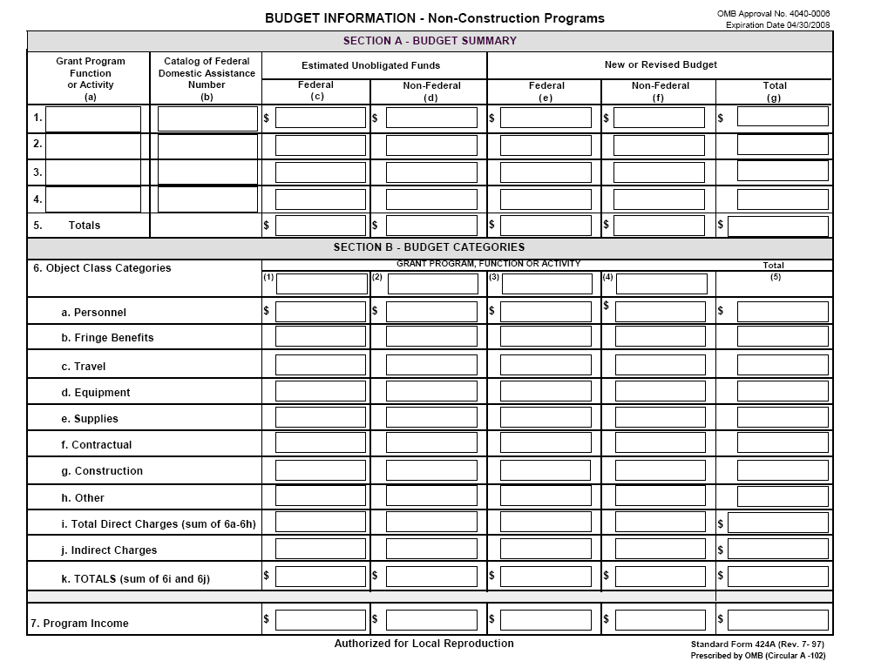
SF-424A Budget Information Non-Construction Programs

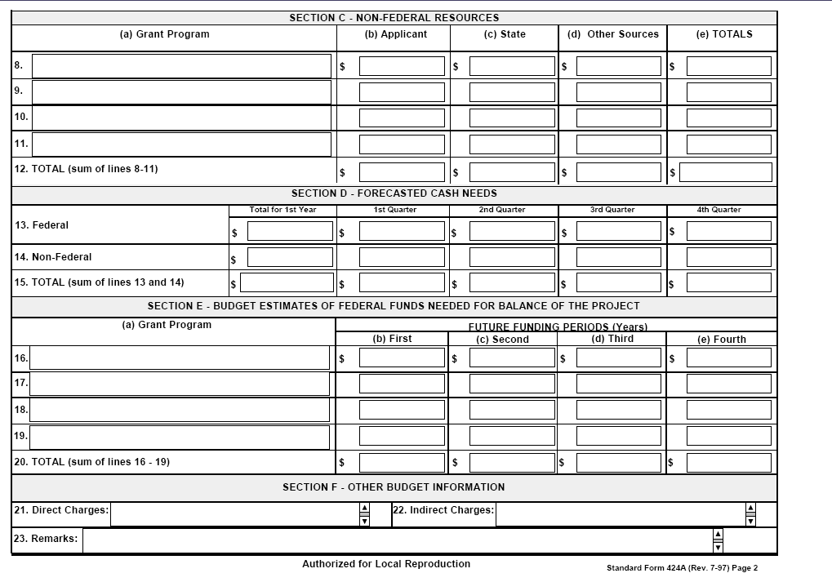
SF-424B Assurances Non-Construction Programs
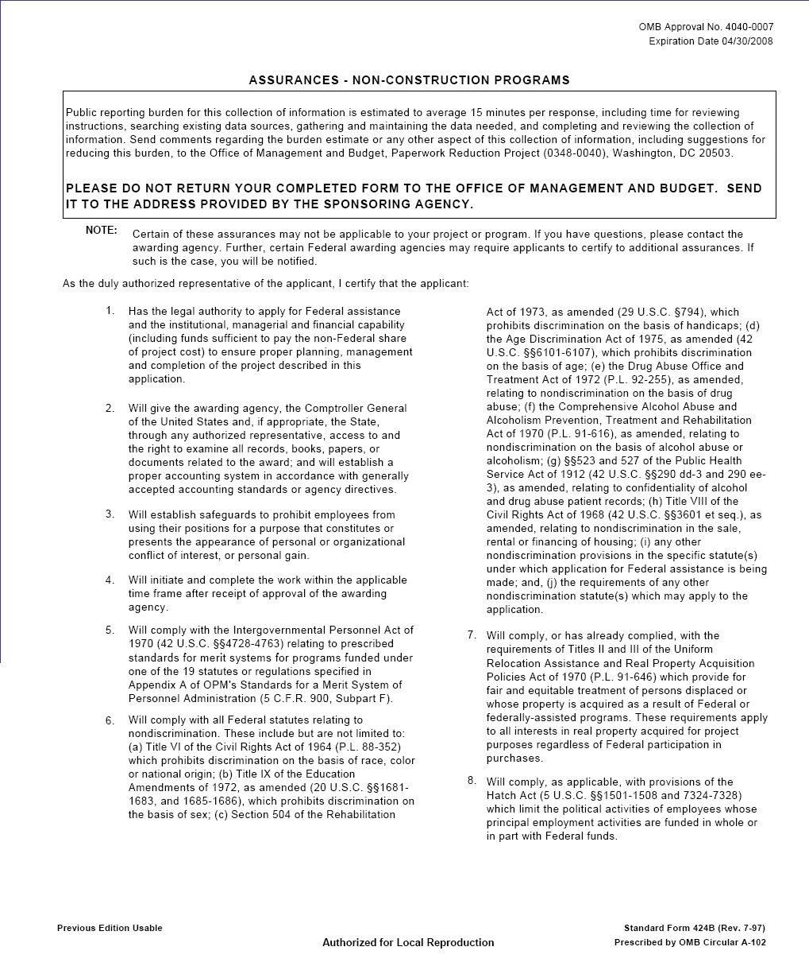
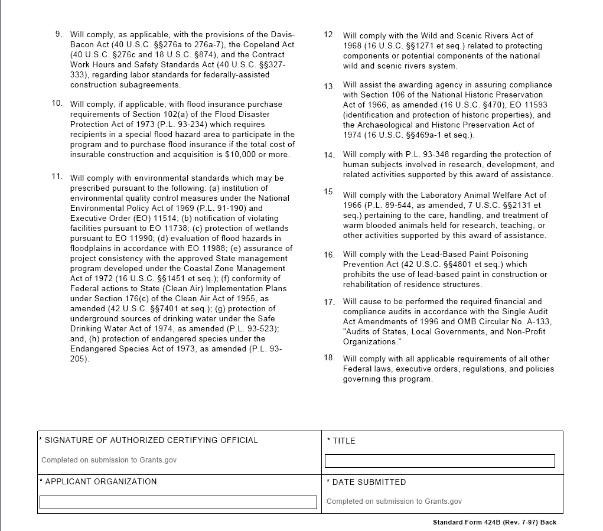

At a minimum, an IT Contingency Plan must be reviewed and/or updated annually.
At a minimum, an IT Contingency Plan must be tested annually.
At a minimum, a Risk Assessment should be conducted once every three (3) years.
At a minimum, a System Security Plan must be reviewed and/or updated annually.
The SF-424 form is available at http://www.grants.gov/techlib/SF424-V2.0.pdf
The SF-424A form is available at http://www.grants.gov/techlib/SF424-V2.0.pdf
The SF-424B form is available at http://www.grants.gov/techlib/SF424B.PDF

