ET HANDBOOK NO. 336

18th Edition

APPENDIX II

REPORTING FORMS AND FORMATS

WORKSHEET UI-3

U.S. DEPARTMENT OF LABOR Exp. Date 08/31/2011
Employment and Training Administration OMB Approval #1205-0132
WORKSHEET UI-3 | QUARTERLY UI ABOVE-BASE EARNINGS REPORT
State |  | Fiscal Year | Quarter

Section A: Program Staff Year Usage
 | Quarter |  | Year-to-Date
Program Category | (a) SY Worked | (b) SY Paid | (c) SY Paid
1. Claims Activities
2. Employer Activities
3. UI PERFORMS
4. Support/AS&T
5. Trade Claims Activities
6. Other
7. Total Staff Years

Section B: Regular Above-Base Entitlement Certification
Standard Hours: Quarterly Year-to-Date Yearly
Claims Activity | (a) Workload | (b) MPU | (c)
1. Initial Claims (Regular, EB, and STC)
2. Initial Claims (Third Tier)
3. Weeks Claimed (Regular, EB, and STC)
4. Weeks Claimed (Third Tier)
5. Nonmonetary Deter. (Regular, EB, and STC)
6. Nonmonetary Deter. (Third Tier)
7. Appeals (Regular, EB, and STC)
8. Appeals (Third Tier)
9. Interstate Appeals Taken (IB-101)
10. Interstate Agent Referrals
11. Multiclaimant Services
12. Monetary Redeterminations
13. SAVE
14. Total Staff Years Worked/Earned = Sum of Lines 1 through 13
15. Entitlement Staff Years Worked = Line 14 - Base SY Worked ( )
16. Entitlement Staff Years Paid = Line 15 x Experienced Leave ( )
17. PS/PB Entitlement $ = Line 16 x Regular Above-Base PS/PB Rate ($ )
18. Support Entitlement $ = Line 17 x Above-Base Support Percentage ( %)
19. Other $ (Specify)
20. Total Dollar Costs = Line 17 + Line 18 + Line 19
21. Advance
22. Net Dollar Entitlement = Line 20 - Line 21
CERTIFICATION: I certify to the best of my knowledge and belief that information provided herein is accurate and complete, and was obtained from agency accounting records.

Signature Title Date
U.S. DEPARTMENT OF LABOR Exp. Date 08/31/2011
Employment and Training Administration OMB Approval #1205-0132
WORKSHEET UI-3 (Continued) | QUARTERLY UI ABOVE-BASE REPORT
State |  | Fiscal Year | Quarter

Section C: Trade ABOVE-BASE Entitlement Certification
Standard Hours: Quarterly Year-to-Date Yearly
Claims Activity | (a) Workload | (b) MPU | (c)
1. Initial Claims
2. Weeks Claimed
3. Nonmonetary Determinations
4. Appeals
5. Trade Redeterminations
6. Other Staff Years (Specify)
7. Total Staff Years Worked = Sum of Lines 1 through 6
8. Staff Years Paid = Line 7 x Experienced Leave ( )
9. PS/PB Entitlement $ = Line 8 x Trade PS, Regular Above-Base PB Rate ($ )
10. Support Entitlement $ = Line 9 x Trade Support Percentage ( %)
11. Other $ (Specify)
12. Total Trade Dollar Costs = Line 9 + Line 10 + Line 11

Section D: Additional Benefits Above-Base Entitlement Certification
Standard Hours: Quarterly Year-to-Date Yearly
Claims Activity | (a) Workload | (b) MPU | (c)
1. Initial Claims
2. Weeks Claimed
3. Nonmonetary Determinations
4. Appeals
5. Monetary Redeterminations
6. Other Staff Years (Specify)
7. Total Staff Years Worked = Sum of Lines 1 through 6
8. Staff Years Paid = Line 7 x Regular Above-Base Experienced Leave ( )
9. PS/PB Entitlement $ = Line 8 x Regular Above-Base PS/PB Rate ($ )
10. Support Entitlement $ = Line 9 x Regular Above-Base Support Percentage ( %)
11. Other $ (Specify)
12. Total AB Dollar Costs = Line 9 + Line 10 + Line 11

INSTRUCTIONS FOR THE UI-3

Public Reporting Burden for the collection of this information is estimated to average 120 minutes per response, including time for reviewing instructions, searching existing data sources, gathering and maintaining the data needed, and completing and reviewing the collection of information. Send comments regarding the burden estimate or any other aspect of this collection of information, including suggestions for reducing this burden, to the Unemployment Insurance Service/ETA, U.S. Department of Labor, Room S-4231, 200 Constitution Avenue, N.W., Washington, D.C. 20210, and or/ to the Office of IRM Policy, U.S. Department of Labor, Room N-1301, 200 Constitution Avenue, N.W., Washington, D.C. 20210; Paperwork Reduction Project (1205-0132)

Please type or print legibly. The following general instructions explain how to use the form itself.

General Instructions

This form is designed so that application can be made for funds from one or more grant programs (Regular UI, Trade, and Additional Benefits). The SAVE program is included on Section B of the UI-3 in order to reimburse ongoing operational costs related to the SAVE program.

The electronic version of this form appears slightly different on the computer screen than the one included in these instructions, which is provided for display only. States should submit their reports electronically. There is minimal data entry necessary in the current UI-3s. Workloads, MPUs, Staff Years Worked/Earned and Experienced Leave Rates are all automatically entered. In addition, the electronic version has a "Comments" section to explain entries in the "Other Staff Years" or "Other $" lines, but does not have a block for certification by a State official. States are urged to use the comment section for explanations of “Other” lines. The comments section is heavily relied upon during the review of the report.

Note: Throughout the UI-3 reports, listed as Sections A, B, C, and D in these instructions, States should enter zero (0) in any cell that must be manually entered but has no data (no activity) for the particular quarter being reported on.

Minutes Per Unit. Minutes per unit (MPU) for each of the four broadband activities in Lines 1 through 8 in Section B and Lines 1 through 4 in Sections C and D are allocated in the annual base budget and the Above-Base funding process. These budgeted MPU values vary for each State from year to year; however, static MPU values have been established for the following functions:

IB Agent Appeals (Line 9, Section B) 20.0
Interstate Referrals (Line 10, Section B) 15.0
Redeterminations (Line 12, Section B and Line 5, Section C and D) (promulgated in the Unemployment Insurance Program Letter (UIPL) for the allocations)
SAVE (Line 13, Section B) 6.5

Position Computation. Generally, staff years earned are computed by multiplying workload by minutes per unit and dividing by the minutes available in the relevant period. This computation yields the number of staff required in the budget period to accomplish the workload. For a calendar quarter, the formulae are expressed as follows:

(Workload x MPU)/(60 x Quarter Hours Paid) = Staff Years Worked/Earned.
Staff Years Worked/Earned x Experienced Leave Factor = Staff Years Paid/Earned.

Experienced Leave Factor. The experienced leave factor is calculated by dividing the quarterly staff years paid/used by the quarterly staff years worked/used for that program activity. Regular UI and Trade Above-Base have different experienced leave factors.

Personal Services/Personnel Benefits (PS/PB) Rate. Attachment II to the UIPL for the yearly allocations contains the approved annual Regular UI Above-Base PS/PB rates. These are expressed as annual rates and must be converted to a quarterly equivalent for use on the UI-3. A staff hour conversion factor should be used by determining the number of staff hours in the quarter as a ratio of staff hours in the year and applying this ratio to the annual rate. For the Trade program, states may use the average experienced personal services rate of staff working in Trade claims activities. Trade personnel benefits will be funded at the same rate as the Regular Above-Base program.

Support. The support percentage may vary from one year to another and from one program to another. Therefore, the total support percentage will be promulgated in the UIPL for the yearly allocations.

Section A. Program Staff Year Usage

Lines 1-7, Columns (a) through (c)

Complete this section for current quarter and fiscal year-to-date. This section lists the UI categories to be reported. For each of Lines 1-7 in Section A, enter quarterly staff years worked in Column (a), quarterly staff years paid in Column (b), and year-to-date staff years paid in Column (c). These lines should reflect total staff years. No adjustment should be made for staff years financed with prior year carry-forward funds.

Line 1 - Enter staff years for claims activities including initial claims, weeks claimed, eligibility reviews, nonmonetary determinations, appeals, and multi-claimant services.

Line 2 - Enter staff years for employer activities including wage records, tax, and tax travel.

Line 3 - Enter staff years for UI PERFORMS activities, less UI PERFORMS AS&T.

Line 4 - Enter staff years for support activities for the UI and Trade programs including benefits and appeals travel, benefit payment control, UI support, internal security, interstate, automation grants staff, and administrative staff and technical services (AS&T), including UI PERFORMS and Trade AS&T. (Note: Some accounting reports that states use to populate the UI-3 do not show AS&T staff years worked in these programs. The SWA should estimate the AS&T staff years worked by analyzing the percentage of AS&T staff years paid charged to these programs.)

Line 5 - Enter staff years for claims activities under the Trade Adjustment Assistance (TAA) provisions of the Trade Act of 1974, as amended.

Line 6 - Enter staff years for special funded activities not included in the above lines (e.g., SAVE), and for activities funded with national activities funds (excluding cooperative agreements).

Line 7 - Enter the sum of the staff years in Lines 1 through 6, for each column.

Section B. Regular Above-Base Entitlement Certification

Lines 1-13, Column (a)

Total workload in Section B will include data from the Regular UI, Extended Benefits (EB), and Short-Time Compensation (STC) programs, and, if enacted, third tier programs (e.g., FSB, FSC, EUC, and TEUC). The following table shows the source of data for total workloads:

Line 1 - Data will automatically be entered from the ETA 5159 Regular, EB, and STC reports: the sum of lines 101, 102, and 103 for columns 2, 3, 5, and 7 of the Regular and EB reports, and the sum of columns 2 and 3 for line 101 of the STC report.

Line 2 - Data will automatically be entered from the ETA 5159 (Third Tier): the sum of lines 101, 102, and 103 for columns 2, 3, 4, and 7.

Line 3 - Data will automatically be entered from the ETA 5159 Regular, EB, and STC reports: the sum of lines 201, 202, and 203 for columns 10 and 13 of the Regular and EB reports, and the workload in line 201, column 9 of the STC report.

Line 4 - Data will automatically be entered from the ETA 5159 (Third Tier) report: the sum of lines 201, 202, and 203 for columns 10 and 13.

Line 5 - Data will automatically be entered from the ETA 207 Regular and EB reports: the sum of lines 101, 103, and 105 for column 1.

Line 6 - Data will automatically be entered from the ETA 207 (Third Tier) report: the sum of lines 101, 103, and 105 for column 1.

Line 7 - Data will automatically be entered from the ETA 5130 Regular and EB reports: the sum of columns 1 through 6 in line 100.

Line 8 - Data will automatically be entered from the ETA 5130 (Third Tier) report: the sum of columns 1 through 6 in line 100.

Line 9 - States should enter IB Agent Appeals: the sum of IB-101s sent to liable States.

Line 10- Data will automatically be entered from the ETA 5159 Regular and EB reports: the difference between the sum of column 4 and the sum of column 5.

Line 11 - States should enter the number of multi-claimant appeals (not appellants). Line 11 is automatically subtracted from line 7 before Staff Years Worked/Earned are calculated on line 7.

Line 12 - States should enter the number of monetary redeterminations. (Reserved for future use.)

Line 13 - Data will automatically be entered from line 1 of the ETA 9016.

* OMB Approval Numbers: ETA 5159: #1205-0010, expires 05/31/2006; ETA 207: #1205-0150, expires 10/31/2004; ETA 5130: #1205-0172, expires 10/31/2004; ETA 9016: #1205-0268, expires 02/28/2005

Lines 1-10 and Lines 12-13, Column (b)

The appropriate MPU values will be entered automatically. If another MPU value is necessary for Line 12, the defaulted MPU value can be overwritten.

Lines 1-10 and Lines 12-13, Column (c)

Staff years worked/earned will be calculated automatically using the formula in the General Instructions.

Line 11, Column (c)

States should enter the number of staff years worked/used for processing multi-claimant non-monetary determinations and appeals for activities such as labor dispute determinations for individual claimants or retroactive payments resulting from an appeal decision. The quarter-to-date multi-claimant staff years used (extracted from the cost distribution report) should be entered in column (c), line 11, Section B. Note: the computer software automatically subtracts the workload count in column (a), line 11 from the workload count (column a) in lines 7 before Staff Years Worked/Earned are computed in column (c), line 7.

Line 14- The Total Staff Years Worked/Earned will be automatically calculated from Lines 1 through 13, column (c).

Line 15- Entitlement Staff Years Worked will automatically be calculated by subtracting Base Staff Years Worked for the given quarter from Staff Years Worked/Earned (Line 14). Base Staff Years Worked will automatically be calculated and entered in the parentheses on line 15. Base Staff Years Worked will be calculated by dividing the Hours per Staff Years Paid by the Hours per Staff Year Worked for the appropriate quarter from the UI-1 to determine the budgeted leave factor; the number of Claims Activity Staff Years Paid will be divided by the budgeted leave factor for that quarter. States which have noted the breakout of quarterly hours in the remarks section of their SF 424-A (See instructions in the yearly UIPL providing Resource Planning Targets and Guidelines; and the UIPL used to promulgate the Resource Allocations) may override the defaulted Base Staff Years Worked entered by the system with their own calculated Base Staff Years Worked.

Line 16- Entitlement Staff Years Paid will automatically be calculated by the system by multiplying the experienced leave factor by the data in Line 15, Column (c). The experienced leave factor will automatically be calculated by dividing the quarterly staff years paid by the staff years worked for claims activities as reported in Line 1, Section A. The experienced leave factor will automatically be entered in the parentheses on Line 16. If part-time or temporary staff do not earn leave, the staff year entitlement in Line 16 will be equal to the entitlement in Line 15.

Line 17- States should enter the Regular UI Above-Base quarterly PS/PB rate, which will automatically be multiplied by the data in Line 16.

Line 18- States should enter the Regular UI Above-Base Support percentage, which will automatically be multiplied by the data in Line 17.

Line 19- States should enter costs relating to special cases and note these in the comments section. States should also enter other costs relating to the SAVE program - such as computer access charges and equipment, and phone leasing charges. The General Services Administration bills states that use the Immigration and Naturalization Service's (INS) computer database to verify claimants' immigration status. In addition, some States must lease phone Lines and equipment in order to use the INS database. These costs are fully reimbursed; however, states that are approved to use the INTERNET system to obtain access to the INS database may not claim leased Line and equipment costs. States should specify all such costs in the "Comments" section.

Line 20- Total dollar costs, the sum of lines 17, 18, and 19 will automatically be calculated and entered on line 20.

Line 21- States should enter the amount of the advance received at the beginning of the quarter for quarterly Above-Base claims operations.

Line 22- The net dollar entitlement, Line 22, will automatically be calculated by subtracting the data in line 21 from the data in Line 20 and entered here.

Section C. Trade Above-Base Entitlement Certification

Lines 1-5,

Column (a) - States should enter total workload data which will include data from the Regular Trade program. Its source is State data.

Column (b) - Trade broadband MPU values, which will automatically be entered, are identical to the Regular broadband MPU values, except for Trade weeks claimed, which excludes the weighted MPU value for the Eligibility Review Program (ERP) from the Regular weeks claimed MPU value. The Trade Redeterminations MPU value is promulgated in the yearly field memorandum for the allocations.

Column (c) - Staff Years Worked/Earned will automatically be calculated by the system using the formula in the General Instructions.

Line 6 - States should enter other staff years, such as Trade Benefit Travel staff years worked/used.

Line 7 - The sum of lines 1 through 6 in Column (c) will automatically be calculated and entered here.

Line 8 - The system will use the same formula to calculate Staff Years Paid as for Section B, but will calculate the experienced leave factor by using Section A, Line 5. If necessary, this defaulted value can be overwritten.

Line 9 - States should enter the combined Trade PS and Above-Base PB rate. The system will multiply this rate by the entry in Line 8.

Line 10- States should enter the Trade Above-Base Support percentage. The system will use this data and multiply it by the entry in Line 9.

Line 11- States should enter other costs relating to Trade Administration in Line 11. Notices in local newspapers for special worker notifications are fully reimbursed. States should specify all such costs in the "Comments" section.

Line 12- The system will automatically enter the sum of Lines 9, 10, and 11 here.

Section D. Additional Benefits (AB) Above-Base Entitlement Certification

Note: Reporting of AB data is not required for statistical purposes, but is necessary in order to calculate the proper entitlement.

Lines 1-5,

Column (a) - States should enter the total broadband AB program workload. Its source is State data.

Column (b) - AB broadband MPU values that will automatically be entered are identical to the Regular broadband MPU values. The AB Redeterminations MPU value, which should be manually entered, is promulgated in the yearly field memorandum for the allocations.

Column (c) - Staff Years Worked/Earned will automatically be calculated by the system using the formula in the General Instructions.

Line 6 - (Reserved for future use.)

Line 7 - The sum of Lines 1 through 6 in Column (c) will automatically be calculated and entered here.

Line 8 - Staff Years Paid will automatically be calculated by the system by multiplying the same experienced leave factor as for Section B by the data in Line 7.

Line 9 - States should enter the Regular UI Above-Base quarterly PS/PB rate in the parentheses on line 9. The system will multiply this rate by the data in Line 8.

Line 10- States should enter the Regular UI Above-Base Support percentage in the parentheses on line 10. The system will use this figure and multiply it by the entry in Line 9.

Line 11- (Reserved for future use.)

Line 12- The system will automatically enter the sum of Lines 9, 10 and 11 here.

FINANCIAL STATUS REPORT ETA-9130
REQUEST FOR ADVANCE OR REIMBURSEMENT SF-270
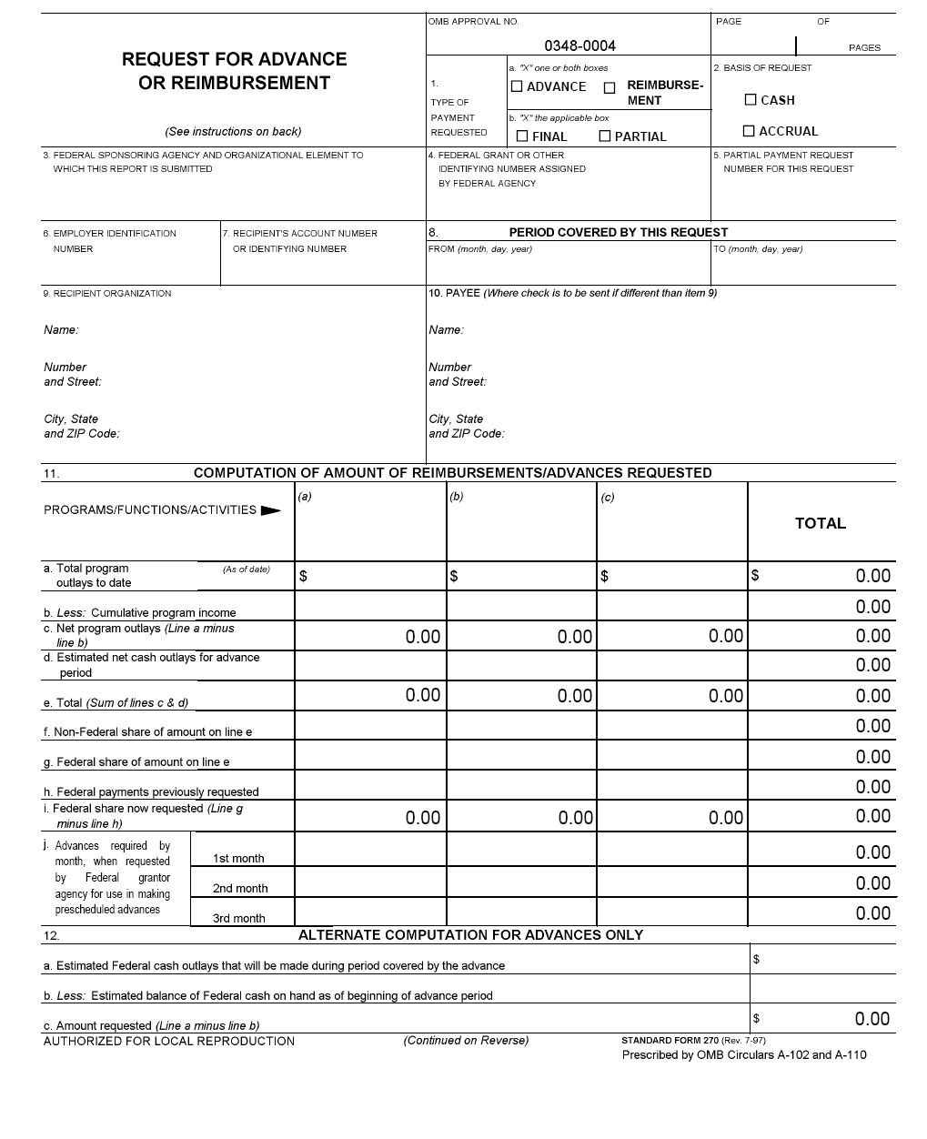
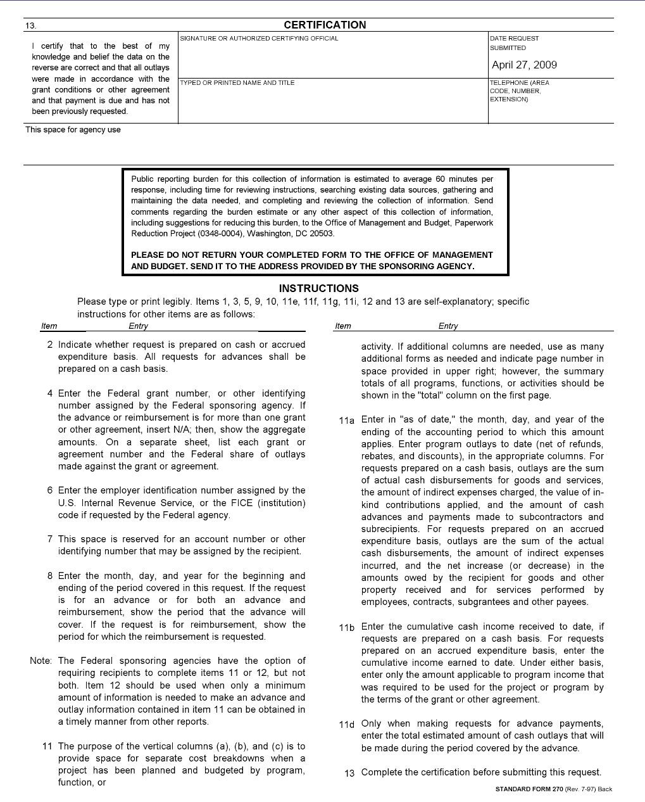

The Financial Status Report ETA-9130 form is available at http://www.doleta.gov/grants/docs/ETA-9130-straightSF269grants.pdf
The SF-270 form is available at http://www.doleta.gov/grants/docs/ETA-9130-straightSF269grants.pdf

