OMB No. 1220-0163
Expires 11/30/12

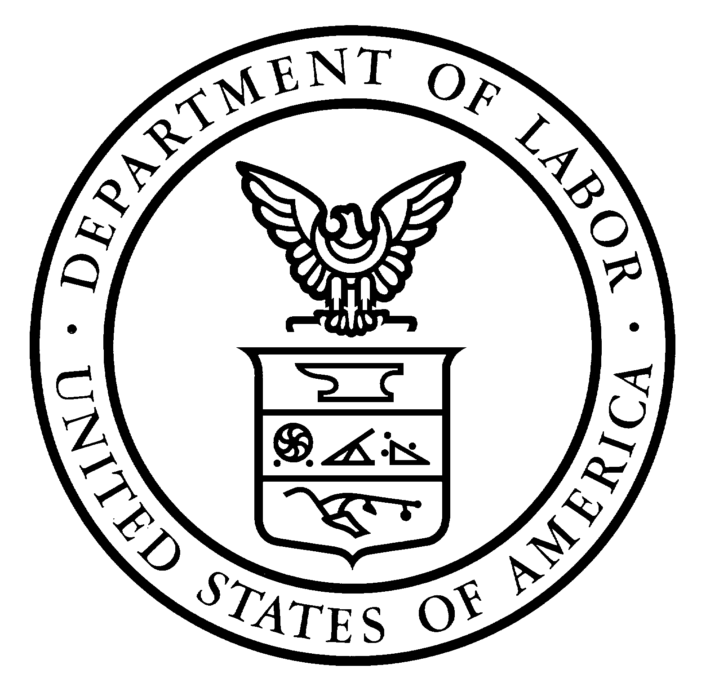 | United States Department of Labor  Bureau of Labor Statistics  Housing Survey

Reminder for the Housing Survey
Did you mail back your response? If so, thank you! If not, please answer the short survey you received a few days ago that asked if your home is owned or rented, and return it in the next five days.

Do You Want to Report On the Web?
You can respond on the Web: www.websrg.com/BLS2009 . Enter the passcode: <passcode>
Although your participation is voluntary, this information is very important and will be kept confidential.

Thank you for your participation!

