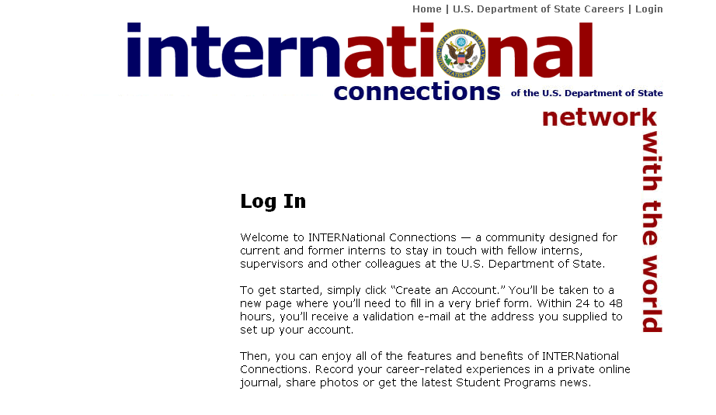
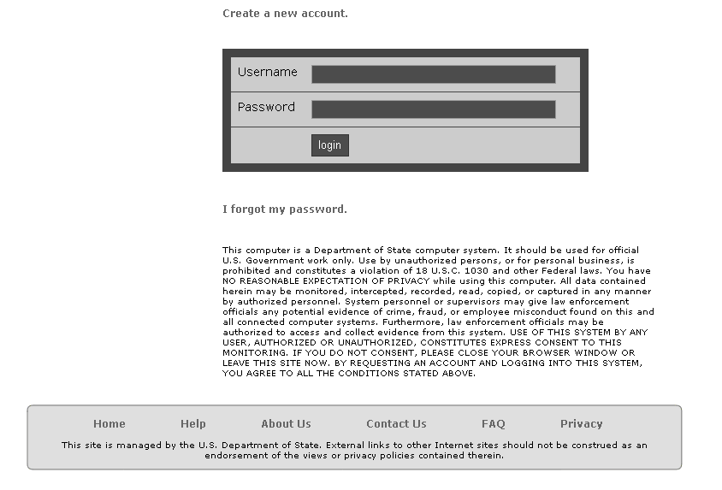
INTERNational Connections home page: http://careers.state.gov/internconnect
Current and former interns will be directed to the home page to (a) create a new account; and
(b) log-in to an existing account.

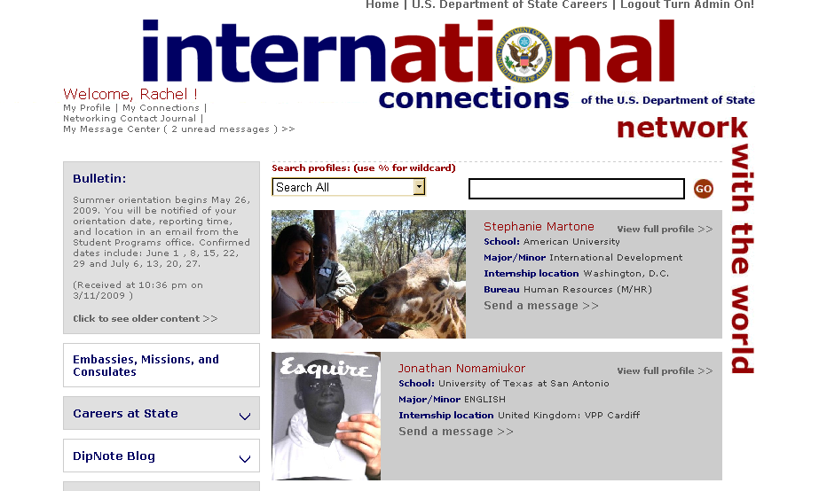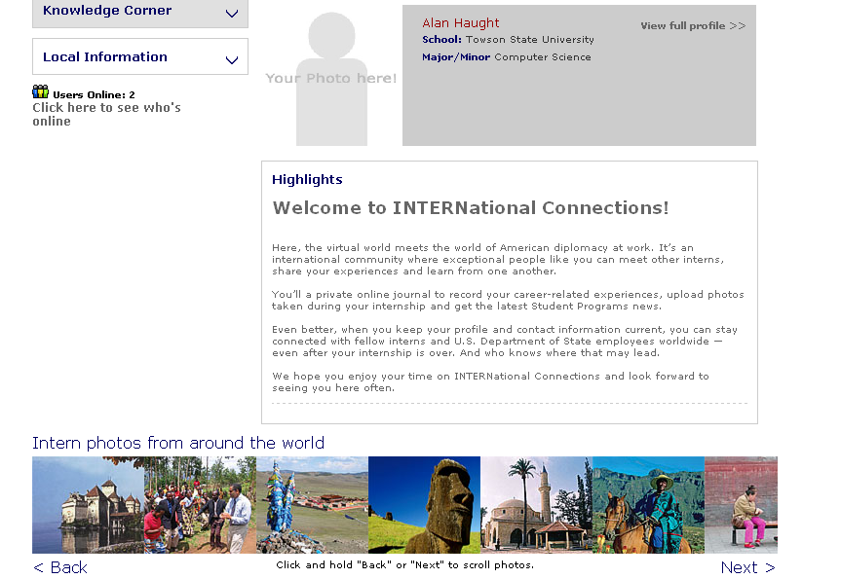
From the home page, users are taken to their personal home page where they can customize a profile.

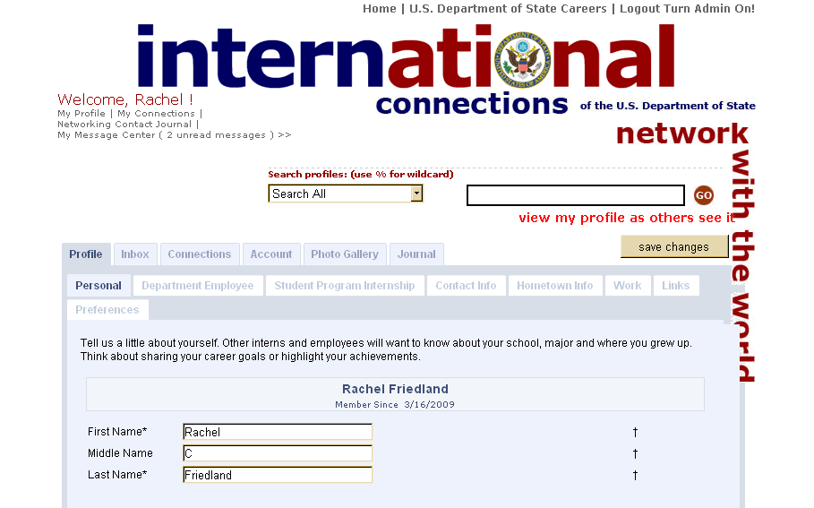
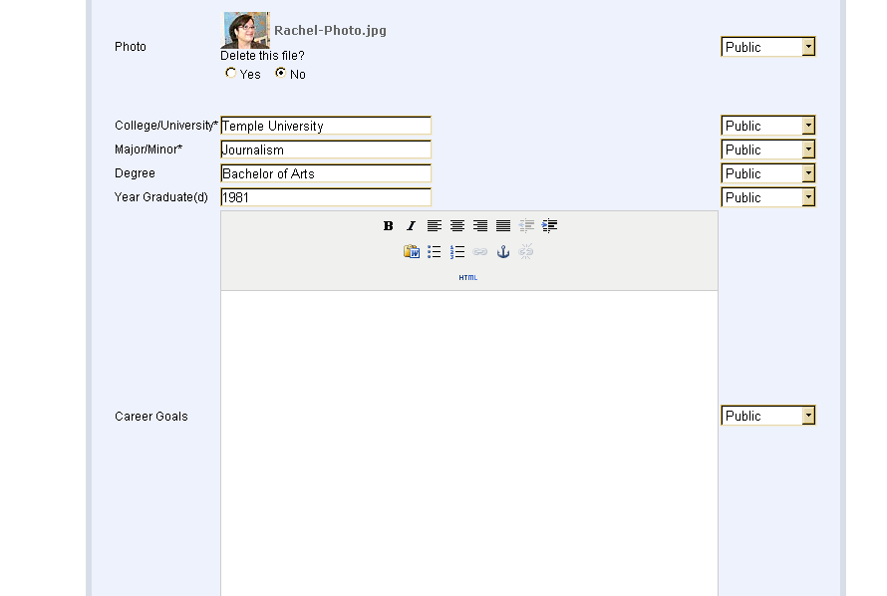
The main tab is the Profile which contains seven sub-categories where current and former interns can provide additional details, including: university attending or graduated; contact email and phone; current work information; Department internships; hometown information; links of interest and preference choices. Five additional tabs allow users to manage their participation with the site, including the ability to send and receive emails; keep track of connections made; manage their account username and password; upload photos; and maintain a personal networking journal.
