Appendix A: Offer in Compromise Satisfaction Survey Form

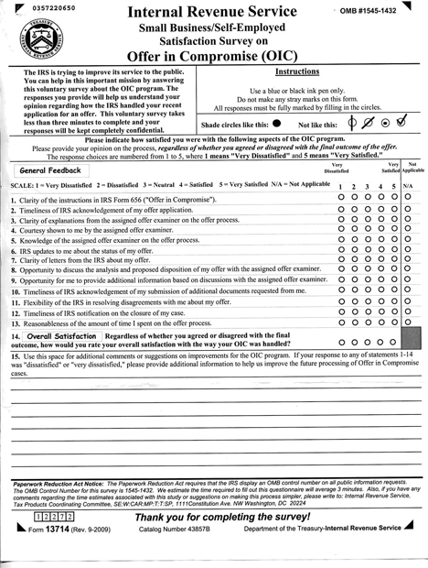

For your convenience, the text of the questions and responses choices on the data collection instrument for FY 2009 are shown below. Please note that changes for the FY 2011 version will be indicated by footnotes. We will use the same survey for FY 2011, with appropriate updates for the form number, revision number, and OMB number, if these change.
For questions 1-14, the responses choices are as follows:
1 = Very Dissatisfied,
2 = Dissatisfied,
3 = Neither Satisfied nor Dissatisfied,
4 = Satisfied, and
5 = Very Satisfied.
A choice of Not Applicable (N/A) is provided for Questions 1-13.
Note: The previously assigned OMB number (1545-1432) is displayed in the upper right hand corner of the data collection instrument as required. Also, we will replace the word “confidential” with the word “private” in the upper left hand corner of the form. We anticipate that the revised revision date in the lower left hand corner will be (Rev. 9-2011).

Survey Questions
1. Clarity of the instructions in IRS Form 656 (“Offer in Compromise”).
2. Timeliness of IRS acknowledgement of my offer application.
3. Clarity of explanations from the assigned offer examiner on the offer process.
4. Courtesy shown to me by the assigned offer examiner.
5. Knowledge of the assigned offer examiner on the offer process.
6. IRS updates to me about the status of my offer.
7. Clarity of letters from the IRS about my offer.
8. Opportunity to discuss the analysis and proposed disposition of my offer with the assigned offer examiner.
9. Opportunity for me to provide additional information based on discussions with the assigned offer examiner.
10. Timeliness of IRS acknowledgement of my submission of additional documents requested.
11. Flexibility of the IRS in resolving disagreements with me about my offer.
12. Timeliness of IRS notifications on the closure of my case.
13. Reasonableness of the amount of time I spent on the offer process.
14. Regardless of whether you agreed or disagreed with the final outcome, how would you rate your overall satisfaction with the way your OIC was handled?
15. Use this space for additional comments or suggestions on improvements for the OIC Program. If your response to any of statements 1-14 was “dissatisfied” or “very dissatisfied,” please provide additional information to help us improve the future processing of offer in compromise cases. (Write-in response.)

Appendix B: Survey Pre-notification Letter

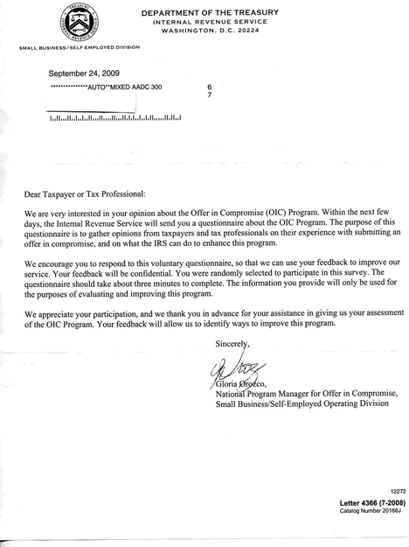

For your convenience, the text of the pre-notification letter for FY 2009 is shown below. Please note that changes for the FY 2011 version will be indicated by footnotes. We will use the same pre-notification letter for FY 2011, with appropriate updates for the date, manager name, manager signature, form number, revision date and catalog number, if these change.
Note: We anticipate that the mailing date will be no later than October 3, 2011 and the revision date in the lower right hand corner will be (Rev. 9-2011).

Survey Pre-notification Letter
October 3, 2011
We are very interested in your opinion about the Offer in Compromise (OIC) Program. Within the next few days, the Internal Revenue Service will send you a questionnaire about the OIC Program. The purpose of this questionnaire is to gather opinions from taxpayers and tax professionals on their experience with submitting an offer in compromise, and on what the IRS can do to enhance this program.
We encourage you to respond to this voluntary questionnaire, so that we can use your feedback to improve our service. Your feedback will be confidential. You were randomly selected to participate in this survey. The questionnaire should take about three minutes to complete. The information you provide will only be used for the purposes of evaluating and improving this program.
We appreciate your participation, and we thank you in advance for your assistance in giving us your assessment of the OIC Program. Your feedback will allow us to identify ways to improve this program.

Appendix C: Survey Cover Letter

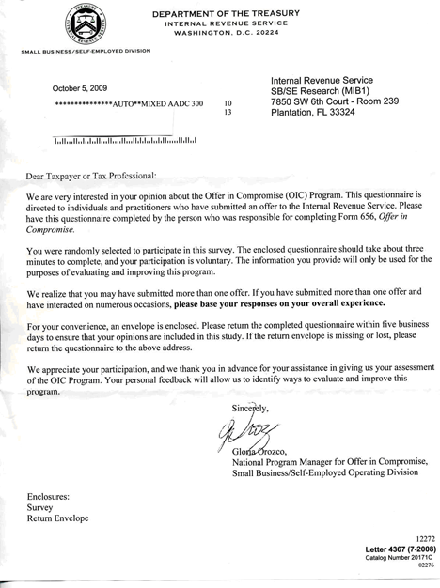

For your convenience, the text of the cover letter for FY 2009 is shown below. Please note that changes for the FY 2011 version will be indicated by footnotes. We will use the same pre-notification letter for
FY 2011, with appropriate updates for the date, manager name, manager signature, form number, revision date and catalog number, if these change.
Note: We anticipate that the mailing date will be no later than October 11, 2011 and the revision date in the lower right hand corner will be (Rev. 9-2011).
Survey Cover Letter
October 11, 2011
We are very interested in your opinion about the Offer in Compromise (OIC) Program. This questionnaire is directed to individuals and practitioners who have submitted an offer to the Internal Revenue Service. Please have this questionnaire completed by the person who was responsible for completing Form 656, Offer in Compromise.
You were randomly selected to participate in this survey. The enclosed questionnaire should take about three minutes to complete, and your participation is voluntary. The information you provide will only be used for the purposes of evaluating and improving this program.
We realize that you may have submitted more than one offer. If you have submitted more than one offer and have interacted on numerous occasions, please base your responses on your overall experience.
For your convenience, an envelope is enclosed. Please return the completed questionnaire within five business days to ensure that your opinions are included in this study. If the return envelope is missing or lost, please return the questionnaire to the above address.
We appreciate your participation, and we thank you in advance for your assistance in giving us your assessment of the OIC Program. Your personal feedback will allow us to identify ways to evaluate and improve this program.

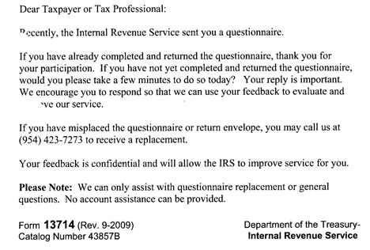Appendix D: Survey Follow-up Notice
For your convenience, the text of the follow-up notice for FY 2009 is shown below. Please note that changes for the FY 2011 version will be indicated by footnotes. We will use the same follow-up notice for FY 2011, with appropriate updates for the form number, revision date and catalog number, if these change.
Note: We anticipate that the revision date in the lower left hand corner will be (Rev. 9-2011).
Survey Follow-up Notice
Recently, the Internal Revenue Service sent you a questionnaire.
If you have already completed and returned the questionnaire, thank you for your participation. If you have not yet completed and returned the questionnaire, would you please take a few minutes to do so today? Your reply is important. We encourage you to respond so that we can use your feedback to evaluate and improve our service.
If you have misplaced the questionnaire or return envelope, you may call us at (954) 423-7273 to receive a replacement.
Your feedback is confidential and will allow the IRS to improve service for you.
Please Note: We can only assist with questionnaire replace or general questions. No account assistance can be provided.

Question 15 will be revised as follows: Use this space for additional comments or suggestions on improvements for the OIC Program. If your response to any of statements 1-14 was “dissatisfied” or “very dissatisfied,” please provide the number of the question you are addressing and enter additional information to help us improve the future processing of offer in compromise cases. Please limit your response to 250 words.
We will replace the word “confidential” with the word “private”.
We will remove the word “randomly” and add the words “because of your experience with the OIC Program.” The sentence will be revised as follows: You were selected to participate in this survey because of your experience with the OIC Program.”
We will remove the word “randomly” and add the words “because of your experience with the OIC Program.” The sentence will be revised as follows: You were selected to participate in this survey because of your experience with the OIC Program.”
We will replace the word “confidential” with the word “private”.

