U.S. Department of Homeland Security

Arlington, VA 20598-6028
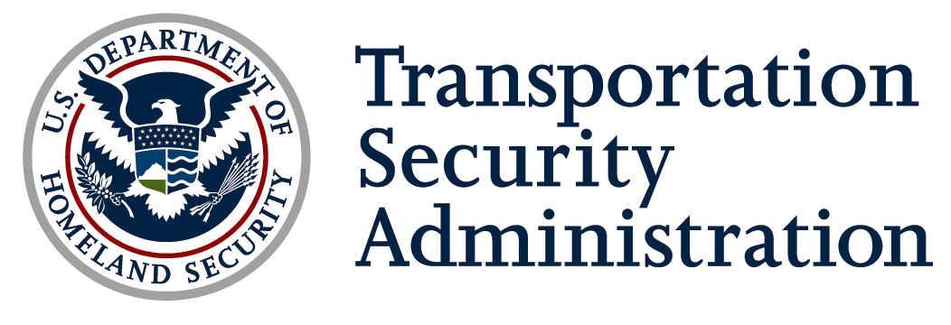

November 6, 2009

Boyd Stephenson, Manager
Security and Cross Border Operations
American Trucking Associations

Clyde J. Hart, Jr.
Senior Vice President
Government Affairs
American Bus Association

Gentlemen:
I thank you for your joint letter dated August 14, 2009 in which you responded to the Federal Register Notice regarding our application for renewal of the Corporate Security Review (CSR) OMB control number. On behalf of TSA, I would like to respond to your comments, which I believe are shared by many in our stakeholder community.
Since the beginning of the CSR initiative several years ago we have come to rely on the CSR as a valuable tool for identifying stakeholder-driven efforts to address security and to identify a baseline from which we could identify security gaps and begin to address mitigation needs. The extension of the program to motor carriers in 2005, which was a natural and necessary step, has further enhanced its value to TSA, specifically leading to the need for a strategy to encourage surface transportation stakeholders to become diligent in effectuating and maintaining security related improvements.
Congress has given TSA specific responsibilities to assume oversight and compliance on transportation security. As a direct result, the Department of Homeland Security (DHS) and the Department of Transportation (DOT) have signed agreements with DOT and its relevant components to delineate clear lines of authority and responsibility, promote communication and efficiency, and avoid duplication of effort through cooperation and collaboration, including in the area of hazardous materials transportation security, based on existing legal authorities and core competencies. One of these Memorandums of Understanding (MOUs), specifically includes TSA’s commitment to coordinating its Corporate Security Review initiative with the Federal Motor Carrier Safety Administration’s (FMCSA) Security Contact Review (SCR) program to limit duplicative security reviews of motor carriers, including those who transport, or offer for transport, hazardous materials. These MOUs, however, also acknowledge that DHS has lead authority and primary responsibility for security activities in all modes of transportation and notes that TSA is the lead Federal entity for transportation security.
TSA and FMCSA continue to work towards delineating each agency’s roles and responsibilities, for both the CSRs/SCRs and other regulatory processes, to avoid duplicating inspections and enforcement activities. TSA is sensitive to the burden on the industry from complying with requests for information from multiple agencies and has taken appropriate steps to avoid overlap where possible. For example, we have reviewed and used information on the SCRs, to the extent it is available and sufficient for our purposes. In addition, we have and will continue to work with FMCSA to avoid requesting a CSR with motor carriers who have had a recent visit from FMCSA for the purposes of a SCR.
While recognizing the success of the Missouri Pilot, TSA considers this use of state officers conducting CSRs as an interim measure. As you noted in your letter, it is important to have CSRs conducted by inspectors who are trained on the goals and scope of TSA’s security programs. To that end, TSA has been building a cadre of surface transportation inspectors with one of their duties being to conduct CSRs. Over the last several months we have trained over 200 federal transportation inspectors who will be utilized to reduce risk and build relationships with stakeholders through several TSA surface transportation programs and initiatives, such as the CSR.
Finally, TSA's authority with respect to transportation security is comprehensive and supported, with specific powers related to the development and enforcement of regulations, security directives (SDs), security plans, and other requirements. Some degree of overlap with other federal agency efforts is inevitable to the extent that there will always be a certain degree of overlap between safety and security. It is, however, our intent to eliminate duplication of efforts by federal agencies to the extent that it is possible. I appreciate your expression of support and will be delighted to have you share this campaign with us.
Thank you again for your comments.
Sincerely,

William H. Arrington
General Manager
Highway and Motor Carrier Division
Transportation Security Administration

