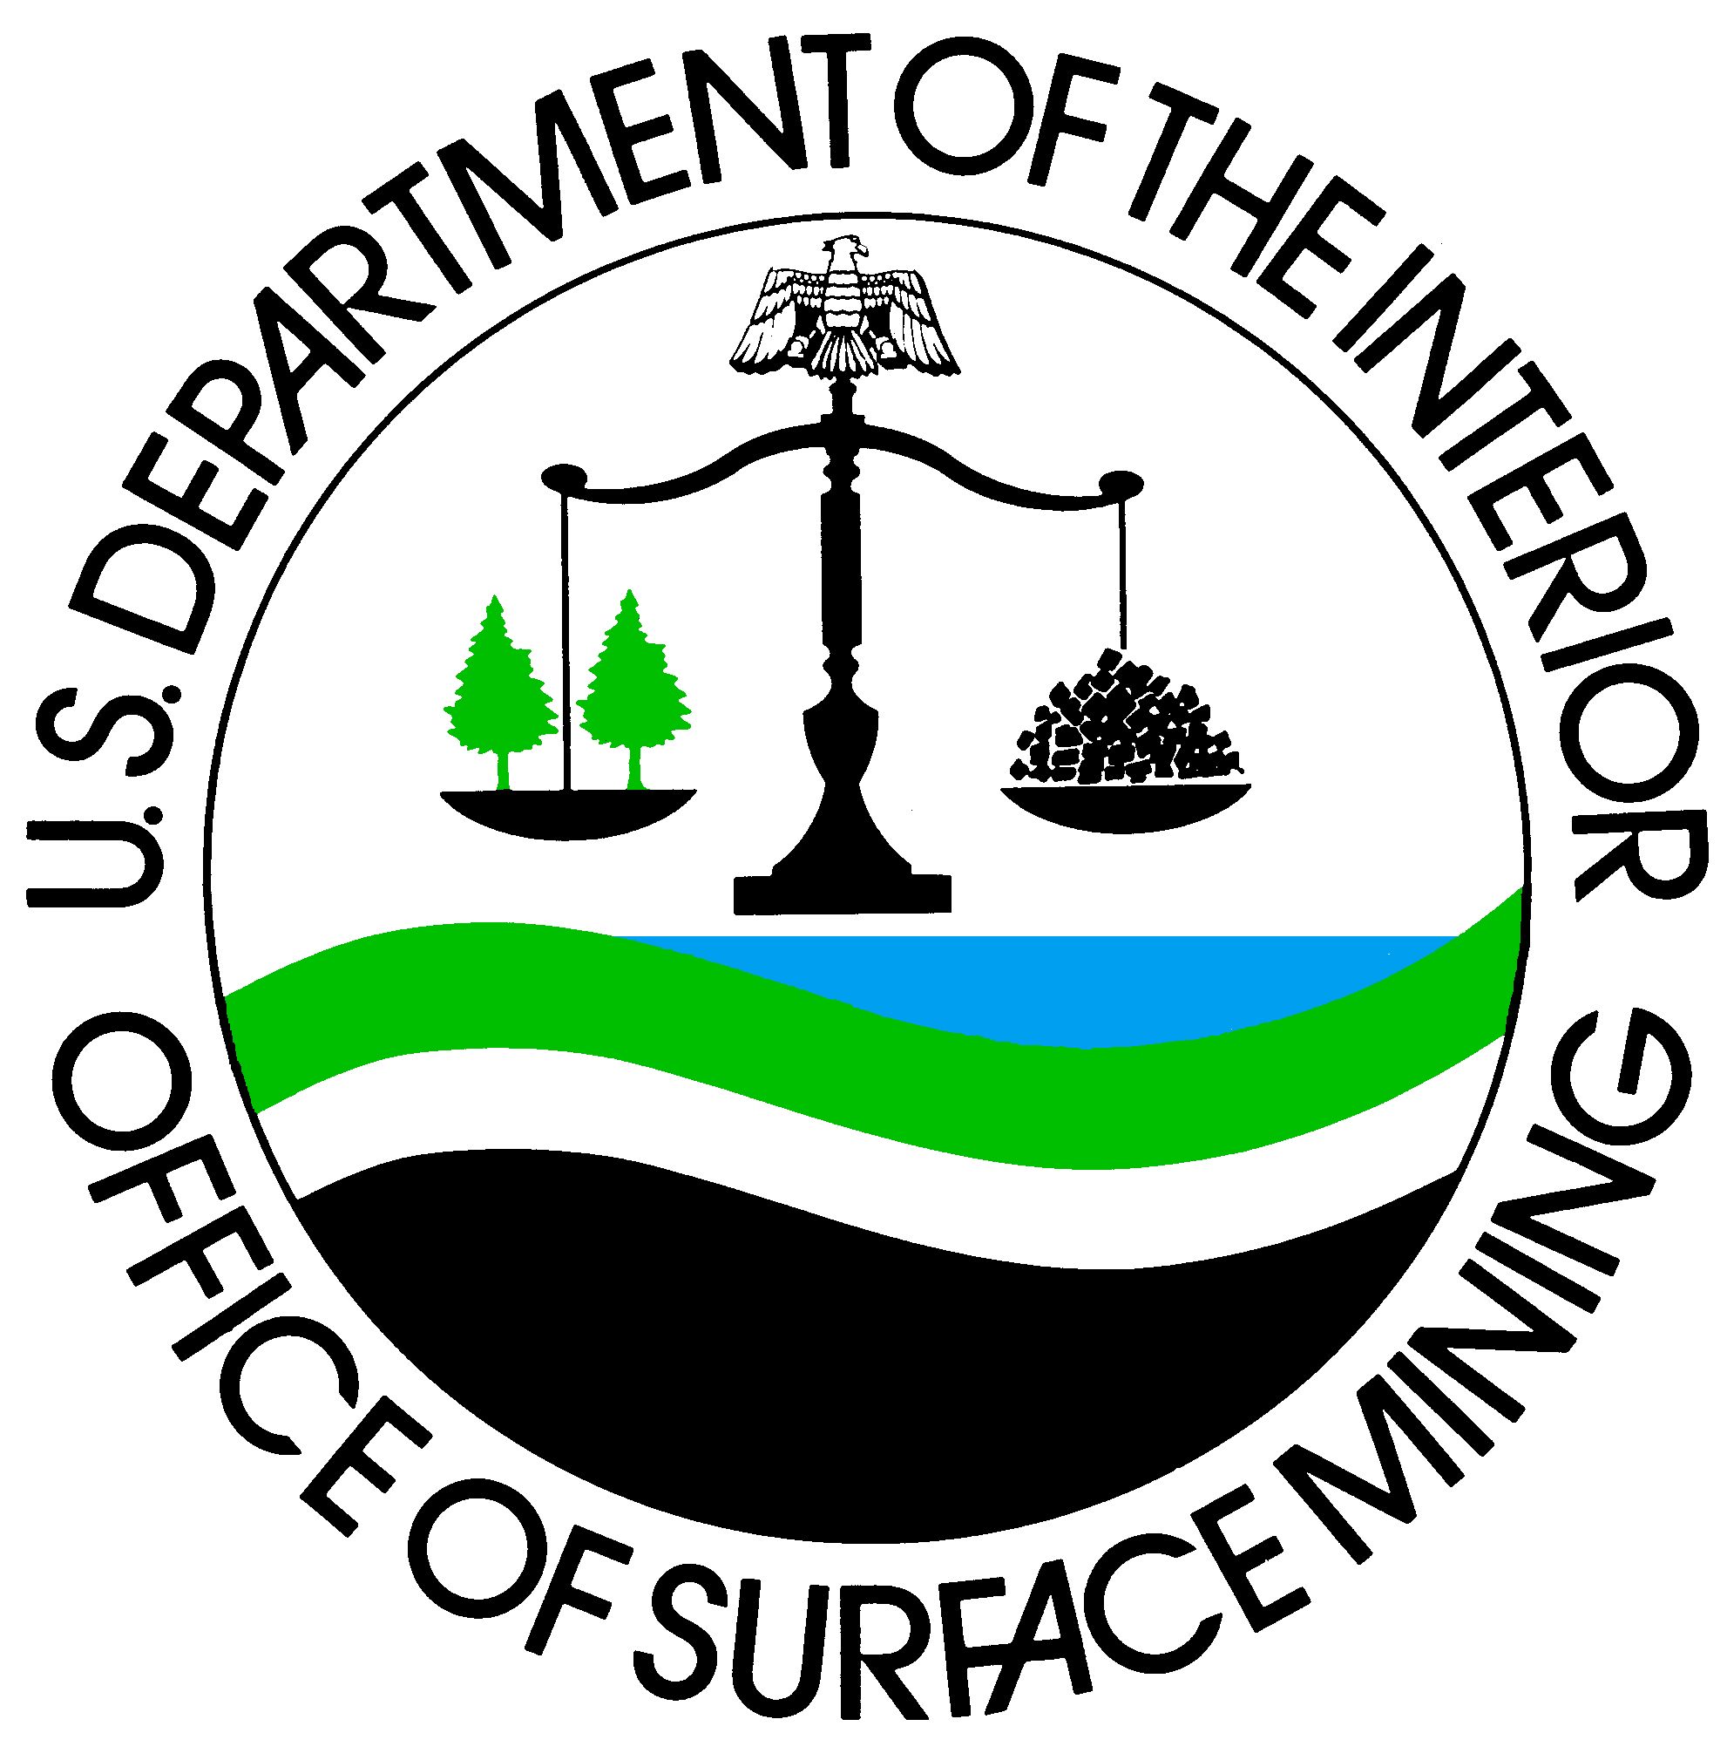
UNITED STATES DEPARTMENT OF THE INTERIOR
Office of Surface Mining Reclamation and Enforcement

Request for payment of TRAVEL and PER DIEM expenses
for State and Tribal Nominees to OSM National Technical Training Course
OMB Control # 1029-0120 Expiration Date: January 31, 2007
1. Course Title: | 2. Dates:
3. Nominee’s Name: (Last, First, MI) | 4. Social Security Number:
5. Nominee’s Title:

E-Mail Address:
6. Official Duty Station: (City, State and Phone)  *Miles to Training Site: _________________________ | 7. Residence: (City and State)  *Miles to Training Site: ______________________
Supervisor’s Name: Supv. E-Mail:

8. Requested Mode of Travel:

[ ] Government-owned vehicle [ ] Common carrier (air)
[ ] Privately owned vehicle [ ] Other (specify)

[ ] Closest airport and miles to: ____________________________________________________________________________

9. Per Diem Requested For:

[ ] Lodging Beginning Date: _______________________ Ending Date: ___________________________
[ ] Meals and incidental expenses

10. Name of Agency:

Fund Request:

*We do not have funds available to pay travel and per diem expenses for the above nominees because:

[ ] Sufficient funds were not made available through the legislature’s appropriation process.
[ ] As a practice, the State does not provide out-of-State travel authority for the purpose identified above.
[ ] Letter attached.
[ ] Other ( Please explain briefly):

_________________________________________________________________
Authorized Signature

OSM 140 (rev. 10/99)

PAPERWORK REDUCTION ACT STATEMENT

The Paperwork Reduction Act of 1995 (44 U.S.C. 3501) requires us to inform you that: Federal Agencies may not conduct or sponsor, and a person is not required to respond to a collection of information unless it displays a currently valid OMB control number. This information is being collected to calculate the type and number of classes and instructors needed to complete OSM’s technical training mission, and to estimate costs for our annual budget. The Debt Collection Improvement Act of 1996 (31 U.S.C. 7701(c)(1)) permits a Federal agency to require each person doing business with that agency to furnish to that agency that person's taxpayer identification number. We collect personal data to reimburse participants in our training program. We do not use the information for any other internal secondary purpose. We may disclose information you give us if required by Federal law, such as the Privacy Act.

Public reporting burden for this form is estimated to average 5 minutes per response, including the time for reviewing the instructions, gathering and maintaining data, and completing and reviewing the form. Response is required to obtain a benefit. Direct comments regarding the burden estimate or any other aspect of this form to the Information Collection Clearance Officer, OSM, Room 202 SIB, 1951 Constitution Ave, NW, Washington, DC 20240.

