FORM APPROVED
OMB Approval No. 0917-New

Exp. Date XX/XX/XX11

Indian Health Service
Director’s 3-Initiative
Best and Promising Practice and Local Effort Electronic Submission Form

The Indian Health Service (I.H.S.) Health Promotion/Disease Prevention (HP/DP), Behavioral Health (BH) and Chronic Care (CC) Programs are creating an inventory of best practice/promising practice and/or local effort (BP/PP/LE), resources, and policies occurring in American Indian/Alaska Native (AI/AN) communities, schools, work sites, health centers/clinics, and hospitals..

The purpose of this inventory is to:

- Assist AI/AN communities in getting problem and indicator specific information on effective AI/AN targeted programming.
- Form an IHS database of programs easily accessed on the IHS website.
- Establish a resource for external and internal collaboration and communication.
- Highlight successful programs and encourage their broader dissemination.
- Demonstrate programs that integrate Health Promotion Disease Prevention, Behavioral Health, and Chronic Care to increase the wellness of the community.

To submit a best practice, promising practice, or local effort, please complete the inventory form below:

*1. Please provide the name, title and contact information for the person filling in this template.

Name:
Site or location name:
Address:
Address 2:
City/Town:
State: | (Drop Down Menu)
ZIP:
Country:
Email Address:
Phone Number

2. Should people reviewing your submission contact someone other than yourself for questions about the program?
○ | Yes → Directed to Question 3
○ | No → Directed to Question 4

*By submitting this form you are agreeing that you or your designee can be contacted regarding this submission.

Public Burden Statement: In accordance with Paperwork Reduction Act (5 CFR 1320.8 (b)(3), a Federal agency may not conduct or sponsor, and a person is not required to respond to, a collection of information unless it displays a currently valid OMB control number. Respondents must be informed (on the reporting instrument, in instructions, or in a cover letter) the reasons for which the information will be collected; the way the information will be used to further the proper performance of the functions of the agency; whether responses to the collection of the information are voluntary, required to obtain a benefit (citing authority), or mandatory (citing authority); and the nature and extent of confidentiality to be provided, if any (citing authority). Public reporting burden for this collection of information is estimated to average 20 minutes per response, including time for reviewing instructions, searching existing data sources, gathering and maintaining the necessary data, and completing and reviewing the collection information. Send comments regarding the burden estimate or any other aspect of this collection of information to the IHS PRA Information Collection Clearance Staff, 801 Thompson Ave., Suite 450, Rockville, MD 20852.
*3. Please provide the contact information of the person reviewer should contact:

Name:
Site or location name:
Address:
Address 2:
City/Town:
State: | (Drop Down Menu)
ZIP:
Country:
Email Address:
Phone Number

*By submitting this form you are agreeing that you or your designee can be contacted regarding this submission.

4. What are you submitting?

○ | Evidence Based Practice: Programs formally evaluated to be effective, or Best Practices, that can be replicated and implemented, even with modifications in other settings.
○ | Promising Practice: Programs not formally evaluated (or formal evaluation is not yet complete) but identified by experts as programs with results suggesting efficacy and worthy of further study in broader pilot implementation efforts.
○ | Local Effort: Programs and/or activities that have not been evaluated but are identified by local programs as producing positive results.
○ | Resources: Information or materials that might help develop a program/project in a community but can not be defined as a Best Practice, Promising Practice, or Local Effort.
○ | Policy: An ordinance, resolution, or law passed by a community that produces positive results.

5. Please choose the service area, from the drop down list below, that best describes the location of the program or information you are submitting. A map of the 12 IHS Areas is below to help you with your selection.
National
Aberdeen
Alaska
Albuquerque
Bemidji
Billings
California
Nashville
Navajo
Oklahoma
Phoenix
Portland
Tucson
Other/Unknown

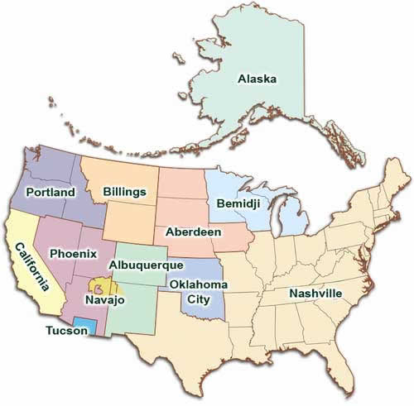

6. What is the Title of the program or information being entered?

7. Please define the project's target age group(s): (check all that apply)
 | Infants  (0-12 months) |  | Children  (2-11 years) |  | Adults (18-64 years)
 | Toddler  (12-24 months) |  | Adolescent (12-17 years) |  | Elderly (65+ years)

8. Please describe the type of location where the project takes place: (check all that apply)
 | Community |  | Hospital |  | School
 | Clinic/Health Center |  | Home |  | Worksite
 | Other:

9. Please check the targeted health indicator(s) impacted by the project. (check all the apply)
 | Cardiovascular Disease |  | Healthcare Access |  | Overweight and Obesity
 | Child Abuse/Neglect |  | Immunization |  | Pets/Animals
 | Diabetes |  | Infectious Disease |  | Physical Activity
 | Domestic Violence |  | Information Technology |  | Substance Abuse
 | Environmental Quality |  | Injury and Violence |  | Tobacco Use
 | Excessive Alcohol Consumption |  | Mental Health |  | Traditional Healing
 | Grants |  | Methamphetamines
 | Health Education |  | Oral Health

Note: Review of content is based partially on the Health Indicator(s) selected. Selecting more than one Health Indicator may require additional review. Information submitted might be approved for some Health Indicators before others, and therefore content might not appear for some searches but does appear for others; this only pertains to submissions that have more than one targeted health indicator selected.
- Please describe the project that you are submitting.
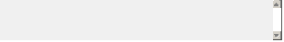

- Please list the website where information about the program can be found (if applicable):
- Please select at least one key word that would describe the project you are submitting (check all that apply):
 | Advocacy |  | Interview and teaching strategies
 | Alcohol/substance abuse prevention |  | Lifestyle coaching
 | Asthma |  | Motivation
 | Behavioral health/behavioral change |  | Nutrition
 | Breastfeeding |  | Physical activity
 | Capacity building or empowerment |  | Pregnancy prevention
 | Child abuse prevention |  | Public Health intervention
 | Chronic conditions |  | Staff qualification or credentials
 | Community assessment |  | School health
 | Community directed intervention |  | Scientific research
 | Community mobilization/organization |  | Sudden Infant Death Syndrome
 | Disability |  | Suicide prevention
 | Drug abuse prevention |  | Surveillance
 | Disability prevention |  | Traumatic Brain Injury
 | Domestic violence prevention |  | Teaching strategies
 | Environmental change |  | Tobacco cessation
 | Group process |  | Unintentional injury
 | Health literacy |  | Violence and Intentional injury
 | Health promotion and wellness |  | Worksite health
 | HIV prevention |  | Zoonotic Disease (disease with an animal link)
 | Other (please specify)

Questions 13 to 14 are required in order to be considered evidence based practice or submission will be considered a promising practice or local effort upon evaluation unless materials are available for review.

13. Was the project evaluated?

○ | Yes → Directed to Question 14
○ | No → Directed to Question 16

14. Is the evaluation summary available?

○ | Yes → If Yes, Directed to Question 15
○ | No → If No, Directed to Question 16

15. Please specify a file or a set of files:

*If you are not able to upload your documents, or your documents are larger than 5 MB in size, send the evaluation materials one of the following ways:

Mail Address:
Indian Health Service
Attn: OSCAR Team
801 Thompson Ave, Suite 300
Rockville, MD 20852

Fax:
(301) 594-6213, or (301) 443-7623
Attn: OSCAR Team
16. What is/was the overall cost (estimate) of the program?

17. Any final comments?

