ENVIRONMENT
(NOTE: these questions are to be asked to each section foreman on a monthly basis via a conference call; please instruct the section foreman that all of the following questions pertain to conditions over the past month.)

- How many working faces do you currently have at your mine (please enter)?___________

- What is the mining height of your section at the face (please enter)?____________

- How would you describe your mine floor conditions at the face (please circle)?

        - Extremely wet/standing water
        - Extremely dry/no mud whatsoever
        - Thick mud
        - Slightly muddy
        - Alternating between muddy and dry depending on the day/week
        - Mostly dry
        - Completely dry
        - Rocky
        - Smooth
        - Soft
        - Other (please specify) ___________________________________

- How much rock is spalling (i.e. breaking into chips or fragments) off from the roof and/or rib (please circle)?

        - None
        - Very little
        - Some
        - A lot

- Referring to your roof control plan

    - What are the length of the bolts you are using (please write down all bolt lengths)?

____________________________________________________________
____________________________________________________________
____________________________________________________________
____________________________________________________________

    - What types of supplemental supports are you using (place an “x” under the answer for each type of support)?

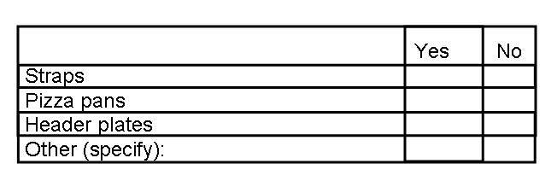

- What types of floor and roof material have you dealt with over the past month (please circle all that apply)?

        - Shale
        - Sandstone
        - Other (please specify) _______________________

- What conditions have changed in your section in the past month (please circle all that apply)?

        - None
        - Type of surrounding rock
        - Roof control plan
        - Quality of roof
        - Amount of wetness
        - Seam height
        - Now have undulating ground conditions
        - Now have non-undulating ground conditions
        - Other (please specify) _______________________

- Is the floor level or does it have a dip or pitch (please circle)?

        - Level
        - Dip or pitch

