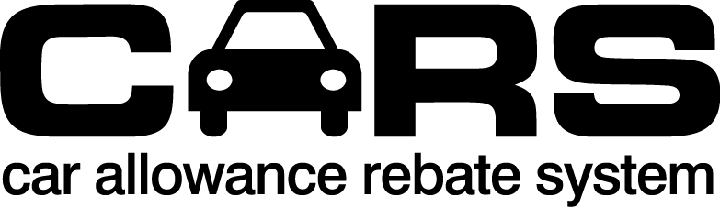
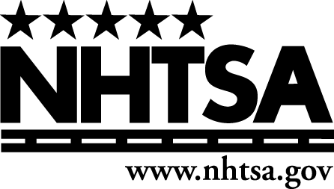
Disposal Facility Certification Form

Disposal Facility Information
CARS Invoice No. (if available)
End of Life Vehicle Solutions (ELVS) Identification No. (if assigned)
Legal Business Name
Doing Business As (DBA)/Common Name (if different from Legal Business Name)
Address (including Street, City, State, ZIP Code)
Trade-In Vehicle Information
Make |  |  |  |  |  |  |  |  |  | Model |  |  |  |  |  |  |  |  |  |  | Model Year
Trade-In Vehicle VIN |  |  |  |  |  |  |  |  |  |  |  |  |  |  |  |  |  |  | Odometer Mileage
Dealer or Salvage Auction Transferring Trade-In Vehicle Information
Legal Business Name
Doing Business As (DBA)/Common Name (if different from Legal Business Name)
Address (including Street, City, State, ZIP Code)
Check one:  [ ] Dealer  [ ] Salvage Auction |  |  |  |  |  |  |  |  |  | Contact Name and Title |  |  |  |  |  |  |  |  |  |  | Contact Phone and Email
Address (including Street, City, State, ZIP Code) |  |  |  |  |  |  |  |  |  |  |  |  |  |  |  | Date this Facility Received the Trade-In Vehicle from Dealer or Salvage Auction

WARNING

This is a legal document that contains certifications under penalty of law. There are significant civil and criminal penalties for submitting false information. Please read each certification and ensure that the information that you are certifying by signing this document is, to the best of your knowledge and belief, true, accurate, and complete.

The person signing this document certifies under penalty of law that:

- This facility appears on the CARS program Disposal Facility List.
- This facility participates in the End of Life Vehicle Solutions (ELVS) program and the ELVS identification number listed above is true and correct. (Excluding facilities located in Maine or a U.S. territory).
- This facility is capable of crushing or shredding the trade-in vehicle, either with its own equipment or by use of a mobile crusher.
- This facility meets all applicable Federal and State laws.
- This facility has a currently active State license to operate as a disposal facility in the State where it is located.
- This facility received the trade-in vehicle bearing the above listed Vehicle Identification Number (VIN) on the date listed above from the dealer or salvage auction listed above.
- I, or an employee of this facility under my direction or supervision, will report to the National Motor Vehicle Title Information System (NMVTIS) the status of the trade-in vehicle as a scrap vehicle not more than seven (7) days after the above-listed date of receipt.
- The trade-in vehicle has not been, and will not be, sold, leased, exchanged or otherwise disposed of for use as an automobile in the United States or in any other country.
- This facility will not transfer the trade-in vehicle to another disposal facility prior to its crushing or shredding.
- This facility will not sell or transfer the trade-in vehicle’s engine block and drive train (unless with respect to the drive train, the transmission, drive shaft, or rear end are sold as separate parts) at any time prior to its crushing or shredding.
- I, or an employee of this facility under my direction or supervision, will dispose of refrigerants, antifreeze, lead products, mercury switches, and such other toxic or hazardous vehicle components prior to the crushing or shredding of the trade-in vehicle, in accordance with all applicable Federal and State requirements.
- If this facility participates in ELVS, I, or an employee of this facility under my direction or supervision, will return all mercury switches in accordance with the procedures of the National Vehicle Mercury Switch Recovery Program (NVMSRP).
- I, or an employee of this facility under my direction or supervision, will crush or shred (or cause to be crushed or shredded on our premises), the trade-in vehicle within one-hundred eighty (180) days after the above-listed date of receipt.
- I, or an employee of this facility under my direction or supervision, will report to NMVTIS that this facility crushed or shredded the trade-in vehicle not more than seven (7) days after the date of crushing or shredding. (Note: The CARS program does not require that this facility, or any other entity which may subsequently receive the crushed trade-in vehicle, subsequently submit to NHTSA a CARS program Disposal Facility Certification Form, nor does it require that this facility, or any other entity which may subsequently receive the crushed trade-in vehicle, report to NMVTIS that the crushed trade-in vehicle has been shredded).
I certify under penalty of law that:
- I have authority to execute this document,
- I have read each of the foregoing certifications,
- This document, and any attachments, were either prepared by me or prepared under my direction or supervision,
- The information set forth in this document, and any attachments, is, to the best of my knowledge and belief, true, accurate, and complete,
- I am aware that there are significant penalties for submitting false information, including the possibility of civil penalties under the CARS program, suspension or revocation of continued participation in the CARS program, as well as fines and/or imprisonment.

DATE: ______, 2009 DISPOSAL FACILITY
___________________________________
(signature)

___________________________________
(print name)

___________________________________
(title)

___________________________________
(contact phone and e-mail)

Privacy Act Statement

This notice is provided pursuant to the Privacy Act of 1974, 5 USC § 552a: This information is solicited under the authority of Public Law 111-32, 123 Stat. 1859. Furnishing the information is voluntary, but failure to provide all or part of the information may result in disapproval of a request for a credit on this purchase or lease transaction under the Cars Program. The principal purposes for collecting the information are to ensure proper disposal of trade-in vehicles, to prevent, identify and penalize fraud in connection with the Program, and to update an existing government database of Vehicle Identification Numbers. Other routine uses are published in the Federal Register at 65 F.R. 19476 (April 11, 2000), available at: www.dot.gov/privacy.

Paperwork Reduction Act Burden Statement

A federal agency may not conduct or sponsor, and a person is not required to respond to, nor shall a person be subject to a penalty for failure to comply with a collection of information subject to the requirements of the Paperwork Reduction Act unless that collection of information displays a current valid OMB Control Number. The OMB Control Number for this information collection is 2127-XXXX. Public reporting for this collection of information is estimated to be approximately XX minutes per response, including the time for reviewing instructions, completing and reviewing the collection of information. All responses to this collection of information are mandatory. Send comments regarding this burden estimate or any other aspect of this collection of information, including suggestions for reducing this burden to: Information Collection Clearance Officer, National Highway Traffic Safety Administration, 1200 New Jersey Ave, S.E., Washington, DC, 20590.

