
USDA eAuthentication
Account Registration Aid

Updated: 11/15/08

This document details how USDA customers and employees can obtain a USDA eAuthentication account that allows access to USDA Web applications and services protected by eAuthentication. Customers may obtain an account with Level 1 or Level 2 access while USDA federal employees may obtain an account with Level 2 access. These accounts are obtained through an electronic self-registration process.

Customer Level 1 Access Self-Registration Process 2
Customer Level 2 Access Self-Registration Process 7
Employee Account Self-Registration Process 13
Additional assistance 20

Customer Level 1 Access Self-Registration Process
To obtain a Level 1 USDA eAuthentication account, all customers must go to: https://eauth.sc.egov.usda.gov/eAuth/selfRegistration/selfRegLevel1Step1.jsp.

The four (4) steps to self-register are:

- STEP 1 of 4: Registration Form Completion
- STEP 2 of 4: User Information Verification
- STEP 3 of 4: Activation Instructions Notification
- STEP 4 of 4: Account Activation

STEP 1 of 4: Registration Form Completion

You are required to fill out the following fields:

DATA POINT | CRITERIA
User ID | User ID must be 6-20 characters in length.  Note: Select your User ID carefully - do NOT include your SSN for example - once your User ID is created you will be unable to modify it.
Password | - • 9 to 12 characters long  - • Contains at least one uppercase letter  - • Contains at least one lowercase letter  - • Contains at least one number or a special character:  - ! # - $ % * = + : ; , ? ~  - • May not contain your name, User ID, Mother’s Maiden Name, Date of Birth, 4-digit PIN, or security questions /answers.  - • May not contain words that can be found in a dictionary, spaces, tabs, or any other special characters not listed above.  - Please note: Your password will expire after 180 days.
First Name, Last Name | Please enter exactly as on your State Driver’s License, State Identification Card, or Passport.
E-Mail | Please enter a valid working E-Mail address.
Country | Please select the country you currently reside in.

You can optionally fill out the following fields:

DATA POINT | CRITERIA
Middle Initial | Please enter exactly as on your State Driver’s License, State Identification Card, or Passport.
Home Postal/ZIP Code | Please enter your current home postal/ZIP code.

After entering the information on the initial screen, click Continue.

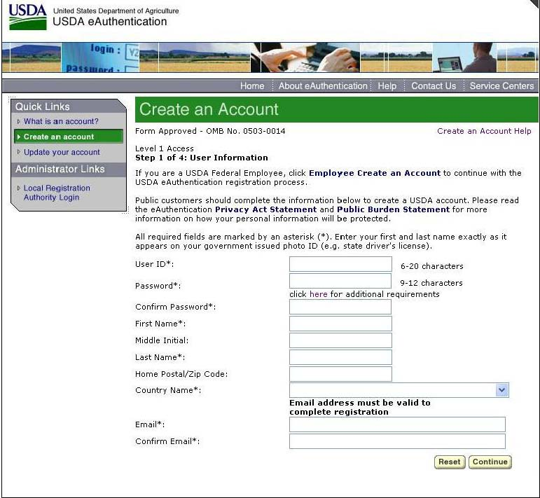
Figure 1: Registration Form

STEP 2 of 4: User Information Verification

On the following screen, verify the information and then click Submit.
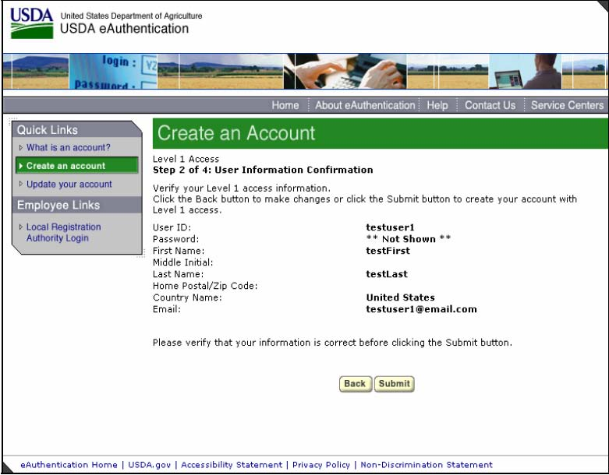
Figure 2: User Information Verification
SECURITY CAUTION!

Once you have confirmed your eAuthentication credential, it will become your official electronic identity online throughout USDA. Please take great care in protecting your password - it is your responsibility to keep this electronic identity private to prevent identity theft. Please do not share your password or write it down in an insecure location.

STEP 3 of 4: Activation Instructions Notification

After submitting your account information, the next screen informs that an activation email will be issued to you, communicating your registration status and the necessary steps to complete the USDA Level 1 Credentialing process. Print this page for your future reference and verify your email address.

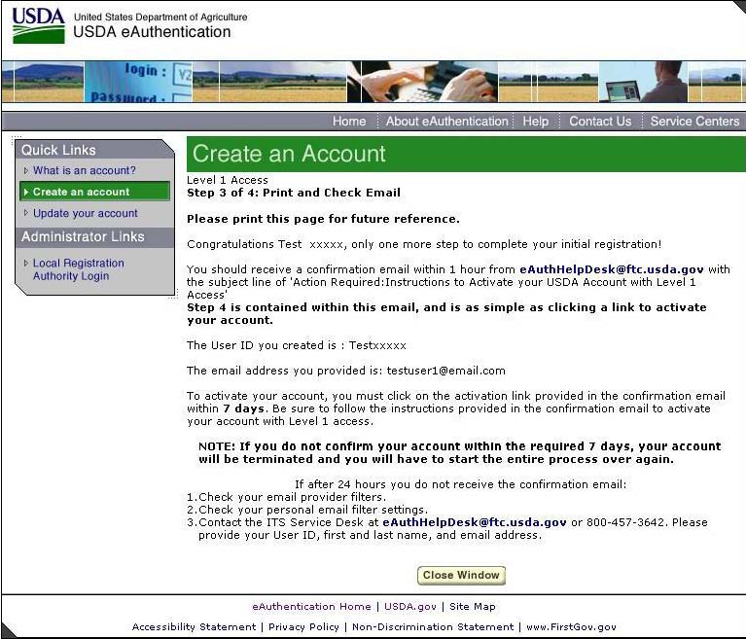 Figure 3: Activation Instructions

STEP 4 of 4: Account Activation

You must verify your email address by clicking on the ACTIVATE MY ACCOUNT link within this email:

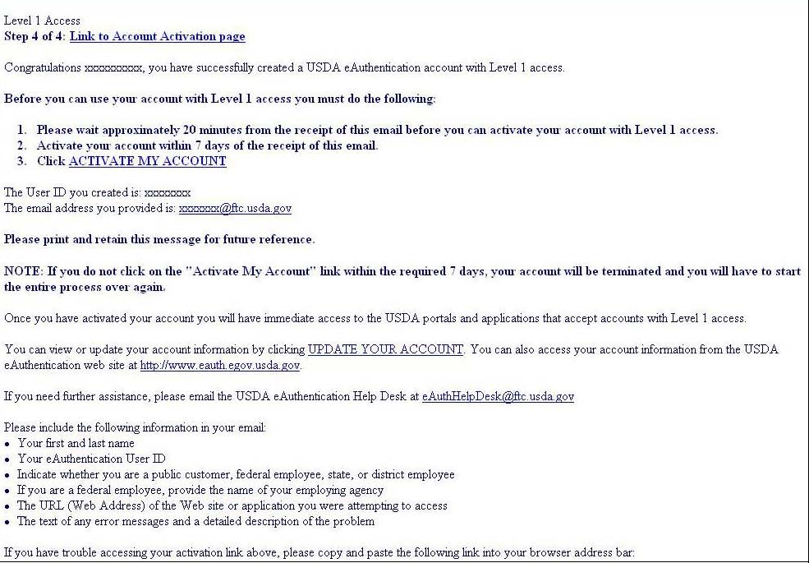
Figure 4: Activation Email

Once you have completed this step, you have a valid Level 1 access USDA Account. You will see this confirmation screen:

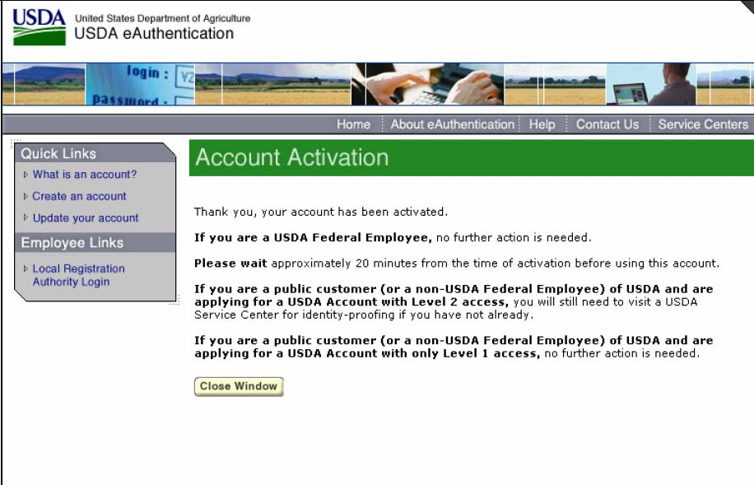
Figure 5: Account Activation

Customer Level 2 Access Self-Registration Process

To obtain a Level 2 USDA eAuthentication credential, all customers must go to https://eauth.sc.egov.usda.gov/eAuth/selfRegistration/selfRegLevel2Step1.jsp.

The five (5) steps to self-register are:

- STEP 1 of 5: Registration Form Completion
- STEP 2 of 5: User Information Verification
- STEP 3 of 5: Activation Instructions Notification
- STEP 4 of 5: Account Activation
- STEP 5 of 5: In-Person Identity Proofing

STEP 1 of 5: Registration Form Completion

You are required to fill out the following fields:

DATA POINT | CRITERIA
User ID | User ID must be 6-20 characters in length.  Note: Select your User ID carefully - do NOT include your SSN for example - once your User ID is created you will be unable to modify it.
Password | - • 9 to 12 characters long  - • Contains at least one uppercase letter  - • Contains at least one lowercase letter  - • Contains at least one number or one of these special characters: ! # - $ % * = + : ; , ? ~  In addition:  - • Your password may not contain your first name, last name, User ID, Mother’s Maiden Name, Date of Birth, 4-digit PIN, security questions or answers.  - • Do not use words that can be found in a dictionary, spaces, tabs, or any other special characters not listed above.  - • Your password will expire after 180 days.
First Name, Last Name | Please enter exactly as on your State Driver’s License, State Identification Card, or Passport.
E-Mail | Please enter a valid working E-Mail address.
Home Address, Home City, and Home State | Please enter your current home address, city, and state.
Home Postal/ZIP Code | Please enter your current home postal/ZIP code.
Country | Please select the country you currently reside in.
Mother’s Maiden Name: | Please enter your mother’s maiden name for security verification purposes.
4 Digit PIN: | Please enter a PIN number
Date of Birth | Please enter exactly as on your State Driver’s License, State Identification Card, or Passport.
Security Questions & Answers | Choose security questions from the pull-down list. Then type answers that only you would know.

You can optionally fill out the following fields:

DATA POINT | CRITERIA
Middle Initial | Please enter exactly as on your State Driver’s License, State Identification Card, or Passport.
Home Phone | Please enter your current home phone.
Alternate Phone | Please enter an alternate phone.

After entering the information on the initial screen, click Continue.
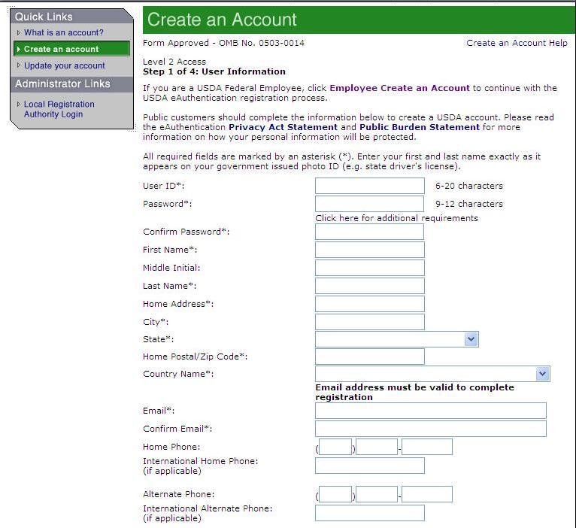
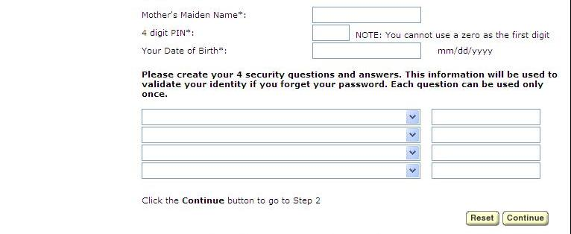
Figure 1: Registration Form

STEP 2 of 5: User Information Verification

On the following screen, verify the information and then click Submit.

SECURITY CAUTION!
Once you have confirmed your eAuthentication credential, it will become your official electronic identity online throughout USDA. Please take great care in protecting your password and the security questions that you stored - it is your responsibility to keep this electronic identity private to prevent identity theft. Please do not share this password or write it down in an insecure location.

STEP 3 of 5: Activation Instructions Notification

After submitting your account information, the following screen informs that an activation email will be issued to you. This activation email will contain instructions for completing the USDA Level 2 Credentialing process. Print this page for your future reference.

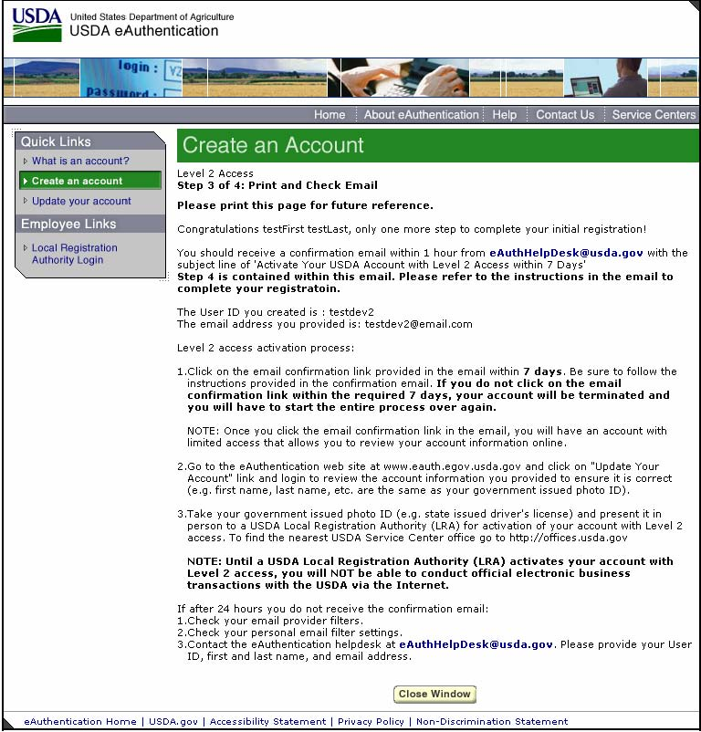
Figure 2: Activation Instructions

STEP 4 of 5: Account Activation

You must confirm your account by clicking on the ACTIVATE MY ACCOUNT link within this email.

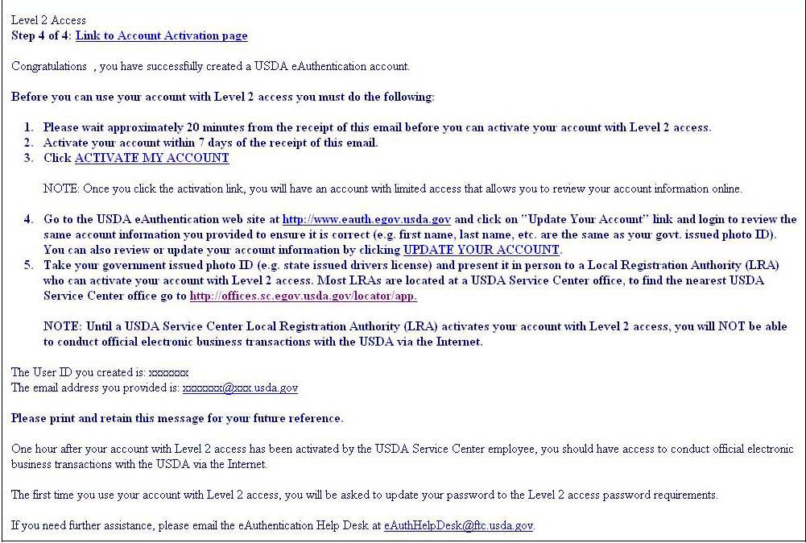
Figure 3: Activation Email

NOTE: Once you have completed this step, you have a valid Level 1 account and will see the following screen. In order to obtain an activated Level 2 account you will need to complete Step 5.

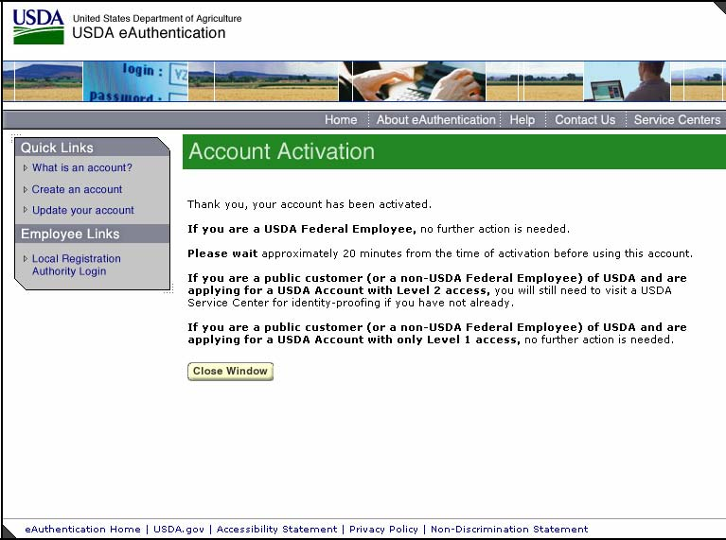
Figure 4: Account Activation
STEP 5 of 5: In-Person Identity Proofing

The final step to obtain Level 2 access will require you to be identity-proofed: take your government-issued photo ID (e.g. state issued drivers license) and present it in person to a USDA Service Center where a USDA employee who is a Local Registration Authority (LRA) can activate your account with Level 2 access. To find the nearest USDA Service Center with an LRA, go to http://offices.sc.egov.usda.gov/locator/app?type=lra. We recommend calling ahead to schedule an appointment.

IMPORTANT NOTE:
Before you visit a USDA Service Center, please verify that all of your information on file with USDA is correct. Incorrect data will result in failure of the in-person Identity Proofing Process. To verify or update your information, go to the eAuthentication web site at www.eauth.egov.usda.gov and click on “Update your account”, then log in with your User ID and password. Select “Modify my profile” and make any needed changes.

Employee Account Self-Registration Process

To obtain an Employee Level 2 USDA eAuthentication account, a USDA federal employee must receive a Registration Invitation email.

Pre-requisites:

- Your HR record must be completed by your HR representative, and you must have a valid email address.
- You must receive the Registration Invitation email and click on the link within the email.

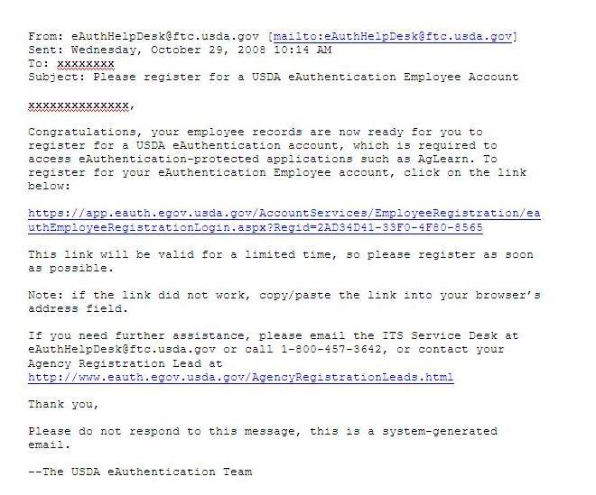
Figure 1: Registration Invitation Email

Once you have clicked on the link within the Registration Invitation, the steps to register are:

- STEP 1 of 6: Credential Verification
- STEP 2 of 6: Employee Verification & User ID Selection
- STEP 3 of 6: Populate Your Security Attributes
- STEP 4 of 6: Confirm Your Security Attributes
- STEP 5 of 6: Password Creation
- STEP 6 of 6: Congratulations Message
- STEP 1 of 6: Credential Verification

You are required to fill out the following fields:

DATA POINT | CRITERIA
Last 4 digits of SSN | Please enter the last 4 digits of your Social Security Number
Date of Birth | Please enter your date of birth, using the pull down menus

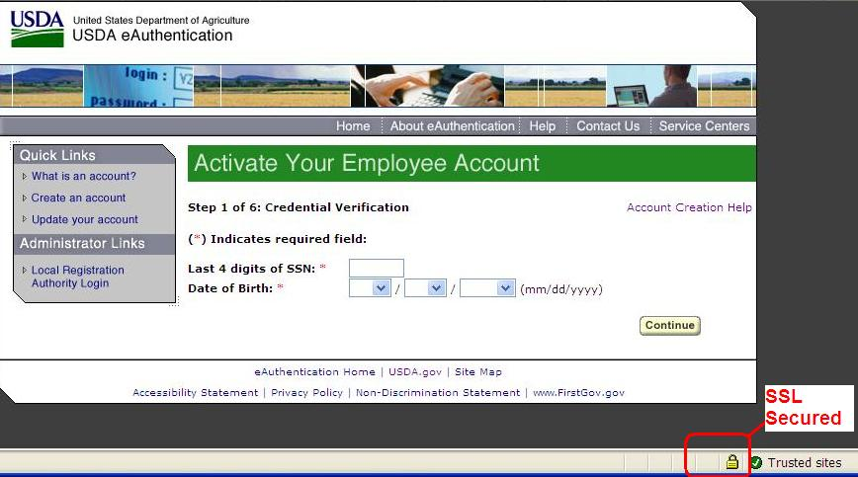
Figure 2: Credential Verification Form

After entering the information on the initial screen, click Continue.

- STEP 2 of 6: Employee Verification & User ID Selection

On the following screen, verify the information that is displayed.
- If your email address is not correct, please close your browser window (click on the red “x”) and contact your Agency Registration Lead for assistance: http://www.eauth.egov.usda.gov/AgencyRegistrationLeads.html
- If any of your HR information is not correct, please note which information is not correct and close your browser window (click on the red “x”). Contact your HR rep and ask them to review the items you’ve noted.

- If ALL of your information is correct, create a User ID using your Agency’s preferred format. If you do not know your Agency’s preferred format, please contact your Agency Registration Lead for assistance: http://www.eauth.egov.usda.gov/AgencyRegistrationLeads.html
  - Your User ID must be 6 to 20 characters long. It is not case sensitive and may contain the following characters: . @ _ - (period, “at” sign, underscore, hyphen)
  - Note: Select your User ID carefully - do NOT include your SSN for example - once your User ID is created you will be unable to modify it.
  - When finished, click Continue.

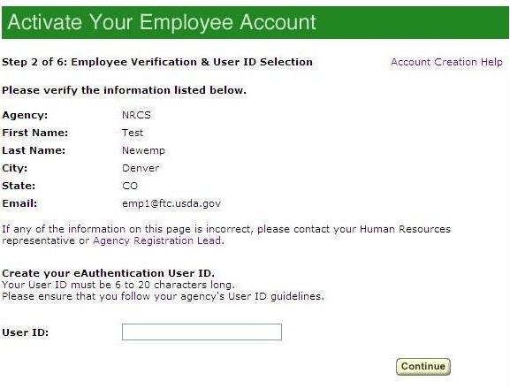 Figure 3: Employee Verification & User ID Selection

STEP 3 of 6: Populate Your Security Attributes

On the next screen, you are required to fill out the following fields:

DATA POINT | CRITERIA
Questions | Select 4 different security questions using the pull-down menus.
Answers | Type an answer that only you would know (i.e., information that is non-researchable.) Answers are not case sensitive, however spaces and spelling do matter, so please enter something that is easy to remember.
Mother’s Maiden Name | Please enter your mother’s maiden name for security verification purposes.
4 Digit PIN | Please enter a 4 digit PIN number. Note: You cannot use a zero “0” as the first digit.

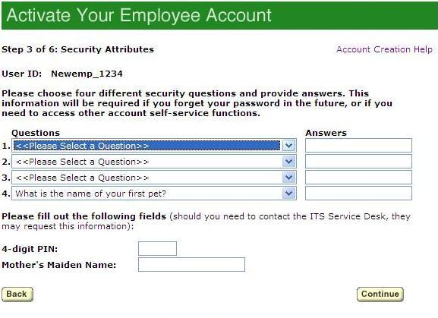
Figure 4: Employee Verification & User ID Selection

After entering the information, click Continue.
STEP 4 of 6: Confirm Your Security Attributes

Verify the information that you entered and click Continue. To change any of the information click on the Back button.

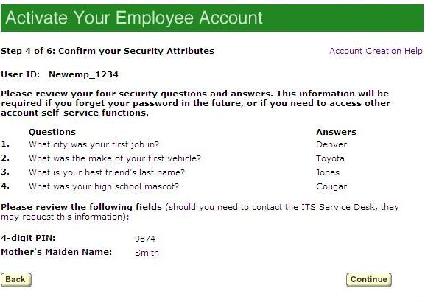 Figure 5: Confirm Your Security Attributes

STEP 5 of 6: Password Creation

Please create a password for your account in accordance with the guidelines.

DATA POINT | CRITERIA
Password | - • 9 to 12 characters long  - • Contains at least one uppercase letter  - • Contains at least one lowercase letter  - • Contains a number or a special character: ! # - $ % * = + : ; , ? ~  - • May not contain your name, User ID, Mother’s Maiden Name, Date of Birth, 4-digit PIN, or security questions / answers.  - • May not contain words that can be found in a dictionary, spaces, tabs, or special characters not listed above.
Confirm Password | Re-type your password

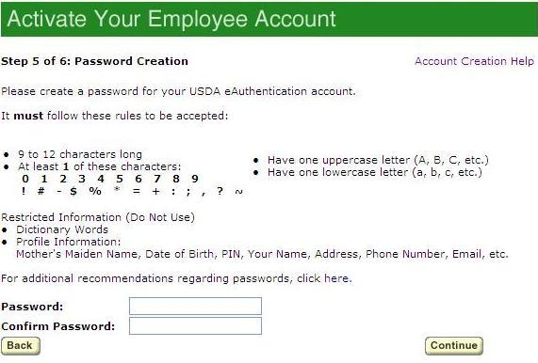
Figure 6: Password Creation

After entering the information, click on Continue.

STEP 6 of 6: Congratulations Message

In the final step, you will receive a “Congratulations” message on the screen. Your Employee account is now active. You will also receive an email message confirming the creation of your account.

Note: We recommend waiting 10 minutes before you attempt to log in to other websites, to allow for system propagation.

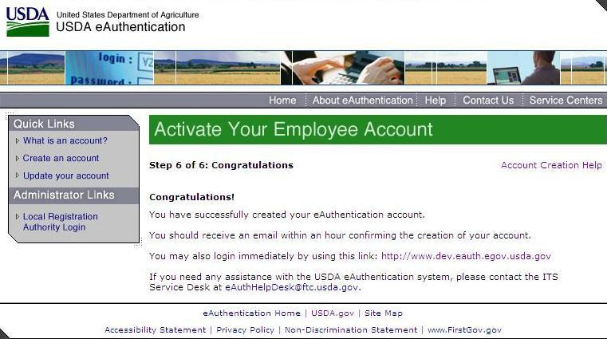
Figure 7: Congratulations Message

Additional assistance

For additional assistance with the eAuthentication account self-registration process, please contact the ITS Service Desk at: eAuthHelpDesk@ftc.usda.gov

Please include:
- Your name and contact information
- Agency (if you are a USDA federal employee)
- Description of the issue:
  - Type of account you are trying to create (Level 1 Customer, Level 2 Customer, or Employee account)
  - If you have received an error message, please also include the exact text of the error message.

