Tools for Schools Training

1. Have you participated in live web training before?

Yes No
2.
Rate your PRIOR knowledge of the content of the training.
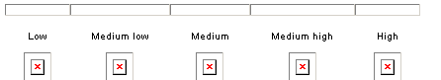

3. The information provided was useful.

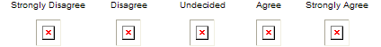

4. The activities were useful and enhanced my learning.

5. The amount of time spent on EACH component of the training was adequate.

6. If you felt that the amount of time devoted to any component was not sufficient or was excessive, please identify it in the space below and provide and any other comments that would help us improve this lesson.
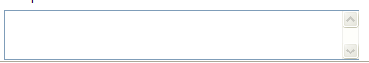

Evaluation of the meeting environment and the trainers
7. I was able to access the Classroom without difficulty.
8. The length of the entire session was about right.

9. I prefer web-based training, rather than classroom-based training with a live trainer.

10. I prefer classroom-based training with a live trainer.

11. The trainers were knowledgeable about the subject matter.

12. The materials aided my learning.

13. Rate your knowledge of the content of the training after completing the course.

14. Please provide any other comments or suggestions you have about how this and future training courses may be improved.

