Sample Web Form for Part A MAI Annual Report

There are three steps included in the Part A MAI Annual Report (Step 1, Step 2A, Step 2B, and Step 3). Fields marked with a red asterisk (*) indicate that the field is editable and required. Some fields are pre-populated from the Plan report and are not editable during the Annual Report.

Step 1
Step 1 is the first page the user sees when they begin their Part A MAI Annual Report.

Figure 1: Step 1 in Part A MAI Annual Report

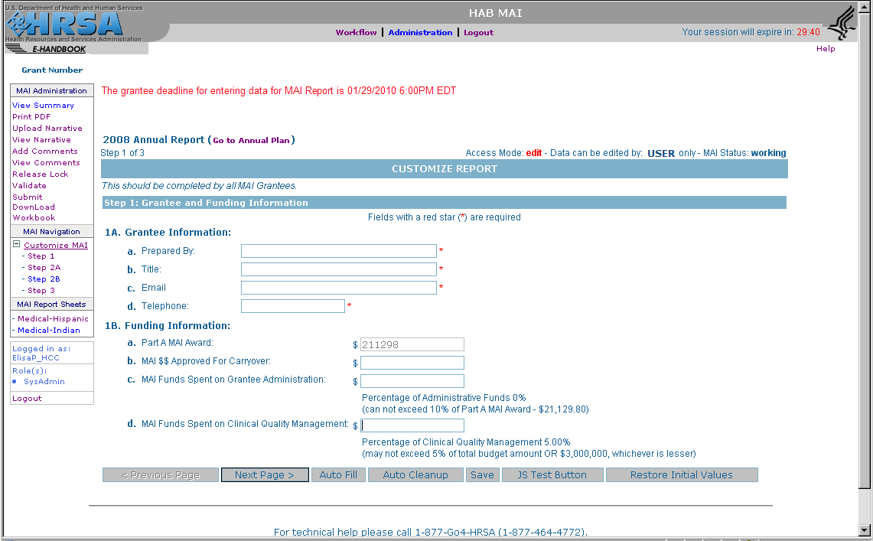

Step 2A
Step 2A is pre-populated with the service categories reported in the Plan report.

Figure 2: Step 2A in Part A MAI Annual Report

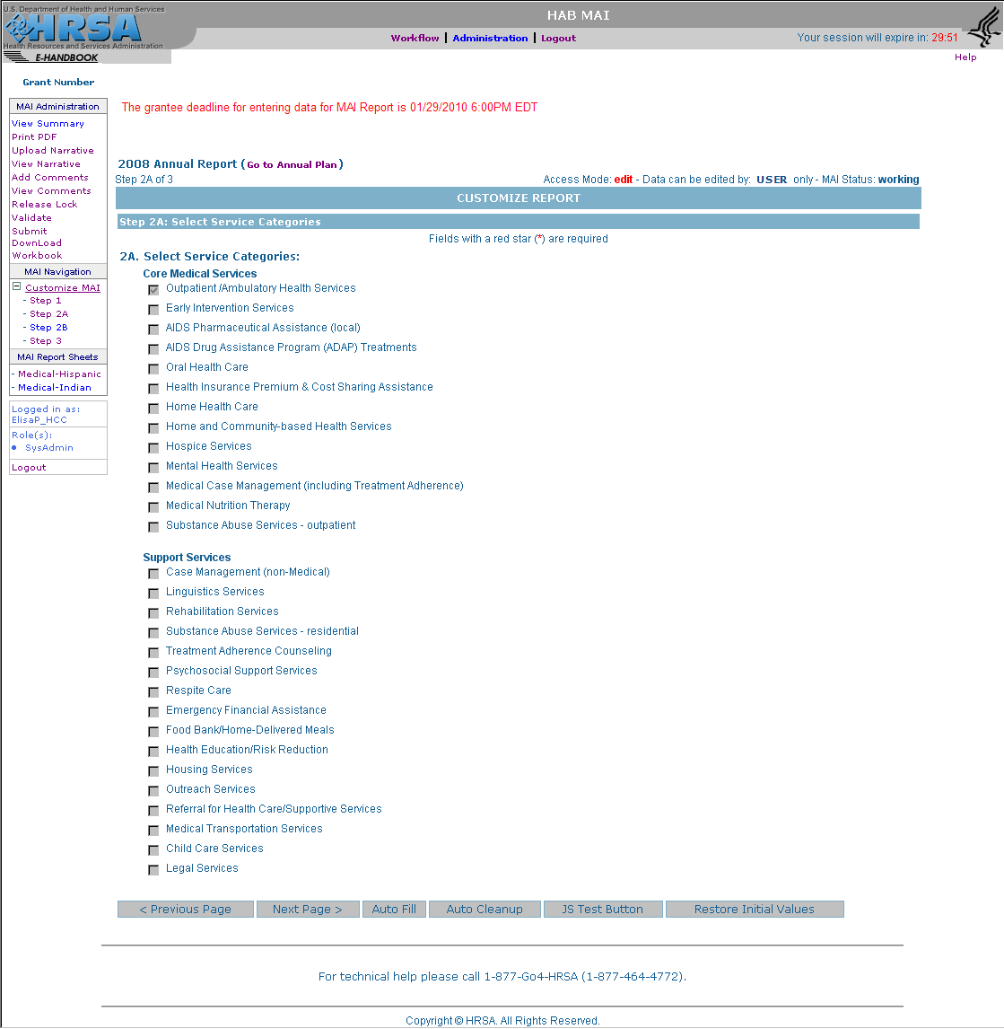

Step 2B
Step 2B is pre-populated with the race/ethnicity and level of effort data for each service category reported in the Plan report.

Figure 3: Step 2B in Part A MAI Annual Report

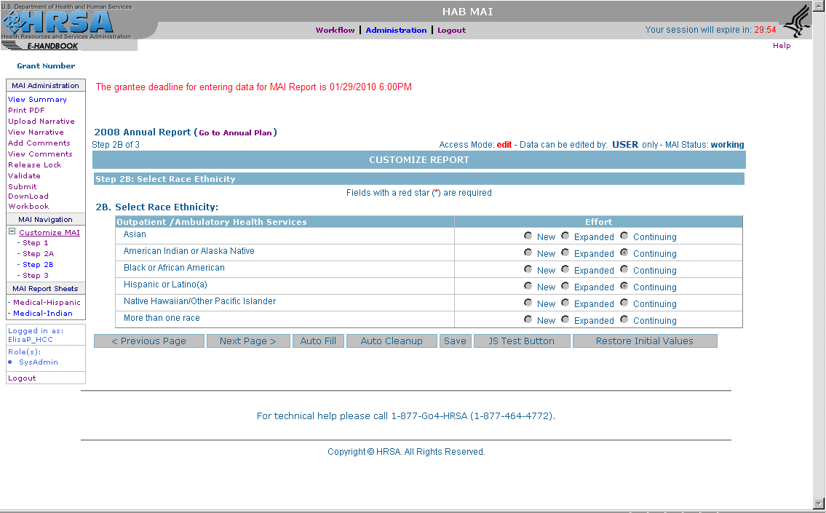

Step 3
Step 3 is the process of filling out the report sheets. There is one report sheet for each race/ethnicity group for each service category. Some fields are pre-populated from the Plan.

Figure 4: Step 3 in Part A MAI Annual Report
