Date: | November 21, 2008
To: | Bill Luckey, PhD., Project Director
From: | Kerry Levin, Chair Westat IRB 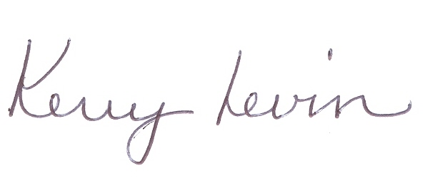
Subject: | PM-Planning and Management- Center for Mental Health Services, Project 8612.01.01  FWA 5551

As Chair of the Westat Institutional Review Board (IRB), I have reviewed the materials submitted for the following: Planning and Management- Center for Mental Health Services, Project 8612.01.01. Pursuant to 45 CFR pt. 46, the IRB reviews all studies involving research on human subjects. This project is funded by Substance Abuse and Mental Health Administration (SAMHSA).

This project provides support for the CMHS for the gathering and housing of performance measurement data from grantees funded by the Center. This work is continuation of a task conducted under Project 7842.

In order to determine that the research is exempt from review by the Board, it is standard Westat practice to request a letter (whenever possible) from the client indicating that the study being conducted is a “program evaluation”, and therefore, qualifies for exemption. Per 45 CFR 46 101 (b) (4) and based on the information provided, this study is a program evaluation and has been exempted from further review.

If activities change, please contact the IRB Office to ensure that the status is accurately reflected in our records. You are only required to submit the study for a continuing review on or before November 21, 2009 if activities change for this project. In the interim, you are responsible for notifying the Office of Research Administration as soon as possible if there are any injuries to the subjects, problems with the study, or changes to the study design that relate to human subjects.

cc: Institutional Review Board
Miriam Aiken

