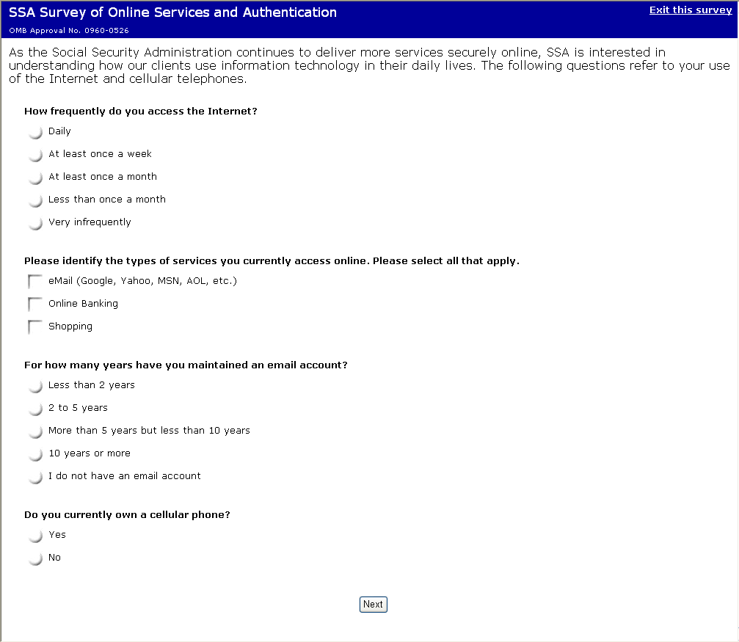

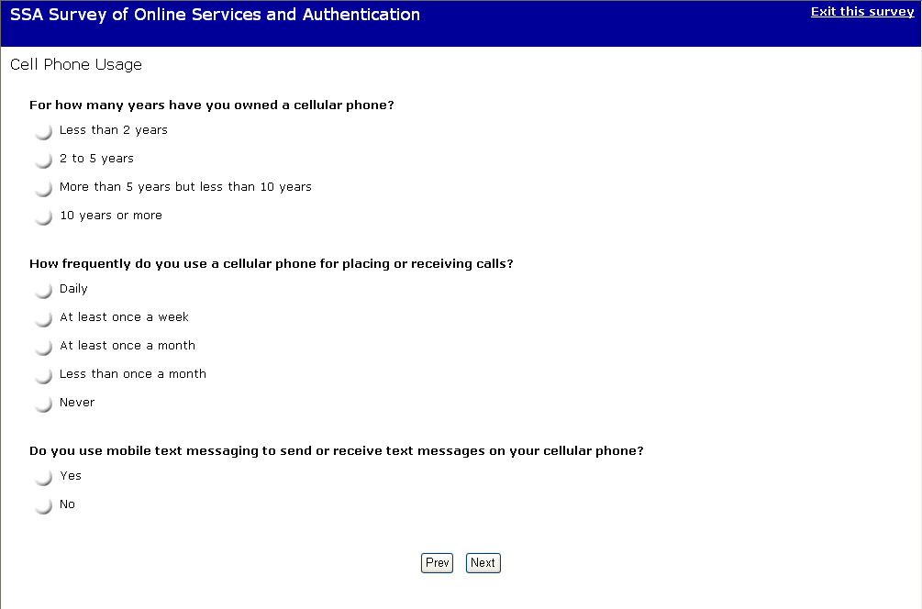

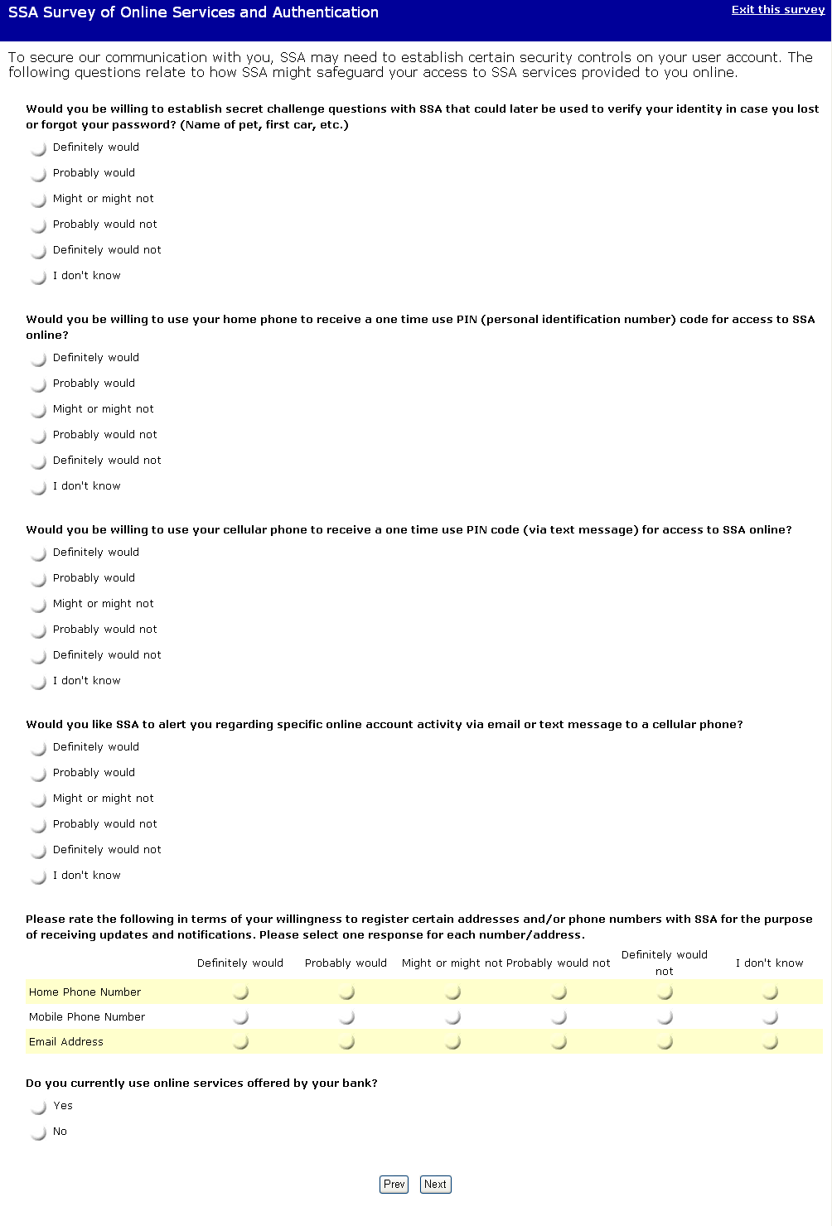

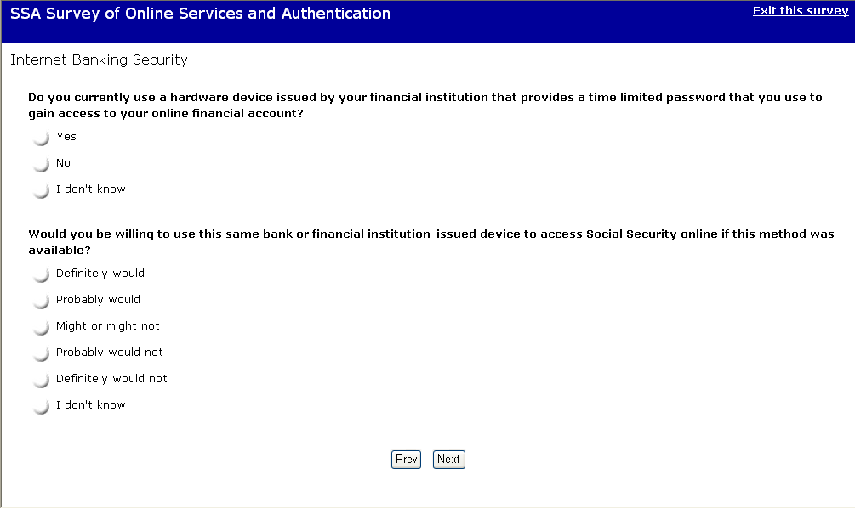

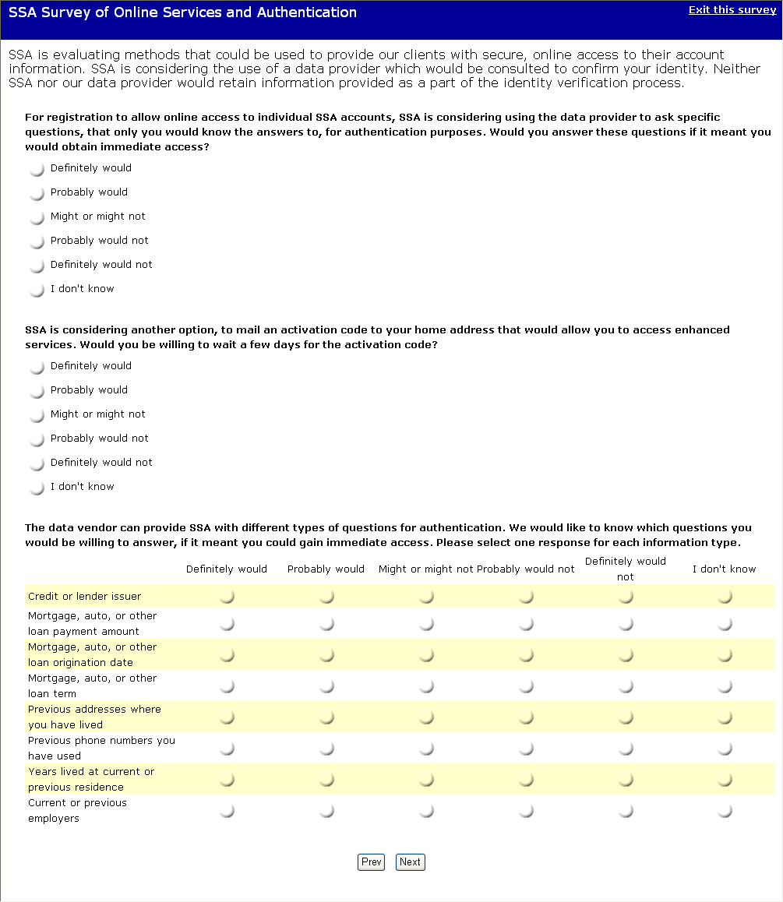

The answer choices for “Please indicate the state in which you currently reside.” are: AL,AK,AZ,AR,CA,CO,CT,DC,DE,FL,GA,HI,ID,IL,IN,IA,KS,KY,LA,ME,MD,MA,MI,MN,MS,MO,MT,NE,NV,NH,NJ,NM,NY,NC,ND,OH,OK,OR,PA,RI,SC,SD,TN,TX,UT,VT,VA,WA,WV,WI,WY, Northern Mariana Islands, Puerto Rico, US Virgin Islands, Other.

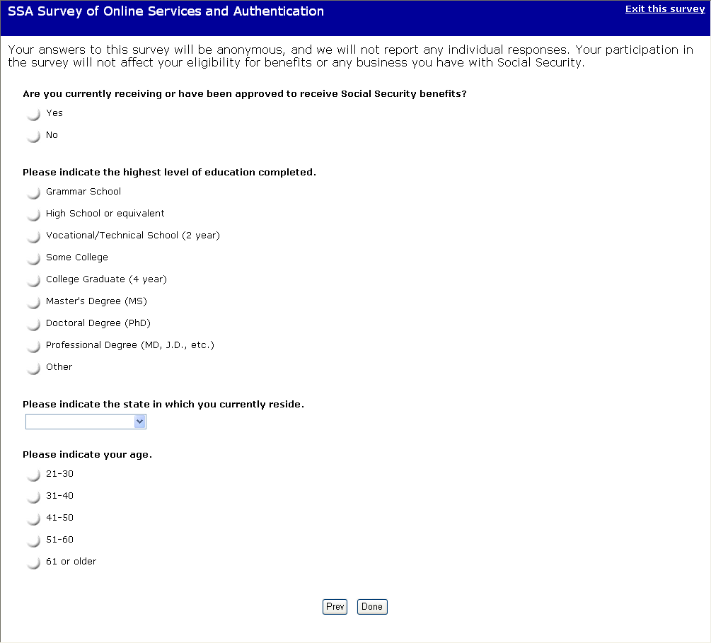

The following thank you page is displayed when the user selects [Done] on the last page of the survey.

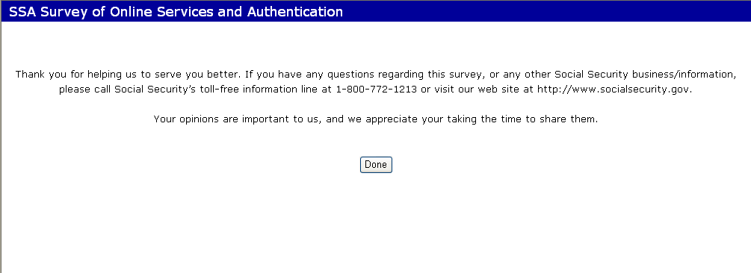

The following page is displayed when the user selects the Exit this survey hypertext link (this link is displayed in all pages of the survey) and when the user selects [Done] on the thank you page.

