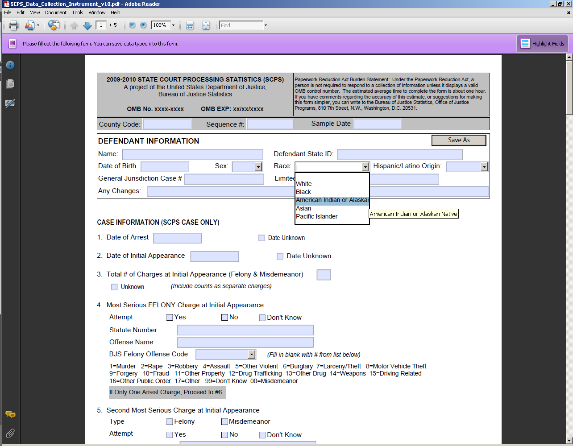
- 2009-2010 State Court Processing Statistics (SCPS) data collection instrument modified to separate “Asian” and “Pacific Islander” into two, separate response options.

