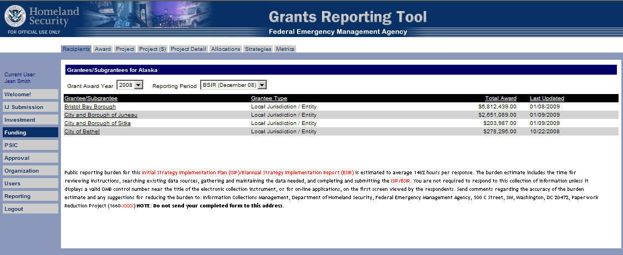
BSIR Submission Funding Module – Recipients Tab – First Screen
(The public reporting burden notice at the bottom of this page will be placed into the system once this data collection effort has been approved by OMB)
Funding Module – Award Tab – Second Screen
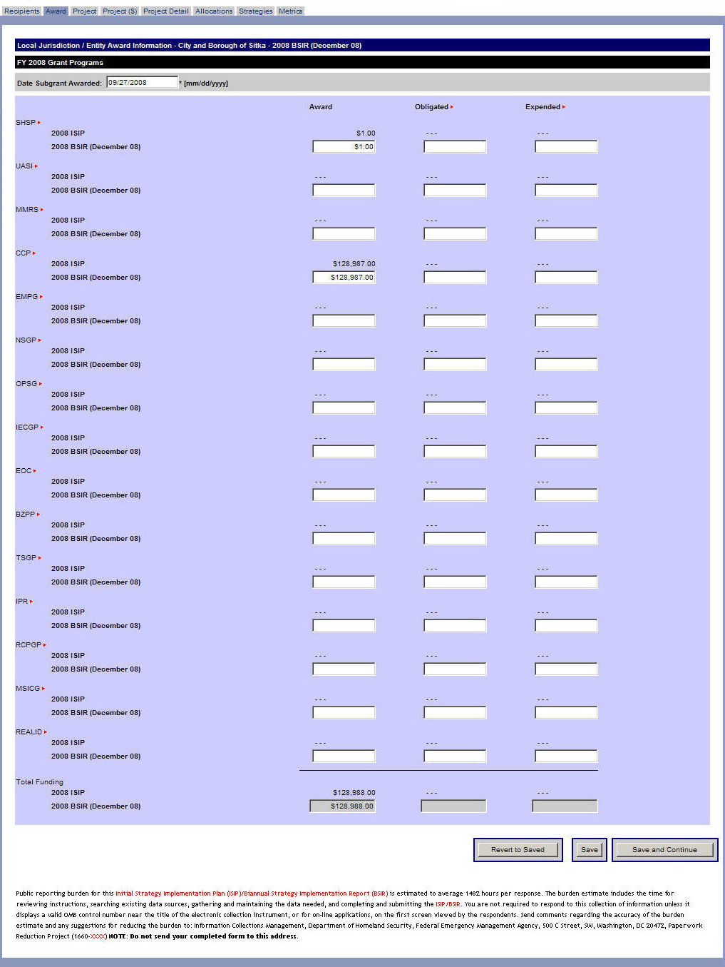
(The public reporting burden notice at the bottom of this page will be placed into the system once this data collection effort has been approved by OMB)
Funding Module – Project Tab – Create Project – Third Screen
(The public reporting burden notice at the bottom of this page will be placed into the system once this data collection effort has been approved by OMB)
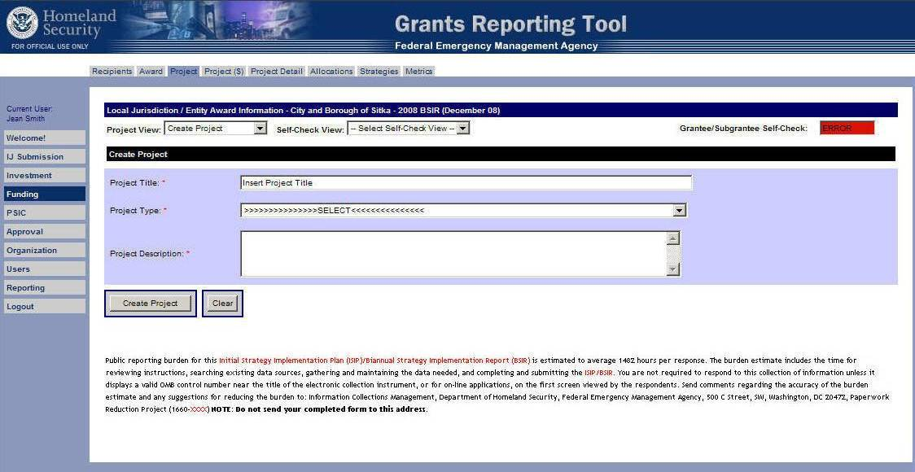
Funding Module – Project Tab – Project History – Fourth Screen
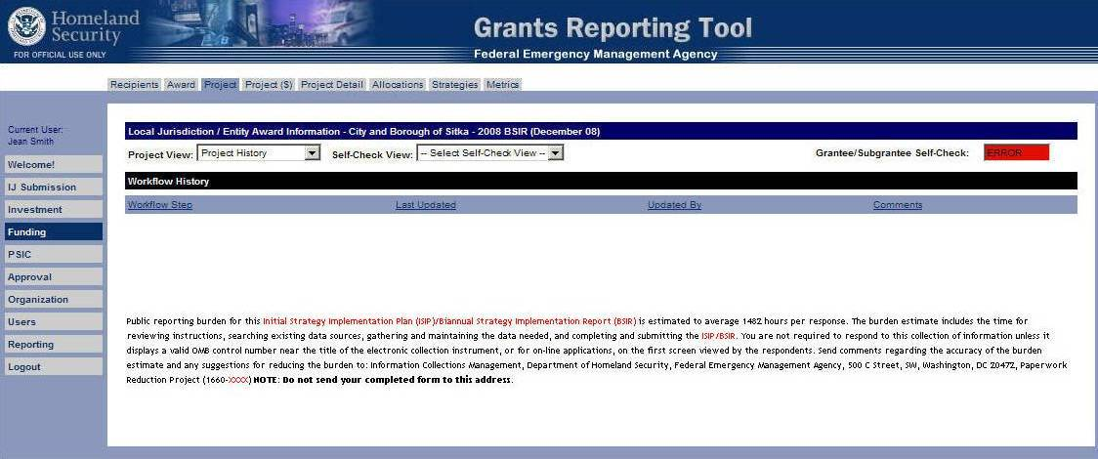
(The public reporting burden notice at the bottom of this page will be placed into the system once this data collection effort has been approved by OMB)
Funding Module – Project Tab – Project List – Fifth Screen
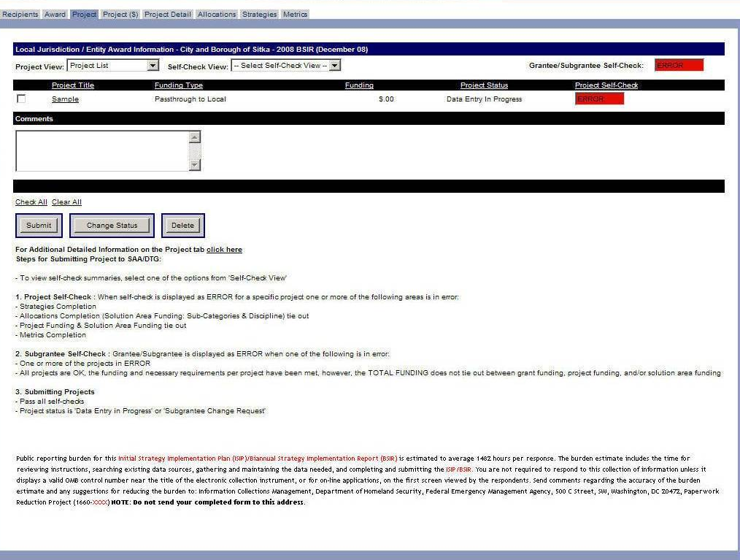
(The public reporting burden notice at the bottom of this page will be placed into the system once this data collection effort has been approved by OMB)
Funding Module – Project ($) Tab – Sixth Screen
(The public reporting burden notice at the bottom of this page will be placed into the system once this data collection effort has been approved by OMB)
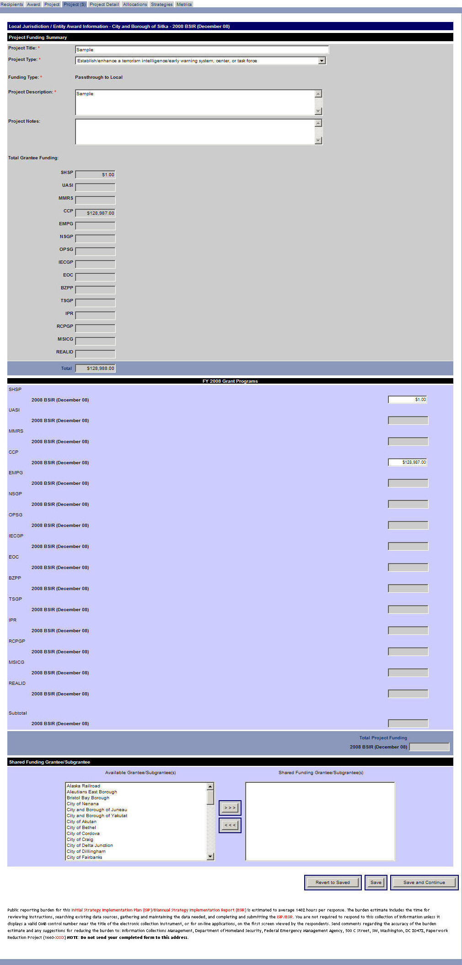
Funding Module – Project Detail Tab – Seventh Screen
(The public reporting burden notice at the bottom of this page will be placed into the system once this data collection effort has been approved by OMB)
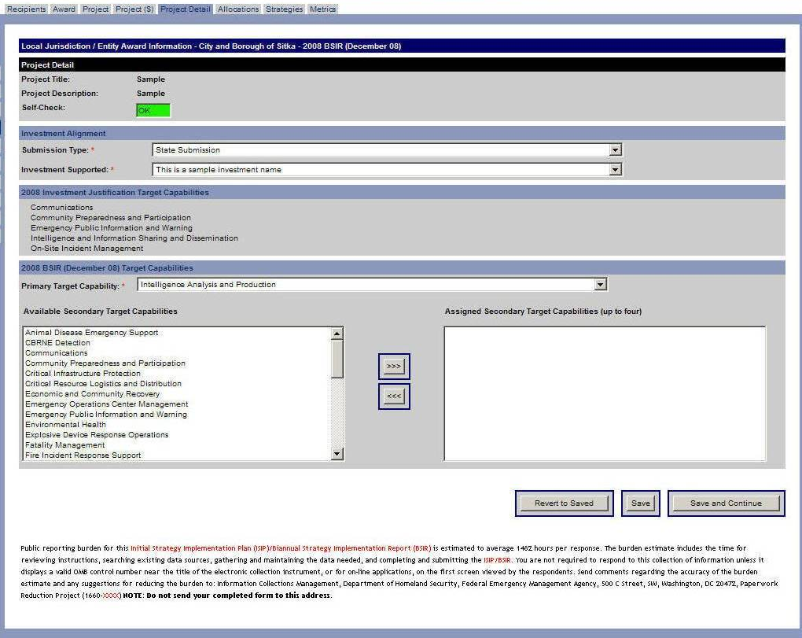
Funding Module – Allocations Tab (Subcategories) – Eighth Screen
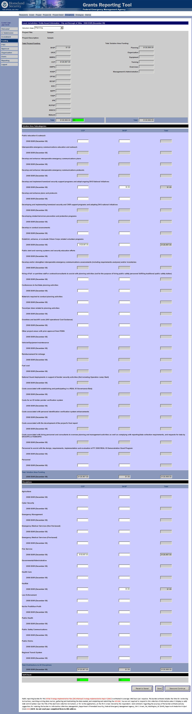
(The public reporting burden notice at the bottom of this page will be placed into the system once this data collection effort has been approved by OMB)
Funding Module – Allocations Tab (Disciplines) – Eighth Screen cont’d
Funding Module – Strategies Tab – Ninth Screen
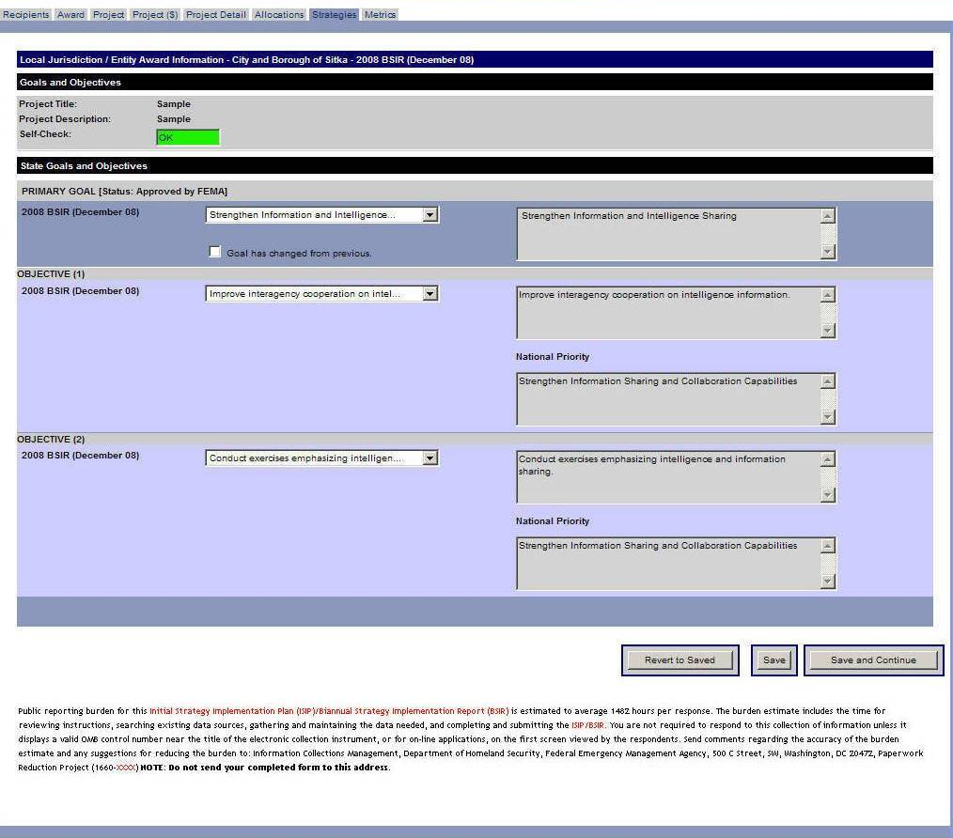
(The public reporting burden notice at the bottom of this page will be placed into the system once this data collection effort has been approved by OMB)
Funding Module – Metrics Tab – Tenth Screen
(The public reporting burden notice at the bottom of this page will be placed into the system once this data collection effort has been approved by OMB)
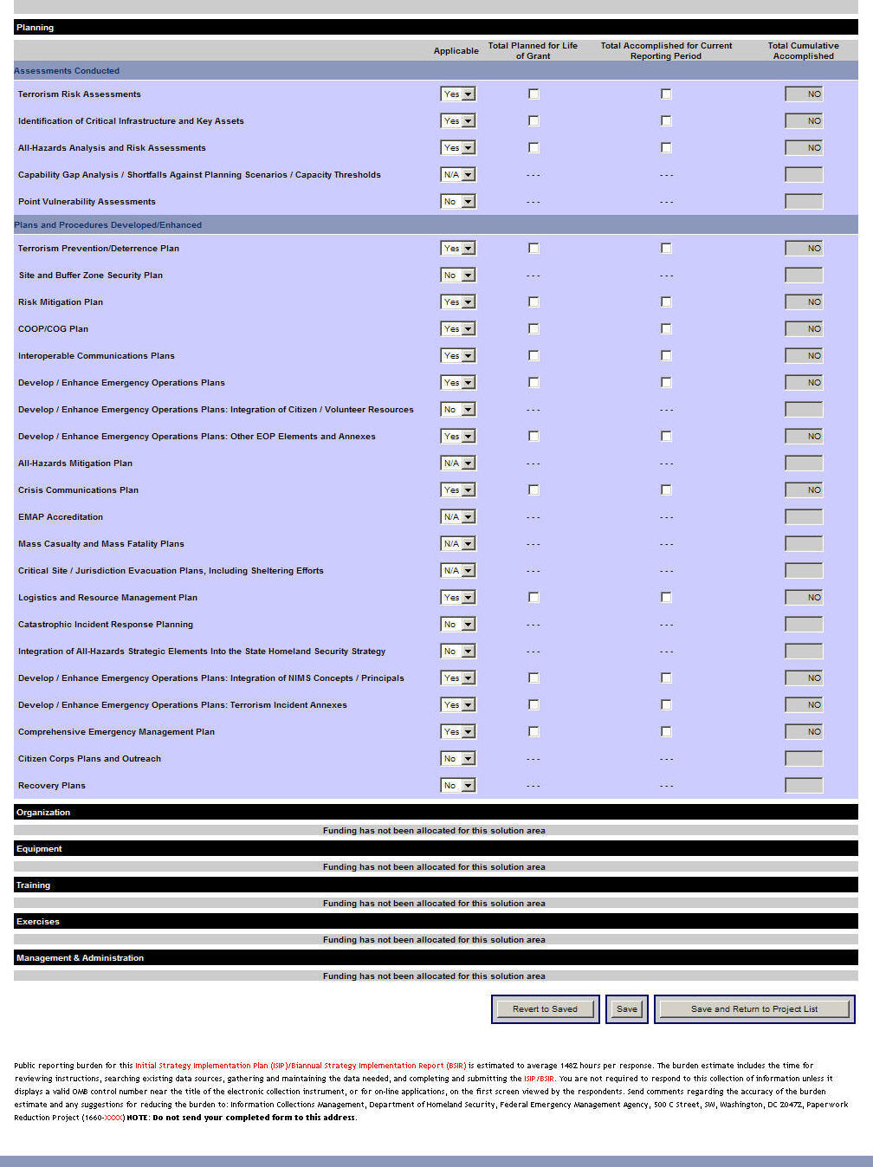
Approval Module – Organization Approval Tab – Eleventh Screen
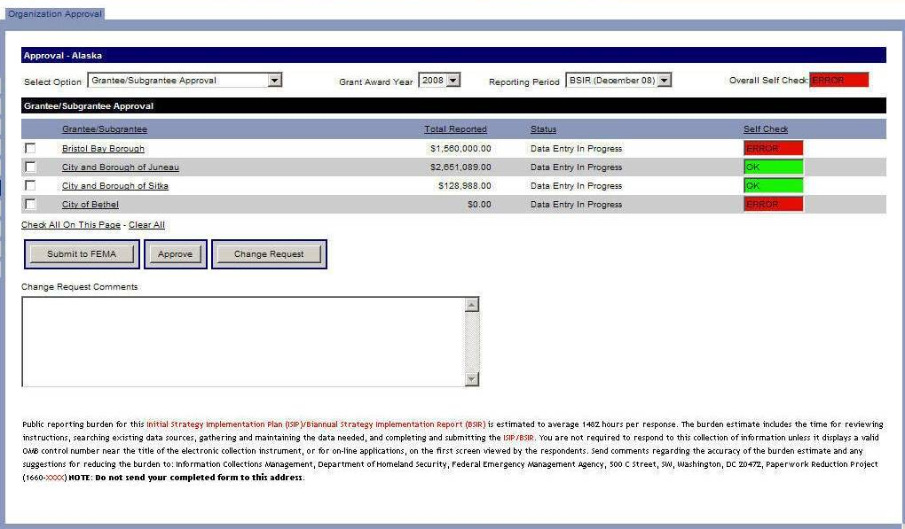
(The public reporting burden notice at the bottom of this page will be placed into the system once this data collection effort has been approved by OMB)

