NATIONAL ASSESSMENT OF
EDUCATIONAL PROGRESS

Volume II
Cognitive Interview Protocols

2010 Puerto Rico Cognitive Interview Study
Related to the Understanding of NAEP Mathematics Items
(Student)

OMB# 1850-0803
(Generic Clearance for Cognitive, Pilot, and Field Test Studies)



February 24, 2009
Revised March 3, 2009

Table of Contents

Paperwork Burden Statement iii
Puerto Rico Cognitive Laboratory Script 1
Audio Recording and Sound Check 2
Digital Voice Recorder (DVR) Instructions 3
Think Aloud Modeling Script 5
Think-Aloud Hints for the Interviewer 8
Additional Question for Interviewer to Model Thinking Aloud. 10
Example Generic Item Script 11
Customized Example of Grade 4 Puerto Rico Cognitive Lab 19
Customized Example of Grade 8 Puerto Rico Cognitive Lab 24

Paperwork Burden Statement

According to the Paperwork Reduction Act of 1995, no persons are required to respond to a collection of information unless such collection displays a valid OMB control number. The valid OMB control number for this information collection is 1850-0803. The time required to complete this information collection is estimated to average 60 minutes including the time to review instructions, search existing data resources, gather the data needed, and complete and review the information collection. If you have any comments concerning the accuracy of the time estimate(s) or suggestions for improving this form, please write to: U.S. Department of Education, Washington, D.C. 20202-4537. If you have comments or concerns regarding the status of your individual submission of this form, write directly to: NAEP/NCES, U.S. Department of Education, 1990 K Street N.W., Washington, D.C. 20006-5651.

A project of the Institute of Education Sciences.
The information you provide will be used for statistical purposes only. In accordance with the Confidential Information Protection provisions of Title V, Subtitle A, Public Law 107-347 and other applicable Federal laws, your responses will be kept confidential and will not be disclosed in identifiable form to anyone other than employees or agents. By law, every NCES employee as well as every agent, such as contractors and NAEP coordinators, has taken an oath and is subject to a jail term of up to 5 years, a fine of up to $250,000, or both if he or she willfully discloses ANY identifiable information about you.
OMB No. 1850-0803 Approval Expires 09/30/2010

Puerto Rico Cognitive Laboratory Script

Text written in italics is to be read aloud by the interviewer.

NOTE: The interviewer should not read the script word for word, but should be familiar enough with its contents to conduct the interview in a natural and conversational manner, paraphrasing or giving further explanation as appropriate.

Prior to Beginning the Interview:
- Arrive early and follow the school’s procedure for signing yourself in at the administrative office.
- If possible, ask to be taken to the location that the cog lab will be held before the student arrives.
- Set up the work space so that
  - you’ll be facing each other across the table or desk, and
  - all of your paperwork and materials (pencils, ancillary materials, test forms, interviewer packet, etc.) are ready when the student arrives.
- Collect the signed consent form from the student.

Introduction:
Hello, my name is ______ and I work for ASPIRA. It’s nice to meet you and thank you very much for helping us out today.

Create small talk to build rapport with the student by asking a question, such as:
- What is your favorite subject in school?
  - If student responds with “mathematics,” follow up with: Good, then I think you’ll enjoy what we are going to be doing today.
  - If student responds with another subject, respond accordingly (e.g., if the student responds with “science,” ask them what they are currently studying in their science class).

Let me begin by explaining why I am here and what you are going to be doing. You are participating in a special study involving sample mathematics test questions from the National Assessment of Educational Progress, or NAEP for short, which is given to students in grades 4 and 8 in Puerto Rico. This study is being conducted at schools all across the island.

I am not here to give you a test. I am here to find out how 4th/8th graders respond to questions like this, and to hear your suggestions for how the questions can be made better.

The goal of this study is to improve the test questions. To achieve this goal, you are going to be answering a small group of test questions in a way that may be different from how you’re used to answering test questions. I will explain more about the process later. Also, after you answer each question, I will ask you some things about the question, and then give you the opportunity to make additional comments or suggestions on how to improve that question.

It’s okay if you do not know how to answer a question. I will not be giving you the answers or grading your work today, and no one will know that it was you who answered the question; however, we ask you to please treat this as if it were a real test.

If at any time you decide you do not want continue, that is your choice and you may stop and go back to class.

Before we continue, do you have any questions about what I just said? [Answer any questions the student may ask.]

Okay, let’s begin.

Audio Recording and Sound Check

Instructions for using the digital voice recorder are on pages 3 to 4 of this document.

I am going to be recording today’s session so I remember the things you say.

Show the student how to clip the microphone to his/her shirt.

First we are going to test the digital voice recorder and microphone to make sure that they are working properly.

When I say, “Go,” I want you to say, “Today is [day of the week]” in a clear voice.

Press the record button on the audio recorder.

“Go.”

Have the student say the test sentence. Press stop on the digital voice recorder when they finish speaking.

Good job, thank you. Now I am going to play back the recording to make sure that I can hear you clearly.

Press play and listen to the quality of the recording.

If the recording is of poor quality, check that the equipment is connected properly and have the student repeat the test sentence until he/she can be heard clearly on the digital voice recorder.

If the recording is of good quality, you can continue with the administration. Press the record button and say clearly into the digital voice recorder:
- the student ID number
- today’s date
- your initials

REMINDER: After the sound check has been successfully performed, make sure the digital voice recorder remains on and is recording for the duration of the session.

Digital Voice Recorder (DVR) Instructions

Instructions for Using the DVR

The digital voice recorder and external microphone are very simple to use. To record a session make sure that the microphone switch is in the “On” position and make sure the plug from the microphone is securely plugged into the “MIC” jack on the digital voice recorder. You should turn the microphone off when it’s not in use.

To make a recording simply press the REC button. You will notice that the timer should be counting up and the little button should light up red. Every time you press REC you store one file in whatever folder is open. Pressing STOP will end that file and the light will turn off. Pressing REC again will create another file in the same folder.

There are 4 folders, A, B, C, D. The screen will have one of these letters displayed to indicate which folder is open. You can move from folder to folder by pressing the FOLDER/INDEX button.

There are 4 different recording quality settings, XHQ, HQ, SP, and LP. We will use the HQ setting and the digital voice recorder should already be in that mode. The recording mode can be seen on the top left hand corner of the display. If it’s not in the HQ mode, you can change the mode by pressing and holding down on the DISP/MENU button for 1 second. Press the Left (<<) and the Right (>>) arrow keys until HQ is flashing. Press the down button (-) and make sure the microphone is set to HI, not LOW. Press the STOP button to exit the menu screen.

It’s easy to replay a recording. As long as you don’t move around folders, just hit the PLAY button. You should be able to hear the recording even if the microphone is plugged into the digital voice recorder. The light will be green when a WAV file is playing.

Between sessions you may put the digital voice recorder on “HOLD;” it serves as the ON/OFF button. To put the digital voice recorder on hold push the side “HOLD” button up.

Saving the Recording

Before the WAV files from the digital voice recorder can be saved onto a computer you first need to install the program to allow the computer to recognize and save the files. Each digital voice recorder comes with a CD with a program that is easy to install. Insert the CD into a computer and follow the prompts for installing the program.

Make a note of the location of the directory that the program will automatically create to save the program and audio files. You will need to access these later so it’s important to know where the files are being stored.

Once the program is installed on a computer you can transport WAV files from the DVR to the computer. Plug the USB connecting cable into the USB drive on the computer and the smaller end of the plug into the DVR in the outlet labeled “PCI/F”. Open the Digital Wave Player program. Press the File A button to Transfer files from the DVR to the computer. Press the File B, File C, and File D buttons individually as well. Transferring the files will likely take a couple of minutes.

Once the files are transferred, all the WAV files on the DVR should show up within the program on the computer.

Test each recording on the computer by pressing the play button on the program to ensure each recording was successfully transferred onto the computer. Look at the length of the recordings on the DVR to ensure that the whole WAV file saved.

Renaming WAV Files on the Computer

There will at least be two recordings per student – one for the recorder test, and one for the rest of the interview. Play each file on the computer and make sure you know which file is which. When you save each file onto the computer, be sure to name the file in a way that will allow you to clearly identify which student/session is on that recording.

Deleting files on the DVR

There is a limited amount of space on the DVR to hold WAV files. It is important to save them to the computer and delete them off the DVR to provide space for future sessions to be recorded.

Once you are sure the entire session was saved successfully on the computer, you can delete the files on the DVR. Within each folder hit ERASE, then press the Left (<<) button to select YES then hit the PLAY button. The file should be erased. To ensure you delete all files you can try hitting play and the recorder should say NO FILE.

Think Aloud Modeling Script

You are going to be answering a small group of mathematics test questions in a way that may be different from how you typically answer questions on a test. Instead of working silently to answer the question, I want you to read the question aloud and think aloud by telling me what you are thinking about while answering the question. In a moment, I will demonstrate the think-aloud process, and then I will give you a chance to practice it.

You will not be evaluated on anything you say while thinking aloud. There are no incorrect thoughts, and everything you say is important to help improve the questions.

I’m now going to show you how to answer a question using the think-aloud process. When I am finished you will get a chance to practice answering a question using this process.

[Give student a copy of the “modeling” question.]

Interviewer Model [Remember: the italicized text should not be read word for word. You should be familiar enough with its contents to demonstrate a think aloud in a natural and conversational manner.] A copy of the item is on page 9 of this document.
- Read both the question and the answer choices aloud.
- Make sense of the question and the figure:
  - The question says the speedometer shows how fast Dale is driving.
  - The speed limit is 55 miles per hour.
  - The speedometer has miles per hour and kilometers per hour written on it.
  - The line on the speedometer is pointing to about 81, so Dale must be going 81 miles per hour. [intentional misinterpretation of the speedometer.]
- Read each option:
  - It says in the question that the speed limit is 55 miles per hour and I know Dale is going 81 miles per hour.
  - Option A says Dale is going about 5 miles per hour over the speed limit, which would be 60 miles per hour. That is not the answer because 81miles per hour is a lot faster than 60 miles per hour.
  - Option B says Dale is going about 25 miles per hour over the speed limit [do “scratch” work on paper and add 25 to 55], which would be 80 miles per hour.
  - This is a true statement because Dale is going about 81 miles per hour, which is close to 80 miles per hour.
  - I think option B is the correct answer, but I want to read the other options before I mark that as my answer.
  - Option C says Dale is going about 5 miles per hour under the speed limit, which would be 50 miles per hour.
- Recognize and “correct the error”:
  - Pause and look at the speedometer again.
  - Wait, 81 miles per hour is wrong; that’s his speed in kilometers per hour. I misread the speedometer. His speed is actually around 51 miles per hour, which is less than the speed limit.
  - I need to look at all the options again.
- Reread each option:
  - Option A says Dale is going about 5 miles per hour over the speed limit, which would be 60 miles per hour and that is not true.
  - Option B says Dale is going about 25 miles per hour over the speed limit, which would be 80 miles per hour and that is also not true.
  - Option C says Dale is going about 5 miles per hour under the speed limit, which would be 50 miles per hour and that is true.
  - Option D says he is driving 25 miles per hour under the speed limit [do “scratch” work on paper and subtract 25 from 55] which would be 30 miles per hour and that is not true.
  - My answer is C. [Fill in oval for option C on paper.]

As you saw, I was talking the whole time I was working on the question.
- I began by reading the question and the answer choices aloud, and then
- I said aloud everything I was thinking about as I answered the question.
- I also made a mistake and had to start over, which is okay because sometimes the answer doesn’t come quickly to me and I have to try several things before I can answer the question.

Do you have any questions about this process? [Answer any questions the student may ask.]

Now I’d like you to practice answering a question by thinking aloud. Please read the question and the answer choices aloud first, and then I’d like you to say all of your thoughts aloud as you answer the question.

[Give student a copy of the “practice” question.]

Student Practice – A copy of the item is on page 9 of this document.
You may need to remind the student to talk aloud as he/she works through the question. If necessary, use the “Think-Aloud Hints” on page 8 of this document to prompt the student but be careful not to lead the student.

If after the student has answered the practice question and if he/she understands what is expected of them, read the following:
Good job!

Do you have any questions before we continue? [Answer any questions the student may ask.]

Okay, let’s move on to the actual test questions. You are going to answer one question at a time, and then I am going to ask you some questions about the particular question you just answered.

Some of the questions may require you to fill in an oval beside your answer choice, while others may require you to write your answer in the space provided.

Because the information you provide for making the test better is so important, I am going to be taking notes while you think aloud and answer the questions. Remember, you are not receiving a grade on the questions you answer today.

Please turn to page x in your packet and follow my instructions.

If after the student has answered the practice question and if he/she does NOT understand what is expected of them, read the following:
That was good.

Before we move on I’d like to demonstrate using the think-aloud process to answer one more question.

[Give student a copy of the second modeling question.]

Second Interviewer Model – Only use if you feel the student could benefit from seeing another demonstration.
[Remember: the italicized text should not be read word for word. You should be familiar enough with its contents to demonstrate a think aloud in a natural and conversational manner.] A copy of the item is on page 10 of this document

- Read both the question and the answer choices aloud.
- Make sense of the question:
- The question is asking me which of the following could be the length of the pencil I use in school.
- Analyze each option:
- All the options have the number 6 in them, but the units are all different.
- Option A says 6 feet, which doesn’t make sense because that would be too big.
- Option B says 6 pounds, [refer back to question] but the question asks about the length of the pencil and pounds are a unit of weight.
- Option C says 6 ounces, which is also a unit of weight.
- Option D says 6 inches, [Look at your pencil] which would make sense for the length of a pencil.
- My answer is D. [Fill in oval for option D on question.]

When you answer the questions I’d like you to use the process of saying aloud everything that you’re thinking.

Do you have any questions about this process before we continue? [Answer any questions the student may ask.]

Okay, let’s move on to the actual test questions. You are going to answer one question at a time, and then I am going to ask you some questions about the particular question you just answered.

Some of the questions may require you to fill in an oval beside your answer choice, while others may require you to write your answer in the space provided.

Because the information you provide for making the test better is so important, I am going to be taking notes while you think aloud and answer the questions. Remember, you are not receiving a grade on the questions you answer today.

Please turn to page x in your packet and follow my instructions.

Think-Aloud Hints for the Interviewer

If the student is silent for 5 or more seconds, use the following as a guideline for encouraging the student to say their thoughts, or to help him/her elaborate their responses.

We’re interested in capturing all the student’s mental processes while answering these questions. Your goal is to have the student speak aloud all his or her thoughts while answering the question by asking follow-up probes after each question. Several things will ensure that the data collected are as complete as possible.

If a student is continually providing short responses or not answering, use "continuers" to encourage the student to be more descriptive. The trick is to get the student to verbalize their thoughts without “putting words in their mouth.” Don’t ask questions that lead the student’s response. You have to be as objective and unbiased as possible, but you may offer a verbal “nudge,” such as:

- “What are you thinking now?”
- “Any other thoughts?”
- “Tell me how you came to pick that answer.”

Use your best judgment. If a student is responsive but is having trouble explaining his or her reasoning, probe the student without biasing the response.

- “I noticed you marked/wrote one answer, but then changed it. Tell me why you decided to change your answer.”

Also, if it seems a student is hung up on something, it’s important to note their frustration and when it occurred.

Sample Question for Interviewer to Model Thinking Aloud.

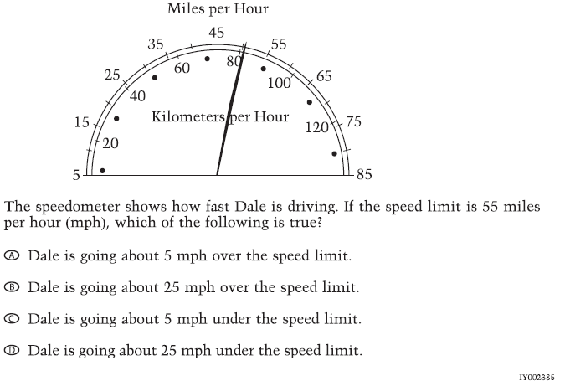

Sample Question for Student to Practice Thinking Aloud.

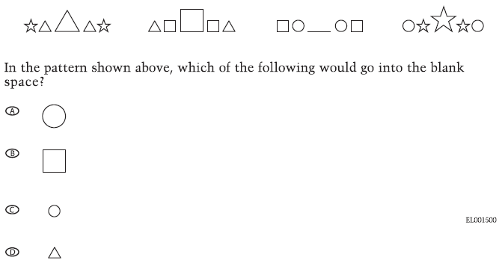

Additional Question for Interviewer to Model Thinking Aloud.

[Use only if you feel the student needs to observe another think aloud before moving on to the actual questions.]

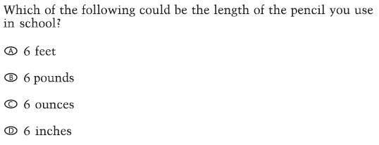

Example Generic Item Script
Puerto Rico Cognitive Labs
NAEP Mathematics
2009 Grade #

Question Identifier: Form #X Sequence #Y Accession Number
Note: The preliminary information should be recorded for each question in this set. Ask student questions 10–12 only once.

Ref # | Question/Prompt | Response
 | Preliminary Information
1 | Name of ASPIRA representative
2 | Date
3 | Student ID | Record student’s unique ID number here.
4 | Student’s Gender | ◻ Male ◻ Female
5 | Name of School
6 | School District
7 | School Location | ◻ Metro ◻ North  ◻ Inland ◻ South
8 | School Category | ◻ 1 ◻ 2
9 | Special circumstances that may have affected the interview
10 | Do you like studying mathematics? | ◻ Yes ◻ No
11.1 | Do you use a calculator in your math class? | ◻ Yes ◻ No
11.2 | If yes, what kind of calculator do you use in class? | ◻ Four-function ◻ Scientific ◻ Graphing
12.1 | Do you use a calculator at home? | ◻ Yes ◻ No
12.2 | If yes, what kind of calculator do you use at home? | ◻ Four-function ◻ Scientific ◻ Graphing

Ref # | Question/Prompt | Response
 | PHASE 1: Student reads question aloud.
101 | [multiple choice]  Please read this question and the answer choices aloud.  OR  [constructed response]  Please read this question aloud.  OR  Please read this question and all the parts aloud. | Record your observations when the student reads the question.
Now please answer the question.
[for first question]
I will be taking notes while you are answering the question.
 | PHASE 2: Student “think-aloud” while responding to question.
201 | If necessary, remind the student to say aloud what his/her thought processes are while answering the question. Use the “Think-Aloud Hints” as needed. | Record student’s think-aloud comments here.  ◻ Additional comments are recorded on interviewer’s copy of the question.
202 | [multiple choice grade 4]  Record the option selected by the student.  OR  [multiple choice grade 8]  Record the option selected by the student.  OR  [constructed response]  Did the student get an answer of XXXXX ? | ◻ A ◻ B ◻ C ◻ D  ◻ Student did not select an option.  ◻ A ◻ B ◻ C ◻ D ◻ E  ◻ Student did not select an option.  ◻ Yes ◻ No  ◻ Student did not respond.
203 | Was the student certain of his/her answer? | ◻ Yes ◻ No  ◻ Student did not respond.
204 | How would you rate the student’s level of motivation while working on this question? | ◻ High ◻ Moderate ◻ Low
205 | Based on your observations, did the student demonstrate understanding of the mathematical concepts in this question? | ◻ Yes ◻ No  ◻ Student demonstrated some understanding.
206 | [for calculator blocks]  Did the student use the calculator to answer the question? | ◻ Yes ◻ No  ◻ Student did not respond.
 | PHASE 3: Interview with student
301 | [multiple choice grade 4]  Follow up with question 301 only if the student has not already addressed this during the think-aloud.  Are there any other answers you thought about choosing?  If so, why?  OR  [multiple choice grade 8]  Follow up with question 301 only if the student has not already addressed this during the think-aloud.  Are there any other answers you thought about choosing?  If so, why? | Select all that apply.  ◻ A ◻ B ◻ C ◻ D  ◻ None  Select all that apply.  ◻ A ◻ B ◻ C ◻ D ◻ E  ◻ None
302 | [and, if the question contains a stimulus; may be more specific for each question]  Follow up with this question only if the student has not already addressed it.
302.1 | Point to the object and ask  How do you think this object helps you answer the question?
303 | [optional]  Follow up with questions 303.1, etc. only if the student has not already addressed them.  Follow up with question 303.1 only if the student has not already addressed it.  When appropriate, also ask the student:  Did you guess what it means? If so:  What did you guess it means?  And/or  Did not knowing the meaning of this keep you from answering the question?
303.1 | What do you think “vocabulary word or phrase” means in this question?
304 | Are there any other words or symbols in the question that you think would be hard to understand for some students? | ◻ No ◻ Yes Which ones?  List unfamiliar words or symbols:
305 | How would you explain what this question means to a student in your class who doesn’t understand the question?
306 | What about this question might make it hard for some students?
307 | Is there anything that you think could make the question clearer? | ◻ No ◻ Yes What is it?  Record student’s suggestions.
308 | If this were a real test, do you think students in your class would have answered this question or would they have left it blank? | ◻ They would have answered the question.  ◻ They would have left it blank.
309 | [optional]  Have you answered questions like this one in your math class? | ◻ Yes ◻ No
310 | [optional]  Have you studied topic in school? | ◻ Yes ◻ No
Thank you. Let’s move on to the next question.

[optional, as needed]
Please collect the object from the student.

[For last question in the form]
Thank you for helping us improve our test questions for other students.

At the Conclusion of the Cognitive Laboratory:

We’re finished. Thank you for participating in the study. The information you’ve provided will be very helpful for making the test questions better.

***TURN OFF THE RECORDER NOW***

Also, remember to
- hand the student remuneration [educational material(s) equivalent to $10],
- collect materials from the student,
- follow the school’s procedure for dismissing the student,
- let school contact person know how the sessions went, and
- express appreciation for school’s participation; hand deliver thank-you letter and gift card ($50 Borders’ Bookstore gift card for the school).

Customized Example of Grade 4 Puerto Rico Cognitive Lab
NAEP Mathematics

Question Identifier: Form 4D Sequence #4 VB434957
Note: The preliminary information should be recorded for each question in this set. Ask student questions 10–12 only once.

Ref # | Question/Prompt | Response
 | Preliminary Information
1 | Name of ASPIRA representative
2 | Date
3 | Student ID | Record student’s unique ID number here.
4 | Student’s Gender | ◻ Male ◻ Female
5 | Name of School
6 | School District
7 | School Location | ◻ Metro ◻ North  ◻ Inland ◻ South
8 | School Category | ◻ 1 ◻ 2
9 | Special circumstances that may have affected the interview
10 | Do you like studying mathematics? | ◻ Yes ◻ No
11.1 | Do you use a calculator in your math class? | ◻ Yes ◻ No
11.2 | If yes, what kind of calculator do you use in class? | ◻ Four-function ◻ Scientific ◻ Graphing
12.1 | Do you use a calculator at home? | ◻ Yes ◻ No
12.2 | If yes, what kind of calculator do you use at home? | ◻ Four-function ◻ Scientific ◻ Graphing

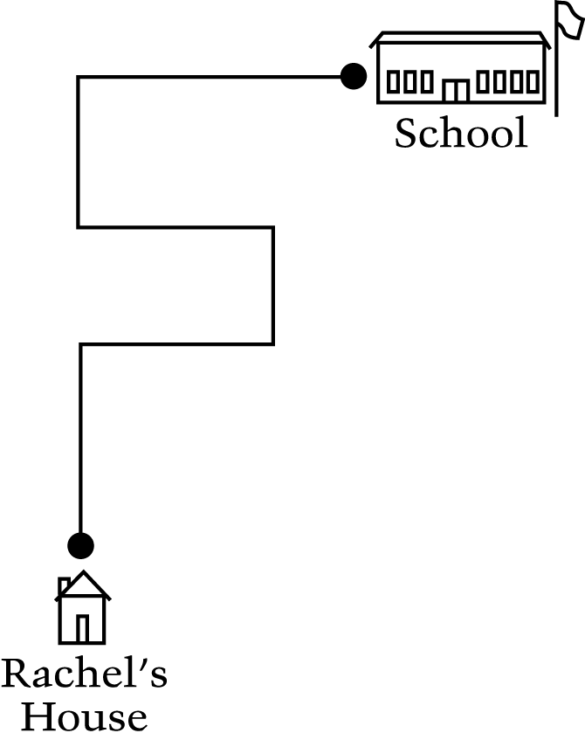

4. The picture shows Rachel’s path to school. How many right angle turns does Rachel make to get to school?
(A) Two
(B) Three
(C) Five
(D) Seven

Ref # | Question/Prompt | Response
 | PHASE 1: Student reads question aloud.
101 | Please read this question and the answer choices aloud. | Record your observations when the student reads the question.
 | Now please answer the question.
 | PHASE 2: Student “think-aloud” while responding to question.
201 | If necessary, remind the student to say aloud what his/her thought processes are while answering the question. Use the “Think-Aloud Hints” as needed. | Record students think-aloud comments here.  ◻ Additional comments are recorded on interviewer’s copy of the question.
202 | Record the option selected by the student. | ◻ A ◻ B ◻ C ◻ D  ◻ Student did not select an option
203 | Was the student certain of his/her answer? | ◻ Yes ◻ No  ◻ Student did not respond.
204 | How would you rate the student’s level of motivation while working on this question? | ◻ High ◻ Moderate ◻ Low
205 | Based on your observations, did the student demonstrate understanding of the mathematical concepts in this question? | ¨ Yes ¨ No  ¨ Student demonstrated some understanding.
 | PHASE 3: Interview with student
301 | Follow up with question 301 only if the student has not already addressed this during the think-aloud.  Are there any other answers you thought about choosing?  If so, why? | Select all that apply.  ◻ A ◻ B ◻ C ◻ D  ◻ None
302 | Follow up with this question only if the student has not already addressed it.
302.1 | Point to the picture and ask  How do you think this picture helps you answer the question?
303 | Follow up with question 303.1 only if the student has not already addressed it.  When appropriate, also ask the student:  Did you guess what it means? If so:  What did you guess it means?  And/or  Did not knowing the meaning of this keep you from answering the question?
303.1 | What do you think “right angle turn” means in this question?
305 | How would you explain what this question means to a student in your class who doesn’t understand the question?
306 | What about this question might make it hard for some students to answer?
307 | Is there anything that you think could make the question clearer? | ◻ No ◻ Yes What is it?  Record student’s suggestions.
308 | If this were a real test, do you think students in your class would have answered this question or would they have left it blank? | ¨ They would have answered the question.  ¨ They would have left it blank.
309 | Have you answered questions like this one in your math class? | ◻ Yes ◻ No
 | Thank you. Let’s move on to the next question.

Customized Example of Grade 8 Puerto Rico Cognitive Lab
NAEP Mathematics

Question Identifier: Form 8E Sequence #4 VB434931
Note: The preliminary information should be recorded for each question in this set. Ask student questions 10–12 only once.

Ref # | Question/Prompt | Response
 | Preliminary Information
1 | Name of ASPIRA representative
2 | Date
3 | Student ID | Record student’s unique ID number here.
4 | Student’s Gender | ◻ Male ◻ Female
5 | Name of School
6 | School District
7 | School Location | ◻ Metro ◻ North  ◻ Inland ◻ South
8 | School Category | ◻ 1 ◻ 2
9 | Special circumstances that may have affected the interview
10 | Do you like studying mathematics? | ◻ Yes ◻ No
11.1 | Do you use a calculator in your math class? | ◻ Yes ◻ No
11.2 | If yes, what kind of calculator do you use in class? | ◻ Four-function ◻ Scientific ◻ Graphing
12.1 | Do you use a calculator at home? | ◻ Yes ◻ No
12.2 | If yes, what kind of calculator do you use at home? | ◻ Four-function ◻ Scientific ◻ Graphing

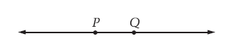

4. What is the intersection of rays PQ and QP in the figure above?
(A) Segment PQ
(B) Line PQ
(C) Point P
(D) Point Q
(E) The empty set

Ref # | Question/Prompt | Response
 | PHASE 1: Student reads question aloud.
101 | Please read this question and the answer choices aloud. | Record your observations when the student reads the question.
 | Now please answer the question.
 | PHASE 2: Student “think-aloud” while responding to question.
201 | If necessary, remind the student to say aloud what his/her thought processes are while answering the question. Use the “Think-Aloud Hints” as needed. | Record students think-aloud comments here.  ◻ Additional comments are recorded on interviewer’s copy of the question.
202 | Record the option selected by the student. | ◻ A ◻ B ◻ C ◻ D ◻ E  ◻ Student did not select an option
203 | Was the student certain of his/her answer? | ◻ Yes ◻ No  ◻ Student did not respond.
204 | How would you rate the student’s level of motivation while working on this question? | ◻ High ◻ Moderate ◻ Low
205 | Based on your observations, did the student demonstrate understanding of the mathematical concepts in this question? | ¨ Yes ¨ No  ¨ Student demonstrated some understanding.
 | PHASE 3: Interview with student
301 | Follow up with question 301 only if the student has not already addressed this during the think-aloud.  Are there any other answers you thought about choosing?  If so, why? | Select all that apply.  ◻ A ◻ B ◻ C ◻ D ◻ E  ◻ None
302 | Follow up with this question only if the student has not already addressed it.
302.1 | Point to the figure and ask  What do you think this figure represents?
303 | Follow up with questions 303.1, etc. only if the student has not already addressed them.  When appropriate, also ask the student:  Did you guess what it means? If so:  What did you guess it means?  And/or  Did not knowing the meaning of this keep you from answering the question?
303.1 | What do you think “intersection” means in this question?
303.2 | What do you think “rays” means in this question?
303.3 | What do you think “segment” means in this question?
303.4 | What do you think “line” means in this question?
303.5 | What do you think “point” means in this question?
303.6 | What do you think “empty set” means in this question?
305 | How would you explain what this question means to a student in your class who doesn’t understand the question?
306 | What about this question might make it hard for some students to answer?
307 | Is there anything that you think could make the question clearer? | ◻ No ◻ Yes What is it?  Record student’s suggestions.
308 | If this were a real test, do you think students in your class would have answered this question or would they have left it blank? | ¨ They would have answered the question.  ¨ They would have left it blank.
310 | Have you studied about points, lines, segments, and rays in school? | ◻ Yes ◻ No
 | Thank you. Let’s move on to the next question.

