Resident Sample Member
12345 Sampled Ave
Cooperation, MD 20850

Month XX, 2010

Dear [CITY] Household:

The U.S. Department of Education is conducting an important national research study about education, and we need your help. This short questionnaire is the first step in a study that provides vital information that is used to improve education for people of all ages – information that is not available anywhere else. The results will help policymakers and educators make wise decisions about the educational needs of our diverse population that will affect all of us.

It usually takes 5 minutes or less to fill out the survey.

All information you provide may be used for statistical purposes and may not be disclosed, or used, in identifiable form for any other purpose except as required by law (Section 9573, 20 U.S. Code).

Your household was chosen as part of this voluntary scientific study, and we cannot replace you with someone else. Every type of household in America needs to be included in the survey.

Please fill out the enclosed survey and mail it back in the postage paid envelope provided.
- All types of households are included – large and small households are equally important.
- This survey is about everybody – young and old.

We have enclosed $2 as a token of our appreciation. Westat, a survey research group, is conducting this survey for us. If you have questions or need assistance, please call 1-888-880-3033. You can find more information about this study online at www.nhessurvey.org.

Thank you for filling out this survey. Your information will help us improve education for everyone.

Sincerely,
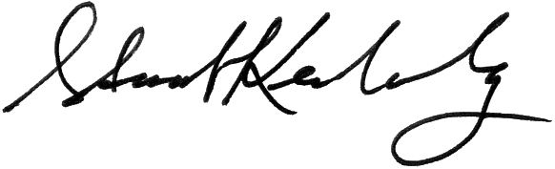
Stuart Kerachsky
Acting Commissioner
Enclosure National Center for Education Statistics

