Resident Sample Member
12345 Sampled Ave
Cooperation, MD 20850

September XX, 2009

Dear [CITY] Household:

The U.S. Department of Education is conducting an important national research study about families and education and we need your help. The brief questionnaire enclosed will help us find households with children and youths. We will be asking households around the country about:
- the ways that schools and families work together to promote learning;
- the learning experiences of young children who have not yet started school;
- the learning experiences and resources available to homeschoolers.
Your household was chosen as part of this scientific study and we cannot replace you with someone else. Although your participation is voluntary, your answers will make sure that households like yours are counted.

This short questionnaire is the first step in a study that provides vital information that is used to improve education for people of all ages – information that is not available anywhere else. The results will help policymakers, researchers, and educators understand the educational needs of our diverse population in changing times. This survey is about all of our families.

Please be assured that all information you provide may be used only for statistical purposes and may not be disclosed, or used, in identifiable form for any other purpose except as required by law (Section 9573, 20 U.S. Code). Your responses will be combined with those of others to produce statistics about all Americans’ educational experience.

Please fill out the enclosed survey and mail it back in the postage paid envelope provided.
- It usually takes 5 minutes or less to fill out these initial questions, and only a few seconds if no one in your household is age 20 or younger.
- If your household does not include anyone age 20 or younger, fill out the first question in the enclosed form and return it in the envelope that is provided.
We have enclosed $2 as a token of our appreciation. If you have questions or need assistance, please call Westat (the research company doing this survey for us) at 1-888-880-3033. You can find more information about this study online at www.nhessurvey.org.

We understand and appreciate that people have many demands on their time, so we are grateful for your generous cooperation. Thank you.

Sincerely,
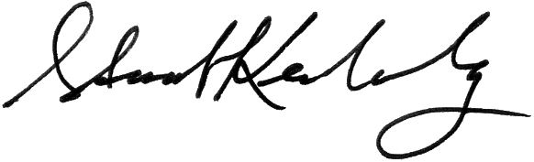
Stuart Kerachsky
Acting Commissioner
Enclosure National Center for Education Statistics

