Resident Sample Member
12345 Sampled Ave
Cooperation, MD 20850

Month XX, 2011
Dear [CITY] Household:

The U.S. Department of Education is conducting an important national research study, and we need your help. This survey is the first step in a study that provides vital information that is used to improve education for people of all ages – information that is not available anywhere else.

Please fill out this survey and mail it back in the postage-paid envelope that is provided.

- It usually takes only a few minutes to fill out.
- The brief questionnaire enclosed will help us find households with children and youths. This information is used to later ask those households about their educational experiences.
- Even if you have no children in your household it is important to us that you return this survey. Every type of household in America needs to be included.
- The results of this study will help policymakers, researchers, and educators understand the educational needs of our diverse population in changing times.

Your household was chosen as part of this voluntary scientific study, and we cannot replace you with someone else. All information you provide may only be used for statistical purposes and may not be disclosed, or used, in identifiable form for any other purpose except as required by law (P.L. 107-279, Title I, Part E, Sec. 183).

We have enclosed a cash token of our appreciation. Westat, a survey research group, is conducting this survey on our behalf. If you have questions or need assistance, please contact them at 1-888-880-3033. You can find more information about this study online at http://nces.ed.gov/nhes.

Thank you for taking part in this important study.

Sincerely,
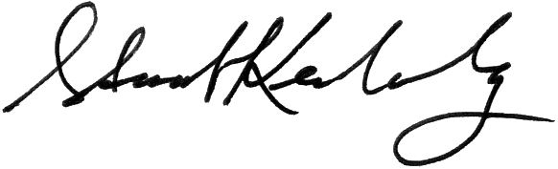
Stuart Kerachsky
Acting Commissioner
Enclosure National Center for Education Statistics

