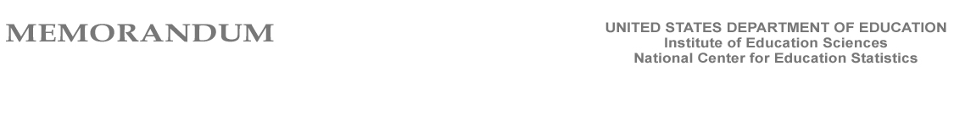

To: Rochelle W. Martinez,
Office of Management and Budget

Through: Michelle Coon
OMB Liaison
National Center for Education Statistics

Thomas Weko
Associate Commissioner
National Center for Education Statistics

From: Elise Miller
IPEDS Program Director
NCES

Subject: IPEDS Non-Substantive Changes Required by New Legislation

The Higher Education Opportunity Act (HEOA), which became law on August 14, 2008, has several implications for Integrated Postsecondary Education Data System (IPEDS) annual web-based data collection. The law requires the immediate implementation of several new institutional reporting requirements. The current clearance for IPEDS expires July 31, 2011 (OMB No. 1850-0582). The National Center for Education Statistics (NCES) will implement the following minor modifications to the 2008-09 IPEDS data collection. Additional substantive changes we discussed due to HEOA requirements will be presented in a separate formal request this fall with the plan to incorporate them into the spring IPEDS data collection period, which opens March 4, 2009.

The following requested modifications will be implemented for the 2008-09 IPEDS data collection; they are non-substantive and will only minimally affect reporting burden:

1) Add a check-box item to the Institutional Characteristics component to obtain information on alternative tuition plans [see HEOA, Sec. 132(i)(Z) for requirement]

Indicate which of the following alternative tuition plans are offered by your institution:
- Tuition guarantee
- Prepaid tuition plan
- Tuition payment plan
- Other (describe in Caveat box)

A caveat box will be provided for the institutions to enter additional contextual information.

2) Add an item to the Fall Enrollment component to allow, in combination with other data items already being collected, for the calculation of a Fall 2008 student-to-faculty ratio for programs with undergraduates. [see HEOA, Sec. 132(i)(M) for requirement]
a. The number of full-time students enrolled in stand-alone graduate or professional programs such as medicine, law, veterinary, dentistry, social work, or public health, in which faculty teach virtually only graduate-level students
b. The number of part-time students enrolled in stand-alone graduate or professional programs such as medicine, law, veterinary, dentistry, social work, or public health, in which faculty teach virtually only graduate-level students
c. The number of full-time instructional staff teaching in stand-alone graduate or professional programs such as medicine, law, veterinary, dentistry, social work, or public health, in which faculty teach virtually only graduate-level students
d. The number of part-time instructional staff teaching in stand-alone graduate or professional programs such as medicine, law, veterinary, dentistry, social work, or public health, in which faculty teach virtually only graduate-level students

3) Add the following text to the survey instructions for the item reporting the institution’s website in the Institutional Characteristics to comply with HEOA Sec. 132(i)(V):

The webpage reported must contain the following information, or links to that information from that page:
- Student activities offered by the institution
- Services offered by the institution for individuals with disabilities
- Career and placement services offered by the institution to students during and after enrollment
- Policies of the institution related to transfer of credit from other institutions

4) Revise instructions to the Student Financial Aid component for the item that collects the “Number of students in the cohort who received any financial aid.” The instructions will be clarified to include Federal Work Study to comply with HEOA Sec. 132(i)(R), as shown below:

Number of students in the cohort who received any financial aid during the year: Report the total number of students in your cohort who received any form of financial aid at any time during the year, including scholarships, grants, loans, and Federal Work Study.

