U.S. Department of Energy - University of California Driver Information Research Project

Thank you for your interest in this study. Researchers at UC Davis working for the U.S. Department of Energy, are seeking households willing to try a display that shows you information about your car and then to tell us about their experience. We are asking households to participate for approximately two months. The device installs simply and easily using a data “plug” in all new cars built since 1996. There is no need for new wiring. No holes will be drilled in your car; there are no sticky adhesives. Just plug it in once, turn it on each time you start a trip, and drive!
Participants will be selected by UC Davis researchers based on the following questionnaire. If you are selected, we will contact you to schedule your research period. When UC Davis researchers come to get you started, we will verify that your car and the device are compatible, and explain how to use the device.
Please fill out the questionnaire one time per household.

1. Participation is open to American Automobile Association (AAA) members in Nevada and northern California who hold AAA automobile insurance policies. So that we may verify your membership, please provide all 16 digits of the AAA membership number located on the front of your AAA card.
16 digit AAA membership number

2. Are any drivers in your household employed by the University of California?
Yes No

3. Do you have access to the internet at home?
Yes No

4. How many people live in your household (including yourself)?
###

[Repeat 5a, b, and c for each household member]
5a. Age: ###
5b. Do you have a valid driver's license?
Yes, Nevada Yes, California No
5c. Work Status
Student Homemaker/Caregiver at home Not employed
Employed Retired Other, please specify:

6. How many automobiles are registered to your household? “Automobile” means a car, truck, van, minivan, sport utility vehicle—any of the sort of car and truck your household normally uses for day-to day travel. Please do not include recreational vehicles or motor homes.
###

[Repeat 7 for all automobiles enumerated in 6.]
7. Please describe your automobiles
Model year:
Make (for example, Chevrolet, Ford, Subaru, Volvo, etc.):
Model:
Did you buy this car new or used? New Used
Does this car display fuel economy—that is, miles per gallon(mpg) or how much fuel you are using—to you?
Yes No I don’t know
Do you or someone else in your household drive this car regularly, that is, at least a few days per week? Yes No

8. In what town or city do you live?
Town/City; Nevada or California
9. Please read the description below.
A. Install a device in your car to 1) record your car’s performance while you drive and 2) display your fuel economy information to you.
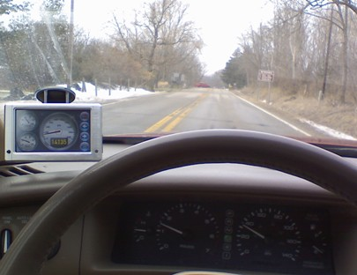
B. Drive your car with this device for approximately eight weeks, though you retain the right to end the trial at any time. The device is returned to UC Davis at the end of your experiment period. A picture of the device is shown here; your installation may be different.
C. Complete two more online questionnaires, a refueling log, and one in-home interview with UC Davis researchers after your experiment period to let you describe more fully your experience.
Are you willing to complete all these stages of this research program:
Yes No
10. Does the University of California, Davis have your permission to contact you for the purpose of asking additional questions pertaining to your eligibility to participate in this demonstration project.
Yes No
If you answered “yes” above, please provide the following contact information:
Name:
Address:
Daytime Phone (with area code): ( )
Evening Phone (with area code): ( )
E-mail:

