FCC Form 323—OMB Control No. 3060-0010
Changes to Section II-A, Question 3(c) and Section II-B, Question 3(c)

Current Text:

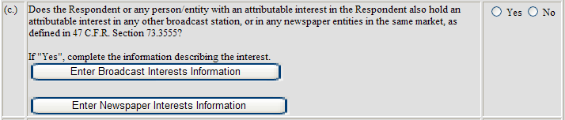

Proposed Text:

(Note: bolded, bracketed text below will appear on buttons (see above for appearance of buttons).)

(c.) | Does the Respondent or any person/entity with an attributable interest in the Respondent also hold an attributable interest in any other broadcast station, or in any newspaper entities in the same market, as defined in 47 C.F.R. Section 73.3555?  If “Yes”, provide information describing the interest(s), using EITHER the subform OR the spreadsheet option below for the applicable type of interest (broadcast or newspaper). Respondents with a large number (50 or more) of entries to submit should use the spreadsheet option. NOTE: Spreadsheets must be submitted in a special “XML Spreadsheet” format with the appropriate structure that is specified in the documentation. For instructions on how to use the spreadsheet option to complete this question (including templates to start with), please Click Here.  [Broadcast Interests Subform] OR [Broadcast Interests Spreadsheet]  [Newspaper Interests Subform] OR [Newspaper Interests Spreadsheet] | Yes  No

(The revised question will include a hyperlink to a web page that will contain instructions on how to use the spreadsheet template to enter the information required by Question 3(c) in lieu of entering the data directly into the form. The spreadsheet template replicates the subform questions in Question 3(c). Copies of the spreadsheet templates are attached.)

