Justification for Changes to IHS Evidence Based and Promising Practices, Local Efforts, Policies, and Resources Online Submission, Consultation and Reporting (OSCAR) System (OMB Number 0917-0034)

The IHS Evidence Based and Promising Practices, Local Efforts, Policies, and Resources Online Submission, Consultation and Reporting (OSCAR) System (OMB Number 0917-0034) development process began 5 years ago. At that time the form was based on information then relevant to the direction of IHS and health programs. Recently the IHS Director and programs have changed which resulted in unforeseen changes in IHS programs and policies when we originally submitted the form. As a result, the health indicators and keywords on the form as approved do not clearly and accurately reflect IHS programs and policies. Senior IHS staffs in the Office of Preventive and Clinical Services (OCPS) have made requested form modifications to clearly and accurately represent current IHS programs and policies. We have implemented the changes that have been recommended from the information gathered. Approving the changes will make the form more comprehensive and accurate when our AI/AN communities, IHS personnel, and others enter in or look for best/promising practices and local efforts health practices targeting improved health among American Indians/Alaskan Natives.

Changes:
- Question 4 - Evidence Based Practice, Promising Practice, Resources, and Policy was redefined in order to make it clear to the end user.
- Question 9-Health Indicator and Question 12-Key Word, selections were revised and some additions were added in order to make it more applicable and clear for identification of programs for the end user.

Note:
- Question numbering varies from what is on the form in the word document format and the screenshots. The variation in question numbering is due to whether the alternate contact information (Question 2) is selected or not. A skip pattern is built into the online system; it is set up to number all the following questions according to the participant’s response to Question 2.
- On the following pages are:
- Appendix A - Screenshots showing the revisions
- Appendix B – Question 9 showing revisions with explanation
- Appendix C - Question 12 showing revisions with explanation
- Attachment 1 -Word document of the Form showing revisions in color. (explanations can be found in Appendix B and Appendix C)

APPENDIX A

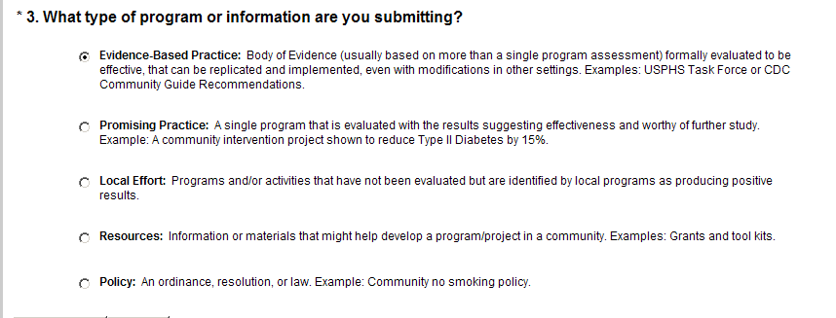

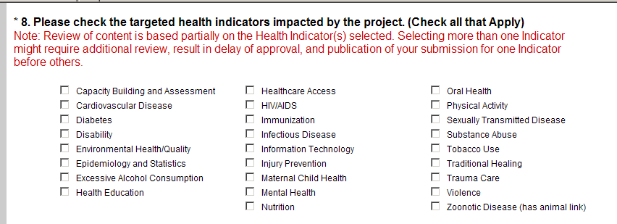

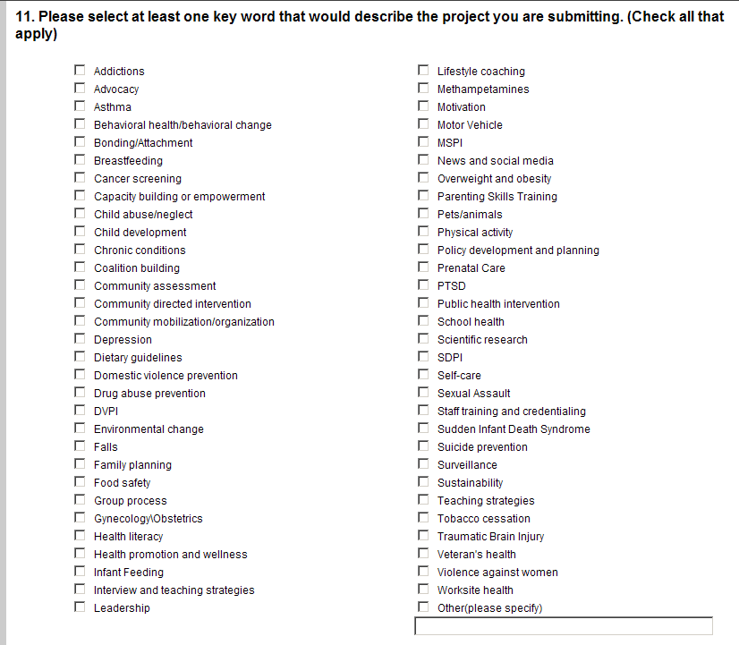

APPENDIX B

Question 9 – Health Indicators

 | Capacity Building and Assessment (added) |  | Healthcare Access |  | Oral Health
 | Cardiovascular Disease |  | HIV/AIDS (added – moved from Key Words) |  | Overweight and Obesity(removed-moved to Key Words)
 | Child Abuse/Neglect (removed-moved to Health Indicator) |  | Immunization |  | Pets/Animals (removed-revised to Zoonotic)
 | Diabetes |  | Infectious Disease |  | Physical Activity
 | Domestic Violence (removed-revised to Violence) |  | Information Technology |  | Sexually Transmitted Infections (added)
 | Disability (added – moved from Key Words) |  | Injury Prevention (revised and added-moved from Key Words) |  | Substance Abuse
 | Environmental Health/Quality |  | Maternal Child Health |  | Tobacco Use
 | Epidemiology and Statistics (added) |  | Mental Health |  | Traditional Healing
 | Excessive Alcohol Consumption |  | Methamphetamine (removed-moved to Key Words) |  | Trauma Care (added – moved from Key Words)
 | Health Education |  | Nutrition (added – moved from Key Words)) |  | Violence (revised- from Domestic Violence)
 |  |  |  |  | Zoonotic Disease (has animal link) (revised-from  Pets/Animal)

APPENDIX C

Question 12 – Key Word

 | Addictions (added-revised from Alcohol/substance abuse prevention) |  | Lifestyle coaching (removed)
 | Advocacy |  | Methamphetamines (added – moved from Health Indicators)
 | Alcohol/substance abuse prevention (removed-revised to Addictions) |  | Motivation
 | Asthma |  | Motor Vehicle (added)
 | Behavioral health/behavioral change |  | MSPI (added)
 | Breastfeeding |  | News and social media (added)
 | Bonding/Attachment (added) |  | Nutrition (removed and moved to Health Indicators)
 | Cancer screening (added) |  | Overweight and obesity (added – moved from Health Indicators)
 | Capacity building or empowerment |  | Parenting skills training (added)
 | Child abuse/neglect (added – moved from Health Indicators |  | Pets/animals (added - moved from Health Indicators)
 | Child development (added) |  | Physical activity
 | Chronic conditions |  | Policy development and planning (added)
 | Coalition building (added) |  | Pregnancy planning (removed – revised to Family planning)
 | Community assessment |  | Prenatal care (added)
 | Community directed intervention |  | PTSD (added)
 | Community mobilization/organization |  | Public Health intervention
 | Depression (added) |  | School health
 | Dietary guidelines (added) |  | Scientific research
 | Disability (removed and moved to Health Indicators) |  | SDPI (added)
 | Disability prevention (removed duplication) |  | Self-care (added)
 | Domestic violence prevention |  | Sexual Assault (added)
 | Drug abuse prevention |  | Staff training or credentials
 | DVPI (added) |  | Sudden Infant Death Syndrome
 | Environmental change |  | Suicide prevention
 | Falls (added) |  | Surveillance
 | Family Planning (revised from Pregnancy prevention)) |  | Sustainability (added)
 | Food safety (added) |  | Teaching strategies
 | Group process |  | Tobacco cessation
 | Gynecology/Obstetrics (added) |  | Traumatic Brain Injury
 | Health literacy |  | Unintentional injury (revised and moved to Health Indicator)
 | Health promotion and wellness |  | Veteran’s health
 | HIV prevention (revised and moved to Health Indicator) |  | Violence against Women (added)
 | Infant feeding (added) |  | Worksite health
 | Interview and teaching strategies |  | Other (please specify)
 | Leadership (added) | 

