PROGRAMMING INSTRUCTIONS APPEAR IN BLUE.
 |  |  | During your career, how long have you been disinfecting medical instruments and other items using HIGH LEVEL DISINFECTANTS?  High level disinfectants, include: .  - Glutaraldehyde (e.g., Cidex®, ColdSport®, Endocide®, Glutacide®, Hospex®, Metricide®, Onicide®, Pro-cide-D®, Rapicide®, Sonacide®, Sporicidin®, Wavicide®),  - Orthophthalaldehyde (e.g., Cidex OPA®),  - Peracetic acid (e.g., Steris® system),  - Hydrogen peroxide (e.g., Accell®, Optim®, Sporox®)  - Hydrogen peroxide and peracetic acid (e.g., Acecide®, Metrex®, Peract®) |  |  |  |  |  |  | - Less than one year  - 1-5 years  - 6-10 years  - 11-20 years  - More than 20 years
 |  | When was the last time you received training on the safe handling of high level disinfectants? |  |  |  |  |  |  |  | - Within the past 12 months  - More than 12 months ago  - I never received training
If you work for more than one employer, the following questions apply to your primary employer, i.e., the one for which you typically work the most hours. If you are self-employed, consider yourself the employer.

 |  | Does your employer have standard procedures for using high level disinfectants? |  |  |  |  |  |  |  | - Yes  - No  - I don’t know
 |  | During the past 7 calendar days, on how many days did you disinfect medical instruments or other items using high level disinfectants?  (Count a partial day as one day.)  display calendar highlighting the past 7 calendar days. Applies to all questions with ‘in the past 7 calendar days’ |  |  |  |  |  |  |  | - 1 day  - 2 days  - 3 days  - 4 days  - 5 days  - 6 days  - 7 days
 |  | During the past 7 calendar days, how much total time did you spend handling or working with high level disinfectants?  Note: Include only the time you spent actually loading and unloading the processing unit or tray; testing, adding and replacing the disinfectant solution; and cleaning the disinfecting process units or trays. |  |  |  |  |  |  |  | - Less than 1 hour  - 1-5 hours  - 6-20 hours  - 21-40 hours  - More than 40 hours
 |  | During the past 7 calendar days, did you handle high level disinfectants... |  |  |  |  |  |  |  | - …more time than usual  - …less time than usual  - …about the same amount of time as usual
 |  | During the past 7 calendar days, how many medical instruments (e.g., endoscopes, probes) did you disinfect using high level disinfectants? |  |  |  |  |  |  |  | - 10 or fewer instruments  - 11-20 instruments  - 21-50 instruments  - 51-100 instruments  - More than 100 instruments
 |  | During the past 7 calendar days, which of the following high level disinfectants did you use for disinfecting medical instruments and other items?  Please all that apply. |  |  |  |  |  | - Glutaraldehyde (e.g., Cidex®, ColdSport®, Endocide®, Glutacide®, Hospex®, Metricide®, Onicide®, Pro-cide-D®, Rapicide®, Sonacide®, Sporicidin®, Wavicide®)  - Orthophthalaldehyde (e.g., Cidex OPA®)  - Peracetic acid (e.g., Steris® system)  - Hydrogen peroxide (e.g., Accell®, Optim®, Sporox®)  - Hydrogen peroxide and peracetic acid (Acecide®, Metrex®, Peract®)  - Other high level disinfectant  (Please specify):  ______________________________

If only one marked in Question 8 Go to Question 10.
 |  | Of the high level disinfectants you checked above, please select the one most often used during the past 7 calendar days. |  |  |  |  | list the HLDs marked in Question 8 (use radio buttons)
 |  | Which of the following disinfection systems did you use during the past 7 calendar days?  Please all that apply. |  |  |  |  | - Automated disinfection system (e.g., closed-system re-processor)  - Manual disinfection system (e.g., tray or container) If manual only GO to Question 12
 |  | 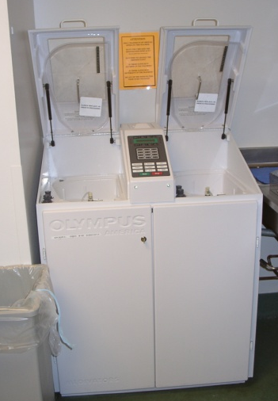  Which of the following statements best describes the ventilation for the AUTOMATED disinfection machine (e.g., re-processor) you used most often during the past 7 calendar days?  Local Exhaust Ventilation (LEV) captures and removes high level disinfectant vapors at the point where they are being produced (i.e., inside disinfection machine). Includes an air vent hose or duct from machine to an external exhaust source). |  |  |  |  |  |  |  | - Local exhaust ventilation (LEV) was present and appears to be effective  - LEV was present but appears to be ineffective  - LEV was absent but general room ventilation appears to be effective  - LEV was absent and general room ventilation appears to be ineffective  - I don’t know whether the automated disinfection machine was equipped with LEV

If ’automated’ ONLY in Question 10 Go to Question 13
 |  | Which of the following statements best describes the ventilation for the MANUAL disinfection system (e.g., tray, container or disinfection station) you used most often during the past 7 calendar days?  Note: Local Exhaust Ventilation (LEV) captures and removes high level disinfectant vapors at the point where they are being produced.  Examples include: a ventilated enclosure above a sink containing disinfection solution (left photo); a probe disinfection station with built-in exhaust vents for removing vapors (right photo)  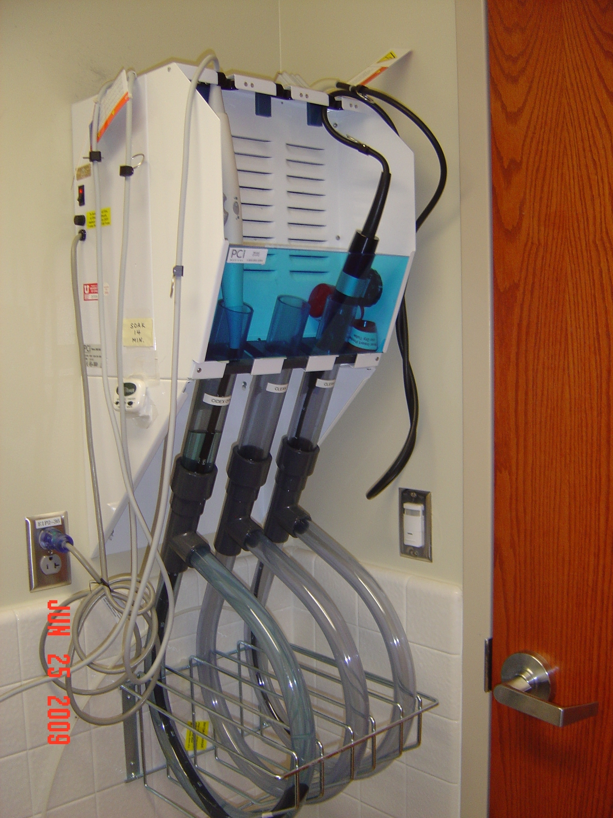 |  |  |  |  |  |  |  |  | - Local exhaust ventilation (LEV) was present and appears to be effective  - LEV was present but appears to be ineffective  - LEV was absent but general room ventilation appears to be effective  - LEV was absent and general room ventilation appears to be ineffective  - I don’t know whether the manual disinfection system was equipped with LEV
 |  | During the past 7 calendar days, did you manually pour fresh or new high level disinfectant(s) into trays or reprocessing units? |  |  |  |  |  |  |  | - Yes  - No GO to Question 15
 |  | During the past 7 calendar days, what was the total amount of high level disinfectant(s) you manually poured into trays or reprocessing units? |  |  |  |  |  |  |  | - Less than one gallon  - 1-2 gallons  - 3-5 gallons  - 6-10 gallons  - 11 or more gallons
 |  | During the past 7 calendar days, did you manually drain high level disinfectant(s) from trays or reprocessing units? |  |  |  |  |  |  |  | - Yes  - No
 |  | During the past 7 calendar days, how many spills occurred while you were handling high level disinfectants? |  |  |  |  | No spills |  |  |  |  | 1-2 spills | 3-5 spills | More than 5 spills
 |  | - Spills less than two cups (500 ml)
 |  | - Spills of two cups (500 ml) or more

If ’No spills’ marked in BOTH Questions 16a and 16b Go to Question 20.

Otherwise Go to Question 17.
 |  | How often was/were the spill(s) cleaned up? |  |  |  |  |  | - Always  - Sometimes  - Never GO to Question 20  - I don’t know GO to Question 20
 |  | How often did you yourself clean up the spill? |  |  |  |  |  | - Always GO to Question 20  - Sometimes  - Never
 |  | Who cleaned up the spill(s)?  Please all that apply. |  |  |  |  |  | - You  - Designated spill cleanup team  - Other (Please specify):  ___________________________________  - I don’t know
 |  | Are hazardous chemical spill kits readily available? |  |  |  |  |  | - Yes  - No  - I don’t know
 |  | During the past 7 calendar days, did your skin come into direct contact with high level disinfectant(s)? |  |  |  |  |  | - Yes  - No
Questions addressing work practices and use of personal protective equipment (PPE) will help us understand what is currently used and under what circumstances. Depending on your job and exposures, PPE may not be required.

 |  | During the past 7 calendar days, how often did you wear a water resistant gown or outer garment while handling high level disinfectants? |  |  |  |  |  |  |  | - Always GO to Question 25  - Sometimes  - Never
 |  | What were the reason(s) you did not always wear a water resistant gown or outer garment while handling high level disinfectants?  Please all that apply. |  |  |  |  |  |  |  | - An engineering control (e.g., closed and/or ventilated disinfection system) was being used  - Skin exposure was minimal  - Not part of our protocol  - Not provided by employer  - No one else who does this work uses them  - Too uncomfortable or difficult to use  - Not readily available in work area  - Cross contamination to other areas is not a concern  - Other (Please specify):

If only one reason marked in Question 23 Go to Question 25.
 |  | Of the reasons you checked above, please indicate the most important reason you did not always wear a water resistant gown or outer garment while handling high level disinfectants. |  |  |  |  | list reasons marked in Question 23 (USE RADIO BUTTONS)
 |  | In your current job, have you taken home any clothing that came into contact with high level disinfectants? |  |  |  |  | - Yes  - No  - I don’t know
 |  | During the past 7 calendar days, how often did you wear protective gloves while handling high level disinfectants? |  |  |  |  |  |  |  | - Always go to Question 29  - Sometimes  - Never
 |  | What were the reason(s) you did not always wear protective gloves while handling high level disinfectants?  Please all that apply. |  |  |  |  |  |  |  | - Skin exposure was minimal  - Not part of our protocol  - Not provided by employer  - No one else who does this work uses them  - Too uncomfortable or difficult to use  - Not readily available in work area  - Cross contamination to other areas is not a concern  - Other (Please specify):

If only one reason marked in Question 27 Go to Question 29.
 |  | Of the reasons you checked above, please indicate the most important reason you did not always wear protective gloves while handling high level disinfectants. |  |  |  |  | list reasons MARKED in Question 27 (USE RADIO BUTTONS)
 |  | During the past 7 calendar days, how often did you wear eye or face protection (e.g., goggles, face shield) while handling high level disinfectants?  Do not include personal eyeglasses |  |  |  |  |  |  |  | - Always GO to Question 32  - Sometimes  - Never
 |  | What were the reason(s) you did not always wear eye or face protection while handling high level disinfectants?  Please all that apply. |  |  |  |  |  |  |  | - An engineering control (e.g., closed and/or ventilated disinfection system) was being used  - Exposure was minimal  - Not part of our protocol  - Not provided by employer  - No one else who does this work uses them  - Too uncomfortable or difficult to use  - Not readily available in work area  - Other (Please specify):  ___________________________

If only one reason marked in Question 30 Go to Question 32.
 |  | Of the reasons you checked above, please indicate the most important reason you did not always wear eye or face protection while handling high level disinfectants. |  |  |  |  | list reasons marked in Question 30 (USE RADIO BUTTONS)
During the past 7 calendar days, did you wear any of the following while handling high level disinfectants?
Please all that apply.

 | 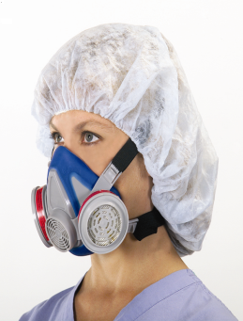  - Half-facepiece air purifying respirator with chemical cartridge(s) |  |  |  |  | 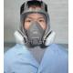  - Full-facepiece air purifying respirator with chemical cartridge(s)
 | - Standard surgical mask  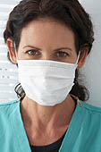 |  |  |  |  | - N95 respirator (includes surgical N95 respirator  Photo will be included
 | - I don’t know |  |  |  |  | - None of above Go to Question 34
DISPLAY FOLLOWING NOTE ON A SEPARATE SCREEN (except those who mark ‘i don’t know’): THE FOLLOWING QUESTIONs ASK ABOUT RESPIRATORS. STANDARD SURGICAL MASKS ARE NOT RESPIRATORS.

IF RESPONDENT MARKED ‘HALF-FACEPIECE AIR PURIFYING RESPIRATOR’ OR ‘FULL-FACEPIECE AIR PURIFYING RESPIRATOR’ IN QUESTION 32 GO to Question 33.

IF RESPONDENT MARKED ONLY ‘STANDARD SURGICAL MASK’ OR ‘NONE OF THE ABOVE’ IN QUESTION 32 GO to Question 34.

If respondent marked ‘I don’t know’ in question 32 GO to Question 37

 | How often did you wear a half-facepiece respirator or a full-facepiece air purifying respirator while handling high level disinfectants? |  |  |  |  | - Always go to Question 36  - Sometimes
 | What were the reason(s) you did not always wear a half-facepiece air purifying respirator with chemical cartridge or a full-facepiece air purifying respirator with chemical cartridge while handling high level disinfectants?  Please all that apply. |  |  |  |  | - An engineering control (e.g., closed and/or ventilated disinfection system) was being used  - Exposure was minimal  - Not part of our protocol  - Not provided by employer  - No one else who does this work uses them  - Too uncomfortable or difficult to use  - Not readily available in work area  - Other (Please specify):

If RESPONDENT marked more than one reason in Question 34 Go to Question 35.

Otherwise, Go to INSTRUCTIONS BEFORE Question 36

 | Of the reasons you checked above, please indicate the most important reason you did not always wear a respirator while handling high level disinfectants. |  | list reasons marked in Question 34 (USE RADIO BUTTONS)

If Respondent marked “Half-facepiece respirator” or “Full-facepiece respirator” in Question 32 Go to Question 36.

Otherwise Go to Question 37.
 | Have you been fit-tested by an occupational health and safety specialist for the respirator(s) you use for high level disinfectants? |  | - Yes  - No
 | Has exposure monitoring (using badges or other sampling devices) been conducted in the past 12 months to assess your or your co-workers’ exposure to high level disinfectants? |  | - Yes  - No  - I don’t know  all responses: if this is the first hazard module completed Go to Core Module  If this is the second hazard module completed, end survey. end with ‘Thank you’ statement.
 | Which of the following high level disinfectants were included in the exposure monitoring?  Please all that apply. |  | - Glutaraldehyde  - Orthophthalaldehyde  - Hydrogen peroxide  - Other (Please specify):  _____________________________  - I don’t know  All responses Go to Core Module, except when this is the 2nd hazard module completed, then end with ‘Thank you’ statement.

Thank you for participating in the NIOSH Health and Safety Practices Survey of Healthcare Workers. Your answers have been submitted.

