How to Collect Cheek Cell Samples

Thank you for agreeing to provide cheek cell samples. To collect the samples, we have included:

- Consent forms
- Cheek cell brushes inside colored envelopes (Two brushes inside each colored envelope. One colored envelope per person.)
- Postage-paid mailing envelope

Please read the following directions before you start collecting the cheek cell samples.

- Read and sign the enclosed consent forms.
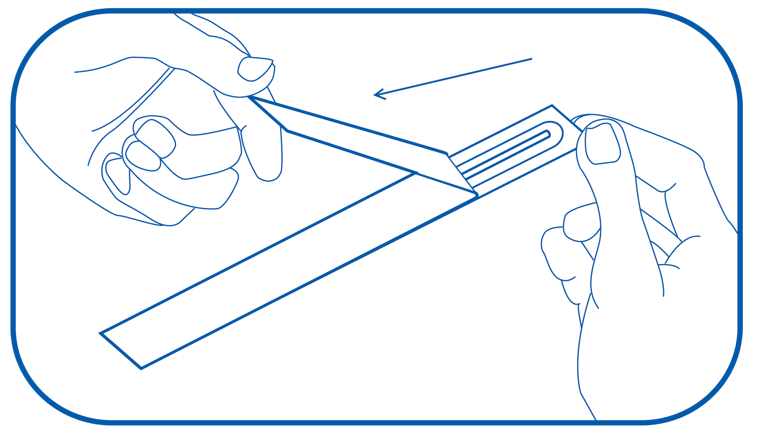

- Starting with the red envelope labeled MOTHER, take out one cheek cell brush wrapper. Peel the white part of the wrapper down to where you see 3 stars (***). Take the brush out of the wrapper. Be sure NOT to touch the brush end. Keep the wrapper; you will need it in step 4.
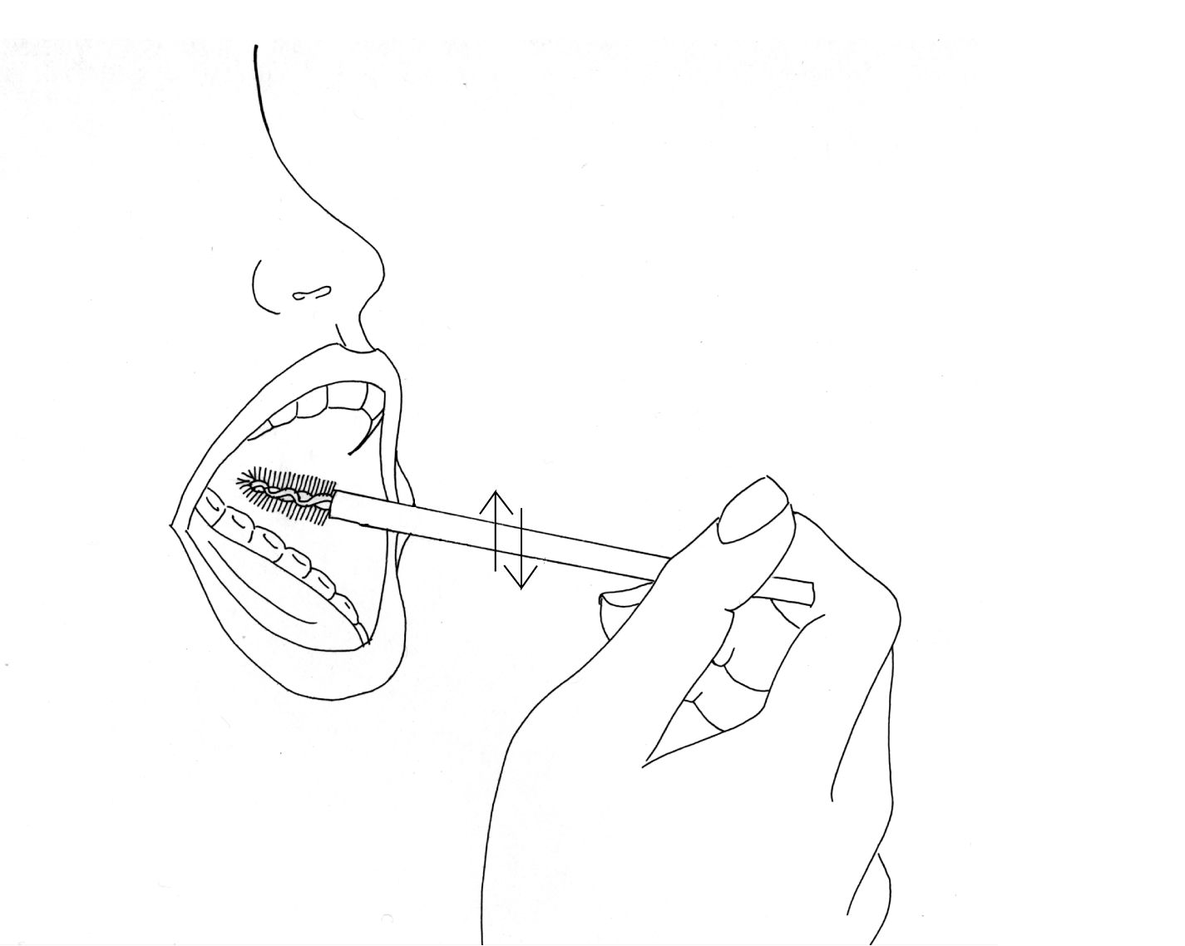
 Place the brush inside your mouth, against the inside of your cheek.
Rub the brush firmly up and down along the inside of your cheek 10 times. Roll the brush on its other side and rub firmly up and down 10 more times in the same area inside your cheek.

⇦ Put it back into the wrapper with the brush end first.
Do not re-use this brush on another person.
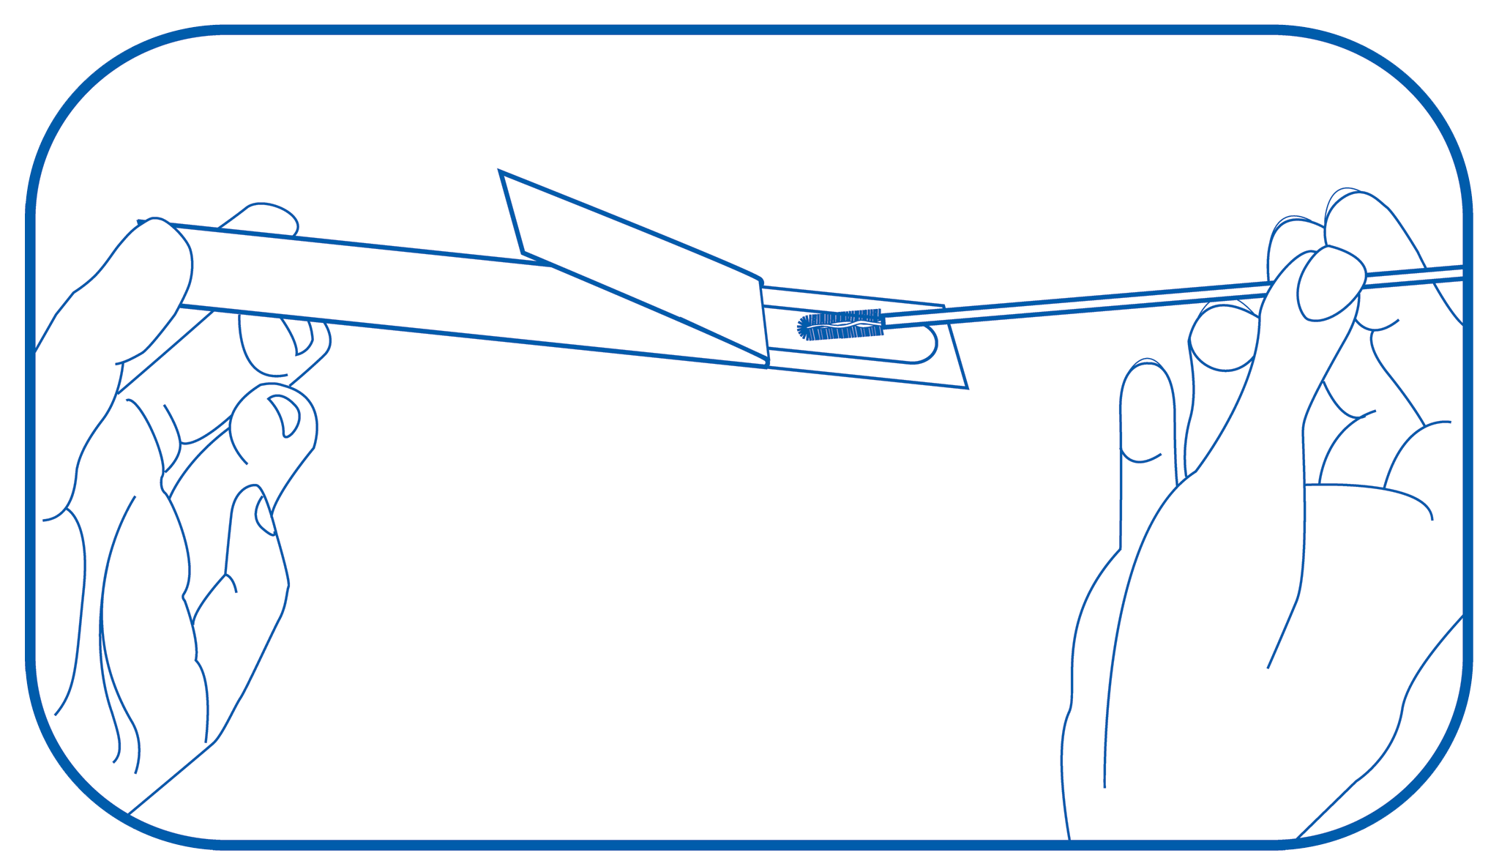
⇨ Take out the second wrapper from the envelope labeled MOTHER. Repeat steps 2-4 with the second wrapper and brush. This time, use the brush on your other cheek.

⇧ Once you have put the brush back into its wrapper, put both wrappers back into the red envelope labeled MOTHER. Close the envelope with the clear seal. Write the date the samples were collected on the envelope.

⇩ After collecting your cheek cell samples, follow steps 2-6 to collect cheek cell samples from the other identified family members.

⬄ Place all colored envelopes and signed consent forms into the big, postage-paid mailing envelope. Securely seal the envelope and return it to us by U.S. mail.

If you have any questions or problems, please call __________________________ at ____________________.

Thank you!
7/2003

