U.S. Department of Labor | Bureau of Labor Statistics  Quarterly Census of Employment and Wages Program  2 Massachusetts Avenue, NE, Room 4840  Washington, DC 20212 | 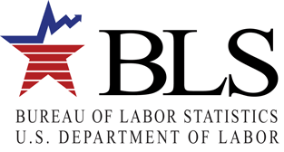
[date]

Attn: Contact_name (if missing use “Department of Accounting/Finance”):
T_name
Ot_addr1
Ot_addr2
Ot_city, Ot_state Ot_zip-Ot_zip_ext

Dear contact_name (if missing use “Department of Accounting/Finance”):

As the chief source of government data on employment, BLS intends to produce data on business employment in the green goods and services sector, defined as those activities that involve renewable energy, energy efficiency, pollution reduction and cleanup, recycling and waste reduction, agriculture and natural resources conservation, and/or environmental regulation and education. This data collection will produce regular tabulations of aggregate employment and wages for businesses whose primary activities fall into the green goods and services sector. This series will be key to analyzing workforce trends in the green goods and services sector.

In order to collect data on green goods and services employment, BLS is requesting your participation by completing the attached survey form. Please complete and return the form within 14 days of receipt whether or not your company is involved in the green activities listed above.

We estimate that it will take you an average of 20 minutes to complete this form. The OMB control number for this survey is 1220-0181 and expires September 30, 2010.

If you have any questions please contact Kristin Fairman or Robert Viegas at 202-691-5185 or GGS@bls.gov.

Thank you for your voluntary cooperation and participation.

Sincerely yours,
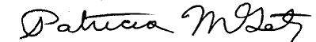

Patricia M. Getz
Assistant Commissioner
Office of Industry Employment Statistics, Office of Employment and Unemployment Statistics

