U.S. Department of Labor | Bureau of Labor Statistics  Quarterly Census of Employment and Wages Program  2 Massachusetts Avenue, NE, Room 4840  Washington, DC 20212 | 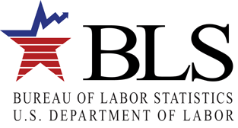
[date]

Attn: Contact_name (if missing use “Department of Accounting/Finance”):
T_name
Ot_addr1
Ot_addr2
Ot_city, Ot_state Ot_zip-Ot_zip_ext

Dear contact_name (if missing use “Department of Accounting/Finance”):

About a week from now, your firm will receive a Green Goods and Services Survey form from the Bureau of Labor Statistics (BLS). When you receive your form, we ask that you please fill it out and mail it in promptly.

The questions in the survey form require information about the percentage of your firm’s employment and revenue associated with activities that involve renewable energy, energy efficiency, pollution reduction and cleanup, recycling and waste reduction, agriculture and natural resources conservation, and/or environmental regulation and education. Please complete and return the form whether or not your company is involved in these activities. If you do not have access to this information, please identify someone in your firm who does and forward the survey form to that person once it arrives at your worksite.

Thank you in advance for your help.

Sincerely,
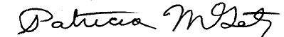

Patricia M. Getz
Assistant Commissioner
Office of Industry Employment Statistics, Office of Employment and Unemployment Statistics

