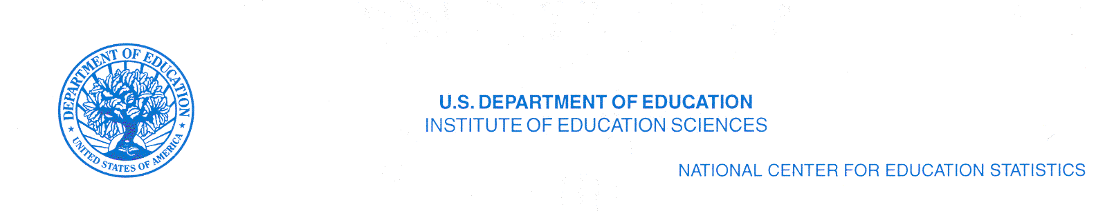
1. First Reminder Letter

Gentle Reminder

December 7, 2010

Dear Library Director:

Data collection for the 2010 Academic Libraries Survey (ALS) began on November 9, 2010. According to our records, your institution has not registered for the survey. The survey ends on February 28, 2011. Please register, then enter and lock your data as soon as possible on the ALS Web site at http://surveys.nces.ed.gov/libraries/als.

If you need your User ID and password, please contact the ALS Help Desk at 1-877-749-4925 or e-mail at govs.aclib@census.gov

The data from the ALS are used to produce online reports, supplemental tables, and a peer comparison tool. These data resources can be found on the ALS web site at http://nces.ed.gov/surveys/libraries/academic.asp. ALS questionnaires, survey instructions, and methodology are also available online.

We appreciate your participation in this survey, and look forward to receiving your data submission in the near future. Thank you for your cooperation and support for this national academic library survey. If you have questions about the survey content, please contact me at Tai.Phan@ed.gov or 202-502-7431.

Sincerely,
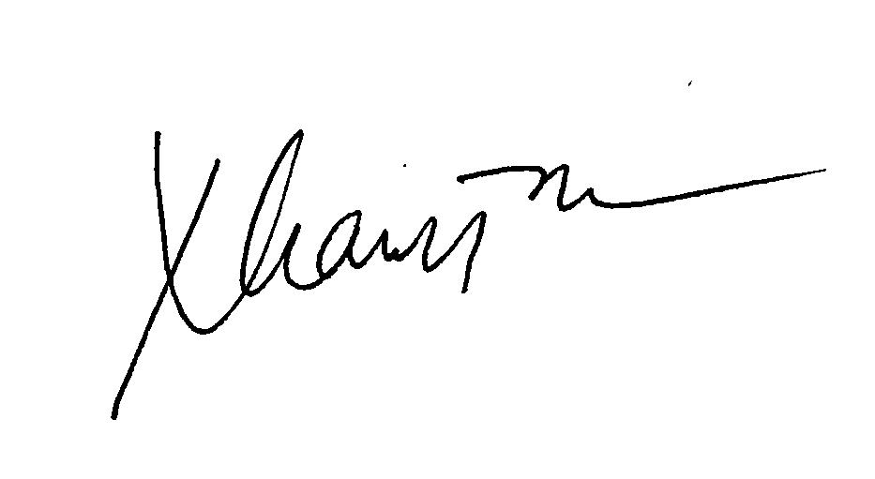
Tai Phan
Survey Director
Academic Libraries Survey
2. Second Reminder Letter

Urgent Reminder!

January 18, 2011

Dear Library Director:

Data collection for the 2010 Academic Libraries Survey (ALS) began on November 9, 2010. According to our records, your institution has not registered on the survey web site. The survey ends on February 28, 2011.

- Please register, then enter and lock your data as soon as possible on the ALS Web site at http://surveys.nces.ed.gov/libraries/als.

Enclosed is your Key Holder Certificate – This document contains your ALS user ID number, personal password, UNIT-ID, institution name, FY 2008 respondent name, as well as critical dates and ALS Help Desk Information. Please keep this document in a safe place, and do not share this password with anyone.

The data from the ALS are used to produce online reports, supplemental tables, and a peer comparison tool. These data resources can be found on the ALS web site at http://nces.ed.gov/surveys/libraries/academic.asp. ALS questionnaires, survey instructions, and methodology are also available online.

It is very important to the success of this survey that all institutions enter and lock their data. We appreciate your participation in this survey, and look forward to receiving your data submission in the very near future. Thank you for your cooperation and support for this national academic library survey. If you have questions about the survey content, please contact me at Tai.Phan@ed.gov or 202-502-7431.

Sincerely,
Tai Phan
Survey Director
Academic Libraries Survey
3. Third Reminder Letter

Urgent Reminder!

February 8, 2011

Dear Library Director:

According to our records, your institution has not registered on the survey web site. The survey ends on February 28, 2011. The quality of this national survey depends on your institution’s participation.

- Please register and complete the five yes/no eligibility questions. If your library is eligible, then enter and lock your data as soon as possible on the ALS Web site at http://surveys.nces.ed.gov/libraries/als.

Enclosed is your Key Holder Certificate – This document contains your ALS user ID number, personal password, UNIT-ID, institution name, FY 2008 respondent name, as well as critical dates and ALS Help Desk Information. Please keep this document in a safe place, and do not share this password with anyone.

The data from the ALS are used to produce online reports, supplemental tables, and a peer comparison tool. These data resources can be found on the ALS web site at http://nces.ed.gov/surveys/libraries/academic.asp. ALS questionnaires, survey instructions, and methodology are also available online.

It is very important to the success of this survey that all institutions enter and lock their data. We appreciate your participation in this survey, and look forward to receiving your data submission in the very near future. Thank you for your cooperation and support for this national academic library survey. If you have questions about the survey content, please contact me at Tai.Phan@ed.gov or 202-502-7431.

Sincerely,
Tai Phan
Survey Director
Academic Libraries Survey
4. Example of an E-mail to the 2008 Keyholder

Dear 2008 Academic Libraries Survey Key Holder,

According to our records, your library has not registered for the 2010 Academic Libraries Survey (ALS) and the survey ends on February 28, 2011. The quality of this national survey depends on your participation. Please find the on-line questionnaire at http://surveys.nces.ed.gov/libraries/als.

**If you are no longer responsible for the completion of the ALS, please forward this email to the 2010 ALS Key Holder

**If you need your library's User ID and password, please contact the ALS Help Desk at 1-877-749-4925.

**If your institution does not have a fully staffed academic library, please contact govs.aclib@census.gov.

Why should I participate?
The U.S. Congress and your state government use data from this survey when considering policy changes concerning academic libraries. To produce valid results, the survey must obtain at least an 85 percent response rate — your survey counts!

The data from the ALS are used to produce on-line reports and supplemental tables for the National Center for Education Statistics at the U.S. Department of Education. The Library Statistics Program web site at http://nces.ed.gov/surveys/libraries/ offers many resources for libraries, including the Compare Academic Libraries tool, which is an easy way to compare your library to other, similar libraries. The peer comparison tool is only available for libraries that respond to the survey.

We very much appreciate your participation in this survey, and look forward to receiving your completed survey by February 28, 2011. Thank you for your cooperation and support of this national academic library survey. If you have any questions about the survey, please contact Tai Phan at Tai.Phan@ed.gov or 202-502-7431.

