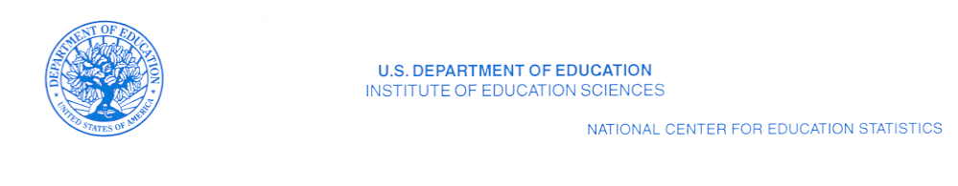
July 20, 2010

(Header Information)

Dear :

The National Center for Education Statistics (NCES) within the U.S. Department of Education requests your assistance in improving the coverage and quality of our private school listings and statistics. Every 2 years, the NCES conducts the Private School Survey (PSS). The PSS data allow NCES to report on enrollment trends; counts of private schools, students, teachers, and high school graduates; program emphasis; and types of private schools. The PSS also serves as a list of private schools for additional NCES studies. In order to conduct the 2011-12 PSS, we must compile a complete and accurate list of all private schools in the United States. Please help us to identify all private or nonpublic schools in your state.

What we request from you

- A computer file (preferably a spreadsheet) of all private and nonpublic schools in your state that provide instruction for at least one grade between kindergarten and grade 12.

- If a computer list is not available, a paper list is acceptable.

Definition of eligible school

- Please include all private, nonpublic, or religious-exempt schools with any of the grades kindergarten through grade 12.
  - Kindergarten is defined as: An educational program for children (primarily 5-year-olds) who would normally enter first grade in the following year, even if “kindergarten” is not in the name of the program.

  - Include programs such as transitional or developmental kindergarten if children are expected to enter the first grade upon completing the program.

- Please exclude all programs that

- teach only adult education or postsecondary students;
- are designed only for 3- or 4-year-old children and do not include kindergarten (e.g., Head Start programs, prekindergarten, or nursery schools);
- provide only before or afterschool care for children who attend school in another facility;
- provide only child care and do not include kindergarten.
The file or list should include the following information for each program:

- school name:
- mailing address:
- telephone number:

- grade range:
- enrollment: and
- number of teachers.

In addition to the information above that we have requested from you in the past, please also provide:
- school location address.

Please supply the date the list was last updated.
Sending the list

- The U.S. Census Bureau collects the private school lists for us. You may send your list to the U.S. Census Bureau by e-mail or regular mail. Please send your list by August 21, 2010.

To transmit your file via e-mail, please send a message to the following address:
dsmd.private.school.lists@census.gov

Note that e-mail attachments have a suggested size limit of 2MB (two megabytes). If you have difficulty sending your attachment because it is too large, please call 1-800-579-8520 to make alternative arrangements.

To send your list on diskette or paper, please mail the file to the following address:

U.S. Census Bureau
ATTN: Lowell Allen
Bldg. 66, Room 313
1201 E. 10th St.
Jeffersonville, IN 47132

For additional information on the PSS and other surveys that NCES conducts, please visit our website: http://nces.ed.gov. If you have any questions about our list updating, please contact Mr. Allen toll free at 1-800-579-8520.

Thank you in advance for your assistance in improving the accuracy of our private school data collection.

Sincerely yours,
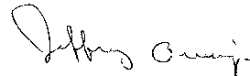

Jeffrey Owings
Associate Commissioner for
Elementary/Secondary and Library Studies

