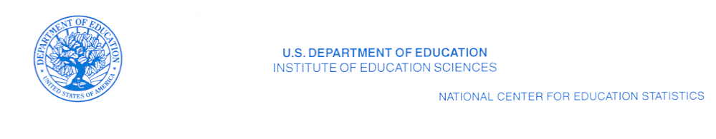
July 20, 2010

Dear CONTACT NAME HERE:

The National Center for Education Statistics (NCES) requests your assistance in improving the coverage and quality of our private school listings and statistics. Every 2 years, the NCES conducts the Private School Survey (PSS). The PSS data allow NCES to report on enrollment trends; counts of private schools, students, teachers, and high school graduates; program emphasis; and types of private schools. The PSS also serves as a list of private schools for updating the school search tool on the NCES website. In order to conduct the 2011-12 PSS, we must compile a complete and accurate list of all private schools in the United States and, new to this cycle, in Puerto Rico as well. Please help us to identify all private or nonpublic schools that currently belong to your association, including those in the United States and in Puerto Rico.

What we request from you

- A computer file (preferably a spreadsheet) of all private and nonpublic schools that currently belong to your association and provide instruction for at least one grade between kindergarten and grade 12.

- If a computer list is not available, a paper list is acceptable.

Definition of eligible school

- Please include all private, nonpublic, or religious-exempt schools with any of the grades kindergarten through grade 12.

  - Kindergarten is defined as: An educational program for children (primarily 5-year-olds) who would normally enter first grade in the following year, even if “kindergarten” is not in the name of the program.

  - Include programs such as transitional or developmental kindergarten if children are expected to enter the first grade upon completing the program.

- Please exclude all programs that

- teach only adult education or postsecondary students;
- are designed only for 3- or 4-year-old children and do not include kindergarten (e.g., Head Start programs, prekindergarten, or nursery schools);
- provide only before or afterschool care for children who attend school in another facility;
- provide only child care and do not include kindergarten;
- are considered a homeschool that teaches family members only.

The file or list should include the following information for each school:

- school name;
- mailing address;
- location address;
- telephone number;

- grade range;
- enrollment;
- number of teachers; and
- school contact e-mail address.

Please supply the date the list was last updated.
Sending the list

- The U.S. Census Bureau collects the private school lists for us. You may send your list to the U.S. Census Bureau by e-mail or regular mail. Please send your list by August 21, 2010.

To transmit your file via e-mail, please send a message to the following address:
dsmd.private.school.lists@census.gov

Note that e-mail attachments have a suggested size limit of 2MB (two megabytes). If you have difficulty sending your attachment because it is too large, please call 1-800-579-8520 to make alternative arrangements.

To send your list on CD or paper, please mail the file to the following address:

U.S. Census Bureau
ATTN: SMQAB-SMS
Bldg. 66, Room 313
1201 E. 10th St.
Jeffersonville, IN 47132

For additional information on the PSS and other surveys that NCES conducts, please visit our website: http://nces.ed.gov. If you have any questions about our list updating, please contact SMQAB toll free at 1-800-579-8520.

Thank you in advance for your assistance in improving the accuracy of our private school data collection.

Sincerely yours,

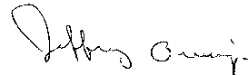

Jeffrey Owings
Associate Commissioner for
Elementary/Secondary and Library Studies

