Letters and Emails to Schools
[Sample Maintenance Enrollment List Update Letter to Schools]

<date>
Go to https://surveys.nces.ed.gov/hsls1/
Select “Student Enrollment Form”
Enter your study ID: <ID fill>
Enter your password: <psswrd fill>

< Principal name>
< school name>
<address>
<city> <state> <zip>

Dear <Principal Name>:

During the 2008-2009 school year, <SCHOOL NAME> participated in the first phase of the High School Longitudinal Study of 2009 (HSLS:09). Thank you very much for your participation in this study and to <SCHOOL COORDINATOR NAME> for helping us to coordinate the study logistics at your school in 2008. As a thank you for your continued support of this important research we are including a copy of the “Coursetaking at the End of High School” (NCES 2008-109). This report is a small sample of the kind of research that will be generated from HSLS:09. For more reports and results from similar studies, please visit http://nces.ed.gov/pubsearch/.
As you may recall, HSLS:09 is a comprehensive longitudinal study that will follow a cohort of high school students over time, so that the high school experience and its effects can be better understood. HSLS:09 is sponsored by the National Center for Education Statistics (NCES) at the U.S. Department of Education and is being conducted by RTI International on behalf of NCES.
We are requesting your assistance to verify the enrollment status of the students at your school who participated in HSLS:09. While actual data collection will occur in spring 2011, it is imperative that we maintain current enrollment records. We thank you in advance for your help in this important updating effort.
In the upper right hand corner of this letter, you will find a web address and a unique Study ID and password. We ask that you go to that web address and in the “Actions” box on the right side of the screen, click on “Student Enrollment Update Form.” Please log in with the study ID and password provided in this letter. You will first be prompted to change your password. Then you will find a list of all the students who were selected to participate in HSLS:09 in fall 2008. We would appreciate your review of these students’ enrollment status at <SCHOOL NAME>. If the student is no longer enrolled at your school, you will be asked to provide:
- Last Date of attendance
- Reason for leaving (dropout*, transferred, early graduate, don’t know, etc.)
- For transfer students: Name, city, and state of new school (if known)
- Last known address for student (City, State, Zip, Phone and Email)
We ask that you provide as much information as you have for these students. We are very grateful for your time and your assistance, which are critical to the success of the study.
The U.S. Department of Education is authorized by federal law (Public Law 107-279) to conduct HSLS:09. Data will be used only for statistical purposes and may not be disclosed or used, in identifiable form for any other purpose except as required by law (Public Law 107-279, Section 183). If you have any questions, please call the HSLS:09 help desk at 866-253-1063. Thank you for your continued support of HSLS:09.

Sincerely,
Dan Pratt
Project Director
High School Longitudinal Study of 2009

*Dropout is defined as an individual who has not been in school for 4 or more consecutive weeks and is not absent due to accident or illness.

[Sample Maintenance EL Email, Group 1: Schools that have not changed their password or initiated the process yet]

Dear <PRINCIPAL>:
In 2008 <SCHOOL NAME> participated in the High School Longitudinal Study (HSLS) sponsored by the National Center for Education Statistics, U.S. Department of Education (NCES). We recently sent you a letter asking you to verify the enrollment status of your students selected to participate in HSLS. We know you are very busy and appreciate your time. If you have already completed this information, we thank you. If you have not provided this information already, please complete this brief update at your earliest convenience.
One of the most powerful aspects of HSLS is the longitudinal component. Our ability to assess the progress of the sampled students over time will help educators better understand what drives students to academic and professional success.
Please visit the web address below and use the study ID and password provided to update your students’ enrollment. We appreciate your continued support of HSLS. If you have any questions, please call the HSLS help desk at 866-253-1063.
Go to https://surveys.nces.ed.gov/hsls1/
Select “Student Enrollment Form”
Enter your study ID: <ID fill>
Enter your password: <psswrd fill>
Thank you in advance for your help with this important effort.

Dan Pratt
Project Director
High School Longitudinal Study of 2009

[Sample Maintenance EL Email, Group 2: Schools that have started to update the form, have changed their password, but have not “submitted” their updated form yet]

Dear <NAME>:
In 2008 <SCHOOL NAME> participated in the High School Longitudinal Study (HSLS) sponsored by the National Center for Education Statistics, U.S. Department of Education (NCES). Our records show that you have begun but not completed the enrollment status update form for the students selected to participate in HSLS. This is a request to please complete this online form at your earliest convenience. We know you are very busy and we appreciate your help with this important effort.
One of the most powerful aspects of HSLS is the longitudinal component. Our ability to assess the progress of the sampled students over time will help educators better understand what drives students to academic and professional success.
To complete the enrollment status update form, go to https://surveys.nces.ed.gov/hsls1/ and in the “Actions” box on the right side of the screen click on “Student Enrollment Update Form.” Your Study ID is <ID fill>. Please use the password you created to resume the update. If you need your password reset, call the HSLS help desk at 866-253-1063. We greatly appreciate your continued support of this important research!

We look forward to hearing from you.

Dan Pratt
Project Director
High School Longitudinal Study of 2009

Sample Screen Shots of Enrollment Update Application for Schools
[HSLS Web Page, including confidentiality statement]
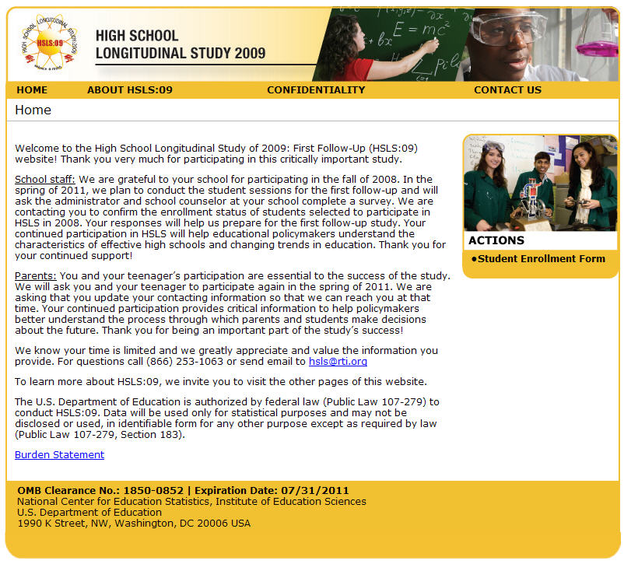
[HSLS School Mailing Password Reset Page]
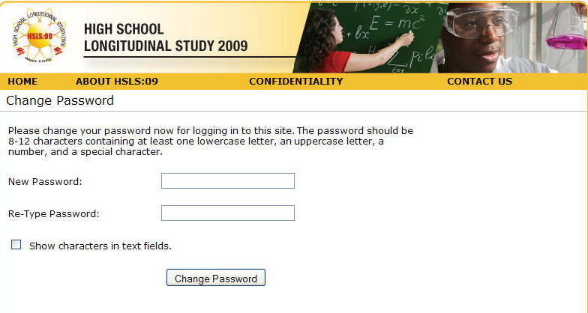

[Student current enrollment update page]
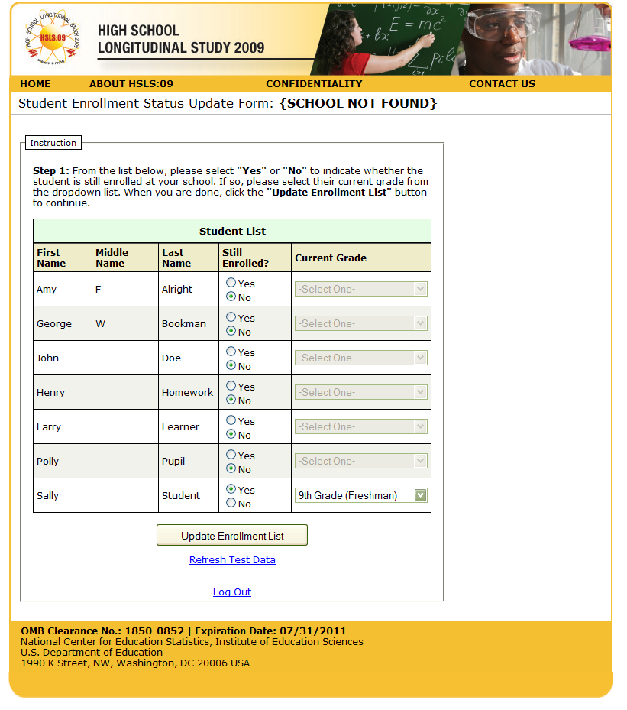
[Update information on students no longer enrolled]
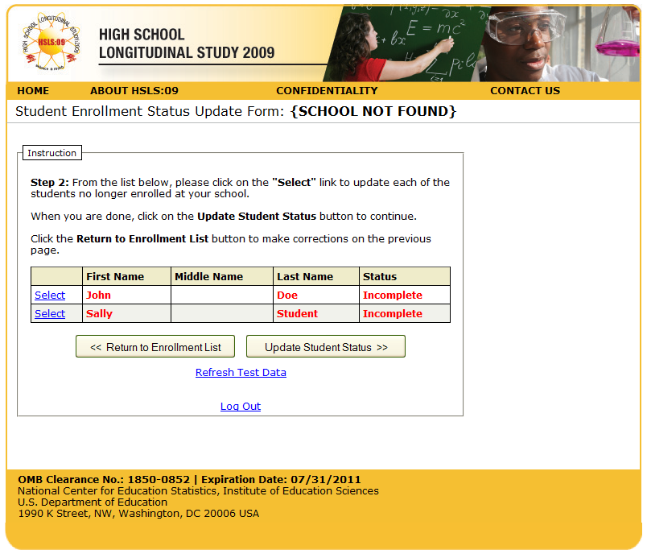
[Student enrollment status update form]
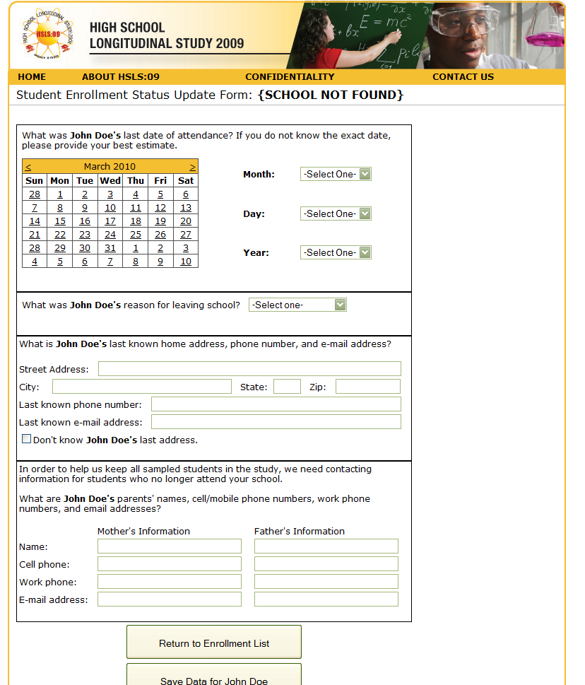

RTI IRB Approval Notice
