ADDENDUM TO SUPPORTING STATEMENT FOR EXTENSION OF OPM FORM 1203-FX

Further Justification

- Explain the circumstances that make the collection of information necessary. Include identification of any legal or administrative requirements that necessitate the collection.

OPM is responsible for open competitive examinations for admissions to the competitive service in accordance with section 1104 of Title 5, United States Code (U.S.C.) and section 3304 of Title 5, United States Code (U.S.C.). OPM is specifically authorized to collect such information as required to carry out its responsibility to examine applicants for competitive service positions.

OPM can delegate the authority to collect such information as required to carry out examinations of applicants for competitive service positions as authorized in section 1104 of Title 5, United States Code (U.S.C.) and 5 CFR § 250.102. The information must be collected from all job applicants. The most common means of collecting this information is through the OPM Form 1203-FX Qualifications and Availability, Form C, which can be submitted by job applicants electronically or via paper. Most applicants enter this information using the electronic version, known as the on-line assessment, via the internet. The paper version is used by job applicants who cannot or will not use the electronic means of applying. The paper version is available on OPM’s Forms web site (http://www.opm.gov/forms) and via a “Forms” link on OPM’s USAJOBS web site (http://www.usajobs.opm.gov).

As part of its delegation agreement, OPM includes a description of minimum standards of performance and the system of oversight to be used by the agency and by OPM in monitoring the use of the delegated authority. For competitive examining, this information is described in the Delegated Examining Operations Handbook: A Guide for Federal Agency Examining Offices, May 2007. The Delegated Examining Operations Handbook (DEOH) is designed to provide assistance to agencies with delegated examining authority granted under section 1104 of Title 5, United States Code (U.S.C.).

The DEOH states:

Electronic applications
While OPM encourages agencies to take full advantage of technology by accepting on-line applications, you may not restrict individuals who do not have Internet access from being able to apply. You may require submission of applications in a particular format or form, but you may not require only electronic submission. Job announcements may encourage and should encourage electronic filing, but you must provide information about alternative methods or a contact for those who do not have Internet access.

From FY2005 - June of FY2010, approximately 95% of applicants chose to file electronically when applying for Federal jobs using USA Staffing, OPM’s Talent Acquisition System. As the total number of applicants increases each year, the number of applicants applying using the paper Form 1203-FX also increases, as indicated in the chart below. It is projected that over 45,000 individuals will apply through USA Staffing in FY10 using the paper Form 1203-FX as an alternative required by the Office of Personnel Management for those individuals who do not have Internet access.

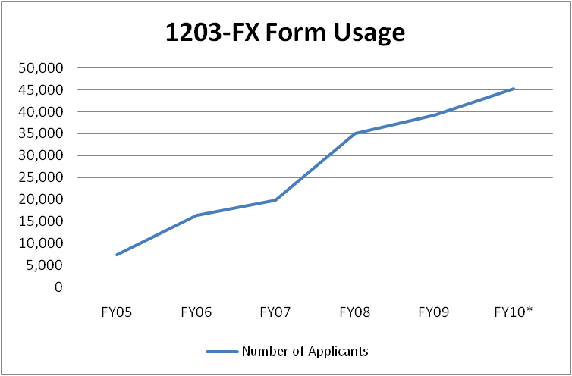
*FY10 total is projected data.
Total number of 1203-FX forms received through June 30, 2010 is 33,679.

15. Explain the reasons for any program changes or adjustments

The 1203-FX is used to collect qualifications information for a variety of occupations, as well as the varying levels of experience information of the applicants, completion time will always vary from year to year based on the number of questions each posted position requires. The burden estimate is influenced by the number of occupational questions for a specific vacancy announcement and the type of questionnaire used to assess applicants. OPM previously reported that 54,202 respondents per year would complete the paper version of the form.
However; we found that on average 31,389 applicants used the paper version while an average of 3,484,764 respondents applied using the electronic version annually. The average completion time is 45 minutes for the 1203-FX; yielding an estimated annual burden of 2,613,573 hours. The electronic version of the 1203-FX was not previously reported due to a separation of duties and programs which separately maintained the electronic version and the paper form submission numbers.
Appendix A – Copy of Cited Statute
5 USC Sec. 1104 02/01/2010
http://uscode.house.gov/uscode-cgi/fastweb.exe?getdoc+uscview+t05t08+118+0++%28%29%20%20AND%20%28%285%29%20ADJ%20USC%29%3ACITE%20AND%20%28USC%20w%2F10%20%281104%29%29%3ACITE%20%20%20%20%20%20%20%20%20

-EXPCITE-
TITLE 5 - GOVERNMENT ORGANIZATION AND EMPLOYEES
PART II - CIVIL SERVICE FUNCTIONS AND RESPONSIBILITIES
CHAPTER 11 - OFFICE OF PERSONNEL MANAGEMENT
-HEAD-
Sec. 1104. Delegation of authority for personnel management
-STATUTE-
(a) Subject to subsection (b)(3) of this section -

(1) the President may delegate, in whole or in part, authority for personnel management functions, including authority for competitive examinations, to the Director of the Office of Personnel Management; and
(2) the Director may delegate, in whole or in part, any function vested in or delegated to the Director, including authority for competitive examinations (except competitive examinations for administrative law judges appointed under section 3105 of this title, the cost of which examinations shall be reimbursed by payments from the agencies employing such judges to the revolving fund established under section 1304(e)), to the heads of agencies in the executive branch and other agencies employing persons in the competitive service.
(b)(1) The Office shall establish standards which shall apply to the activities of the Office or any other agency under authority delegated under subsection (a) of this section.
(2) The Office shall establish and maintain an oversight program to ensure that activities under any authority delegated under subsection (a) of this section are in accordance with the merit system principles and the standards established under paragraph (1) of this subsection.
(3) Nothing in subsection (a) of this section shall be construed as affecting the responsibility of the Director to prescribe regulations and to ensure compliance with the civil service laws, rules, and regulations.
(4) At the request of the head of an agency to whom a function has been delegated under subsection (a)(2), the Office may provide assistance to the agency in performing such function. Such assistance shall, to the extent determined appropriate by the Director of the Office, be performed on a reimbursable basis through the revolving fund established under section 1304(e).
(c) If the Office makes a written finding, on the basis of information obtained under the program established under subsection (b)(2) of this section or otherwise, that any action taken by an agency pursuant to authority delegated under subsection (a)(2) of this section is contrary to any law, rule, or regulation, or is contrary to any standard established under subsection (b)(1) of this section, the agency involved shall take any corrective action the Office may require.

5 USC Sec. 3304 02/01/2010
http://uscode.house.gov/uscode-cgi/fastweb.exe?getdoc+uscview+t05t08+230+0++%28%29%20%20AND%20%28%285%29%20ADJ%20USC%29%3ACITE%20AND%20%28USC%20w%2F10%20%283304%29%29%3ACITE%20%20%20%20%20%20%20%20%20

-EXPCITE-
TITLE 5 - GOVERNMENT ORGANIZATION AND EMPLOYEES
PART III - EMPLOYEES
Subpart B - Employment and Retention
CHAPTER 33 - EXAMINATION, SELECTION, AND PLACEMENT
SUBCHAPTER I - EXAMINATION, CERTIFICATION, AND APPOINTMENT
-HEAD-
Sec. 3304. Competitive service; examinations
-STATUTE-
(a) The President may prescribe rules which shall provide, as nearly as conditions of good administration warrant, for -
(1) open, competitive examinations for testing applicants for appointment in the competitive service which are practical in character and as far as possible relate to matters that fairly test the relative capacity and fitness of the applicants for the appointment sought;
(2) noncompetitive examinations when competent applicants do not compete after notice has been given of the existence of the vacancy; and
(3) authority for agencies to appoint, without regard to the provision of sections 3309 through 3318, candidates directly to positions for which -
(A) public notice has been given; and
(B) the Office of Personnel Management has determined that there exists a severe shortage of candidates or that there is a critical hiring need.
The Office shall prescribe, by regulation, criteria for identifying such positions and may delegate authority to make determinations under such criteria.
(b) An individual may be appointed in the competitive service only if he has passed an examination or is specifically excepted from examination under section 3302 of this title. This subsection does not take from the President any authority conferred by section 3301 of this title that is consistent with the provisions of this title governing the competitive service.

[Code of Federal Regulations]
[Title 5, Volume 1]
[Revised as of January 1, 2009]
From the U.S. Government Printing Office via GPO Access
[CITE: 5CFR250.102]

http://frwebgate.access.gpo.gov/cgi-bin/get-cfr.cgi

[Page 84]

TITLE 5--ADMINISTRATIVE PERSONNEL

CHAPTER I--OFFICE OF PERSONNEL MANAGEMENT

PART 250_PERSONNEL MANAGEMENT IN AGENCIES--Table of Contents

Subpart A_Authority for Personnel Actions in Agencies

Sec. 250.102 Delegated authorities.

OPM may delegate its authority, including authority for competitive examinations, to agencies, under 5 U.S.C. 1104(a)(2), through a delegation agreement. The delegation agreement developed with the agency must specify the conditions for applying the delegated authorities. The agreement must also set minimum standards of performance and describe the system of oversight by which the agency and OPM will monitor the use of each delegated authority.

Delegated Examining Operations Handbook: A Guide for Federal Agency Examining Offices, May 2007
http://www.opm.gov/deu/Handbook_2007/DEO_Handbook.pdf

Electronic applications
While OPM encourages agencies to take full advantage of technology by accepting on-line applications, you may not restrict individuals who do not have Internet access from being able to apply. You may require submission of applications in a particular format or form, but you may not require only electronic submission. Job announcements may encourage and should encourage electronic filing, but you must provide information about alternative methods or a contact for those who do not have Internet access.

