TSA required information:
Name (First, Middle, Last):
(This should match the ID you will show TSA at the airport)
Your likely Departure Airport:
Date of Birth:
Place of Birth:
Gender: | ___ Female ____ Male
For honorarium (see next page for locating banking numbers—Banking information only needed for U.S.-based participants):
Social Security Number:¹
Bank Routing Number:
Account Number:
Bank Name, City, State, and Zip Code:
Account type (circle): | Checking Savings Other __________________
Business Address:
Organization:
Department:
Address:
City:
State:
Postal Code & Country (if not U.S.):
Phone:
FAX:
E-mail:
Express Mail Address (if different):
Home Address:
Address:
City, State, Postal Code
& Country
Phone:
Cell:
Keywords describing your scientific expertise:

Please e-mail curriculum vitae (CV) or resume including recent publications, panels, awards, honors, etc. to osqr@ars.usda.gov.

For Panel Reviewers Only:
- Review the list of projects enclosed and notify OSQR if you believe you have a conflict.
- Provide below name and contact information for your supervisor so that OSQR may send a letter acknowledging your participation:

Your signature below indicates that all of the information provided is true and that you understand all of the instructions and request for information. If questions remain, please call 301-504-3282.

Peer Reviewer’s Signature _______________________________________ Date __________________

Note:
¹A Social Security Number (SSN) is needed for all panelists in order to establish the appropriate travel authorizations for those who will be traveling at USDA expense and to pay an honorarium. If you are receiving neither travel support nor an honorarium this information is not needed. Non U.S. participants without a SSN should leave this blank.

We request your SSN under the authority of Executive Order 9397 in order to keep your records straight; other people may have the same name. As allowed by law or Presidential directive, USDA may use your SSN to seek information about you from employers, schools, banks, and others who know you. Your SSN may also be used in studies matching with other Government files, for example, files on unpaid student loans. The OSQR does not retain your SSN in its electronic files.

How to find your bank routing number:
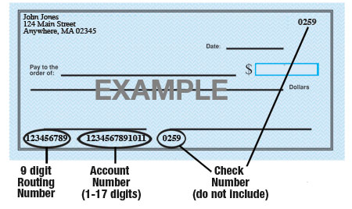
Please fax this form with your Confidentiality Agreement (fax: 301-504-1251) promptly, and then mail both forms to OSQR. This allows us to start processing your paperwork right away. OSQR requires original signatures for our official records.

Public Burden Statement: According to the Paperwork Reduction Act of 1995, an Agency may not conduct or sponsor, and a person is not required to respond to a collection of information unless it displays a valid OMB number. The valid OMB control number for this information collection is 0518-0028. The time required to complete this information collection is estimated to average 30 minutes, including time for reviewing instructions, searching existing data sources, gathering data, and completing and reviewing the information. You may send comments regarding the burden estimate or any other aspect of the collection of information, including suggestions for reducing the burden to the U.S. Office of Personnel Management, Reports and Forms Management Officer, Washington, DC 20415-0001.

