Hawaiian Monk Seal

Ilio holo ikauaua

  - Public Opinion Survey

  - Survey for Individuals (Short Version)

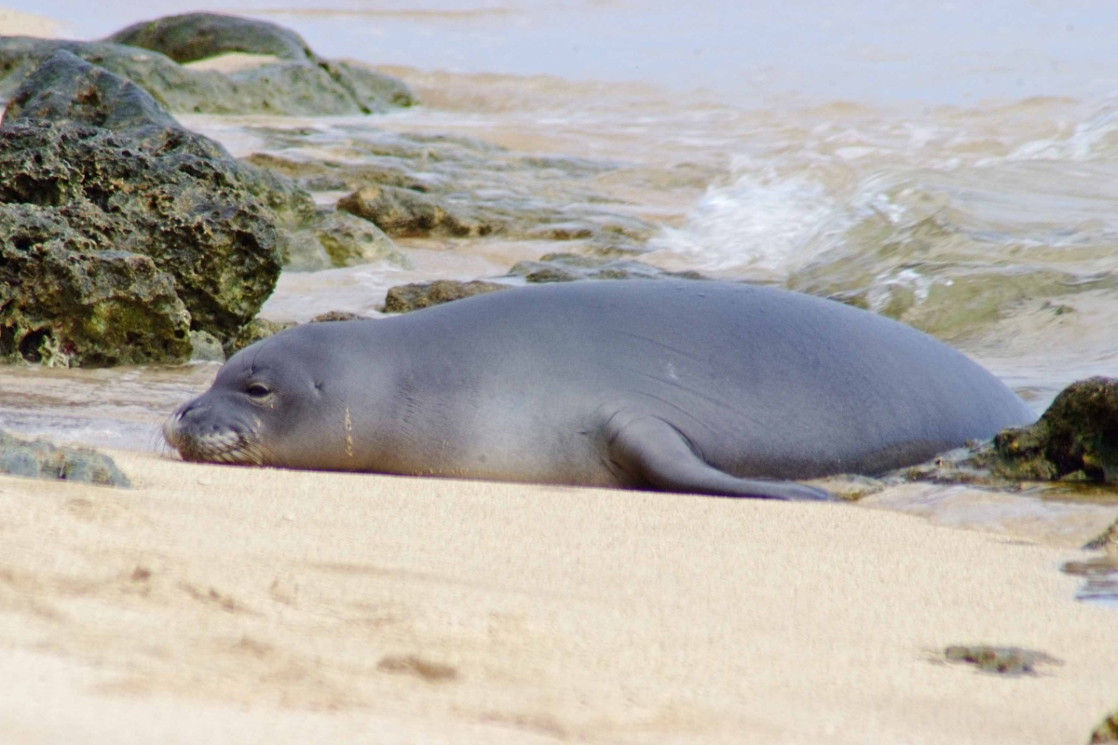

Your participation in this survey is voluntary. Any material that might identify you will be destroyed at the end of the study.

OMB Control #: XXXX-XXXX
Expiration Date: xx/xx/xxxx

This survey is being conducted to gather information on the public’s knowledge and opinions about wild Hawaiian monk seals (Ilio holo ikauaua; Monachus schauinslani). The questions in this survey are about the Hawaiian monk seal in the wild rather than monk seals in public display facilities (i.e., zoos and aquaria). Throughout this survey all references to monk seals mean Hawaiian monk seals. The results of the survey will be used to help develop public outreach activities for wild Hawaiian monk seal conservation and to help develop and assess management strategies for dealing with human-seal interactions. Your participation will help provide valuable information.

- Have you ever personally observed a monk seal in the wild in Hawai‘i (outside of zoos and aquaria)?
 | Yes (Go to Q 2) |  | No (Go to Q 3)

- If you have observed monk seals in the wild, how many different times have you seen them in the past five years? (Mark one)
1 time | 2-5 times | 6-10 times | More than 10 times

- If you have a monk seal in the wild, where? (Mark all that apply)
 | Seal was on the beach |  | I was on a commercial tour
 | Seal was in the water |  | I was in a personal /non-commercial boat or other type of watercraft
 | I was on the beach |  | Don’t know
 | I was in the water (swimming, snorkeling, diving, etc.) |  | Other (Please describe)

WHAT DO PEOPLE KNOW ABOUT MONK SEALS?
- What is your level of knowledge about the Hawaiian monk seal?
No knowledge | Small amount | Average amount | Large amount

- Do you think the population of Hawaiian monk seals in general has been increasing or decreasing over the past twenty years?
Significant decrease | Slight decrease | Stable (neither increasing nor decreasing) | Slight increase | Significant increase | Not sure

Hawaiian monk seals are legally protected under Federal and State laws.
- Prior to this survey, were you aware of any legal protections in place for the Hawaiian monk seal?
 | Yes |  | No

- Do you think it is dangerous for people to swim with or be in close contact in the water with monk seals?
 | Yes |  | Not sure
 | No |  | Other (Please describe)

- If you saw a monk seal would you be likely to report it?
 | Yes |  | Not sure
 | No |  | Other (Please describe)

- Do you know which authorities to report monk seal sightings to?
 | Yes (Please describe) |  | No

- People have different opinions about what is considered appropriate behavior around wildlife. Which of the following, if any, do you consider appropriate behavior regarding monk seals? (Mark all that apply)
Viewing monk seals from 100 ft away
Viewing monk seals from 10 ft away
Approaching monk seals within 10 ft on land
Touching monk seals
Feeding monk seals
Swimming close to monk seals
Shooting at or around monk seals
Photographing monk seals
Fishing around monk seals
Yelling, or making other very loud noises around monk seals
Trying to scare monk seals away
Allowing dogs to approach and/or interact with monk seals

- Do you or any family members in your household fish?
Yes
No (Go to Q 13)

- Do you think that if monk seals are present in an area where you are fishing, you catch less fish?
 | Yes |  | Not sure
 | No |  | Other (Please describe)

When monk seals haul out onto beaches that people frequent, an area around the monk seal is often roped off to ensure people do not try to get too close.
- Do you agree with current practice of closing a portion of the beach surrounding monk seals when they are present?
 | Yes |  | Not sure
 | No |  | Other (Please describe)

- Would one of the signs below, if placed near a monk seal, be likely to convince you not to disturb the seal?
Yes (If yes, please mark the one that would work best)
No
Not sure (If not sure, please mark the sign you prefer)
Both signs would be equally effective

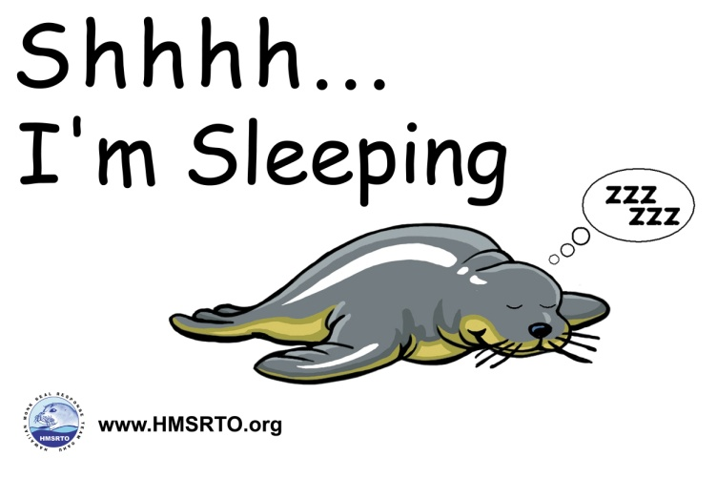

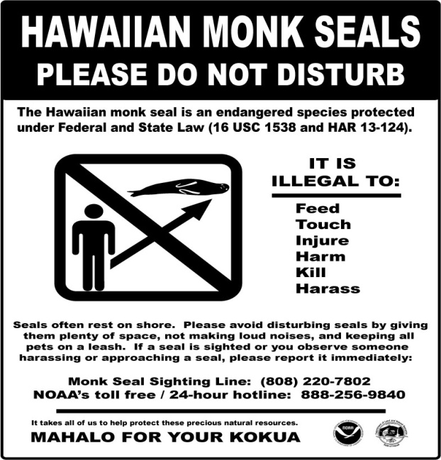

All personal information will be destroyed at the end of the study.

- Which statement best describes your living situation.
 | I am a permanent resident of Hawai‘i |  | I am a first-time visitor to Hawai‘i
 | I am part-time residents of Hawai‘i |  | I am a repeat visitor to Hawai‘i

- What is your ethnicity?
Hispanic or Latino
Not Hispanic or Latino

- What is your race? (Mark all that apply)
 | Asian |  | Native Hawaiian
 | American Indian or Alaska Native |  | Other Pacific Islander
 | Black or African American |  | White

- What is the highest level of education you have attained?
Some high school or less
High school diploma or equivalent
Some college, no degree
Two year degree (AA, AS) or technical school
Four year college graduate (BA, BS)
Some graduate work but did not receive a graduate degree
Graduate degree (MA, MS, PhD, JD, MD, etc.)

Thank you for taking the time to complete this survey. Your participation is greatly appreciated! Please use the space below to provide any additional comments.

This survey is funded by the National Oceanic and Atmospheric Administration, National Marine Fisheries Service. Public reporting burden for this collection of information is estimated at 5 minutes, including time for reviewing instructions, answering all questions and returning the survey to the administrator. Please send comments regarding this burden estimate or any other suggestions for reducing this burden to Jennifer Metz, National Marine Fisheries Service, Outreach and Education Specialist, Protected Resources Division, NOAA Fisheries, Pacific Islands Regional Office, 1601 Kapiolani Blvd., Suite 1110, Honolulu, HI 96814-0047. All responses will be protected and will not be released for public use except in aggregate statistical form (and without providing and personally identifying characteristics). Notwithstanding any other provision of the law, no person is required to respond to, nor shall any person be subject to a penalty for failure to comply with, a collection of information subject to the requirements of the Paperwork Reduction Act, unless that collection of information displays a currently valid OMB Control Number.

