Hawaiian Monk Seal

*Ilio holo ikauaua*

Public Opinion Survey

Survey for Fisher People (Short Version)

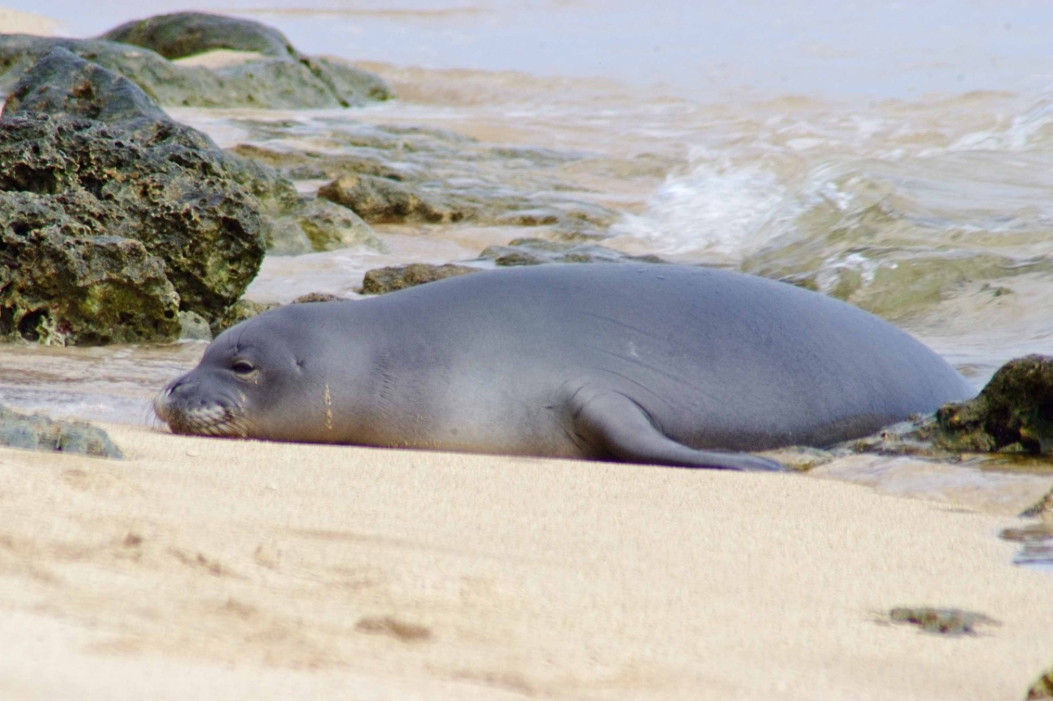

Your participation in this survey is voluntary. Any material that might identify you will be destroyed at the end of the study.

OMB Control #: XXXX-XXXX

Expiration Date: xx/xx/xxxx

This survey is being conducted to gather information on the public’s knowledge and opinions about **wild Hawaiian monk seals** (Ilio holo ikauaua; *Monachus schauinslani*). The questions in this survey are about the Hawaiian monk seal in the wild rather than monk seals in public display facilities (i.e., zoos and aquaria). Throughout this survey all references to monk seals mean Hawaiian monk seals. The results of the survey will be used to help develop public outreach activities for wild Hawaiian monk seal conservation and to help develop and assess management strategies for dealing with human-seal interactions. Your participation will help provide valuable information.

1. Have you ever personally observed a monk seal in the wild in Hawai‘i (outside of zoos and aquaria)?

|  |  |
| --- | --- |
|  | Yes (Go to Q 2) |
|  | No (Go to Q 3) |

1. If you have observed monk seals in the wild, how many different times have you seen them in the past five years? (Mark one)

|  |  |  |  |
| --- | --- | --- | --- |
| 1 time | 2-5 times | 6-10 times | More than 10 times |

1. What is your level of knowledge about the Hawaiian monk seal?

|  |  |  |  |
| --- | --- | --- | --- |
| No knowledge | Small amount | Average amount | Large amount |

1. Please indicate all of the reasons you or any family members in your household fish. (Mark all that apply)

|  |  |
| --- | --- |
|  | Fish to provide food for my family |
|  | Fish to provide income |
|  | Fish for recreation/sport only |
|  | Fish for recreation/sport and sometimes keep part of my catch to eat |
|  | Fish for recreation/sport and sometimes sell part of my catch |
|  | Other (Please describe) _____________________ |

1. Do you think that if monk seals are present in an area where you are fishing, you catch less fish?

|  |  |  |  |
| --- | --- | --- | --- |
|  | Yes |  | Not sure |
|  | No |  | Other (Please describe) |

1. Do you think that if the number of monk seals increases, you would catch less fish?

|  |  |  |  |
| --- | --- | --- | --- |
|  | Yes |  | Not sure |
|  | No |  | Other (Please describe) |

1. If you were fishing and a monk seal became hooked on a fishing line how would you likely respond? (Mark all that apply)

|  |  |  |  |
| --- | --- | --- | --- |
|  | Cut the line |  | Try to scare it away |
|  | Try to get the hook free in some way |  | Don’t know/Not sure |
|  | Call the authorities |  | Other (Please describe) |

1. Would you be willing to use hooks without barbs while fishing in order to reduce the possibility of hooks becoming stuck in the mouths of monk seals?

|  |  |  |  |
| --- | --- | --- | --- |
|  | Yes |  | Only if required by law |
|  | No |  | Only in areas where monk seals are present |
|  | Not sure |  |  |

1. Do believe that using hooks without barbs would affect fish catch?

|  |  |  |  |
| --- | --- | --- | --- |
|  | Yes |  | Only for certain types of fish |
|  | No |  | Not sure |

## People have various opinions about whether fishing should be regulated to protect monk seals.

1. Do you agree or disagree that regulations for recreational hook and line fishing in the main Hawaiian Islands should be enacted SPECIFICALLY to reduce or prevent monk seals from becoming hooked?

|  |  |  |  |  |
| --- | --- | --- | --- | --- |
| Strongly disagree | Disagree | Agree | Strongly agree | Not sure |

1. Do you think the population of Hawaiian monk seals in general has been increasing or decreasing over the past twenty years?

|  |  |  |  |  |  |
| --- | --- | --- | --- | --- | --- |
| Significant decrease | Slight decrease | Stable (neither increasing nor decreasing) | Slight increase | Significant increase | Not sure |

## Hawaiian monk seals are legally protected under Federal and State laws.

1. Prior to this survey, were you aware of any legal protections in place for the Hawaiian monk seal?

|  |  |  |  |
| --- | --- | --- | --- |
|  | Yes |  | No |

1. If you saw a monk seal would you be likely to report it?

|  |  |  |  |
| --- | --- | --- | --- |
|  | Yes |  | Not sure |
|  | No |  | Other (Please describe) |

1. Do you know which authorities to report monk seal sightings to?

|  |  |  |  |
| --- | --- | --- | --- |
|  | Yes (Please describe)__________________ |  | No |

1. People have different opinions about what is considered appropriate behavior around wildlife. Which of the following, if any, do you consider appropriate behavior regarding monk seals? (Mark all that apply)

|  |  |
| --- | --- |
|  | Viewing monk seals from 100 ft away |
|  | Viewing monk seals from 10 ft away |
|  | Approaching monk seals within 10 ft on land |
|  | Touching monk seals |
|  | Feeding monk seals |
|  | Swimming close to monk seals |
|  | Shooting at or around monk seals |
|  | Photographing monk seals |
|  | Fishing around monk seals |
|  | Yelling, or making other very loud noises around monk seals |
|  | Trying to scare monk seals away |
|  | Allowing dogs to approach and/or interact with monk seals |

## When monk seals haul out onto beaches that people frequent, an area around the monk seal is often roped off to ensure people do not try to get too close.

1. Do you agree with current practice of closing a portion of the beach surrounding monk seals when they are present?

|  |  |  |  |
| --- | --- | --- | --- |
|  | Yes |  | Not sure |
|  | No |  | Other (Please describe) |

1. If small areas of beach you visit were blocked off from all human activity during periods of the monk seal birthing season, would you consider this a hardship?

|  |  |  |  |
| --- | --- | --- | --- |
|  | Yes |  | Not sure |
|  | No |  | Other (Please describe) |

# All personal information will be destroyed at the end of the study.

1. Which statement best describes your living situation.

|  |  |  |  |
| --- | --- | --- | --- |
|  | I am a permanent resident of Hawai‘i |  | I am a first-time visitor to Hawai‘i |
|  | I am part-time residents of Hawai‘i |  | I am a repeat visitor to Hawai‘i |

1. What is your ethnicity?

|  |  |
| --- | --- |
|  | Hispanic or Latino |
|  | Not Hispanic or Latino |

1. What is your race? (Mark all that apply)

|  |  |  |  |
| --- | --- | --- | --- |
|  | Asian |  | Native Hawaiian |
|  | American Indian or  Alaska Native |  | Other Pacific Islander |
|  | Black or African American |  | White |

1. What is the highest level of education you have attained?

|  |  |
| --- | --- |
|  | Some high school or less |
|  | High school diploma or equivalent |
|  | Some college, no degree |
|  | Two year degree (AA, AS) or technical school |
|  | Four year college graduate (BA, BS) |
|  | Some graduate work but did not receive a graduate degree |
|  | Graduate degree (MA, MS, PhD, JD, MD, etc.) |

## Mahalo for taking the time to complete this survey. Your participation is greatly appreciated! Please use the blank space to provide any additional comments.

*This survey is funded by the National Oceanic and Atmospheric Administration, National Marine Fisheries Service. Public reporting burden for this collection of information is estimated at 5 minutes, including time for reviewing instructions, answering all questions and returning the survey to the administrator.* *Please send comments regarding this burden estimate or any other suggestions for reducing this burden to Jennifer Metz, National Marine Fisheries Service, Outreach and Education Specialist, Protected Resources Division, NOAA Fisheries, Pacific Islands Regional Office, 1601 Kapiolani Blvd., Suite 1110, Honolulu, HI 96814-0047. All responses will be protected and will not be released for public use except in aggregate statistical form (and without providing and personally identifying characteristics). Notwithstanding any other provision of the law, no person is required to respond to, nor shall any person be subject to a penalty for failure to comply with, a collection of information subject to the requirements of the Paperwork Reduction Act, unless that collection of information displays a currently valid OMB Control Number.*