Hawaiian Monk Seal

*Ilio holo ikauaua*

Public Opinion Survey

Survey for Commercial Tour Operators

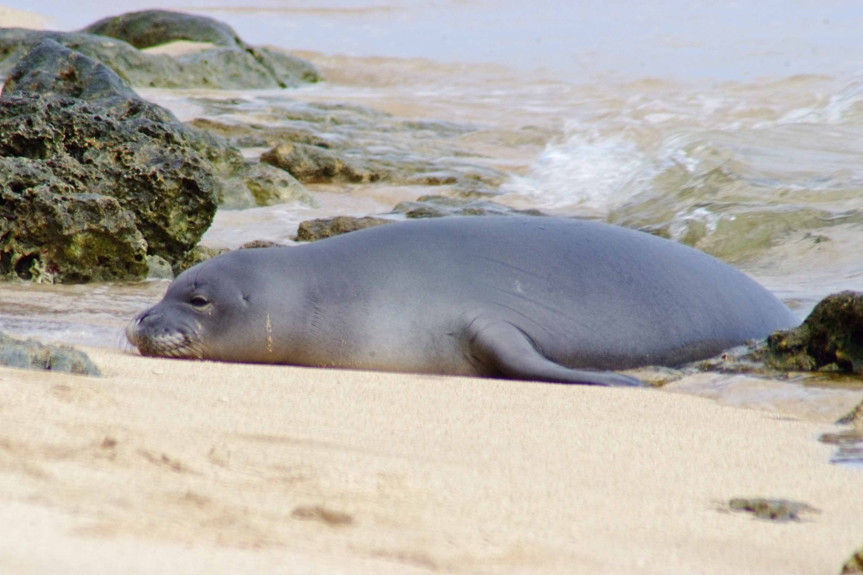

Your participation in this survey is voluntary. Any material that might identify you will be destroyed at the end of the study.

OMB Control #: XXXX-XXXX

Expiration Date: xx/xx/xxxx

Throughout this survey all references to monk seals mean Hawaiian monk seals.

1. Have your clients ever reported observing a monk seal in the wild while on one of your tours in Hawai‘i (outside of zoos and aquaria)?

|  |  |
| --- | --- |
|  | Yes (Go to Q 2) |
|  | No (Go to Q 4) |

1. If clients have reported observing monk seals during tours, how often in the past year has this happened?

|  |  |  |  |
| --- | --- | --- | --- |
| 1 time | 2-5 times | 6-10 times | More than 10 times |

1. If clients have reported observing a monk seal in the wild while on one of your tours, where? (Check all that apply)

|  |  |
| --- | --- |
|  | Seal was on the beach |
|  | Seal was in the water |
|  | Client was on the beach |
|  | Client was in the water (swimming, snorkeling, diving, etc.) |
|  | Client was on a commercial tour |
|  | Client was in a personal /non-commercial boat or other type of watercraft |
|  | Don’t know |
|  | Other (Please describe)____________________ |

1. Do you make a point of trying to locate monk seals for your clients to view?

|  |  |
| --- | --- |
|  | Yes |
|  | No |

1. Do you discuss information about monk seals with your clients?

|  |  |  |  |  |
| --- | --- | --- | --- | --- |
| Never | Rarely | Only when they ask, or we see monk seals | With many clients | With every client |

# WHAT DO PEOPLE KNOW ABOUT MONK SEALS?

1. What is your level of knowledge about the Hawaiian monk seal?

|  |  |  |  |
| --- | --- | --- | --- |
| No knowledge | Small amount | Average amount | Large amount |

1. Do you think monk seals are native to the Hawaiian Islands?

|  |  |
| --- | --- |
|  | Yes |
|  | No |
|  | Not sure |

1. Do you think the population of Hawaiian monk seals in general has been increasing or decreasing over the past twenty years?

|  |  |  |  |  |  |
| --- | --- | --- | --- | --- | --- |
| Significant decrease | Slight decrease | Stable (neither increasing nor decreasing) | Slight increase | Significant increase | Not sure |

## Hawaiian monk seals are legally protected under Federal and State laws.

1. Prior to this survey, were you aware of any legal protections in place for the Hawaiian monk seal?

|  |  |
| --- | --- |
|  | Yes (Go to Q 10) |
|  | No (Go to Q 11) |

1. How well do you think the monk seal is protected under current regulations?

|  |  |  |  |  |
| --- | --- | --- | --- | --- |
| Not at all protected | Protected, but not enough | Well protected | Over protected | Not sure |

1. Do you agree or disagree with the following statement: *Protection of the Hawaiian monk seal is NOT very important because there are many types of seals throughout the world.*

|  |  |  |  |  |  |
| --- | --- | --- | --- | --- | --- |
| Strongly disagree | Disagree | Neither agree nor disagree | Agree | Strongly agree | Not sure |

1. Are you familiar with the Endangered Species Act?

|  |  |
| --- | --- |
|  | Never heard of it (Go to Q 14) |
|  | Heard of it, but don’t know much about it |
|  | Somewhat familiar |
|  | Very familiar |

1. Do you think that violations of the Endangered Species Act are regularly enforced?

|  |  |
| --- | --- |
|  | Yes |
|  | No |
|  | Not sure |

# HUMAN-MONK SEAL INTERACTIONS

1. People have different opinions about what is considered appropriate behavior around wildlife. Which of the following, if any, do you consider appropriate behavior regarding monk seals? (Mark all that apply)

|  |  |
| --- | --- |
|  | Viewing monk seals from 100 ft away |
|  | Viewing monk seals from 10 ft away |
|  | Approaching monk seals within 10 ft on land |
|  | Touching monk seals |
|  | Feeding monk seals |
|  | Swimming close to monk seals |
|  | Shooting at or around monk seals |
|  | Photographing monk seals |
|  | Fishing around monk seals |
|  | Yelling, or making other very loud noises around monk seals |
|  | Trying to scare monk seals away |
|  | Allowing dogs to approach and/or interact with monk seals |

1. Do you think it is dangerous for people to approach monk seals on land?

|  |  |
| --- | --- |
|  | Yes, for the person only |
|  | Yes, for the seal only |
|  | Yes, for both the person and the seal |
|  | No, if the seal is used to being around people |
|  | No, I think it is safe |
|  | Depends on the situation |
|  | Don’t know / Not sure |

1. Do you think it is dangerous for people to swim with or be in close contact in the water with monk seals?

|  |  |
| --- | --- |
|  | Yes, for the person only |
|  | Yes, for the seal only |
|  | Yes, for both the person and the seal |
|  | No, if the seal is used to being around people |
|  | No, I think it is safe |
|  | Depends on the situation |
|  | Don’t know / Not sure |

1. If a client told you that they saw a monk seal while on a tour, would you be likely to report it?

|  |  |
| --- | --- |
|  | Yes |
|  | No |
|  | Not sure |
|  | Other (Please describe) _____________________ |

1. Do you know which authorities to report monk seal sightings to?

|  |  |
| --- | --- |
|  | Yes (Please describe) ______________________ |
|  | No |

1. Have clients ever reported encountering a monk seal while they were doing activities in the water while on your tour?

|  |  |
| --- | --- |
|  | Yes (Go to Q 20) |
|  | No (Go to Q 21) |
|  | Not sure (Go to Q 20) |
|  | Doesn’t apply (Go to Q 21) |

1. If clients have reported encountering monk seals while in the water on your tour, how often has it happened in the past year?

|  |  |  |  |
| --- | --- | --- | --- |
| 1 time | 2-5 times | 6-10 times | More than 10 times |

1. Are clients given any instruction on what to do if they encounter monk seals, either in the water or on the beach?

|  |  |
| --- | --- |
|  | Yes |
|  | No |
|  | Only if we think they are likely to encounter one |
|  | Only if we know they are likely to encounter one |
|  | Other __________________________ |

1. If a client reported encountering a live monk seal tangled in a net, what would you suggest? (Mark all that apply)

|  |  |
| --- | --- |
|  | Do nothing |
|  | The client should try to cut it free |
|  | Myself or my staff should try to cut it free |
|  | The client should call the authorities |
|  | Myself or my staff should call the authorities |
|  | Don’t know/Not sure |
|  | Other (Please describe) _____________________ |

# FISHING AND MONK SEALS

1. Do clients on any of your tours engage in fishing?

|  |  |
| --- | --- |
|  | Yes (Go to Q 24) |
|  | No (Go to Q 29) |

1. Do you think that if monk seals are present in an area where your clients are fishing, less fish are caught?

|  |  |
| --- | --- |
|  | Yes |
|  | No |
|  | Not sure |
|  | Other (Please describe) _____________________ |

1. Do you think that if the number of monk seals increases, your clients would catch less fish?

|  |  |
| --- | --- |
|  | Yes |
|  | No |
|  | Not sure |
|  | Other (Please describe) _____________________ |

1. If clients were fishing and a monk seal became hooked on a fishing line how would you likely respond? (Mark all that apply)

|  |  |
| --- | --- |
|  | Cut the line |
|  | Try to get the hook free in some way |
|  | Call the authorities |
|  | Try to scare it away |
|  | Don’t know/Not sure |
|  | Other (Please describe) _____________________ |

1. Would you be willing to provide hooks without barbs to clients who fish in order to reduce the possibility of hooks becoming stuck in the mouths of monk seals?

|  |  |
| --- | --- |
|  | Yes |
|  | No |
|  | Only if required by law |
|  | Only in areas where monk seals are present |
|  | Not sure |

1. Do believe that using hooks without barbs would affect fish catch?

|  |  |
| --- | --- |
|  | Yes |
|  | No |
|  | Only for certain types of fish |
|  | Not sure |

## People have various opinions about whether fishing should be regulated to protect monk seals.

1. Do you agree or disagree that regulations for recreational hook and line fishing in the main Hawaiian Islands should be enacted SPECIFICALLY to reduce or prevent monk seals from becoming hooked?

|  |  |  |  |  |
| --- | --- | --- | --- | --- |
| Strongly disagree | Disagree | Agree | Strongly agree | Not sure |

# RESTRICTING HUMAN ACTIVITY AROUND MONK SEALS

1. Do you think certain human activities should be prohibited around monk seals?

|  |  |
| --- | --- |
|  | Yes (Go to Q 31) |
|  | No (Go to Q 32) |
|  | Not sure (Go to Q 31) |

1. Do you think that any of the following human activities should be prohibited in the known presence of monk seals? (Mark all that apply)

|  |  |  |  |
| --- | --- | --- | --- |
|  | Beach going |  | Fishing with nets |
|  | Swimming |  | Boating (motor) |
|  | Surfing |  | Jet skis/Personal watercraft |
|  | Snorkeling and / or Diving |  | Water skiing, parasailing and other motorized towing activities |
|  | Kayaking |  | Other_____________________________ |
|  | Spear fishing |  | None of the activities listed should be  prohibited. |
|  | Fishing with hook and line |  |  |

## When monk seals haul out onto beaches that people frequent, an area around the monk seal is often roped off to ensure people do not try to get too close.

1. Do you agree with current practice of closing a portion of the beach surrounding monk seals when they are present?

|  |  |
| --- | --- |
|  | Yes |
|  | No |
|  | Not sure |
|  | Other (Please describe) _____________________ |

## Female monk seals select a site to give birth, usually the same each year, and nurse their newborn pup for five to seven weeks. During this time the mother usually remains on land without eating.

1. Do you think it is appropriate to close sections of beach areas that are heavily used by mother monk seals to human activity during the height of the birthing season (March & April)?

|  |  |
| --- | --- |
|  | Yes |
|  | No |
|  | Only when a mother and pup are present |
|  | Not sure |

1. If small areas of beach you visit were blocked off from all human activity during periods of the monk seal birthing season, would you consider this a hardship?

|  |  |
| --- | --- |
|  | Yes |
|  | No |
|  | Only in certain instances (Please describe) _________________________________ |
|  | Not sure |

# EDUCATION AND OUTREACH

1. How did you learn what to do or what not to do when encountering monk seals? (Mark all that apply).

|  |  |
| --- | --- |
|  | I don’t have any knowledge about what to do when encountering monk seals |
|  | Internet |
|  | Television |
|  | Newspaper |
|  | Magazines |
|  | Radio |
|  | Aquarium or zoo |
|  | Word of mouth (e.g., from friends and family) |
|  | From school – (learned it yourself, or learned it from a child who learned it in school) |
|  | From Federal programs (such as NOAA) |
|  | From State programs (such as Division of Aquatic Resources) |
|  | From law enforcement agents |
|  | From lifeguards |
|  | Other (Please describe) _____________________ |

1. How effective do you think each of the following methods would be to help clients learn about wild monk seal conservation issues? (Mark one number for each category)

|  |  |  |  |  |
| --- | --- | --- | --- | --- |
|  | Not at all effective | Somewhat effective | Very effective | Not sure |
| Educational brochures and pamphlets provided to the clients | 1 | 2 | 3 | 0 |
| Personal presentations given to the clients | 1 | 2 | 3 | 0 |
| Showing videos to the clients | 1 | 2 | 3 | 0 |
| Print materials (e.g. posters) displayed where they could be viewed by the clients | 1 | 2 | 3 | 0 |
| Posting information on social media (Facebook, MySpace, Twitter) for clients | 1 | 2 | 3 | 0 |

1. Do you have any other suggestions on ways to inform and educate people about monk seal conservation issues?
2. Would one of the signs below, if placed near a monk seal, be likely to convince your clients not to disturb the seal?

|  |  |
| --- | --- |
|  | Yes (If yes, please mark the one that would work best) |
|  | No |
|  | Not sure (If not sure, please mark the sign you prefer) |
|  | Both signs would be equally effective |

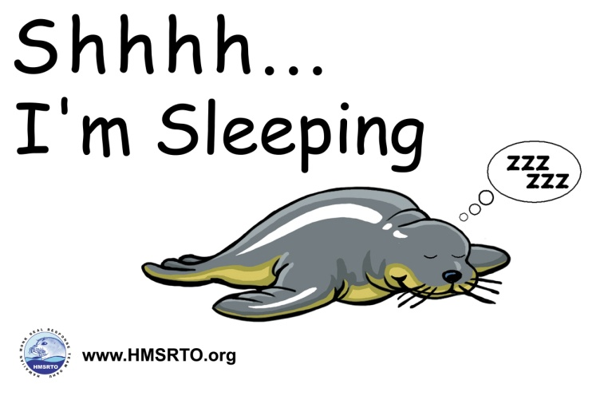

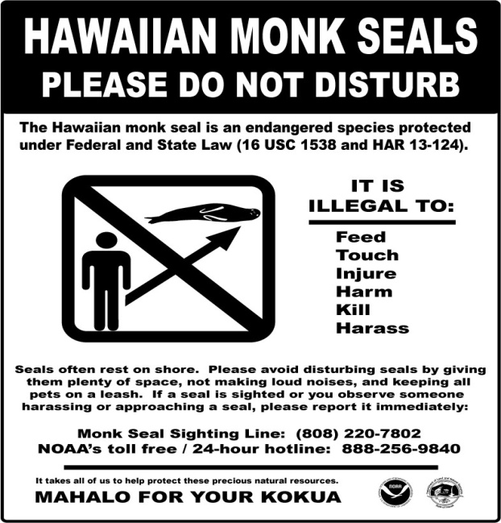

1. Would you be likely to provide or display educational materials to your clients about monk seals if they were provided free of charge?

|  |  |
| --- | --- |
|  | Yes |
|  | No |
|  | Not sure |
|  | Other _______________________ |

1. Would you be willing to participate in a training/educational workshop for commercial tour operators regarding monk seal issues, what activities can be conducted around monk seals without disturbing them, and methods of communicating conservation information to clients?

|  |  |
| --- | --- |
|  | Yes |
|  | No |
|  | Not sure |

1. Would you be likely to participate in a one-day, semi-annual state wide monk seal count that takes place every April and October?

|  |  |
| --- | --- |
|  | Yes |
|  | No |
|  | Not sure |
|  | Other_______________________ |

## **DEMOGRAPHICS**

## The following demographic information will be used to help make general conclusions about the survey participants. Any personal information will be destroyed at the end of the study.

1. Which statement best describes the majority of your clients.

|  |  |
| --- | --- |
|  | Permanent resident of Hawai‘i |
|  | Part time residents of Hawai‘i |
|  | Visitors to Hawai‘i |

1. What type of water activities do your clients engage in? (Mark all that apply)

|  |  |
| --- | --- |
|  | Diving |
|  | Snorkeling |
|  | Fishing |
|  | Swimming |
|  | Surfing |
|  | Boogie boarding |
|  | Kite surfing |
|  | Wind surfing |
|  | Lounging on the beach |
|  | Other (Please describe) ______________________ |

1. What is the highest level of education you have attained?

|  |  |
| --- | --- |
|  | Some high school or less |
|  | High school diploma or equivalent |
|  | Some college, no degree |
|  | Two year degree (AA, AS) or technical school |
|  | Four year college graduate (BA, BS) |
|  | Some graduate work but did not receive a graduate degree |
|  | Graduate degree (MA, MS, PhD, JD, MD, etc.) |

## Mahalo for taking the time to complete this survey. Your participation is greatly appreciated! Please use the space below to provide any additional comments.

*This survey is funded by the National Oceanic and Atmospheric Administration, National Marine Fisheries Service. Public reporting burden for this collection of information is estimated at 20 minutes, including time for reviewing instructions, answering all questions and returning the survey to the administrator. Please send comments regarding this burden estimate or any other suggestions for reducing this burden to Jennifer Metz, National Marine Fisheries Service, Outreach and Education Specialist, Protected Resources Division, NOAA Fisheries, Pacific Islands Regional Office, 1601 Kapiolani Blvd., Suite 1110, Honolulu, HI 96814-0047. All responses will be protected and will not be released for public use except in aggregate statistical form (and without providing and personally identifying characteristics). Notwithstanding any other provision of the law, no person is required to respond to, nor shall any person be subject to a penalty for failure to comply with, a collection of information subject to the requirements of the Paperwork Reduction Act, unless that collection of information displays a currently valid OMB Control Number.*